**STUDY ON PROBLEMS AND CHALLENGES FACED BY GOVERNMENT TAMIL MEDIUM STUDENTS IN NEET EXAM**

A field study submitted to

**GOVERNMENT ARTS AND SCIENCE COLLEGE, ARAKKONAM-631 051**

In partial fulfillment of the requirements for the degree of

**MASTER OF ARTS IN ENGLISH**

By

**B.YOGESH**

REG.NO:35621P02016

Under the Guidance of

**Dr. P. SAMUEL., M.A., B.Ed., M. Phil., Ph.D.,**

HOD, PG Department of English

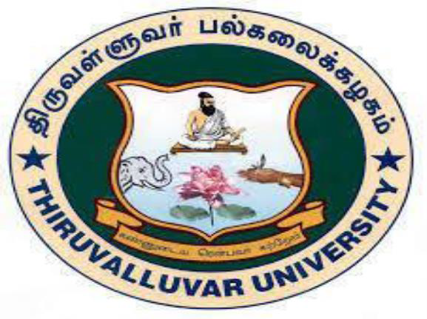

**PG DEPARTMENT OF ENGLISH**

**GOVERNMENT ARTS AND SCIENCE COLLEGE, ARAKKONAM-631 051 JUNE 2022**

**FORM-A**

TITLE OF FIELD STUDY : **PROBLEMS AND CHALLENGES**

# FACED BY GOVERNMENT TAMIL MEDIUM STUDENTS IN NEET EXAM

LANGUAGE : English NAME OF THE CANDIDATE : **YOGESH.B** REG.NO : 3562IP02016

AGE : 21

MALE/FEMALE : Male

DEPARTMENT : PG ENGLISH

YEAR/SEMESTER : I/II

COLLEGE ADDRESS : Government Arts and Science College,

Arakkonam-631 051

RESEARCH SUPREVISOR : **Dr.P.SAMUEL, M.A., B.Ed., M.Phil., Ph.D.,**

**B.YOGESH**

Govt. Arts and Science College Arakkonam-631 051

# DECLARATION

I, **YOGESH.B**, hereby declare that the Field Study entitled **PROBLEMS AND CHALLENGES FACED BY GOVERNMENT TAMIL MEDIUM STUDENTS IN NEET EXAM**

is the result of my original and independent research work, carried out under the guidance of **Dr. P. SAMUEL, M.A., B.Ed., M.Phil., Ph.D.,** Assistant Professor & HOD, Government Arts and Science College , Arakkonam and that it has not been submitted for the award of any Degree, Diploma, or Fellowship or any other similar titles of any university or institution previously.

Place : Arakkonam **YOGESH.B**

Date :

**PG DEPARTMENT OF ENGLISH GOVERNMENT ARTS AND SCIENCE COLLEGE,**

**ARAKKONAM**

**CERTIFICATE**

This is to certify that the Field study entitled **PROBLEMS AND CHALLENGES FACED BY GOVERNMENT TAMIL MEDIUM STUDENTS IN NEET EXAM** is a bonafied work

of **YOGESH.B**, Government Arts and Science College, Arakkonam, during the year 2021-2022. It is certified that this Field Study is an original work of the candidate carried out under my supervision.

Signature of the HOD Signature of Research Supervisor

# Dr.P.SAMUEL, Dr.P.SAMUEL,

**M.A., B.Ed., M.Phil., Ph.D., M.A., B.Ed., M.Phil., Ph.D.,**

Assistant Professor & Head Assistant Professor & Head

PG Department of English PG Department of English

Govt. Arts and Science College Govt. Arts and Science College

Arakkonam-631 051 Arakkoam-631 051

|  |  |  |
| --- | --- | --- |
| S.NO | CONTENT | PAGE  NO |
| 1  2  3  4  5  6  7  8  9  10  11  12  13  14  15  16  17  18  19 | INRODUCTION PREFACE OF STUDY PLACE OF THE STUDY  ADVANTAGE OF **NEET** EXAM DISADVANTAGE OF **NEET** EXAM THINGS TO OVERCOME IN THE FUTURE **NEET** EXAM CHALLENGES OBJECTIVES OF ENGLISH BARRIERS FIELD STUDY TOOLS  STATISTICAL DATA COLLECTIONS **NEET** AND PURPOSE OF STUDY FIELD STUDY WORK PLAN STATISTICAL ANALYSIS  STUDY RESULT  GET OVER **NEET** FEAR  TIPS TO CRACK **NEET** IN FIRST ATTEMPT  TIPS FOR NEET ASPIRANTS TO OVERCOME THE PRESSURE AND ANXIETY OF **NEET** EXAM  PHOTOS CONCLUSION | 1  2  2  3  4  5  6  7  8  8  8  10  13  13  14  15  16  19  26 |

**PROBLEMS AND CHALLENGES FACED BY GOVERNMENT TAMIL MEDIUM STUDENTS IN NEET EXAM**

# INTRODUCTION

The National Eligibility Entrance Test (NEET) formerly the All India Pre-Medical Test is the qualifying test for MBBS and BDS programmes in Indian Medical and dental colleges. It is conducted by the National Testing Agency. The NEET exam is conducted online and in 11 languages – English, Hindi, Marathi, Odia, Tamil, Urdu Bengali, Telugu, Kannada, and Assamese. The duration of the examination is three hours and a candidate needs to answer 180 questions. The exam Paper is divided into three sections- Physics, Chemistry, Biology (Botany and Zoology).

As soon as NEET results are announced, declare National Testing Agency the counselling process too. The Schedule for NEET counselling gets uploaded on the Medical Counselling committee website. Every student in India faces the challenges and obstacles of the NEET exam. The CBSE syllabus has been using in the NEET test question paper; nevertheless, our state board pupils are unfamiliar with it Government school students have a harder time qualifying for the NEET test because the state board and CBSE syllabus are so divergent .To eliminate the challenges and obstacles of the NEET exam, the government maintains the same syllabus for both CBSE and state boards. NEET exams success is unachievable without a private coaching class. Private NEET exam coaching is out of reach for most schoolchildren. As a result, all students should have free coaching. Certainly when you try to get something which not everyone can, you`ll get hindrance. They have catered them all. They had to handle them too. Biggest obstacle in my opinion. It

slows them down. Puts they in a situation from where they can`t get out. It`s like quick sand. The more they try to get out the more they get in. What will happen if I don`t get selected (?)How will? be the question ? Am I preparing the right way? What will be the cutoff? These and many more questions just waste our time. For droppers it`s more of a certain. They get bored of reading the same time and again. It`s frustrating. “My daughter is pursuing MBBS. By the way how many more drops would they take? Go for something else.”Breaks heart. Certainly does. It’s something we really do have. Especially a dropper ends up studying very less. Neglects NCERT. Overconfidence is a big hindrance. These obstacles will always be there. They are the indicators to show them that they on the right track. Cheers to the obstacles which make the victory more delightful.

# PREFACE OF STUDY

NEET is one of the most difficult medical entrances Test. After failing ready to move on next time, or move on to the other career. But the mind set is fully focused on the medical field to the failure students.

# PLACE OF THE STUDY

Panappakkam, kaveripakkam, Nemili, kanchipuram

# ADVANTAGES OF NEET EXAM

Because of NEET, people from all walks of life can now purse a career as a doctor. So because exams will be conducting on the same day across India. There will be a better chance of bolstering India`s integrity and expanding opportunities for those in undeveloped areas .Because we live in a country like India, where millions of kids are completing their school education, getting into a degree is quite competitive. Medicine, in a particular, is a class discipline of study that provides dignity and satification to doctors. As a result corruption is unavoidable. National Testing Agency also revelead that in the future NEET exams will be conducting entirely online. If this occurs, the risk of a question paper leak will reduce. People from the upper class used to pay lakhs of rupees to get (purchase a medical seat for their children in private colleges. This practice was abolished with the introduction of NEET. Previously, each medical college had its entrance exam. This could raise the expense of applying and getting to the testing locations. The NEET exam that is taken by all private and government medical schools in India. As a result, the admission exam is basic and straightforward.

Students are no longer under the stress of preparing for a variety of medical admission exams based on a variety of syllabuses. As a result, students are forced to focus solely on one material and one exam. The fact that the exam is thoroughly checked before it is given promotes the transparency and accountability of the NEET exam. Because most students used to learn the important courses and receive outstanding results on their board exams, this type- examination improves the effectiveness of this professional degree. Where they were given seats based on how well they performed. The largest disadvantage is those brilliant students who could understand, but not memorize, the courses were unable to follow their dream of becoming a doctor.

# DISADVANTAGES OF NEET EXAM

Aspirants who fail NEET continue to commit suicide, believing that NEET is only route to achieve their MBBS dream. By seeing one another do the same in the years to come. Every year, we were seeing suicide deaths alongside the NEET results, which is a sad circumstance. Because the NEET exam can only be taken at certain locations, rural students may be unable to take it. Candidates that arrive late may be given a second chance by the National Testing Agency on a predetermined date. Even though NEET has reduced the number of donation seats in private colleges, it has had little effect on the pricing structure of private and government colleges. In places like Tamil Nadu, where medical seats were filling rests faced plenty of challenges, both legally and psychologically. NEET scams are becoming more common these days, with candidates hiring persons with extensive knowledge to write their examinations for them. It is well-know in India’s southern states. Since NEET hopefuls spend one or two years preparing for the exam, their future careers may be jeopardizing. Finally, if they do not pass the exam, two must begin again by enrolling in a institution in a different field. Students from several states with varying syllabuses may be able to match the CBSE syllabus and ultimately fail the exam. Student’s mental stress levels are rising as they prepare for both their board examinations and the NEET at the same time. They attempt to attend different tuitions for coaching, which adds to the mental strain on parents. The nature of the questions answered in NEET is the first and foremost reason for people’s opposition to it. The National Testing Agency only concentrates on the CBSE syllabus, which is still considering a high level of education by many students. Exam centre security should not threaten students, especially female students. To pass this exam, you’ll need to invest in expensive private instruction. According to Tamil Nadu government data, barely 1.6

percent of candidates pass NEET without paying for pricey private coaching. For Tamil medium kids/Government school pupils, this makes MBBS an unachievable aspiration.

# THINGS TO OVERCOME IN THE FUTURE

1. Each training centre in the nation should carefully regulate by authorities. Many fake/illegal schools defraud students by providing inferior education while charging a higher charge.
2. For government school students taking the NEET exam, the government should set up special teaching faculties.
3. Government should run more NEET exam coaching centres in big numbers to help rural students.
4. Most kids struggle because they prepare for NEET simply for their parent’s purpose or aspiration. Proper career counselling must be provided in every school for 12th- grade students to know what profession they are truly competent at.
5. The NEET syllabus would be simplified in a fair manner, allowing students from all boards to study and pass the exam with ease.
6. Aspirants confront numerous challenges and obstacles of the NEET exam, some of which do not even surface at times. It is solely the obligation of the government to give appropriate solutions to the difficulties that students encounter. Well, problem with the English language. Most of people would be conversing in English while you would be feeling bad and embarrassed. They can use this embarrassment as fuel in order to get flourished in English language.

# NEET EXAM CHALLENGES

No doubt, NEET is a difficult and challenging exam. We are talking about the single-level medical entrance examination of the country with lakhs of students appearing for the exam, and limited seats offered in desired colleges. They passion to become a doctor and drive to save lives must decide they course of action. Inevitably, NEET is laborious but rewarding. However, they efforts, dedication, preparation will decide how back and check for success/failure stories on NEET, everyone has a different tale to tell, but the one common thing in all of them is how dedicated they were in their efforts (less or more). If they let the exam pressure get the better of they, undermining they effort, and not confident enough with a giving-up attitude, they are being they own enemy. The competition is simply overwhelming wherein a difference of mere 5 marks can bring them down by 50 ranks! The pressure is extremely high. So instead of concentrating on how difficult the exam is, they focus should be on what they can get to the table. Here, the key to getting through NEET is accuracy coupled with speed. Give the 300% avoid all sorts of distractions, for the coming few months, chant NEET only.

Dedicated study planner, intense revisions, rigorous practice sessions must be part of the journey. There should not be a single line unread by them when it comes to NCERT textbooks. Master all topics, by those possible questions on it. The possible questionnaire can come from previous years’ papers, mock tests, sample papers, they own questions framed on a topic. When he started preparing for NEET, he realised that even the private coaching to crack the test was too costly for his family to afford. Luckily, they were selected for the free residential programme in 2018. While the coaching was hope on mock test papers. “I have been solving one every day. I hope I make it this time.” For Guhan, and a million other students like him, access to was not

merit but money that was the biggest barrier in their path. Of the 539 medical colleges in India currently, close to half (260) are in private hands.

# OBJECTIVES OF ENGLISH BARRIERS

To start speaking English as much as possible To get an experienced tutor

To interact in English at every single day To use resources made for their level

To work on their pronunciation To learn phrases not words

To consider a big lifestyle change

To plan their conversation when they can

To learn early, do not focus too much on English Grammar To make the most of Technology

# FIELD STUDY TOOLS

1. Population of the study : 12th standard passed Students
2. Variable of the Study : Problems and Challenges faced by NEET

Students

1. Sample of the Study : 30(15boys, 15 girls)
2. Measuring Tools : Questionnaire method

# STATISTICAL DATA COLLECTIONS

30 Students for my study Understand students’ perception of NEET Exam questionnaires and studies. Documents and records obtaining registration by interviewing students.

# NEET AND PURPOSE OF STUDY

1. To know the basic knowledge of Tamil way students.
2. Students are required to write the NEET exam.
3. Need to find the right way to choose need to understand student’s problems?
4. Statistically, data collection is the process of gathering information from all relevant sources to solve a research problem. It helps to evaluate the outcome of the problem. Data collection

methods allow completing the answer to the relevant question. Parent require to make students aware of the specific purpose of medicine students should realize that English is a language just like Tamil, So if students improve their ability in English daily they can succeed in NEET exam.

# FIELD STUDY WORK PLAN

Selection of site for study

Selecting the tool for study

Preparation of quiz list for statistics

Statistical collection

Statistical Analysis

Knowing the details of the problem from the Results

Consulting and deciding on a solution

Solution Implementation

# QUESTIONNAIRE FOR FIELD STUDY ON PROBLEMS AND CHALLENGES FACED BY GOVERNMENT TAMIL MEDIUM STUDENTS IN NEET EXAM

* 1. Name of the student :
  2. Name of the school :
  3. Date of birth :
  4. Age :
  5. Gender :
  6. Mobile no &E-mail id
  7. Higher education pass out year a) 2017

b) 2018

c) 2019

d) 2020

* 1. HSC standard percentage
     1. Below 60%

b) 70% - 80%

c) 80% - 90%

d) 90% - 100%

* 1. Life after failing NEET
     1. Other carrier
     2. To try one more coaching
     3. More on to coaching
     4. Self training
  2. Disadvantages of NEET
     1. Different state board
     2. Entrance exam
     3. Merit list
     4. Pattern was changed
  3. Study plan & Preparation for NEET
     1. Material
     2. Net searching
     3. Library
     4. Consul tutors
  4. Difficulties faced in the Exam
     1. Heavy Syllabus
     2. Lack of adequate training
     3. Vigour of the curriculum in creasing
     4. Lack of Exam time
  5. Mindset after failing the exam
     1. Tried again
     2. Not tried again
     3. Depression
     4. Not depression
  6. Suggestions for the candidates
     1. Attend coaching class
     2. High quality study materials
     3. Follow a time table
     4. Prepare regularly
  7. Where did you attend NEET coaching?
     1. Government sector
     2. Private sector
     3. Online coaching
     4. Self study

# STATISTICAL ANALYSIS

The problems faced by the NEET exam students who were failed. A perusal depicts that out of 30 students, 9 students that mentioned other carrier after failing whereas 21 students mentioned self training. Out of 30 students, 11 students mentioned library to prepare for whereas 19 mentioned consul tutors. Out of 30 students, 10 students that mentioned online coaching to attend the place of coaching whereas 20 students mentioned self study. Out of 30 students, 15 students that mentioned passed out year in 2019 whereas 15 mentioned 2017.

# STUDY RESULT

1. In NEET exam, the students were asked higher education pass out year, in response to that out of 30 students 7 opted option ‘a’ ,15 opted option ‘b’, 8 opted option ‘c’, and 0 opted option ‘d’.
2. In NEET exam, the students were asked HSC standard percentage in response to that out of 30 students 3 opted option ‘a’, 13 opted option ‘b’, 10 opted option ‘c’, 4 opted option‘d’.
3. In NEET exam , the students were asked life after failing NEET, in response to that out of 30 students 9 opted option ‘a’, 5 opted option ‘b’, 7 opted option ‘c’, 9 opted option ‘d’.
4. In NEET exam, the students were asked Disadvantages of NEET, in response to that out of 30 students 12 opted option ‘a’, 3 opted option ‘b’, 7 opted option ‘c’, 8 opted option‘d’.
5. In NEET exam, the students were asked study plan & preparation for NEET, in response to that out of 30 students 11 opted option ‘a’, 9 opted option ‘b’, 5 opted option ‘c’, 4 opted option‘d’.
6. In NEET exam, the students were asked difficulties faced in the exam , in response to that out of 30 students 18 opted option ‘a’, 5 opted option ‘b’, 2 opted option ‘c’, 5 opted option ‘d’.
7. In NEET exam, the students were asked mindset after failing the exam, in response to that out of 30 students 2 opted option ‘a’, 7 opted option ‘b’, 20 opted option ‘c’, 1 opted option ‘d’.
8. In NEET exam, the students were asked suggestions for the candidates, in response to that out of 30 students 9 opted option ‘a’, 5 opted option ‘b’, 6 opted option ‘c’, 10 opted option‘d’.
9. In NEET exam, the students were asked where did you attend NEET coaching, in response to that out of 30 students 9 opted option ‘a’, 7 opted option ‘b’, 4 opted option ‘c’, 10 opted option‘d’

# GET OVER NEET FEAR

If you want to study medicine to become a doctor successfully, then it’s imperative that you qualify for the entrance exam first. But this clause should not be a matter of anxiety or concern for they. After all, they say, “Thinking will not overcome fear, but action will,” NEET is just around the corner and in these few months, they preparation is very crucial in terms of a final set of revisions before giving there best. The competition is tough and not the exam. Some factors that there parents, peer pressure etc. Here are a few tips which they need to retain before going to the exam; tips that will help them to realize, there preparation for the test is adequate to succeed in NEET.

Always maintain a positive approach: They friends finished practising 10 sample papers.

Don’t panic. They aim for 15 if not 20. Don’t limit them self by stumping they esteem, thinking that they are not prepared and others are. It is a human tendency to fell jittery; however, a determined mind integrated with hard work can let them overcome any obstacle.

Relentlessly work Hard: There is no substitute for hard work. They know there strengths and weaker sections. One must attempt to at least clear the fundamentals of such topics as it is a competitive exam, and they can’t afford to do any mistakes.

Have a Though knowledge if NEET question paper pattern: Once they are familiar with the exam pattern, marking scheme, and time duration, they can analyze and figure out what section or what kind of questions they want to attempt first. After all, a well- planned execution is as though is as though half the battle is won.

# TIPS TO CRACK NEET IN FIRST ATTEMPT

1. Plan a study schedule to complete the NEET syllabus in time.
2. Don’t leave out topics and chapters that they think are less important for NEET.
3. Study from NCERT textbooks, coaching modules and reference books for practicing NEET level problems.
4. Revise daily, make revision notes for last minute revision before the tests and exam.
5. Join a coaching to enhance your chances of cracking the NEET exam.
6. Attend all classes and complete your homework/assignments on time.
7. Clear all they doubt as soon as possible.
8. Give mock tests, analyse mistakes and improve they performance.
9. Manage they time well between studies and other tasks.
10. Stay positive and determined to achieve the goal.

# TIPS FOR NEET ASPIRANTS TO OVERCOME THE PRESSURE AND ANXIETY OF NEET EXAM

Start revising early: Often, students schedule their revision for the 17th hour and, as the time is low, they may miss some topics. This creates more pressure on students and even a single question strongly form those topics will highly affect the student’s mind in the exam hall. So, it is always better to schedule revision 2-3 months before the exam, and the one before the exam should be kept for relaxation.

Follow learn-practice-test pedagogy: The learn-practice-test is the best method of preparing for NEET. Many students skip one of these steps and feel pressure. Speed and accuracy are important factors while preparing so, always consider speed and accuracy in their learning process.

Make their own timetable: Every individual thinks differently. And studies differently. Then how a common standard timetable suits everyone. Instead of following the standard timetable, analyze the syllabus, their strengths, and weak subjects and accordingly create their own timetable.

Mix subjects: Many students often focus only on one subject or create a schedule for revising one subject or create a schedule for revising one subject after the other. While doing so, there may miss out on revising those. So, it is advisable to dedicate some hours to each subject are left out at the end and they may miss out on revising those. So, it is advisable to dedicate some hours to each subject daily to create a balance.

Take notes, short notes, and also make mistakes journal: Along with their classroom notes, make short notes of the important points such as formulae, names, events, incidents, etc., while studying a chapter. While practicing and attempting tests, note down their mistakes in a journal. These notes will help them to revise.

Sleep well: As per the doctors, a minimum of 6-7 hours of sleep is necessary to relax the body and mind. If they fail to dedicate a certain time to sleep, they may face many health issues. So, they should include relaxation time and sleep hours in their timetable so that they don’t miss them. It is also important to take at least a 10 minutes break after 1-2 hours of study to relax their body. During the breaks, try to stretch their hands and legs, and drink sufficient amounts of water to rejuvenate their body. According to health experts, stretching helps in improving the circulation of the body.

The bottom line: Preparing for the National Eligibility cum Entrance Test exam is fraught with challenges and distractions, and self-doubts. They tips, mentioned above help them to overcome the stress and anxiety that they may face while taking more pressure for the NEET exam. Always remember that no one can achieve success overnight, even if they take more pressure and stress. A lot of dedication and commitment is required to achieve a good score in the NEET exam and admission to the best medical institutions.

# PHOTOS

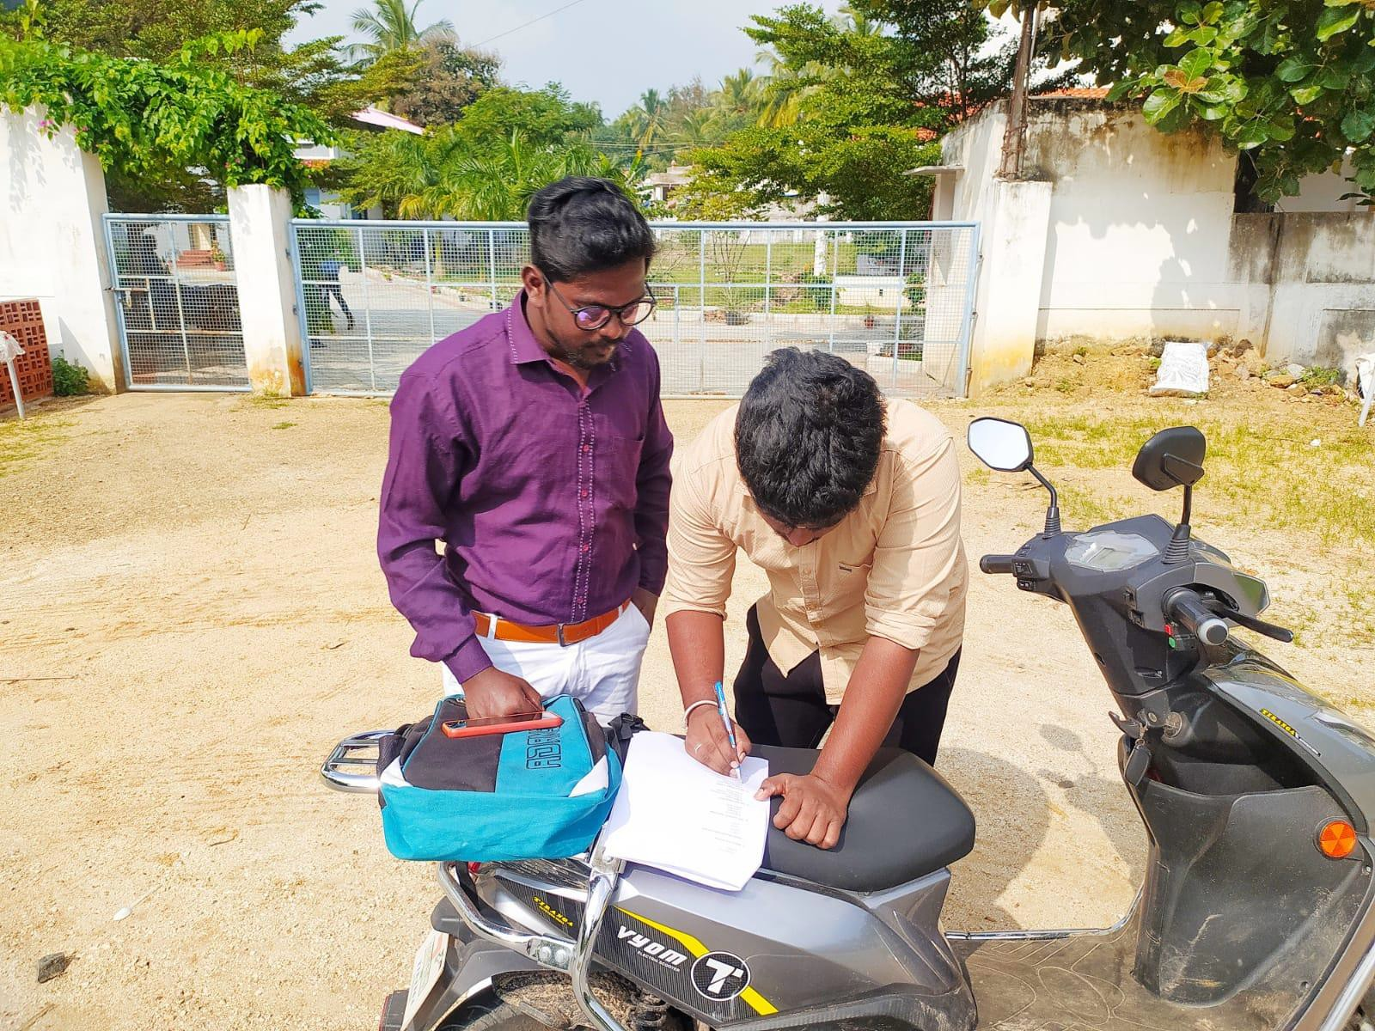

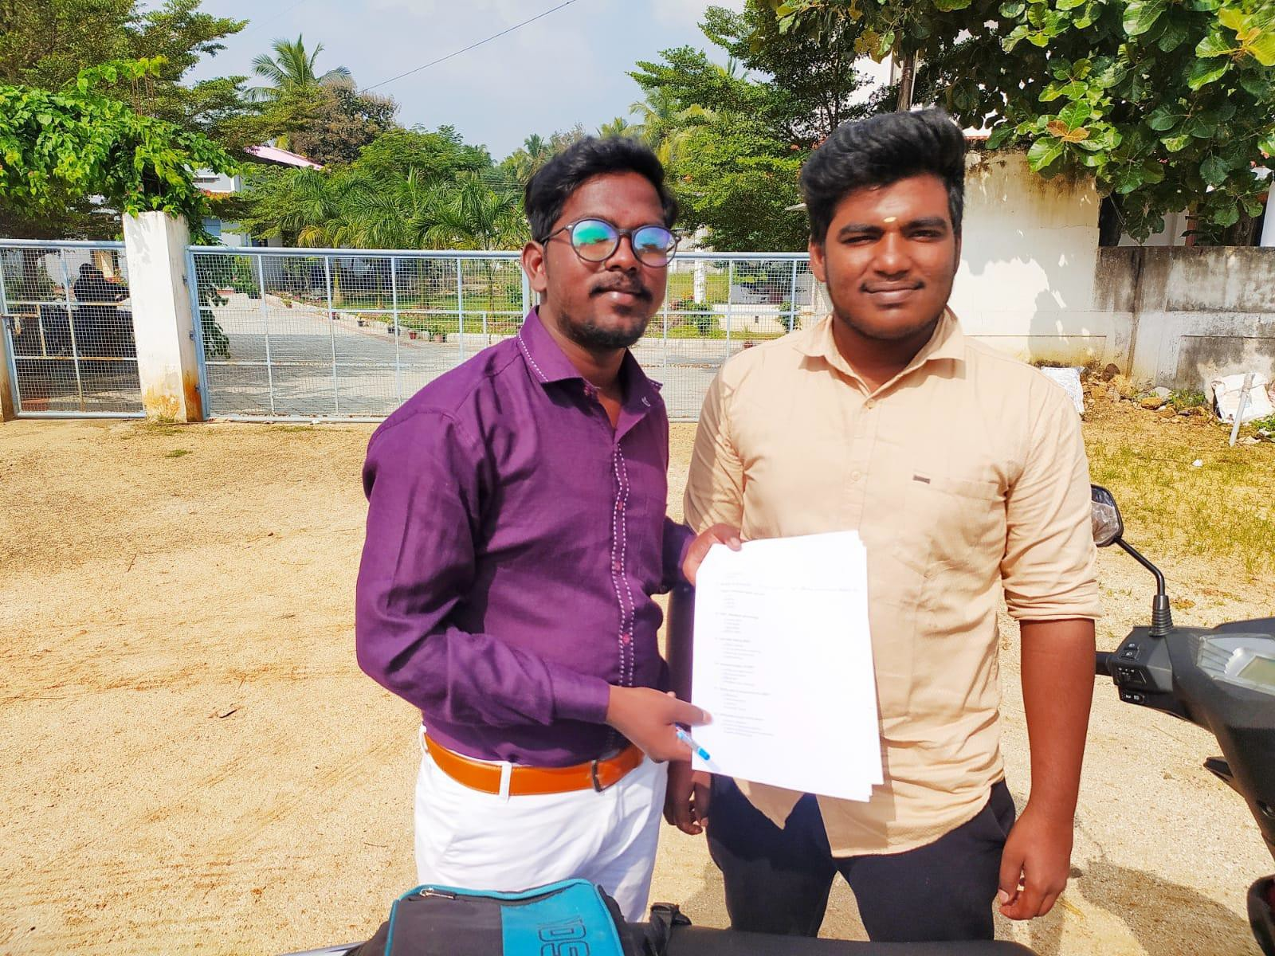

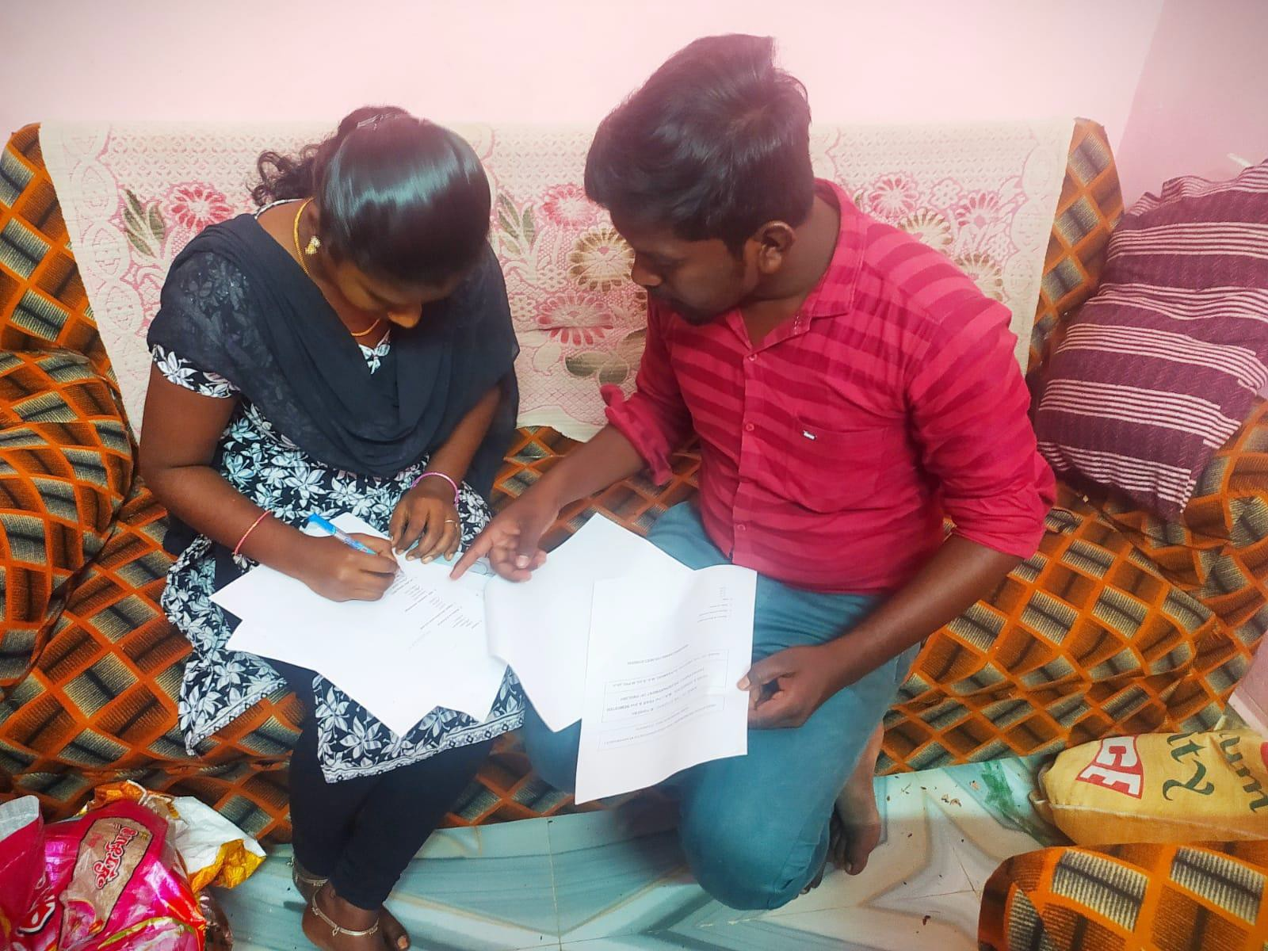

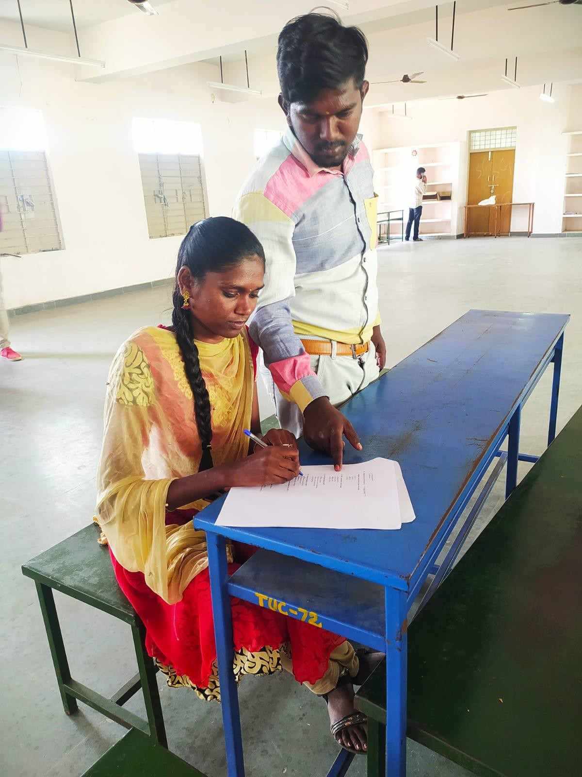

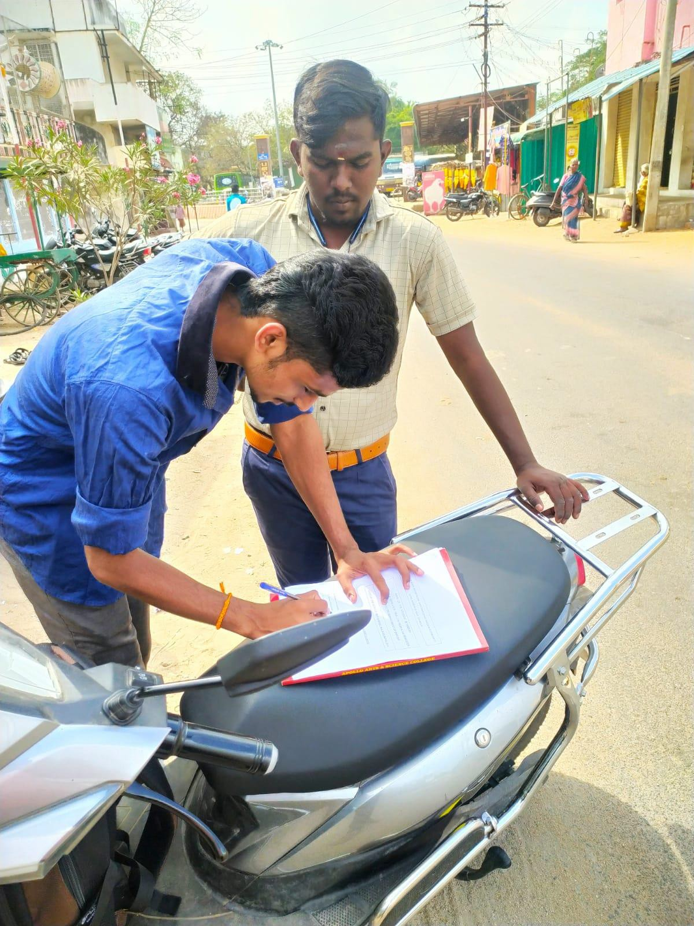

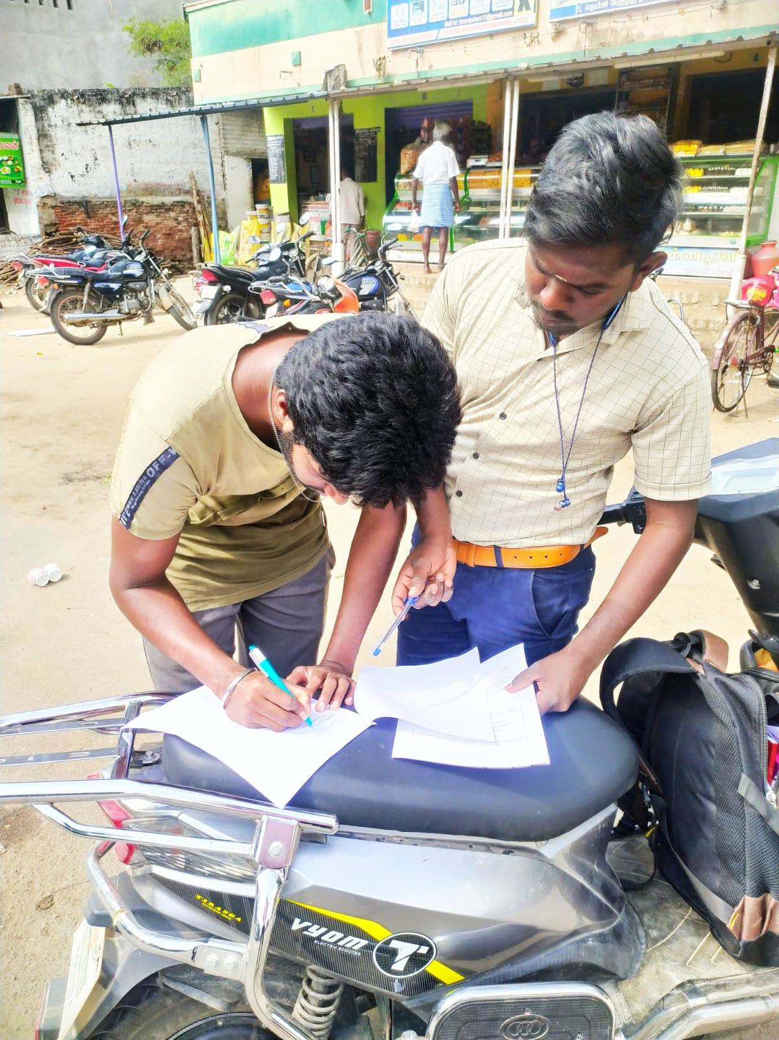

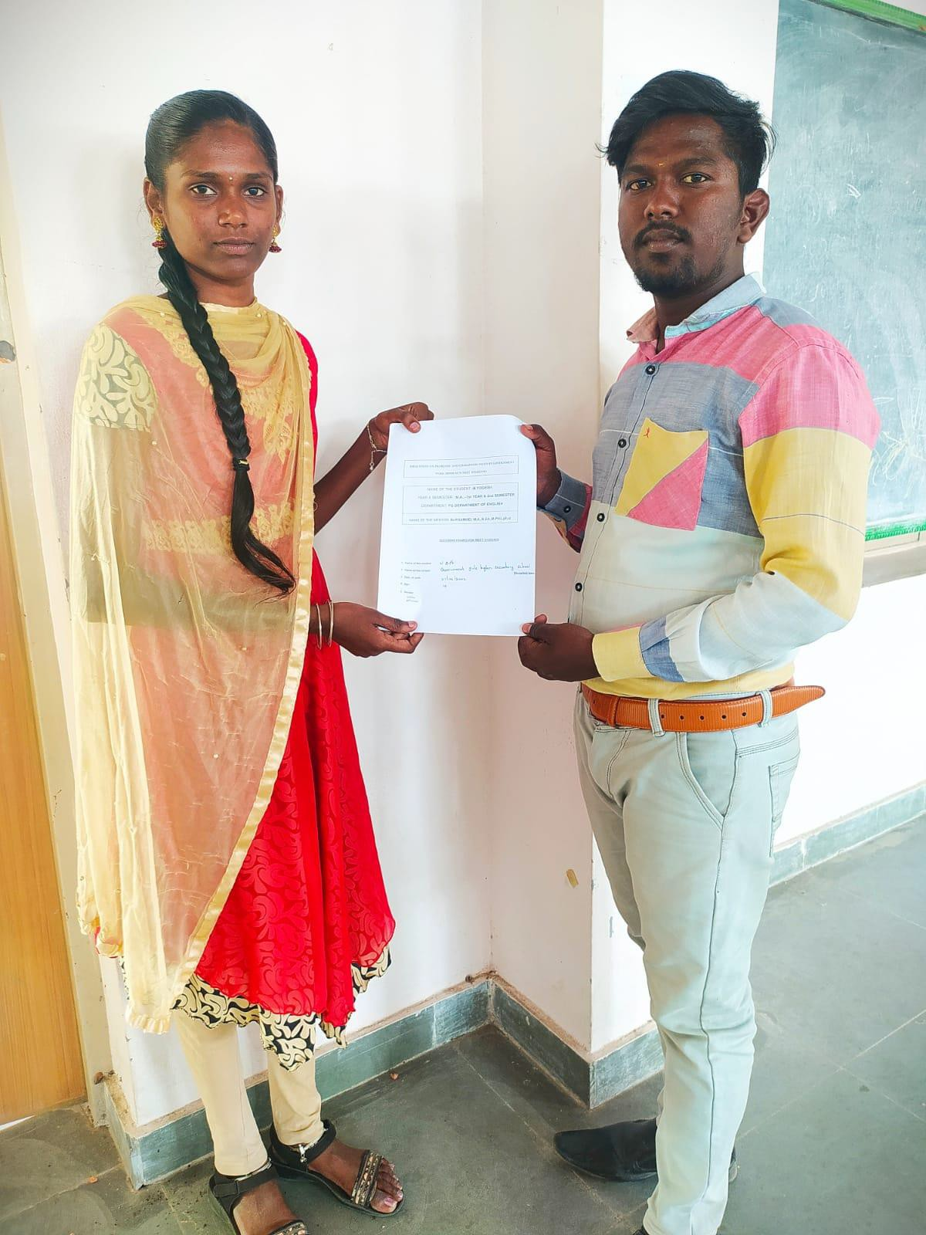

**CONCLUSION**

NEET adversely impacts poor students and those who studied in Tamil medium school, the AK Rajan committee had highlighted in its report on the impact of NEET in Tamil Nadu, which was realised in September this year. Though there were numerous contradictions when the report was released, the NEET-UG 2021 results yet again prove that Tamil –medium students are struggling to crack the entrance examination. This is mainly attributed to the lack of study material in Tamil. Even in the capital city, tutors rue that there isn’t even one exclusive NEET coaching centre in Tamil. “While we could provide practice test papers to English –medium students daily, Tamil – medium students daily, Tamil – medium students got them only twice a month.

Even on the National Testing Agency (NTA) website, study material is available in English. Of the few Tamil- medium students who attempted NEET, even the academically bright ones struggled to clear it. We only depended on our textbooks. Even if we had access to English – medium test papers, they would have been too difficult to understand. Tamil Nadu will be very badly affected. There may not be enough doctors being posted at various primary Health Centers. There may not be enough experts doctors for being employed in government hospitals, the report says, according to the report, the aspirations of rural students, especially from the Tamil medium of instruction, took a bighit post NEET. It showed that in both government and self-financed colleges, far fewer rural student secured admissions secured admissions than their urban counterparts compared to the pre-NEET period. The problem is in fact for students form Tamil medium and economically disadvantaged background, he said. There is a need to exclude the creamy layer so that students from poor backgrounds stand a better chance of admission in medical colleges.

Student who qualifies NEET will get the opportunity to secure a seat at any medical colleges in any state. Qualifying NEET with high scores and secure a good rank in the All India Merit List enables the students to get a seat into the most prestigious medical college in the country. Students who will appear for the NEET exam will have to attempt only 180 questions for 3 hours as compared to the previous years. This gives the students more time to think and concentrate on their papers and a chance to score more in the exam.

NEET exam changes a lot in the medical entrance examination. It saves the student’s time from appearing multiple exam for the admissions to the medical colleges. Having one exam to attempt saves the student’s money as well since there will only be one-time registration. NEET exam is introduced to bring about uniform admission process to the medical colleges in India. The admissions to the medical universities are only accepted through NEET qualification. These are some the reasons why the NEET exam is important for admissions to medical colleges in India and also abroad. Some of the medical universities abroad offer MBBS seats to the medical aspirants after they qualify the NEET exam.

Every student in India faces the challenges and obstacles of the NEET exam. The CBSE syllabus has been using in the NEET test question paper: nevertheless, our state board pupils are unfamiliar with it government school students have a harder time qualifying for the NEET test because of the state board and CBSE syllabus also divergent. To eliminate the challenges and obstacles of the NEET exam success is unachievable without a private coaching class. Private NEET exam coaching is out of reach for most school children. As a result, all students should have free coaching. Certainly when they try to get something which not everyone can they will get hindrance.

However, it assumes that all aspirants are competing from the same position and with the same constraints. The Rajan report highlights this as a flawed approach and compares India’s test and medical admissions to practices in other countries, including the UK and US. Colleges there, instead of relying exclusively on standardized test scores, also assess whether the student is a consistent performer, by taking note of the scores alongside school and college grades, personal statements including those that reveal a commitment to a potential career, and other factors. Moreover, the tests are so designed to evaluate subject knowledge along with writing and analytical skills.

Even though there are gifted students in Governments schools, It is a great challenge to government school students as they meet with several disadvantages in the leaning stage. A proper teaching and coaching method is required for Government school students to meet the NEET. By doing that, we can increase the admission of Government, school students in the as medical courses.