Matrix Consulting Network Configuration

Jace Alexander

University of Advancing Technology

The company that I am with is Matrix Consulting. They will make sure that any size of a business can be down through them and will make sure that the unique corporate model can make sure they have success no matter what the needs are. For their smaller locations, they are located inside every major city of Arizona. Whenever you hire them as a company they will assign you your own technician that is only working on you. When you grow as a company so will the technician. Their technicians have the support, training, knowledge, and backup of the entire company. They all have their A+ and make sure they have professional and technical development every year with no extra cost to you. Their big rule is that if there’s a Wal-Mart in town so are they. When it comes to the Mid and Large divisions they are based in a wider regional location. They are grown within from the small and midsize business divisions. They are familiar with all the processes and the problems that can come with the company growth. They will all have A+, Network+, Server+. The larger side of things have all those and have their MCSE and CCNA.

* **Switches**
  + DMZ Switch (Fredd)
  + North Region Switch (North)
  + Admin switch (Medd)
  + South Region Switch (South)
  + Central Region Switch (Central)
* **Routers**
  + Edge Router (Tedd)
  + Core Router (Redd)
* **Firewall**
  + Edge Firewall
  + Inside Firewall (Firewall #2)

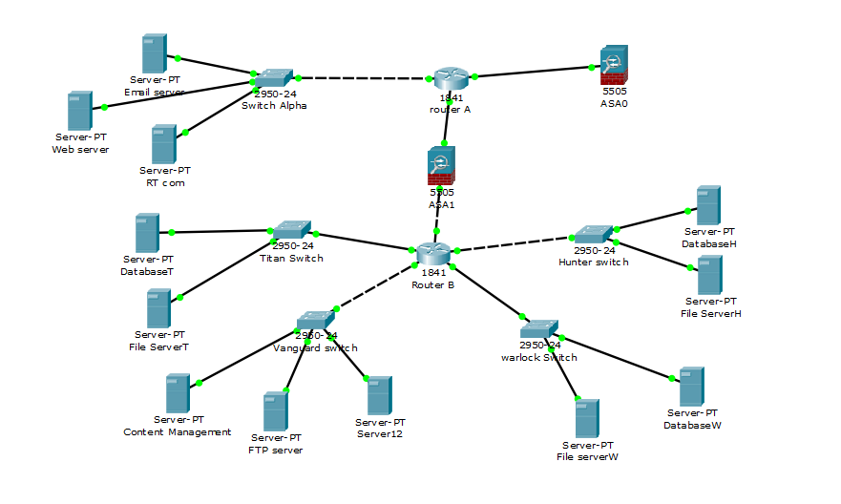

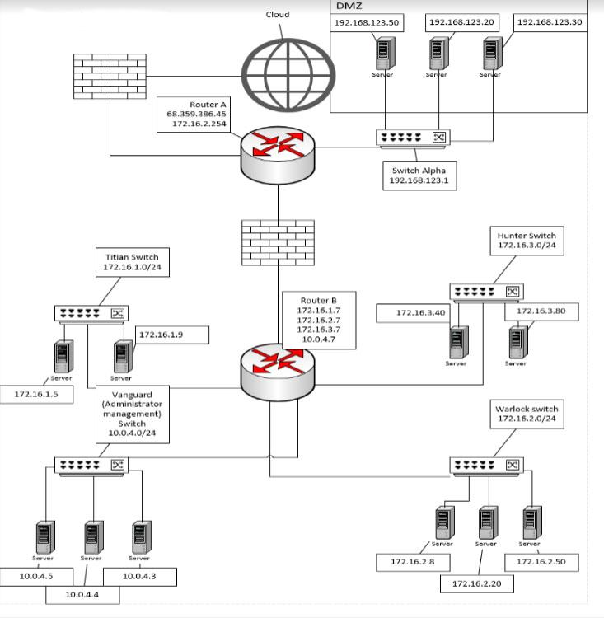

References  
Files/ Corporate_Profiles/matrixflyer.pdf