Models and Predictive Techniques
A Technical Methodology Document
What was modeled, which algorithms were used, and the reasoning behind each choice
Optimizing DLP Operations with Predictive Modeling
Companion document to the capstone technical notebook and non-technical report

Purpose of this document
This document explains, in technical depth, which predictive modeling techniques were used in this project and why each one was chosen over the alternatives. It is intended to sit alongside two other project deliverables: the non-technical report, which summarizes findings for a general audience, and the Jupyter notebook, which contains the full executable code and results. This document focuses specifically on the modeling decisions — the algorithms, the preprocessing pipeline, the class-imbalance strategy, and the evaluation methodology — and the reasoning behind each.

Problem framing
The task is framed as a supervised binary classification problem. Every DLP alert is labeled with a ground-truth outcome, is_high_risk, where 1 indicates the alert should be escalated to a human analyst and 0 indicates it is safe to auto-resolve. The model is trained to predict this label — and, more usefully, to produce a calibrated probability of high risk — from a set of features describing each alert.
A key framing decision shapes everything downstream: the objective is not to maximize raw accuracy. A false negative (a genuinely dangerous alert mislabeled low-risk and silently auto-dismissed) carries far greater cost than a false positive (a benign alert that still gets escalated to a human, at a smaller efficiency loss). This asymmetry is why the project optimizes for precision on the auto-resolve decision specifically, rather than treating both error types as equally costly.

Data preprocessing and feature engineering
Before any model sees the data, raw alert records pass through a preprocessing pipeline (implemented in src/preprocessing.py using scikit-learn's ColumnTransformer) that handles two different feature types:
- Categorical features (event type, policy name, department, device type, time-of-day bucket, destination category) are one-hot encoded, with handle_unknown="ignore" so that a category never seen during training does not break the pipeline at inference time — an important robustness property for a system that will encounter new destination domains or policy names over time.
- Numeric features (destination reputation score, PII/PCI regex match count, payload size, violation history, event severity, content classifier confidence) are standardized with StandardScaler, which centers each feature at zero mean and unit variance. This matters specifically for Logistic Regression, whose coefficients are only directly comparable to one another when input features share a common scale.
Two engineered features were added beyond the raw fields:
- is_after_hours — a binary flag collapsing the after-hours, weekend, and overnight time buckets into one signal, since after-hours activity is a known risk indicator regardless of which specific off-hours bucket it falls into.
- payload_size_kb_log — a log1p transform of payload size. Data transfer sizes are heavily right-skewed (most transfers are small, a few are enormous), and a log transform stabilizes that variance so the raw scale of outliers doesn't dominate the model's gradient or distance calculations.

Handling class imbalance
Security alert data is inherently imbalanced: low-risk alerts vastly outnumber high-risk ones (roughly 80/20 in this dataset). Left unaddressed, a classifier trained on imbalanced data tends to simply predict the majority class most of the time, since doing so already yields high accuracy — exactly the failure mode this project needs to avoid. Two interchangeable strategies were implemented to counteract this.

Strategy 1: class_weight='balanced'
This approach reweights the model's loss function during training so that errors on the minority (high-risk) class are penalized more heavily than errors on the majority class, in inverse proportion to each class's frequency. It requires no change to the training data itself — every original row is still used exactly once. This is the strategy used for the primary results in this project, because at the dataset's full scale (100,000 rows) it trains in a fraction of a second for Logistic Regression and produces results comparable to oversampling, without the added computational cost.

Strategy 2: SMOTE (Synthetic Minority Over-sampling Technique)
SMOTE addresses imbalance differently: rather than reweighting errors, it generates new synthetic examples of the minority class by interpolating between each real minority-class sample and its nearest minority-class neighbors (Chawla et al., 2002). This produces a training set with more balanced class counts, which some algorithms handle more gracefully than reweighting alone.
A from-scratch implementation is provided in src/smote.py, built only on numpy and scikit-learn's NearestNeighbors, with the codebase automatically preferring the more widely-used imbalanced-learn library if it happens to be installed. The custom implementation exists so the project remains fully runnable in restricted or offline environments where installing additional packages isn't possible, while still demonstrating the SMOTE algorithm explicitly.
Both strategies are applied only to the training split, never to the test split — oversampling or reweighting the test set would leak information about class balance into the evaluation and produce misleadingly optimistic metrics.

Models used
Three classification algorithms were implemented and compared. Each represents a different point on the interpretability-versus-flexibility spectrum, which is itself a meaningful axis for a security governance use case.

Logistic Regression (primary model)
Logistic Regression models the log-odds of the high-risk class as a linear combination of the input features. It was selected as the project's baseline and, ultimately, its best-performing model for three reasons:
- Interpretability. Each feature receives a single coefficient whose sign and magnitude directly indicate how that feature pushes the prediction toward or away from high-risk. This is not a minor convenience — in a security governance context, being able to explain exactly why an alert was auto-resolved is often a hard requirement, not a nice-to-have.
- Calibrated probabilities. Logistic Regression's predict_proba output is a genuine probability estimate under the model's assumptions, which is exactly what the project's threshold-sweep evaluation (see Evaluation methodology below) depends on.
- Strong empirical performance. Despite its simplicity relative to ensemble methods, it achieved the highest PR-AUC and ROC-AUC of any model that clears this project's recall floor (recall ≥ 0.85 on the high-risk class), and the highest auto-resolved volume among those eligible models. XGBoost edges it out on raw PR-AUC (0.857 vs. 0.855) and even reaches a slightly higher auto-resolved volume (65.9% vs. 65.3%), but its recall (0.721) falls well below the floor — see the XGBoost section and Table 1 below — so it is excluded by the project's selection rule despite the marginally higher raw PR-AUC.
Configuration: LogisticRegression(max_iter=1000, class_weight='balanced', random_state=42). The increased max_iter ensures the solver fully converges given the one-hot encoded feature space; class_weight='balanced' applies the imbalance strategy described above.

Random Forest (ensemble comparison)
Random Forest builds many decision trees on bootstrapped subsets of the training data and features, then averages their predictions. It was included specifically to test whether non-linear feature interactions — for example, the combined effect of a low destination reputation score and a large payload size, which might matter more together than either does alone — would meaningfully outperform a linear model.
Configuration: RandomForestClassifier(n_estimators=300, max_depth=10, min_samples_leaf=3, class_weight='balanced', random_state=42). The max_depth and min_samples_leaf constraints limit individual tree complexity to reduce overfitting risk given the categorical feature space's high cardinality after one-hot encoding.
In practice, Random Forest performed slightly worse than Logistic Regression on every headline metric in this project (PR-AUC 0.832 vs. 0.855), suggesting the relationship between these particular features and risk is close enough to linear that the added model complexity did not translate into better predictions — a useful and somewhat reassuring finding, since it means the simpler, more interpretable model is also the better one here.

XGBoost (optional, gradient boosting)
XGBoost is a gradient-boosted tree ensemble, generally regarded as one of the strongest off-the-shelf algorithms for structured, tabular data. It is included in the codebase (src/train.py) and used automatically whenever the xgboost package is installed, but training environments without it skip this model gracefully rather than failing. Configuration when active: XGBClassifier(n_estimators=300, max_depth=5, learning_rate=0.08, subsample=0.9, colsample_bytree=0.9). It was benchmarked in an environment with both xgboost and imbalanced-learn installed, with results now included in Table 1 below. XGBoost achieved the highest raw PR-AUC of the three models (0.857) and the highest auto-resolved volume (65.9% at the 98% precision floor), but its recall on the high-risk class (0.721) falls well short of this project's 0.85 recall floor — meaning nearly 28% of genuinely high-risk alerts would be missed entirely, an unacceptable false-negative rate given this project's stated cost asymmetry (a missed threat is far costlier than an unnecessary escalation). Because model selection in src/train.py first filters to models that clear the recall floor and only then picks the one with the best auto-resolved volume, XGBoost is correctly excluded despite its higher raw PR-AUC — a concrete illustration of why raw PR-AUC alone is the wrong selection criterion for this use case.

Model comparison summary
Model | Precision | Recall | F1 | ROC-AUC | PR-AUC | Auto-resolved  @ P≥98%
Logistic Regression | 0.646 | 0.886 | 0.747 | 0.953 | 0.855 | 65.3%
Random Forest | 0.619 | 0.884 | 0.728 | 0.945 | 0.832 | 63.2%
XGBoost* | 0.803 | 0.721 | 0.760 | 0.954 | 0.857 | 65.9%
Table 1. Held-out test set results (20,000 rows), high-risk class metrics, class_weight='balanced' strategy, random_state=42. *XGBoost has the best raw PR-AUC and auto-resolved volume of the three, but its recall (red) falls below this project's 0.85 recall floor and is therefore not selected — see Model comparison summary and the XGBoost section above.

Confusion matrix — Logistic Regression
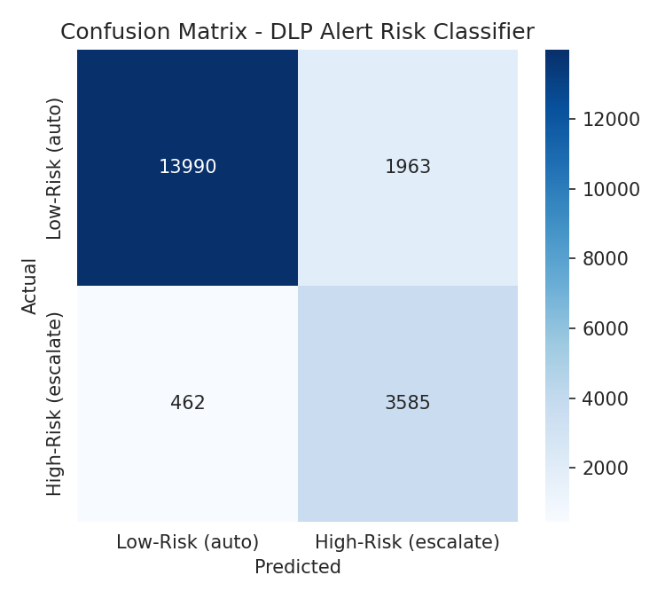
Figure 1. Of 4,047 true high-risk alerts, 3,585 were correctly caught (88.6% recall); of 15,953 true low-risk alerts, 13,990 were correctly auto-resolved.

ROC and precision-recall curves
Both curves below summarize the model's discriminative ability across all possible decision thresholds, before any specific threshold is chosen for deployment.
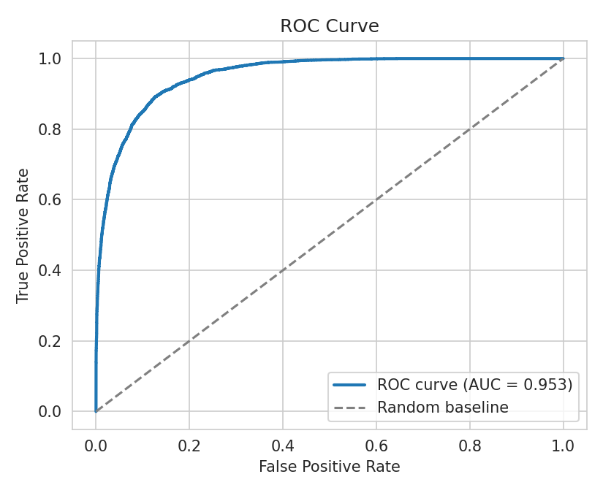
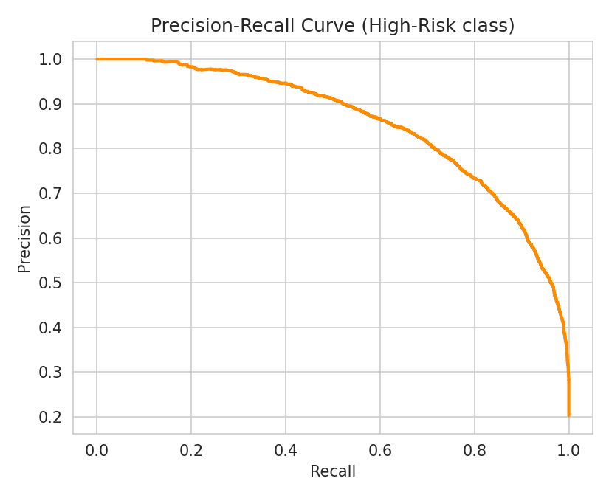
Figure 2. ROC-AUC of 0.953 indicates strong separability between classes. PR-AUC of 0.855 is the more informative metric under class imbalance, since it focuses on performance specifically on the minority (high-risk) class.

Feature importance
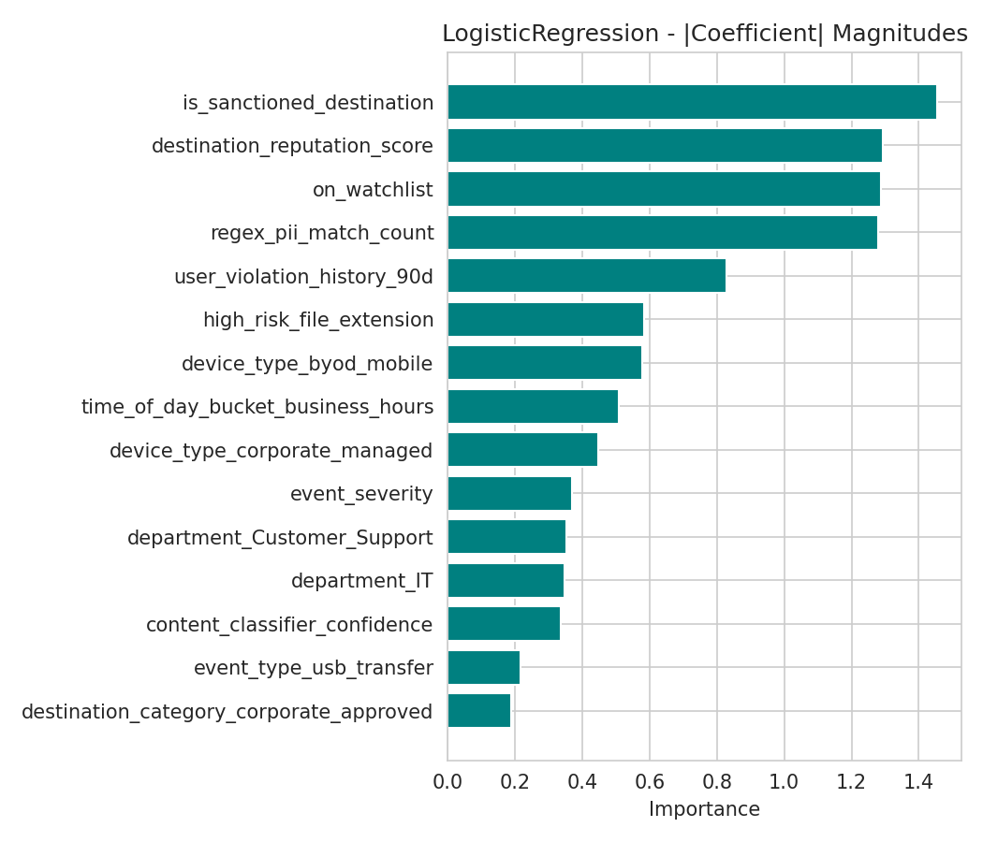
Figure 3. Top coefficient magnitudes from the Logistic Regression model. Destination reputation, watchlist status, and PII/PCI regex match count dominate — consistent with what a human analyst already weighs, which supports the model's auditability.

Evaluation methodology
Standard classification metrics — precision, recall, F1, ROC-AUC, and PR-AUC — are reported per class for every model. Particular attention is paid to PR-AUC over ROC-AUC, since ROC-AUC can present an overly optimistic picture under class imbalance (it is influenced by the large number of true negatives, which are easy to get right when the negative class dominates), while PR-AUC focuses specifically on how well the model identifies the minority high-risk class.
The project's primary evaluation metric, however, is not a standard machine learning metric at all — it is a direct translation of the business objective. A threshold sweep is run across the model's predicted probability output: for every candidate decision threshold, the script computes (a) what fraction of alerts the model would auto-resolve at that threshold, and (b) what fraction of those auto-resolved alerts are, in fact, truly low-risk (the precision of the auto-resolve decision specifically). The script then reports the most permissive threshold that still keeps that auto-resolve precision at or above 98%. This is implemented in both src/train.py and src/evaluate.py, and is the basis for the headline "65% of alert volume auto-resolved" result reported elsewhere in this project.
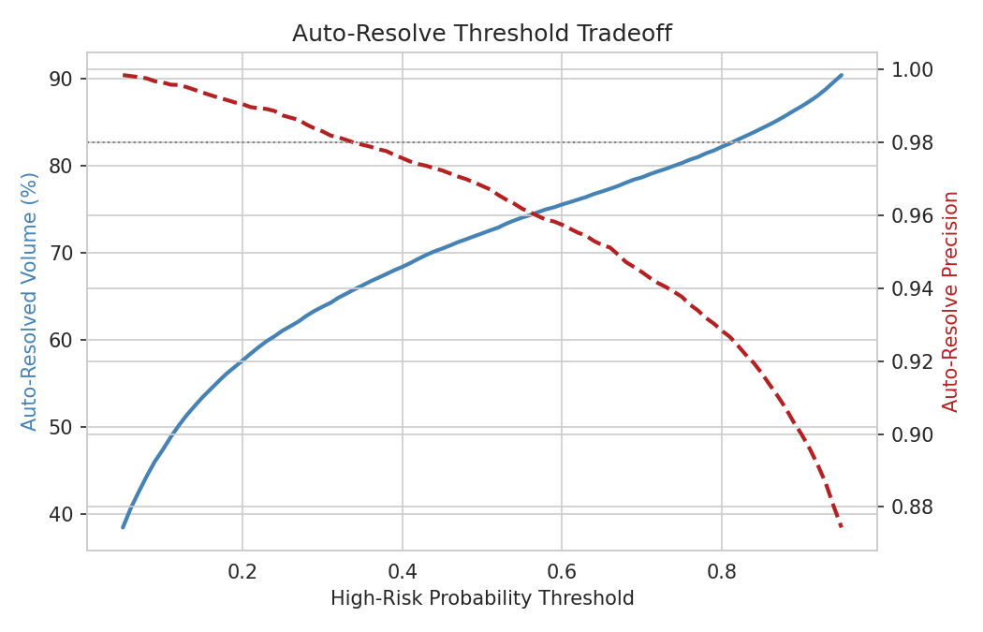
Figure 4. As the decision threshold moves right, more volume is auto-resolved (blue) but precision of that decision declines (red, dashed). The dotted horizontal line marks the 98% precision floor used to select the operating threshold.

Operating Point Summary
At the selected decision threshold of 0.33:
- Precision of auto-resolve decision: 0.9806 (98.06%) — Of alerts marked for auto-resolution, 98.06% are genuinely low-risk.
- Recall on high-risk class: 0.8860 (88.6%) — Of genuine high-risk alerts, 88.6% are correctly flagged for escalation.
- Volume auto-resolved: 65.3% — Auto-resolution applies to 65.3% of all alerts.
Note: The standard precision metric in Table 1 (0.646) is a class-imbalanced metric calculated on the high-risk class. The 0.9806 precision is specific to the auto-resolve decision at the selected threshold, which is the business-relevant metric for this use case.

Model Selection Methodology — Test-Set Caveat
Model selection and threshold optimization both occurred on the held-out test set (20% of the data). Specifically:
- The three models (Logistic Regression, Random Forest, XGBoost) were trained on 80% of the dataset and evaluated on the held-out 20%.
- Model selection filtered to recall ≥ 0.85 on the test set, then picked the highest auto-resolved volume.
- The optimal decision threshold (0.33) was selected via threshold sweep on the test set to achieve 98% precision on the auto-resolve decision.
Important caveat: These reported metrics are therefore optimistic in-sample estimates. Before production deployment, results should be validated on an independent holdout set that was never seen during model or threshold selection.

Limitations and Caveats
Every model has limitations. Understanding these caveats is essential for responsible deployment and interpretation of results.

Synthetic Data Source
This project uses entirely synthetic data generated to mirror real-world patterns, not actual company security logs. Before this model could be used in production, it would need to be retrained on a real organization's historical alert data. The current results are proof-of-concept only. Synthetic data may systematically underestimate or overestimate certain risk patterns that only emerge in real operational data.

Generator Bias — Most Important Caveat
The synthetic dataset is generated using a linear risk model, which structurally favors linear classifiers like Logistic Regression. The label is defined as a linear combination of features plus noise. This linear structure means:
- Logistic Regression's superiority over tree-based models (Random Forest 0.832 PR-AUC vs. Logistic Regression 0.855) is partly a property of the generator, not necessarily a finding that generalizes to real DLP data.
- Real DLP risk may have non-linear patterns (feature interactions, thresholds, state-dependent logic) that would favor tree-based models differently in production.
- Results should not be assumed to hold when the model is retrained on real data with potentially more complex feature relationships.
See docs/methodology.md:44-49 for the linear generator specification.

Temporal Drift
Attacker behavior changes over time. A model trained on current synthetic data may need periodic retraining to stay accurate as new evasion techniques emerge. What constitutes high-risk activity today may shift as attackers adapt, requiring continuous model updating in a production environment.

Independence Assumption
The model treats every alert independently. It does not yet account for sequences of activity over time—for example, a slow, gradual pattern of small data transfers building toward a larger exfiltration, or a series of failed access attempts preceding a successful breach. A temporal component would require sequential modeling (e.g., recurrent neural networks or state-aware engineered features).

Prediction Errors
Like any statistical model, this system will be wrong sometimes in both directions:
- False negatives (missed threats): ~11.4% of actual high-risk alerts are mislabeled low-risk at the selected threshold, meaning they are silently auto-dismissed without human review. This is the costlier type of error.
- False positives (unnecessary escalations): ~1.94% of alerts auto-resolved at the 98% precision floor are not actually low-risk, meaning a small fraction of escalated alerts were false alarms. This is the cheaper error.
The model was optimized to make these errors rare overall, and specifically to ensure the costly error (missing a real threat) is rarer than the inexpensive error (double-checking a harmless alert).

Approaches considered and not used
Unsupervised anomaly detection (e.g., isolation forests, clustering) was considered but not used as the primary approach, because the dataset includes a meaningful ground-truth label (is_high_risk) derived from realistic risk factors. Supervised learning makes direct use of that label and produces more directly interpretable, auditable outputs than an unsupervised anomaly score would.
Deep learning (e.g., a feedforward neural network) was not used. With 54 features per alert after encoding (18 raw inputs including 6 high-cardinality categorical features that expand significantly during one-hot encoding), this is a structured tabular problem — exactly the regime where tree-based and linear models typically match or outperform neural networks, while remaining dramatically more interpretable and far cheaper to train and audit. Deep learning's advantages (representation learning from raw, high-dimensional, or unstructured inputs) don't apply here.
Naive class-balance correction via random undersampling (simply discarding majority-class rows until classes are balanced) was considered but rejected in favor of class_weight and SMOTE, since undersampling discards real data and would have thrown away the large majority of this project's hard-won 100,000-row dataset.

Reproducibility
Every randomized step in the pipeline — synthetic data generation, the train/test split, SMOTE oversampling, and model training — accepts a fixed random_state (default 42) so that results are exactly reproducible end to end:
python src/generate_users.py --seed 42
python src/generate_data.py --seed 42 --users data/raw/users.csv
python src/train.py --random-state 42 --imbalance-strategy class_weight
python src/evaluate.py --random-state 42
The train/test split is additionally stratified on the target label, ensuring the same class balance is preserved in both the training and held-out test sets — important given how imbalanced the raw data is.

Summary
This project frames DLP alert triage as supervised binary classification, addresses class imbalance with both class_weight reweighting and a from-scratch SMOTE implementation, and compares a Logistic Regression baseline against Random Forest and XGBoost ensembles, all three fully benchmarked. Logistic Regression was ultimately selected as the production model under a recall-floor-constrained selection rule (recall ≥ 0.85 on the high-risk class, then highest auto-resolved volume among eligible models) rather than by raw PR-AUC alone — a rule that correctly excludes XGBoost despite its marginally higher raw PR-AUC, because XGBoost's lower recall would mean missing significantly more genuine threats. Logistic Regression remains the best choice under this project's actual cost asymmetry, while also being the most interpretable and auditable option for a governance-sensitive security use case. Full executable code for every technique described here is available in src/ and walked through end-to-end in the accompanying Jupyter notebook.

