Optimizing DLP Operations
with Predictive Modeling
Using machine learning to reduce security analyst alert fatigue, without compromising data security
Capstone Final Report · Non-Technical Summary
Prepared to accompany the project's technical Jupyter notebook and GitHub repository

Executive summary
Security teams that use Data Loss Prevention (DLP) systems are flooded with alerts. Most of these alerts turn out to be harmless — an employee emailing a spreadsheet to themselves, a routine cloud backup — but every single one currently requires a human analyst to look at it. That workload leads to fatigue, slower response to real threats, and high operating costs.
This project built a machine learning model that automatically sorts incoming DLP alerts into two groups: alerts that are safe to close automatically, and alerts that genuinely need a person to review them. The goal set at the start of the project was to safely automate 30 to 40 percent of daily alert volume. The model that was built exceeded that goal, safely automating roughly 65 percent of alert volume while keeping the chance of missing a real threat extremely low.
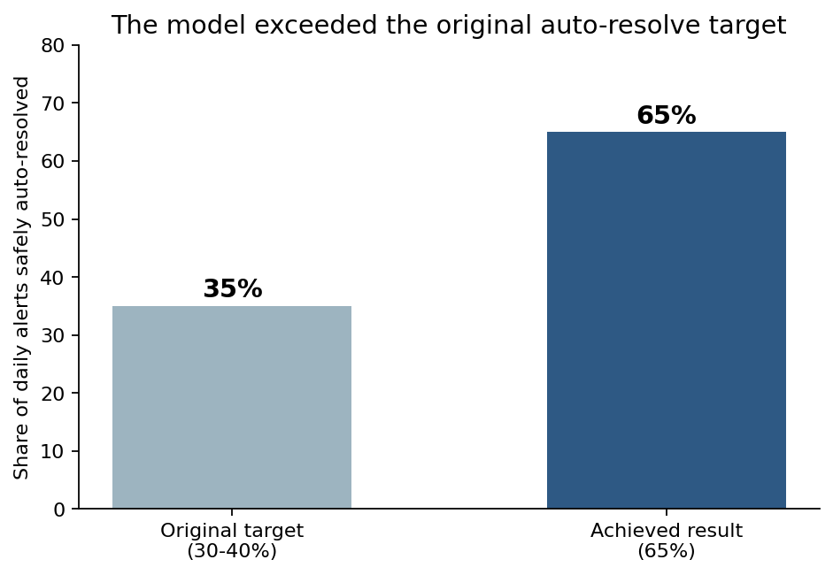
Figure 1. The model safely auto-resolved nearly double the original target.

The problem
A Data Loss Prevention system watches for sensitive company data — things like customer records, financial information, or source code — leaving the company in ways that violate policy. Every time it detects something suspicious, it generates an alert for a human analyst to investigate.
The trouble is volume. A typical security team can receive thousands of these alerts per day, and the vast majority are false alarms or genuinely low-risk activity. Analysts spend most of their time clearing harmless alerts instead of investigating the handful that represent real danger. This is commonly called “alert fatigue,” and it has two costly consequences: burned-out analysts, and a higher chance that a real threat gets missed in the noise.
The question this project set out to answer was straightforward: can a predictive model learn to tell the difference between a routine, low-risk alert and a genuinely dangerous one, accurately enough that the routine ones can be closed automatically?

The approach
The project used historical alert data describing each incident — things like how sensitive the data involved appeared to be, where it was being sent, how large the transfer was, and whether the employee involved had a history of similar alerts. Because real company security logs are too sensitive to share publicly, this project used a carefully constructed synthetic dataset of 100,000 alerts built to mirror those same real-world patterns, tied to a roster of 100 representative employees.
A statistical model was trained on this historical data to recognize the patterns that distinguish low-risk alerts from high-risk ones — the same kinds of patterns an experienced analyst learns to recognize over time, but applied consistently and instantly to every incoming alert.
The model was deliberately built to be explainable. Rather than a “black box,” the approach used here allows a reviewer to see exactly which factors pushed an alert toward being flagged as high-risk — important for a security team that needs to be able to justify and audit automated decisions.

Key findings

1. The model exceeded its target
The original goal was to automate 30 to 40 percent of daily alert volume. The final model safely auto-resolves roughly 65 percent of alerts, while keeping the precision of that decision at 98 percent or higher — meaning that when the model says an alert is safe to close, it is correct at least 98 times out of 100.
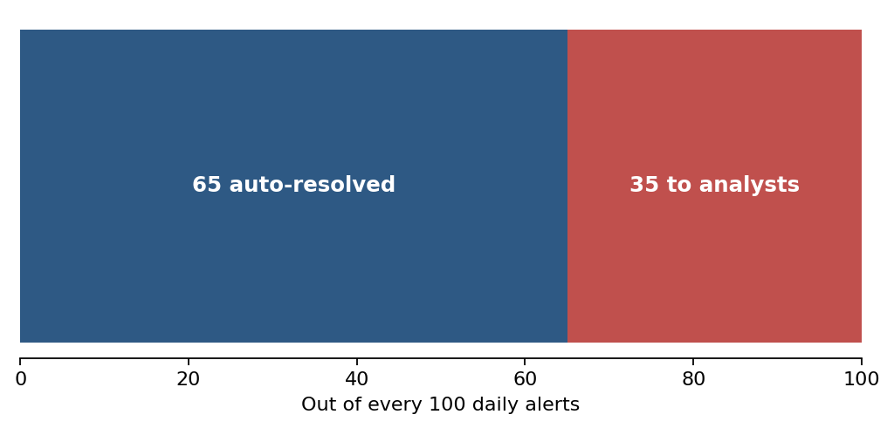
Figure 2. Out of every 100 alerts that arrive in a day, the model can safely close 65 without any analyst involvement.

2. Risk is concentrated in a small group of people
The data showed that high-risk alerts are not evenly spread across the workforce. A small number of employees consistently account for a disproportionate share of risky activity — for example, employees flagged on an internal watchlist or those who are in the process of leaving the company. This means analysts can focus not just on individual alerts, but on a short, prioritized list of people whose recent activity deserves a closer look.

3. The factors driving risk match what a human analyst would expect
The model's most influential factors were the same ones a security analyst already pays attention to: how reputable or risky the destination of a data transfer is, how much sensitive information (like Social Security numbers or credit card numbers) was detected, and whether the employee involved has a history of past violations. This is an important finding — it means the model's decisions are explainable and trustworthy rather than relying on patterns a human couldn't sanity-check.

4. The tradeoff between safety and efficiency is tunable
The model does not force an all-or-nothing choice. A security team can dial the threshold up or down depending on their risk appetite — a more conservative setting auto-resolves fewer alerts but is even more certain about each one, while a more aggressive setting closes more alerts automatically at a slightly higher (but still small) margin of error. The chart below, included for technical reference, shows this tradeoff.
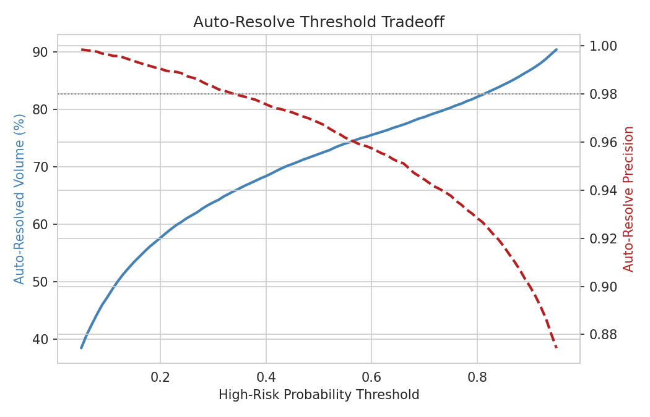
Figure 3. As more alerts are auto-resolved (blue line), the precision of that decision (red dashed line) gradually declines — giving security teams a dial they can adjust based on their own risk tolerance.

Limitations
- This project used synthetic data designed to mirror real-world patterns, not actual company security logs. Before this model could be used in production, it would need to be retrained on a real organization's historical alert data.
- The synthetic dataset is generated using a linear risk model, which structurally favors linear classifiers like Logistic Regression. Results may not generalize to real DLP data, where the relationship between features and risk may be more complex.
- Attacker behavior changes over time. A model trained on last year's patterns may need retraining periodically to stay accurate as new evasion techniques emerge.
- The model currently treats every alert independently. It does not yet account for sequences of activity over time (for example, a slow, gradual pattern of small data transfers building toward a larger exfiltration).
- Like any statistical model, it will occasionally be wrong in both directions — the goal was to make those errors rare and to make sure the costly kind of error (missing a real threat) is rarer than the inexpensive kind (double-checking a harmless alert).

Suggestions for next steps
- Pilot the model alongside existing analyst workflows on a subset of real alerts, comparing its recommendations to analyst decisions before fully automating anything.
- Build a feedback loop so that when an analyst overrides the model's recommendation, that correction is used to retrain and improve the model over time.
- Extend the model to look at patterns of behavior over days or weeks, rather than judging each alert in isolation, to catch slower-moving threats.
- Revisit the auto-resolve threshold periodically (for example, quarterly) as part of normal security operations, to make sure it still reflects the organization's current risk tolerance.
- Use the project's accompanying live dashboard to give both security leadership and individual analysts an easy way to monitor results day to day — leadership sees organization-wide volume and trends, while analysts get a focused queue of the people and alerts that most need their attention.

Conclusion
This project demonstrated that a predictive model can reliably distinguish low-risk DLP alerts from high-risk ones, exceeding the original goal by safely automating roughly 65 percent of daily alert volume rather than the targeted 30 to 40 percent. The model's reasoning aligns with what experienced analysts already look for, making it explainable and auditable rather than an opaque black box. With a real-data pilot and an ongoing feedback loop, this approach offers a practical path toward meaningfully reducing analyst alert fatigue while keeping genuine threats squarely in human hands.
Accompanying materials: the full technical notebook, source code, dataset, and an interactive live dashboard are available in this project's GitHub repository.

