Noam Lerner
Assess Learners
Report

Does overfitting occur with respect to leaf_size? For which values of leaf_size does overfitting occur?
Overfitting does occur with respect to leaf_size at low values for leaf_size. Particularly, at leaf_size = 1, overfitting is at its strongest.
Figure 2
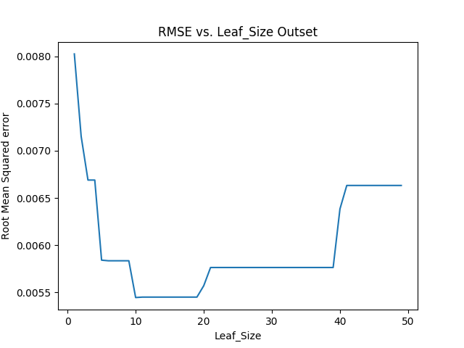
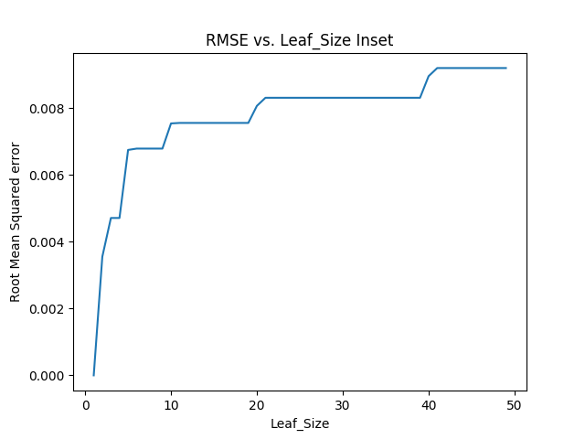
Figure 1

In order to see that overfitting occurs at low values for leaf_size, I generated two plots (Figure 1 and Figure 2). Both ran my implementation of a Decition Tree Learner (DTLeaner) 50 times with every possible value for leaf_size in the range [1-50] inclusive. Both plot the root mean squared error of their respective data set on the y-axis, and the leaf_size that produced said error on the x-axis. Figure 1 was run on the training data-set (or Inset). Figure 2 was run a different data set (outset).
In figure 1, one can see that the RMSE increases as the leaf_size increases. In Figure 2, the RMSE is very high at first, it then decreases and increases again. This can be explained by how the DTLearner works.
The DTLearner works similar to a k-nearest-neighbor(knn) algorithm, where k is the leaf_size. It picks the nearest neighbors from its training data-set. The proximity of neighbors is based on the heuristic it uses to split values. When the leaf_size is 1, like when k is 1 for knn, it will always return a y-value it has already seen, thus overfitting the data. We can see that it does this by the 0 RMSE in figure 1 when leaf_size is 1. Since it has already seen every data point, and is returning that exact data-point, it does not have any error. However in Figure 2, it hasn’t seen any of the data points yet and so has a high RMSE when it returns values that are too specific to the inset.
The increase in error from leaf_size 20 and up in Figure 2 can be thought of as an over-generalization. It’s using too many other data-points to find values and is becoming very inaccurate. If this was also overfitting, we would see figure-1 once again showing a RMSE of 0, but that error is increasing as well proving that overfitting isn’t the case.

Can bagging reduce or eliminate overfitting with respect to leaf_size?
Bagging can help reduce overfitting, but it does not eliminate it.
Once again I created two figures (Figure 3 and Figure 4). They plot the same data as Figures 1 and 2 respectively, but instead of running my DTLearner implementation, I ran my BagLearner implementation which used 20 bags. The leaf_size was once again set between [1 and 50] inclusive.
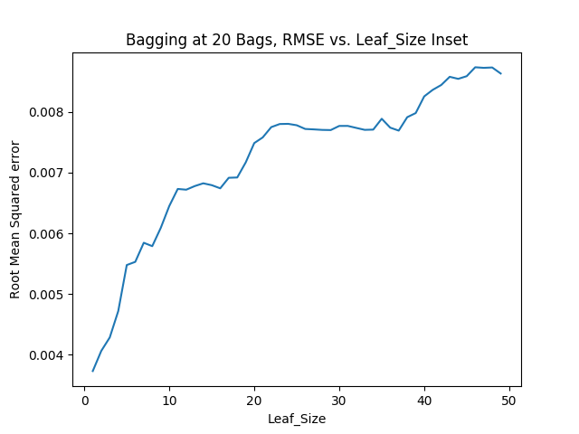
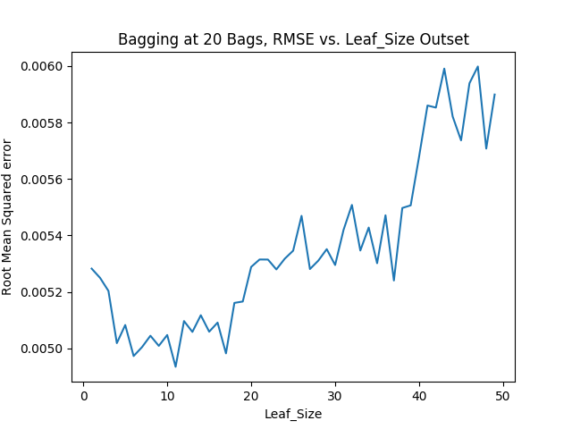
Figure 3
Figure 4

The trend that indicated overfitting is still present in figures 3 and 4. That is, Figure 3, which shows the Inset, starts with a low RMSE, while Figure 4 which shows the outset first decreases than increases its RMSE when increasing the leaf_size from 1 onwards. On the other hand, the RMSE for the outset starts out smaller in figure 4 than it did in figure 2.
This implementation of BagLearner provided every DTLearner with a data set that is the same size as the original dataset, but randomly chosen with replacement. It is reasonably certain that no tree has the same data set as another tree or as the original inset. This reduces overfitting for two reasons.
1) This causes every tree’s answer to vary slightly for any given point, since they are all working with slightly different training sets.
2) Their split values will vary. Different data points will lead to different correlations between X’s and Y’s, which once again causes slightly different answers for every given input.
At low values for leaf_size where overfitting occurs, averaging together these slightly different answers allows for answers that weren’t in the inset which makes a big difference in reducing overfitting.
Quantitatively compare “classic” decision trees versus random trees. In which ways is one method better than the other?
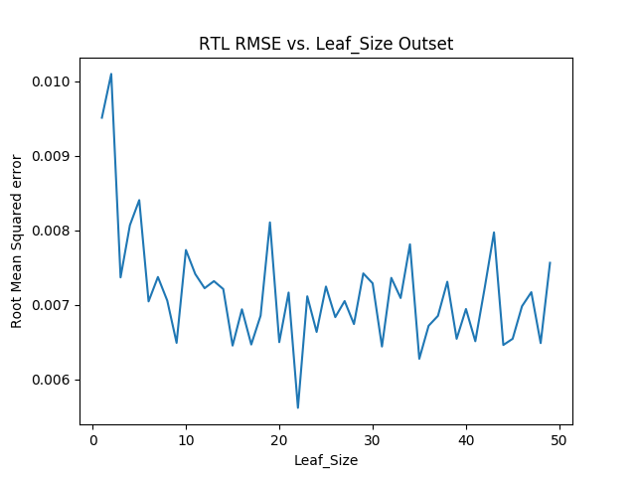
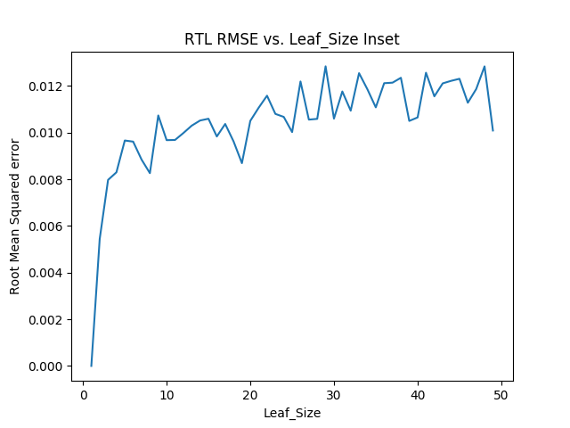
Figure 5
Figure 6
Figure 6

Figure 5 and Figure 6 once again plot leaf_size vs RMSE for increasing values of leaf_size in the range [1 50] inclusive. Figure 5 plots the inset while Figure 6 plots the outset. This time the learner used was my implementation of a random tree learner (RTLearner). A similar trend can be observed as to what we have seen so far. Overfitting occurs at low leaf_sizes.
There are a few main differences that can be observed between DTLearners graphs (Figures 1 and 2) and RTLearners graphs (Figures 5 and 6). RTLearner has a higher average RMSE, and a higher variance for that RMSE. This makes sense when the algorithm is taken into account. The RTLearner randomly chooses where to split, this means that more often than not it will probably find worse splits than the DTLearner which has a developed heuristic. On the other hand it might also occasionally and accidentally stumble upon a good set of splits.
Another difference that can be seen is how error grows with leaf_size. As I stated earlier, as leaf_size grows these algorithms tend to overgeneralize and get worse results. An easy explanation of this is to take it to the extreme – if the leaf_size was the entire dataset, every input would have an ouput that is the average of the entire input dataset. RTL’s average RMSE error doesn’t increase as quickly as DTL’s. To show this I created the following graphs.
Figure 7
Figure 8
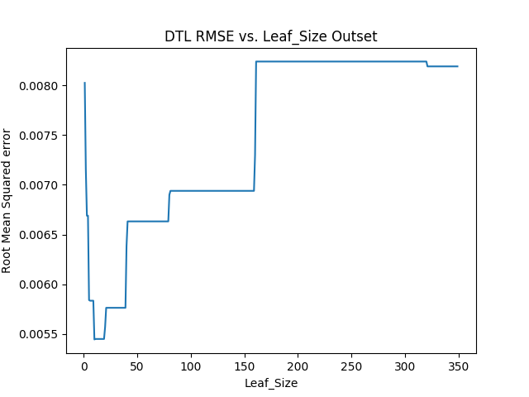
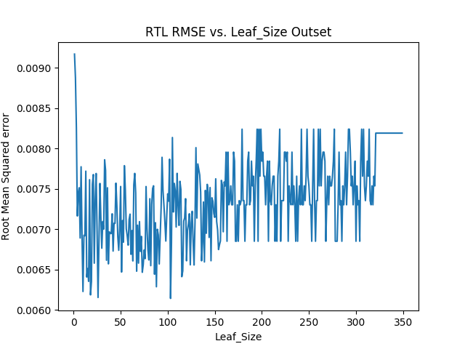
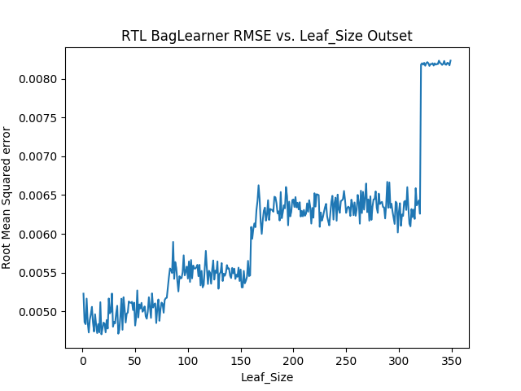
Figure 7 and Figure 8 both plot RMSE vs leaf_size in the range [1 350] inclusive on the outset. Figure 7 does so for DTL, figure 8 for RTL. The outset’s size would around 320 datapoints. When looking at the graphs, it can be seen that at around that leaf_size and increasing, the RMSE becomes constant (and the same value) in both learners. At a value for leaf_size of around half the dataset, DTL in Figure 7 spikes an error that is extremely high. RTL will bounce around between high and low values of error. Thus it seems ideal to use DTL for leaf_size low (but not too low) relative to the data set count, and RTL for leaf_size values that are high relative to the dataset count. DTL would be my choice for using a single learner.

Figure 9

Figure 9 plots the outset for a bag learner using RTL as its learner. Combining many RTL learners together allows for the variance to be greatly reduced. The average response performs much better than any single RTL. This can be explained by RTL being a weak learner. Bagging together all many RTL’s creates a boosting effect that gives great results. This makes RTL a better choice when deciding to use more than one learner.

