Manual Trader Project
Noam Lerner
903047143

Part 1: indicators
I chose to work with 3 indicators; Bollinger Bands, RSI and Momentum.
Bollinger Bands
Bollinger Bands consist of two bands, the ‘upper band’ and the ‘lower band’. Each band lies roughly two standard deviations away from the average of the stock price. In order to calculate these bands, one must first find the rolling mean for the stock’s price. The rolling mean, abbreviated rolling_SMA for any given date is found by calculating the mean of the price over some past time period relative to the date. Once this is done, the rolling standard deviation abbreviated rolling_STD, is found. Like the rolling mean, for any given date the rolling standard deviation is found by calculating the standard deviation for some past time period relative to the date. Once both values are calculated the upper and lower bands are calculated like so for every date in the stock price’s data:
lower_band = rolling_SMA - 2 * rolling_STD
upper_band = rolling_SMA + 2 * rolling_STD
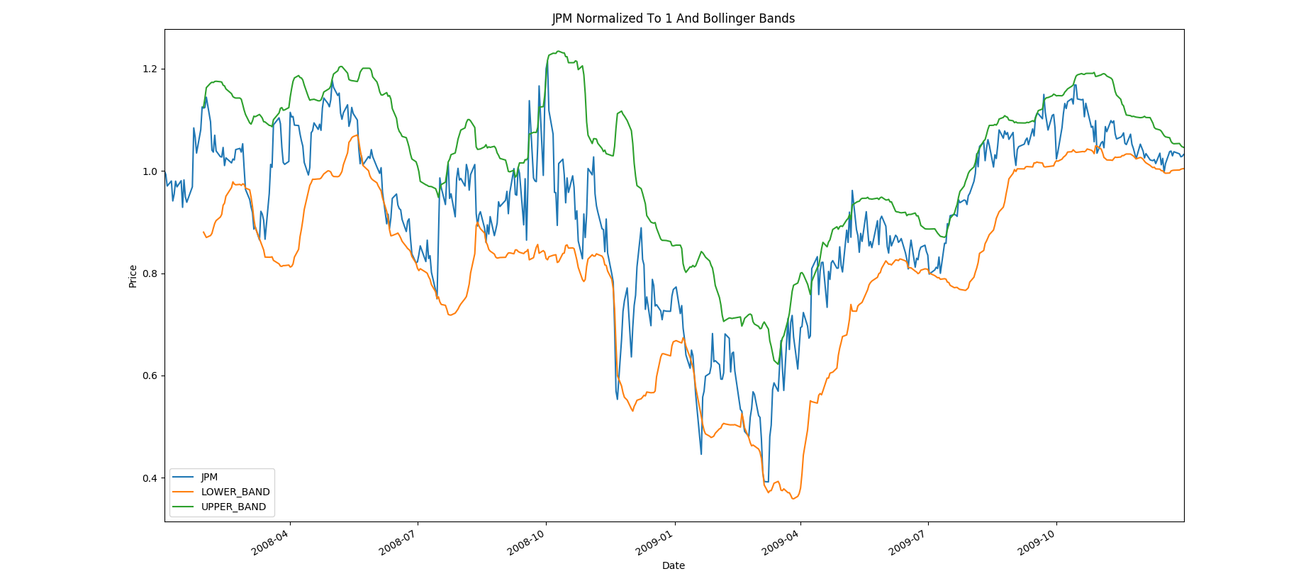
Figure 1 shows the Bollinger Bands for the JPM stock price between January, 1st 2008 and December 31st 2009. The upper band is in green, the lower band is in orange and the stock price is in blue. As can be seen, the stock price usually stays between the two bands. The stock price is normalized so that on January 1st 2008, it’s value is 1 and the Bollinger Bands were calculated based on the normalized values for the stock price. rolling_SMA and rolling_STD were calculated with a 20 day window. It can be seen that both bands tend to follow the stock. Their movement is smoothed due to the 20 day window.
Figure 1
The bands become useful when the stock enters and exits the bands. If the stock price fell below the band, we can assume that it will probably rise back near it’s rolling_SMA meaning it is undervalued. When the stock starts rising back up through the lower band, buying the stock will probably lead to an increase in portfolio value since we assume that it will likely continue to rise. Likewise, if the price exits the upper band, it is probably over valued, and so when it starts falling back through the upper band towards the rolling_SMA, we should sell to maximize profits.

RSI
RSI stands for Relative Strength Indicator. Once again, I used a rolling value, meaning that every RSI was based on some past time period. For any given time period, we iterate over the values and find the change in stock price between every pair of consecutive values, maintaining two sums: total_gains and total_losses. When the change between two consecutive values is negative, we add the absolute value of that change to total_losses. When the change between any two consecutive values is positive, we add the change to total_gains. Once we have all the values, we create two new values, average_gains and average_losses calculated like so:
average_gains = total_gains/(total number of values)
average_losses = total_losses/(total number of values)
If we had closing price data over 20 days, “(total number of values)” would be 20. Lastly, the RSI for the time period is calculated using the expression
RSI = 100 – 100 / (1 + average_gains/average_losses).
Figure 2
This is a value that always lies between 0 and 100.
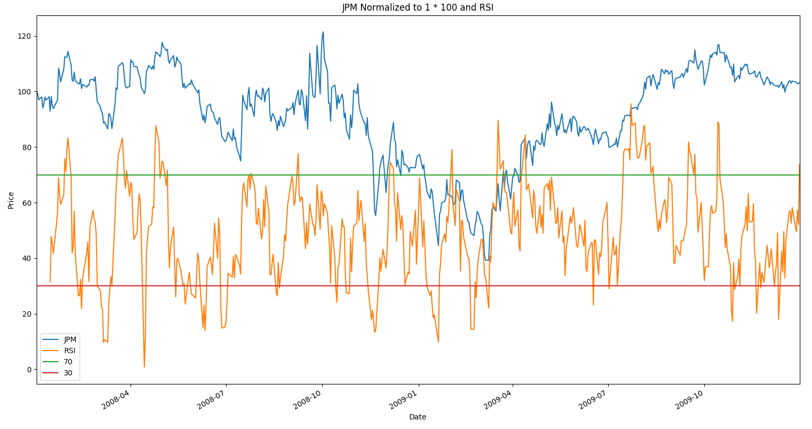
Figure 2 shows the RSI calculated for JPM between the same dates as the Bollinger Bands were calculated for. This time, in order to better see the relationship between RSI and the stock price, the stock price has been normalized to 1 and then multiplied by 100 which as the effect of a normalization to 100. The JPM stock price is in blue, the RSI is in orange, a 20 day window was used to calculate it. In red I have plotted a line at y=30 and in green I plotted a line at y=70. You can see from the relationship that when the stock seems to quickly rise, the RSI is high and when the stock seems to quickly fall the RSI is low. The RSI can be used to signal when a stock is either overbought or oversold. The RSI is able to indicate when a stocks price has rapidly changed, which usually indicates that the stock will return to a more normal value. I used the standard values of 70 and 30 as indicators for ‘too big a change’. What this means is that when the RSI rises above 70, the stock is overbought which means it’s probably being valued too high. This was an indication to sell when the RSI falls back below 70 in order to maximize profits. The waiting is done in case the stock keeps rising. When the RSI falls below 30 it is oversold, meaning it’s price is probably being valued too low and this is an indication to buy when the stock rises back above 30 in order to sell at a higher price later.

Momentum
The momentum of a stock measures the general slope of it’s movement over some time period. If we had a time period with values enumerated as value[0], value[1]...value[N] we would calculate the momentum as value[N]/value[0] – 1.
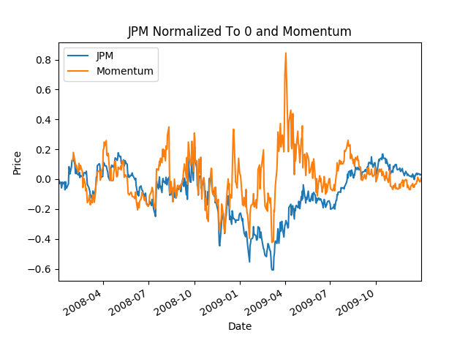
Figure 3 shows the Momentum of JPM and JPM’s closing stock price data. The stock price has been normalized to 0 in order to better see it’s relation with momentum. The time window used for calculated momentum was 20 days. One can see that momentum acts like similar to taking the derivative of the stock. It oscillates around 0 where positive values indicate the stock price is increasing and negative values indicate the stock price is decreasing. With a significantly long momentum, one can see if a stock is generally rising or falling in price over a period of time. If the momentum is above some threshold (in my case 0.32) for a long period of time, one can assume that the stock is increasing in price over time and should be bought. If it it is negative, then the stock should be sold.
Figure 3

Best Possible Strategy
Stock trading is easy when you know how the stock is going to act. I started by calculating the rolling momentum of the stock with a window size of 2, as described in the indicators section. This means that on every given date, I would know how the stock moved relative to the day prior. If The stock on day 2 was higher than it was on day 1, the momentum would be positive. If the stock was lower on day 2 the momentum would be negative. I then bought and sold stock on days that were turning points for the momentum (days where it went from positive to negative or negative to positive). If on a given day, the momentum is positive, but the following day it will be negative, then it is a good day to sell since I can re-buy tomorrow at a lower price. If on a given day the momentum is negative but it will be positive on the next day, it was a good day to buy the stock since I can sell it no the next day for a higher price. If multiple consecutive days were positive or negative, I would wait until the final positive/negative day to make my transaction in order to maximize gains.
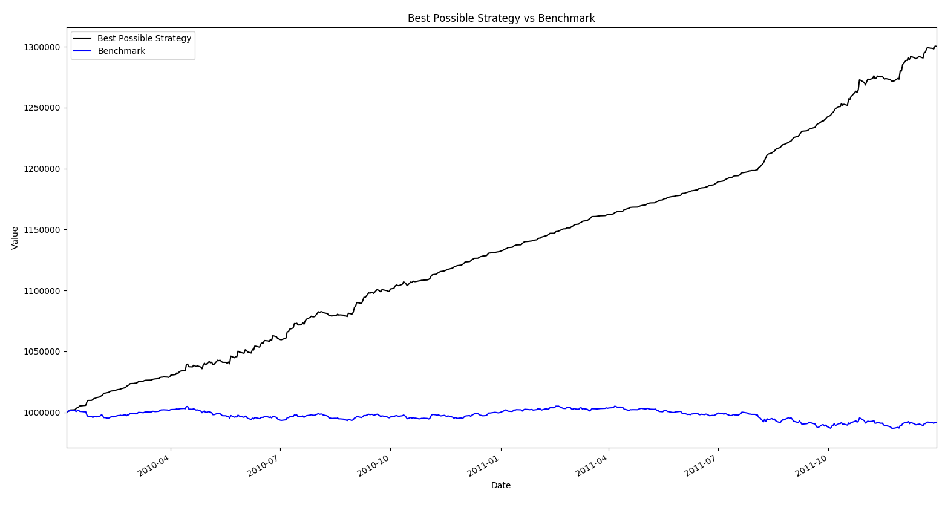
Figure 4 shows the value of two portfolios over the time period between January 1st 2010 – December 31st 2011. The portfolio employing the Best Possible Strategy is shown in black and the benchmark portfolio is shown in blue. The following descriptive statistics were also generated for the two portfolios:
Figure 4
 | Best Possible Strategy | Benchmark
Cumulative Return | 0.30034 | -0.00834
Mean of Daily Returns | 0.000522824679488 | -1.63202258841e-05
Standard Deviation of Daily Returns | 0.00106928253977 | 0.000812787618015
It can be seen that the Best Possible Strategy massively out performed the benchmark. The stock went down over the time period, but the Best Possible Strategy was able to make a gain.

Manual Strategy
My manual strategy worked by considering all 3 indicators. Each indicator would get the stock’s price on a given day along with historical stock data. It would would vote with a -1, 0 or 1. If an indicator voted -1, it would mean that the indicator thinks the stock should be sold. A 1 means to buy the stock and a 0 means to do nothing. Each stock voted according to the descriptions provided in the indicators section. The Bollinger Band indicator voted -1 if the stock fell through the upper band, 1 if the stock was coming up through the lower band and 0 otherwise. The RSI indicator would vote -1 if the if the RSI was falling down past 70, 1 if it was rising up past 30 and 0 otherwise. The Momentum indicator would vote 1 if the momentum was below 0, -1 if it was above 0 and 0 otherwise. Each vote was then weighted and added together. If the total weighted sum of votes above a 0, my trader would buy for the day. If it was below a 0 it would sell for the day.
My manual strategy therefore had 6 parameters. 3 of the parameters were the weights assigned to an indicators vote. Each indicator had a different weight which could give it’s vote more or less of a say in the decision of what to do with a stock. 3 of the parameters were what window size to use for each of the indicators. I used logic to assign the window sizes. Momentum and Bollinger both got a window size of 20, since they are looking at the general trends of the stock. RSI got a window size of 3 since it informs of me of overbought and oversold states which don’t last long.
In order to find the best assignment of weights I created a function called find_best_parameters on my ManualStrategy class. It tries the manual strategy trader many times setting each of the weights to a value from the set {2,3,4,8}. I chose this set because it allows for a number of meaningful assignments. The weighting system is used to decide what to do when the indicators disagree. For example, with an assignment from the set {2,3,4,8} it could be found that they should all have equal weights, or it can be found that one should be higher than the other two unless the other two both agree with each other and disagree with the first which would be the assignment (3,3,4) or (2,2,3). For the in-set date range. The weights I chose were 2 assigned to the Bollinger and Momentum indicators, and 2 assigned to the RSI indicator.
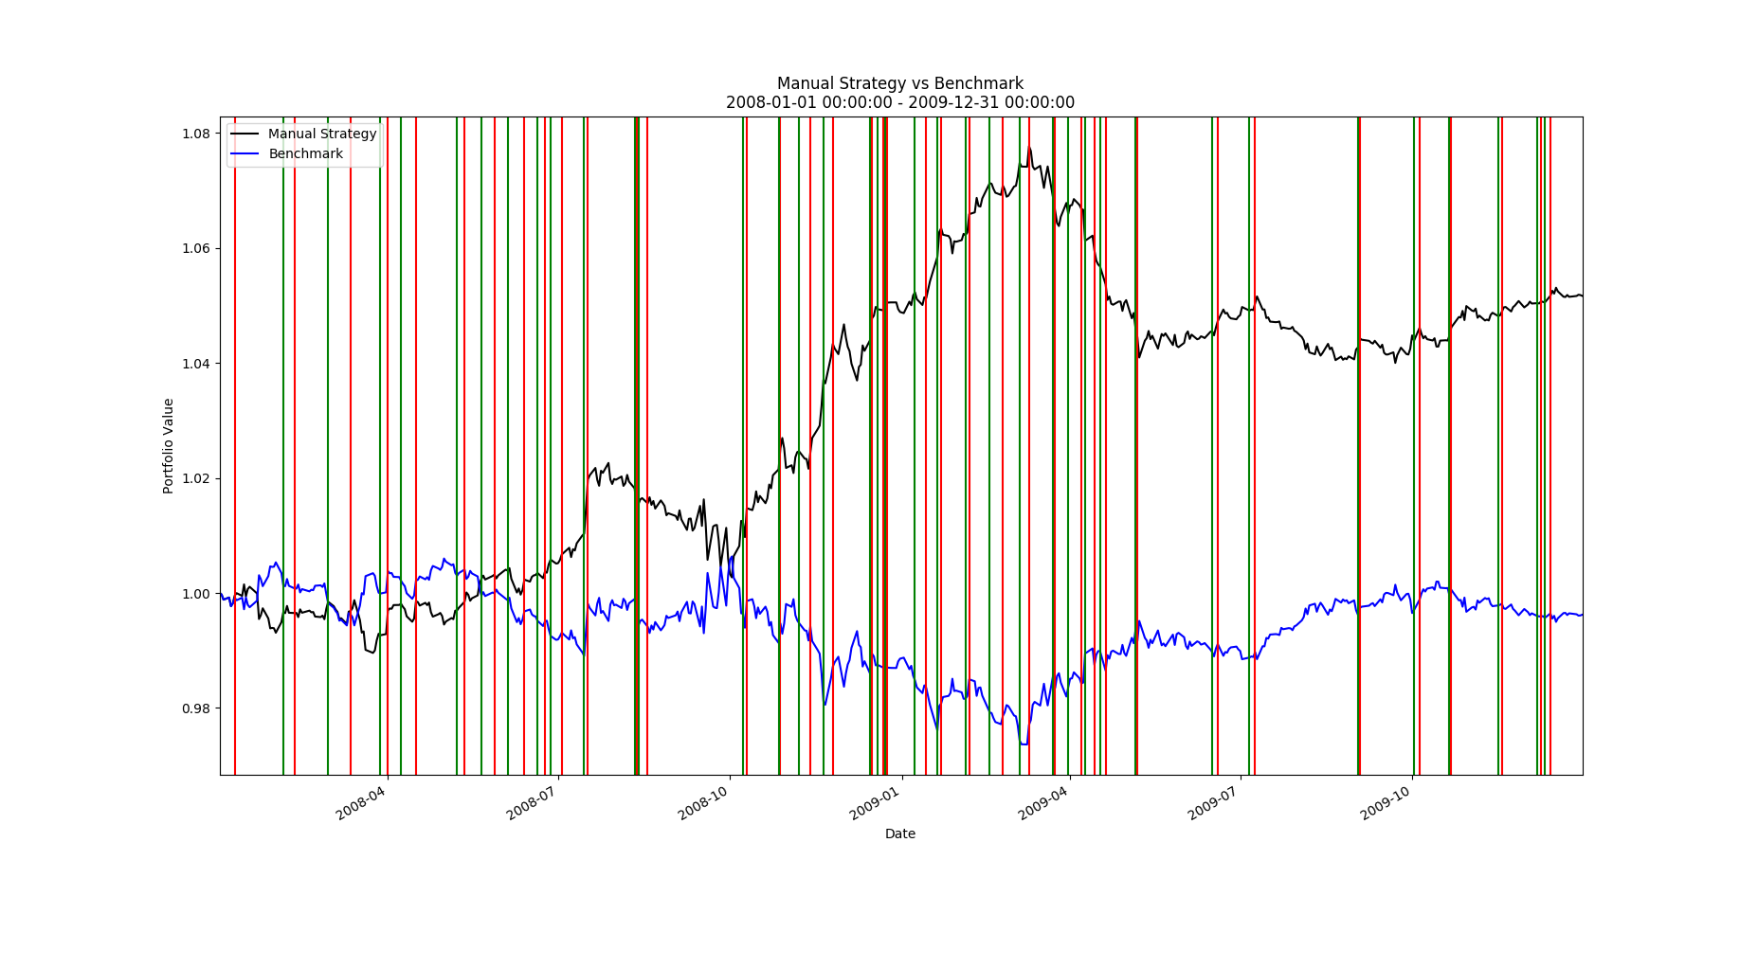
Figure 5
Figure 5 shows the performance of my Manual Trader against the benchmark on the inset. Green vertical lines represent longs and red vertical lines represent shorts. As can be seen, the manual trader is able to outperform the benchmark and make a profit while the stock has gone down.

Comparative Analysis
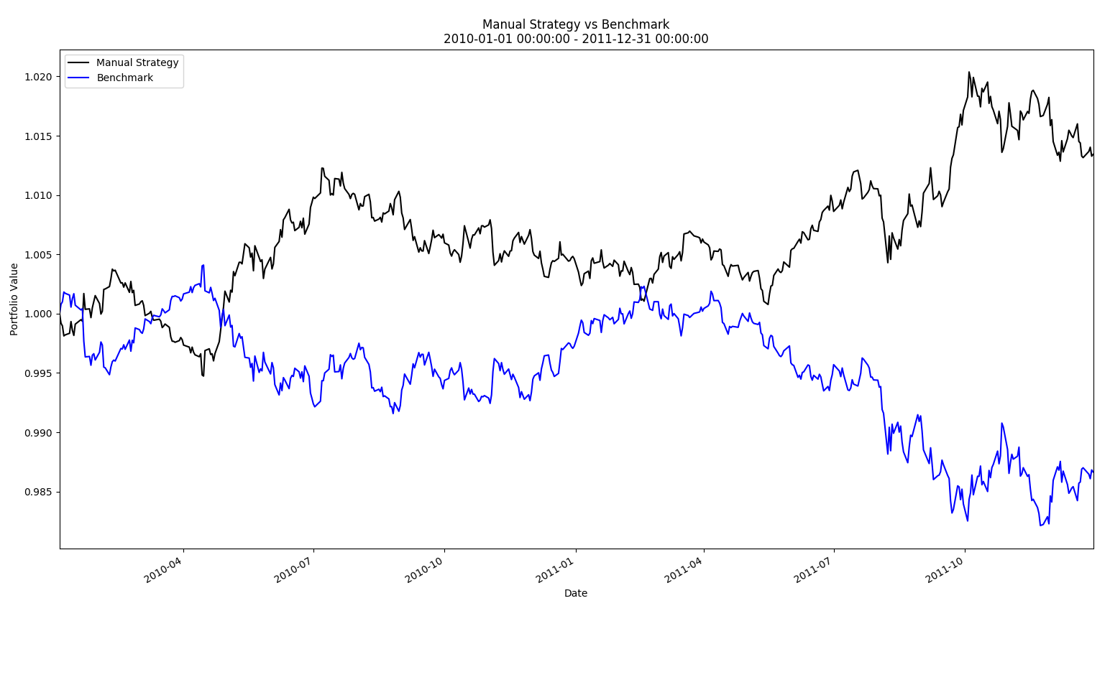
Figure 6
Figure 6 shows the performance of my Manual Trader and the performance of the benchmark. Once again, the manual trader performed better.
The following two tables summarize the trader’s performance on the in sample and out sample respectively.

In Sample | Manual Trader | Benchmark
Cumulative Return | 0.0517 | -0.00379
Mean of daily returns | 0.00010 | -6.2215
Standard deviation of daily returns | 0.0016 | 0.0016

Out Sample | Manual Trader | Benchmark
Cumulative Return | 0.0134 | -0.01335
Mean of daily returns | 0.0000468 | -0.0000264
Standard deviation of daily returns | 0.000813 | 0.000815

The In sample has a cumulative return that was 3.8 times higher than that of the out sample. There are two factors that could have caused this. First, the stock itself performed generally better in the in sample than it did in the out sample. This can be seen when looking at the Cumulate Return for the benchmarks in both sample. In the in sample, the cumulative return was -0.00379, in the out sample it was -0.01335 which is roughly 3.55 worse, a number that is very close to the relative performance of the manual trader. Another factor that would have contributed to this was the parameter tweaking. I tweaked the parameters in order to maximize gains on the in-sample. While I might have found the best general parameters for my algorithm, I may have also overfit my parameters to the in-set. A different set of parameters might prove to do significantly better on the outset.

