**Assignment**

Q1. In cell D4, create an **=IF**function to calculate **Discount Applied**.  Use the following information to help you:

* If the order quantity is greater than 2000, the discount is 10%
* 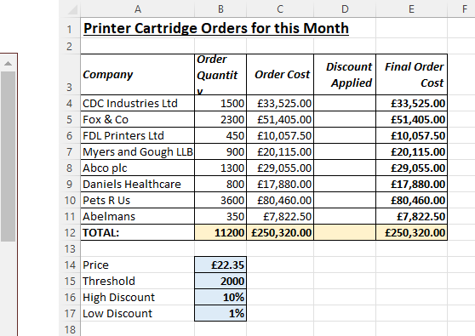Anything less, the discount is 1%
* Copy the **=IF** formula down column D to calculate the other discounts applied.
* 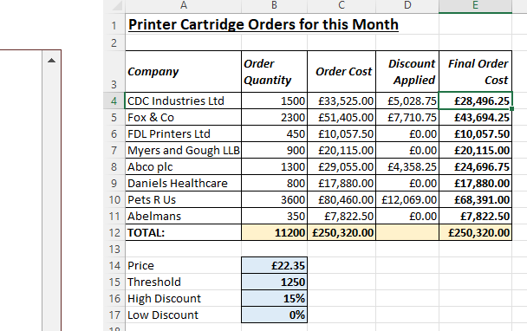Change the input cells for the % discounts to check that your **=IF** is working correctly as shown below:

Q2. Using If to Calculate different parking charges for car parking data.  
In cell C4 create a formula using the **=IF** function to calculate the parking charge, then copy the formula down the rest of the column to calculate the other cars' parking charges.

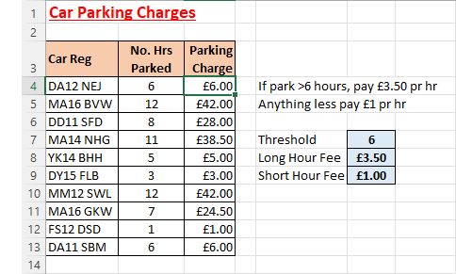*The****=IF****function charges either £3.50 or £1 for parking.*

Change the threshold and parking fees to different values to check that your **=IF** function is working correctly, then use **Save As...**to save the file in your own new Excel work folder.

Q3. Using various text functions in Excel to parse film names

Open the file contained within the folder name shown above.

Most of the information is currently contained within a single cell in column B:

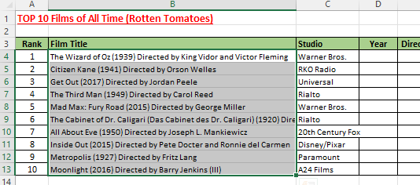

*We want to split the long text from column****B****out into separate columns.*

See how many of the following text functions you can create:

* In cell **D4** use Excel text functions to display only the date of each film.  Copy this down to the rest of the column.
* In cell **E4** use Excel text functions to only display the text **Directed by** and the name of each director.  Copy this down to the rest of the column.
* In cell **F4** use Excel text functions to remove the words **Directed by** from the text in cell E4, to show only the director's name.  Copy this down to the rest of the column.
* In Column B, change some of the dates and directors' names to check that your formulae are working.

Here's what you should create by the end:

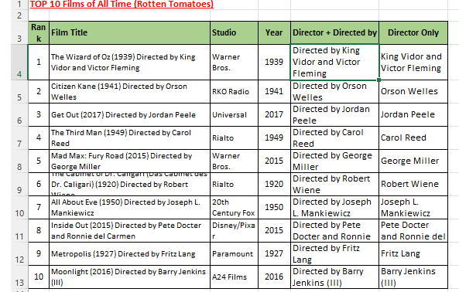*What your newly created columns should show.*

Use **Save As...**to save the file in your own new Excel work folder.

Q4. Use Microsoft Excel to calculate basic statistics about big budget movies

Create a formula to work out the profit for each of the movies in the list and copy this down:

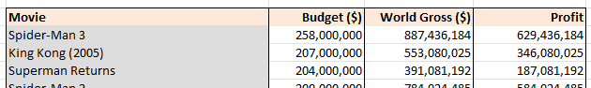

*Can you spot the flops?*

Use functions to calculate the lowest and highest profit of all the movies at the bottom of the list:



*Use the****MAX****and****MIN****functions to do this.*

*Show the Highest and Lowest values using the chart also.*

Choose the **Save As ...**option to save your file in your new work folder, and then close it down.

Q5. **Creating sparklines in cells to report on accidents involving animals**

Insert some sparklines in column F to create tiny charts of the accident data in columns **B:E**.

Use the sparkline tools **Design**tab to edit the sparklines.  Add some colour markers and change the line colour (changing the row height and adding some cell background shading is usually effective too).

In column G, add some column sparklines.  Change the formats for these too until you are happy with their appearance:

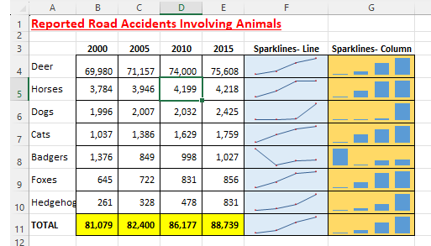

*Your sparklines don't have to be the same as these.*

Change the accident figure for deer in 2010 to just 100 to see the effect it has on the sparklines:



*Sparklines always reflect the data in the cells.*

Use **Save As...**to save the file in your own new Excel work folder.

Q6. **Using =IF and Concatenation to display different text messages**

We want to create a formula that uses =IF to display a test message about the length of each beetle in our field study of the school playing fields:

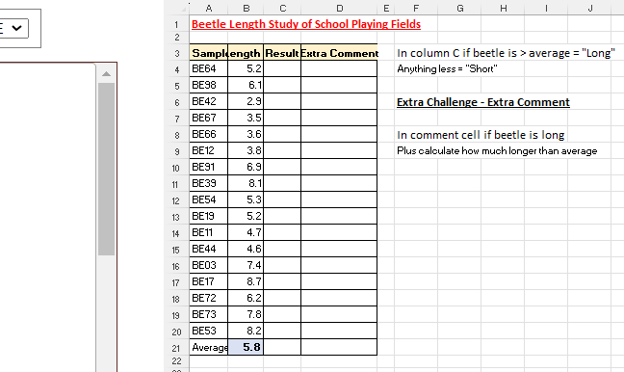

*The message in column C should be****SHORT****or****LONG****.*

In cell **C4**, create a formula using **=IF** function to calculate the following:

* If the beetle length > average in cell **B21**, set the text message to **LONG**
* If length is shorter, set the text message to **SHORT**

Copy the formula down to the rest of column C to calculate all the other messages.

Change the length of the sample in cell **B4** to 50.2 (this would be an alien monster beetle!).  This will pull the average up and change many messages to **SHORT**.

If you like a challenge, have a go at creating a formula using **=IF** in cell **D4**to display a message that calculates how much longer than average the beetle is:

* If the beetle length is **LONG** your message should say **This sample is x.xx longer than average**
* The cell should be blank if the beetle length is not **LONG**.

Change the length of the sample in cell **B4**to 20.7 to check that your **=IF**formula works:

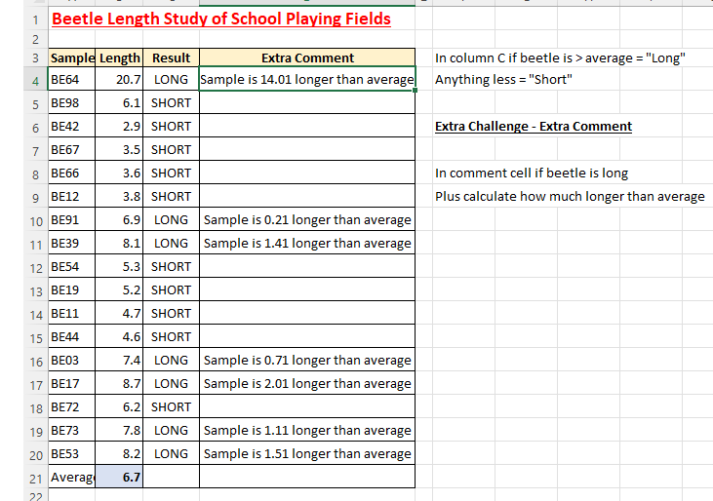

*You will need to use the****&****(concatenate) symbol to display the text and the formula result.*

Use **Save As...**to save the file in your own new Excel work folder.

Q7. **Creating scatter charts of sales data with regression trendlines**

Select all the data and press **F11** to create a chart.

Change the chart type to a scatter chart and change the axis scale to start at 20000 and end at 40000.  You might also like to edit the marker and the grid options.  Your scatter chart should now be similar to this:

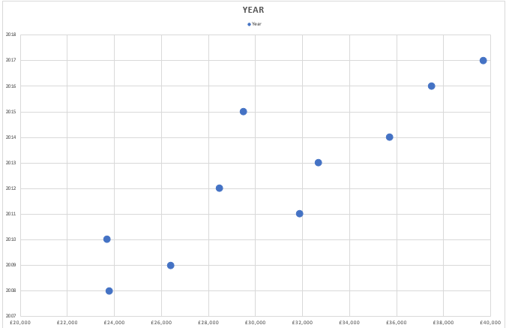

*The next step is to add a regression trendline.*

Select the scatter chart markers and ask Excel to insert a trendline:

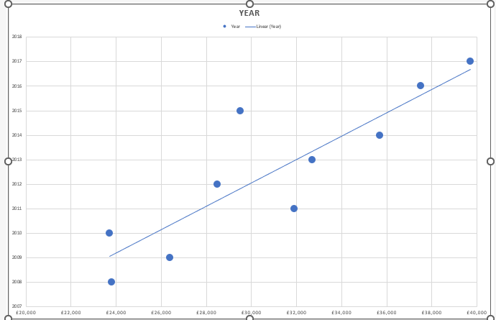

*A linear trendline is a good place to start if you're not sure.*

You can display the trendline equation on the chart which can be useful:



*Displaying the trendline equation.*

Format the trend line to emphasize it better:

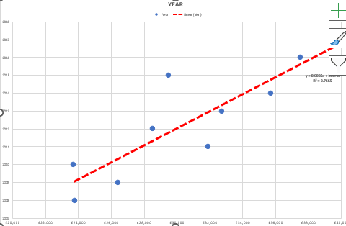

*Trendlines can help give a clearer picture of your data.*

Use **Save As...**to save the file in your own new Excel work folder.

Q8. **Using 3D sums to calculate totals across sheets for teenage spending**

This workbook has separate sheets showing an (imaginary) child's expenditure from January to May:

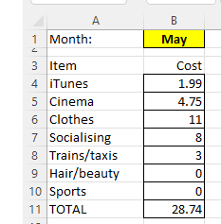

*Click on the sheet tabs for each month to see the expenditure for that month.*

Use your **CTRL** key to copy the **May** sheet to create another copy and re-name it as **June**:



*When you click and drag using****CTRL****it creates another copy of that sheet.*

Type in new figures for June as shown below:

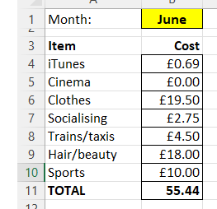

*June is an expensive month!  Change the month name in cell****B1****to****June****.*

Use your **CTRL** key to copy the **June** sheet to create another copy and re-name it as **TOTALS**.

Delete all the costs in cells **B4:B10**.

On the **TOTALS**sheet, in cell B4, use a 3D sum to add together all iTunes costs for all 6 months.

Copy this down to calculate all the other costs.

Change the iTunes cost in June to £45 (do people still use iTunes?) and check that the total updates:

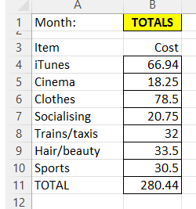

*Your formula in column B is a 3D sum.*

Select all the sheet tabs to go into group mode so that any changes you now make will be made to all the sheets, then do the following:

* Format all the numbers to **Currency**with 2 decimal places;
* Add light shading behind all the number cells;
* Change the text in cell **A7**from **Socialising** to **Tickets for Clubs**
* Remove row 10 - your child says sport is too expensive!
* The new **TOTALS**sheet should look very similar to this:

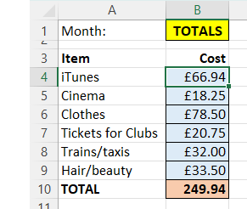

*No more sport, sadly!*

* Use **Save As...**to save the file in your own new Excel work folder.