1.INTRODUCTION
The Periyar University NSS Portal is a web-based application designed to digitize and simplify the management of National Service Scheme (NSS) activities across different institutional levels. In the existing system, processes such as volunteer enrollment, event management, and report submission are carried out manually, leading to inefficiency, errors, and poor data management. This project introduces a centralized platform that connects administrators, colleges, and NSS units, ensuring better coordination and transparency.
The system is structured into multiple functional modules including Authentication & Secure Access, Administrator Command, College Administration, Unit Operations & Volunteer Management, Student Enrolment & Demographic, Automated Document & Reporting, and Event Management & Field Activity modules. Each module is designed to handle specific operations, ensuring a well-organized and scalable system architecture.
The system follows a role-based access structure, where Admin, College, and Unit users have specific permissions and responsibilities. It is developed using modern technologies to ensure performance and scalability. The frontend is built using React with Vite for a fast and responsive interface, while the backend uses Node.js and Express to handle server-side operations. MongoDB is used for efficient data storage, and communication between components is handled through RESTful APIs. Secure authentication is implemented to protect user data, along with additional features like email notifications.
The application provides functionalities such as digital volunteer enrollment, event creation and tracking, collaborative participation, and report generation. Overall, the system improves efficiency, reduces manual work, and offers a reliable solution for managing NSS activities in a structured and effective manner.

1.2.SYSTEM SPECIFICATION :
1.2.1.HARDWARE CONFIGURATION:
- Processor : Dual-Core Processor or higher (e.g., Intel Core i3 or equivalent) with a clock speed of 2.0 GHz or higher.
- RAM : Minimum 4 GB of RAM.
- Storage : Minimum 512 MB of free disk space.
- Network : Stable internet connection for cloud database connection(MongoDB atlas)
The selected hardware configuration provides sufficient performance to run development tools like Node.js, React, and database services smoothly. A minimum of 4 GB RAM and a dual-core processor ensures efficient multitasking during coding and testing. Stable internet connectivity is essential for accessing cloud services like MongoDB Atlas and Cloudinary.

1.1.2.SOFTWARE SPECIFICATION:
- Operating System : Windows 10 or 11, Linux (Ubuntu 16.04 or later).
- Framework : Node.js with Express.js for backend.
- Libraries : React.js for frontend.
- Package Manager : Node Package Manager ( npm ) for managing dependencies.
- Database : MongoDB ( Atlas for Cloud Database ).
- API Testing : Postman.
- Cloud storage : Cloudinary ( For storing event brochures )
- Version Control : Git and GitHub.
- Code Editor : Visual Studio Code (or) CodeSandbox( for online coding ).
- Browser : Latest versions of Chrome, Firefox, Microsoft Edge or Brave.

The chosen MERN stack enables efficient full-stack development using a single language (JavaScript), improving development speed and consistency. Node.js and Express.js support scalable backend development, while React.js provides a dynamic user interface. Additionally, MERN applications can be easily deployed on cloud platforms, making the system flexible and accessible. Tools like MongoDB Atlas, GitHub, and Postman ensure reliable database management, version control, and API testing.

2.SYSTEM STUDY
2.1.EXISTING SYSTEM
2.1.1. DESCRIPTION
The existing system for managing NSS activities is mostly manual and paper-based. Processes like volunteer enrollment, event management, and report submission are handled using physical forms such as Annexure-A. Data is stored in files or registers, making it difficult to organize and retrieve information.
In addition, the Existing NSS webpage https://www.periyaruniversity.ac.in/nss.php mainly provides downloadable links for forms and displays a few past event images, but lacks interactive features or a centralized digital system for managing activities. Communication between administrators, colleges, and units is not centralized, leading to delays and confusion.
2.1.2. DRAWBACKS
- Manual Process: Most NSS activities such as enrollment, attendance, and report preparation are handled using paper-based methods, increasing manual effort.
- Time Consumption: The overall process is slow, as tasks like data entry, verification, and report generation require significant time.
- Human Errors: Manual handling of data often leads to mistakes in recording, duplication, and loss of important information.
- Poor Data Management: Maintaining records in physical files or basic formats makes it difficult to store, organize, and retrieve data efficiently.
- Lack of Centralization: There is no single unified platform to manage all activities, leading to scattered and uncoordinated operations.
- Low Transparency: Administrators and higher authorities have limited visibility into the activities of colleges and units.
- Tracking Issues: Monitoring volunteer participation, event progress, and outcomes becomes challenging without a proper system.
2.2.PROPOSED SYSTEM
2.2.1. DESCRIPTION
The proposed system is a web-based Periyar University NSS Portal designed to automate and simplify NSS activities through a centralized platform. It replaces manual processes like volunteer enrollment, event management, and reporting with a digital solution. The system uses role-based access control for Admin, College, and Unit users to ensure secure and organized operations. It allows easy storage, retrieval, and management of data in real time. The platform also supports collaborative events and improves communication between different levels. Automated notifications and structured report generation enhance efficiency. Overall, the system reduces manual work, minimizes errors, and improves transparency.
2.2.2. FEATURES
- Digital Enrollment: Provides an online system for registering NSS volunteers with detailed personal, and activity-related information, replacing paper-based forms.
- Role-Based Access Control: Ensures secure and structured access for different users such as Admin, College, and Unit, with specific permissions for each role.
- Event Management: Enables users to create, update, and manage NSS events, including scheduling, descriptions, and tracking progress.
- Collaborative Events: Allows multiple NSS units to participate and coordinate in a single event, improving teamwork and resource sharing.
- Centralized Data Storage: Maintains all data in a unified database, making it easy to access, update, and manage information efficiently.
- Automated Notifications: Sends real-time alerts and updates to users regarding new events, changes, and report submissions.
- Report Generation: Automatically generates structured reports for events and volunteer participation, reducing manual effort.
- Data Export Options: Supports exporting data in formats such as PDF, Excel, and CSV for administrative and official purposes.
3. SYSTEM DESIGN AND DEVELOPMENT
3.1.DATABASE DESIGN
The database design of the Periyar University NSS Portal is structured to efficiently manage data related to users, units, volunteers, events, and program officers. It follows a flexible schema approach to handle different types of data while maintaining proper relationships between entities. Each component in the system is interconnected, ensuring smooth data flow and consistency. The design supports scalability, allowing the system to handle increasing data over time. It also ensures efficient storage, retrieval, and updating of records.
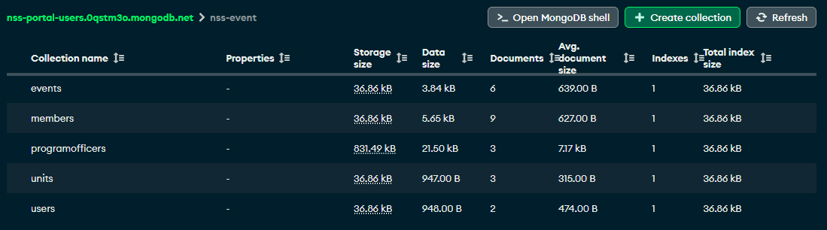
The Member, Unit, and User models form the core structure of the system. The Member model stores detailed volunteer information, including personal, academic, and enrollment details, and is linked to specific units and colleges. The Unit model manages NSS units, their members, and associated activities within a college. The User model represents institutional-level data, including login credentials and organizational details, and maintains relationships with multiple units.
The Event and Program Officer models handle operational and administrative functionalities. The Event model stores complete event details such as schedule, venue, participants, collaborators, and final reports. It also supports tracking attendance and post-event outcomes. The Program Officer model maintains details of NSS coordinators, including their personal and professional information. Together, these models ensure efficient data management, reduce redundancy, and support the overall functioning of the system.

Table(Collection) Name | Purpose
User (College) | Manages institution login, overall units, events, and adopted villages
AdoptingVillages (Sub-table) | Stores details of villages adopted by the college for NSS activities
Unit | Represents an NSS unit under a college, manages members and events
Member | Stores student details including personal info and NSS enrolment data
Event | Manages event details like schedule, venue, participants, and unit association
ProgramOfficer | Stores details of NSS officers who manage and guide units
Collaborators (Sub-table) | Handles collaboration between different units for an event
Report (Sub-table) | Stores post-event report details like participants count, outcome, and files

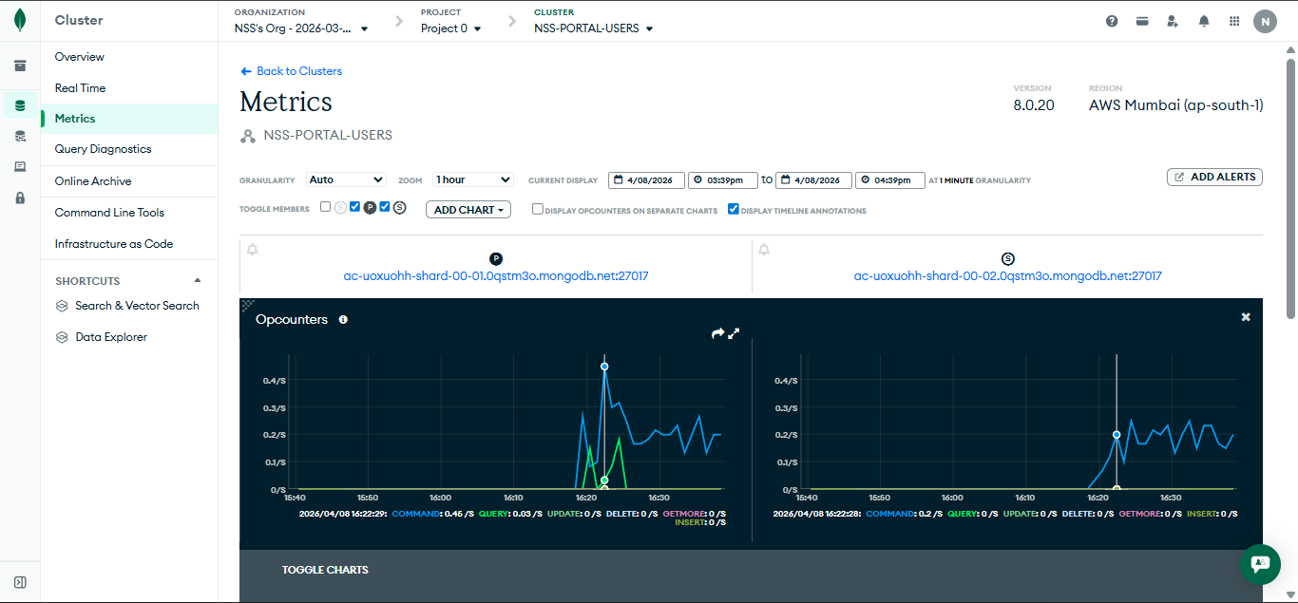
MongoDB is used as the database management system to store and manage all application data efficiently. It provides a flexible, document-based structure that allows easy handling of complex and dynamic data. As we use the MongoDb Atlas (Cloud) Its scalability and high performance support the smooth functioning of the Periyar University NSS Portal .

3.2.INPUT DESIGN
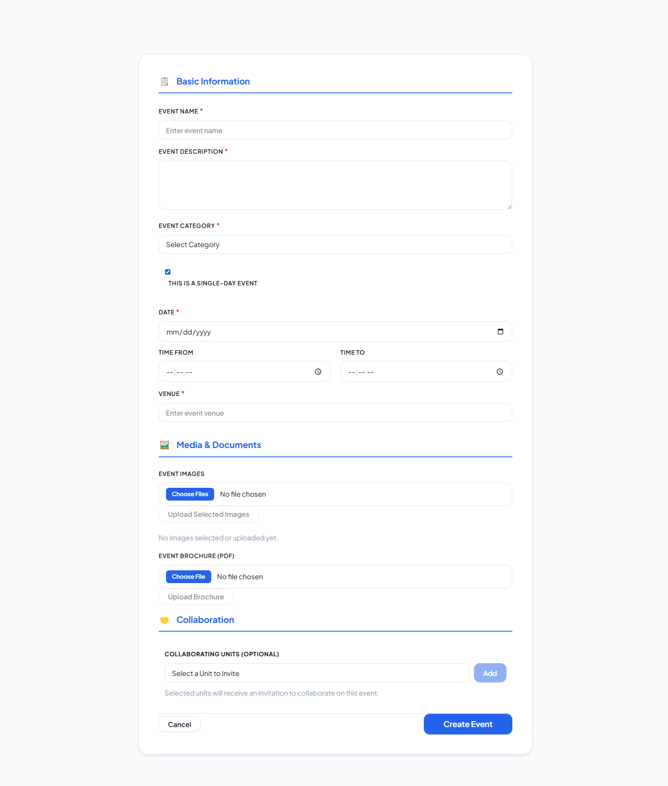

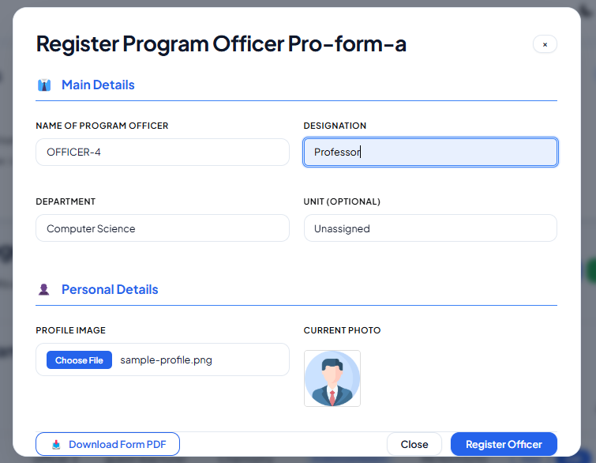

The input design of the Periyar University NSS Portal focuses on providing a user-friendly and consistent interface for data entry. All input fields such as text boxes, dropdowns, date pickers, and file uploads are designed with a clean and modern style using rounded corners, proper spacing, and readable fonts. Interactive states like hover and focus are included to guide users during data entry. The system also applies input validation to ensure accuracy and reduce errors. This improves overall usability and ensures reliable data collection.

The application uses structured forms for different modules to simplify complex inputs. The Event Creation Form allows users to enter details like event name, category, date, venue, and collaborators in an organized manner. The Volunteer Enrollment Form (Annexure-A) is divided into sections such as personal, academic, physical, and skills to reduce user complexity. Advanced UI elements like icons, placeholders, and grouped inputs further enhance clarity. Overall, the input design ensures efficient, accurate, and smooth user interaction.

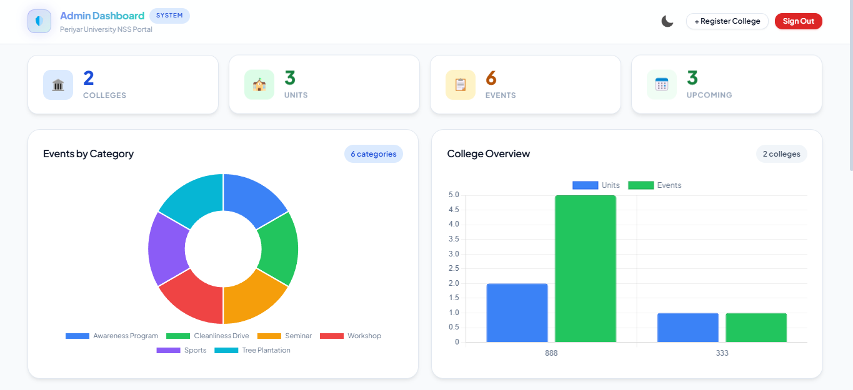
3.3.OUTPUT DESIGN

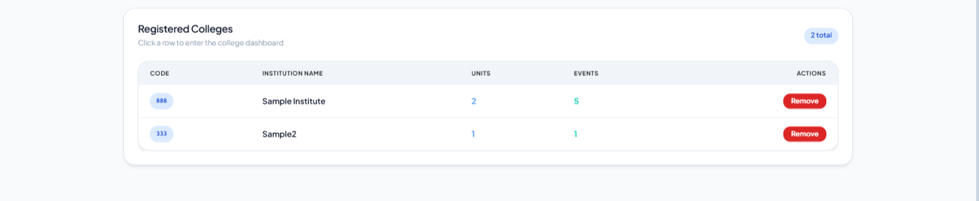

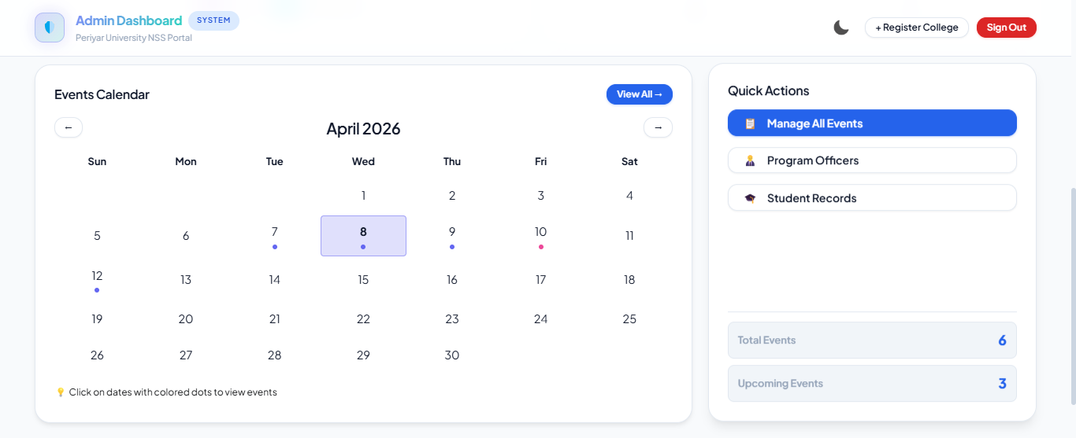
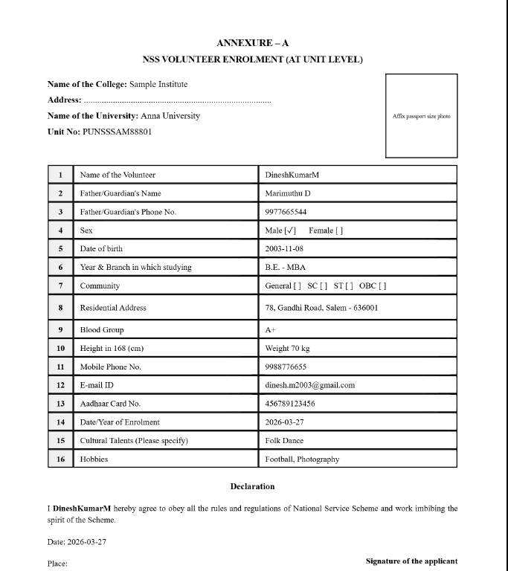


The output design of the Periyar University NSS Portal focuses on presenting data in a clear, structured, and visually appealing manner. The system provides dashboards with graphical representations such as charts and key metrics to help administrators easily analyze NSS activities. Visual elements like charts and calendars are used to display event distribution, institutional performance, and daily schedules. These outputs improve decision-making by providing real-time insights and better understanding of data.
The system also supports professional reporting and data export functionalities. It generates detailed PDF reports for completed events, including participation details, outcomes, and supporting images. Additionally, data can be exported in formats like Excel for offline use and official submissions. Automated email notifications are used to communicate updates and alerts to users. The system also produces standardized documents such as the Annexure-A enrollment form. Overall, the output design ensures effective data presentation, reporting, and communication.

3.4.CODE DESIGN
The code design of the Periyar University NSS Portal follows a well-structured and modular architecture based on modern software engineering principles. The application is developed using the MERN stack, ensuring scalability, flexibility, and efficient handling of dynamic data. The frontend is built using a component-based approach, where reusable components such as forms, modals, dashboards, and input elements improve code reusability and maintainability. State management is handled using Context API, enabling smooth data flow across components, while routing is implemented with proper protection mechanisms to restrict unauthorized access.
The backend is designed following RESTful API architecture. Each API endpoint is structured with proper request handling and standardized responses, along with effective error handling using try-catch mechanisms. Security is a key aspect of the design, implemented through JWT-based authentication and role-based access control to manage Admin, College, and Unit privileges. Sensitive data such as passwords are securely handled using encryption techniques. The system also integrates third-party services for functionalities like email notifications, media storage, and data visualization. Overall, the code design ensures a secure, scalable, and maintainable system that supports efficient development and future enhancements.
frontend/
├── src/
│ ├── components/ # All UI modules & Dashboards
│ ├── context/ # State management (User/Theme)
│ ├── assets/ # Global images & icons
│ └── App.jsx # Main Routing & Entry point
backend/
├── server.js # Core server logic & API Routes
├── middleware/ # Auth & Security checks
└── .env # Secure configuration

3.5.SYSTEM DEVELOPMENT

Requirement Analysis
This phase involves understanding the needs and objectives of the NSS Portal. The system requirements are gathered by identifying the functionalities such as member management, unit handling, and activity tracking. Both functional and non-functional requirements are clearly defined to ensure the system meets user expectations.

System Design
In this phase, the overall architecture of the system is planned. The application is designed using the MERN stack, ensuring a clear separation between frontend and backend. Database schema, user interface layout, and system workflows are structured to provide efficiency, scalability, and ease of use.

Implementation (Development)
During implementation, the actual coding of the system is carried out. The frontend is developed using React.js to create an interactive user interface, while the backend is built using Node.js and Express.js to handle server-side operations. MongoDB is used to store and manage data efficiently.
Testing
The system is thoroughly tested to ensure all functionalities work correctly. Different types of testing such as unit testing, integration testing, and user testing are performed. Errors and bugs are identified and fixed to improve system reliability and performance.
Deployment
After successful testing, the system is deployed to a production environment (netlify for frontend and render for backend). This makes the NSS Portal accessible to users. Proper configuration and hosting are ensured so that the application runs smoothly in real-time usage.

Maintenance
Maintenance is an ongoing process where the system is monitored and updated regularly. Any issues faced by users are resolved, and new features or improvements are added to enhance performance and usability over time.
3.5.1. MODULE DESCRIPTION
1. Authentication & Secure Access Module
- Role-Based Access Control (RBAC): Implements specialized login gateways for three distinct user levels: System Administrator, College Coordinator, and NSS Unit Head.
- JWT Security Integration: Ensures data integrity using JSON Web Tokens (JWT) for all API requests, providing end-to-end encryption for session management.
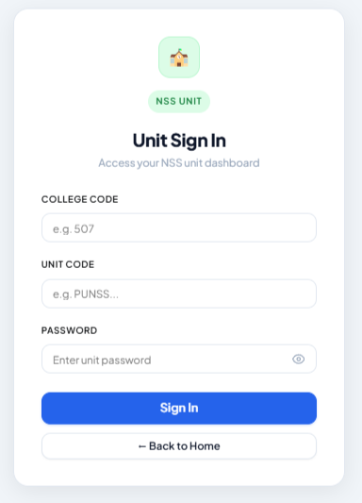
- Aesthetic UI Persistence: Includes a specialized Theme Toggle system that dynamically switches between Light and Night modes with state persistence.
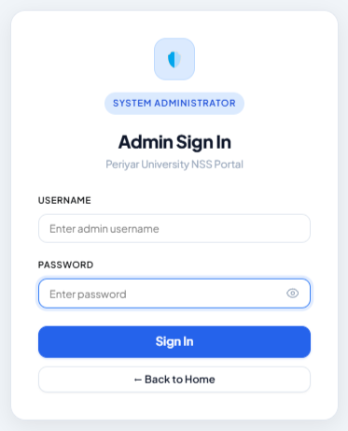
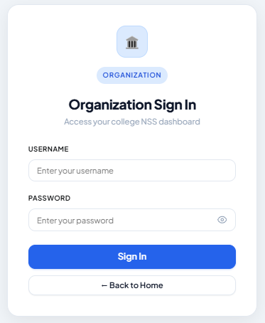

2. Administrator Command Module (Centralized Oversight)
- Institutional Monitoring: Provides a bird's-eye view of all registered colleges, their organizational structures and the events.
- Master Student Registry: A searchable database of all students across the region, featuring multi-layered filtering by community, college, and department.
- Officer Management: Centralized tracking and management of Program Officers' registration and performance metrics.
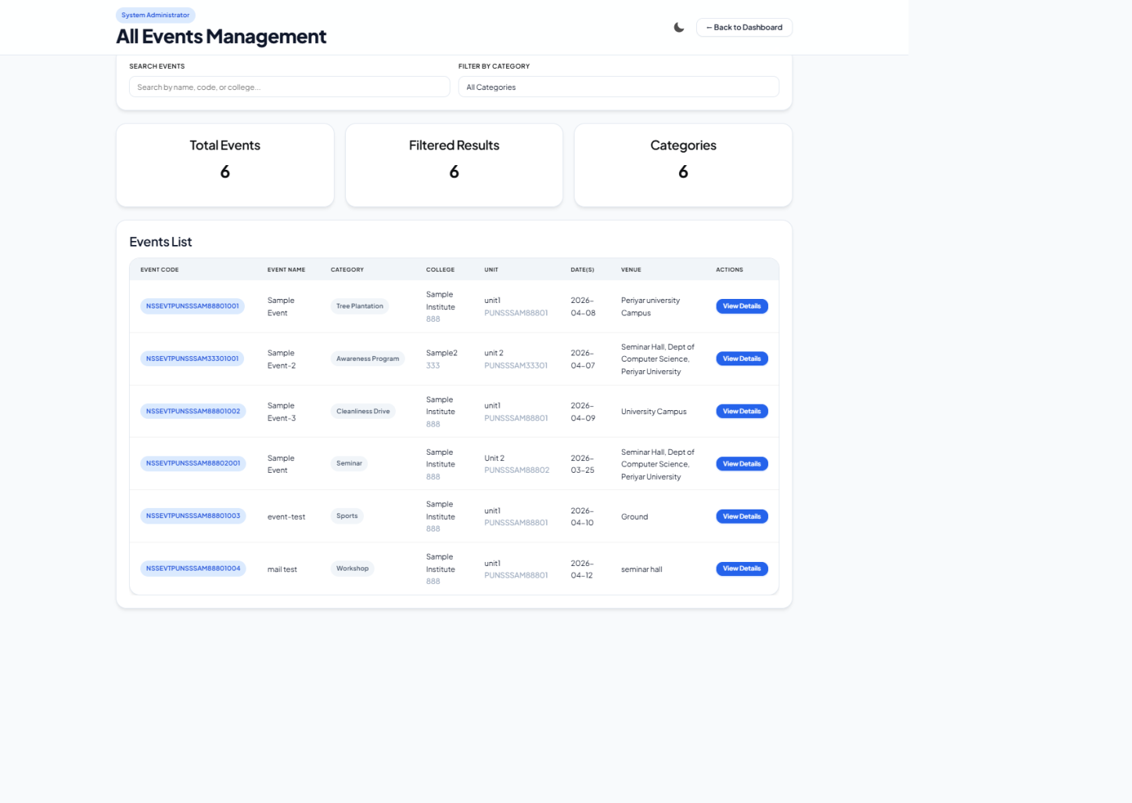

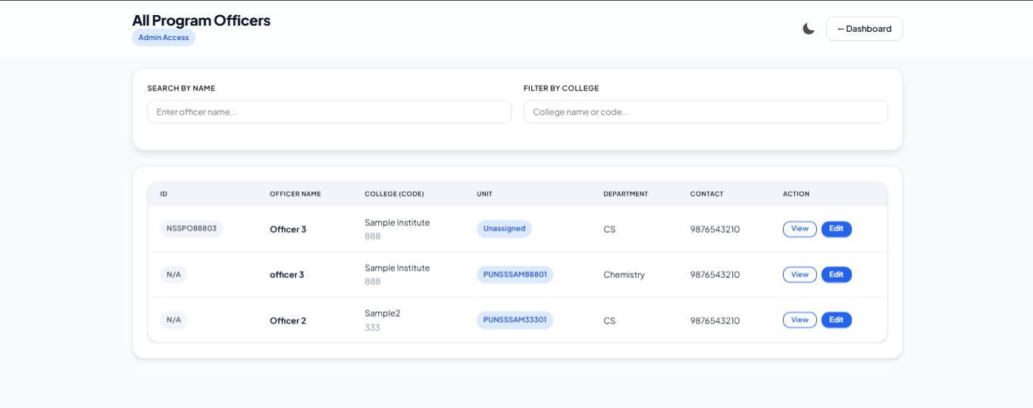

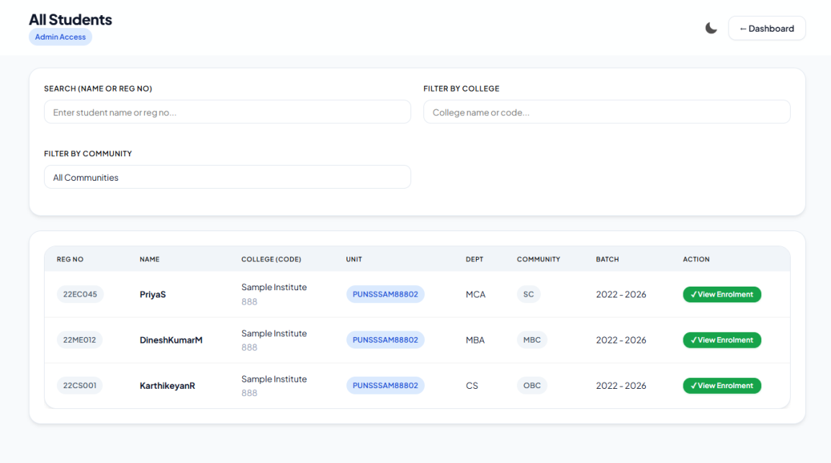

3. College Administration Module (Institutional Dashboard)
- NSS Unit Orchestration: Facilitates the creation and management of up to six NSS units per institution.
- Program Officer Recruitment: Manages the appointment of officers, ensuring unique leadership per unit through intelligent synchronization logic.
- Village Adoption System: A dedicated interface for managing rural outreach data, capturing location-specific details like Block, Taluk, and District for adopted villages.
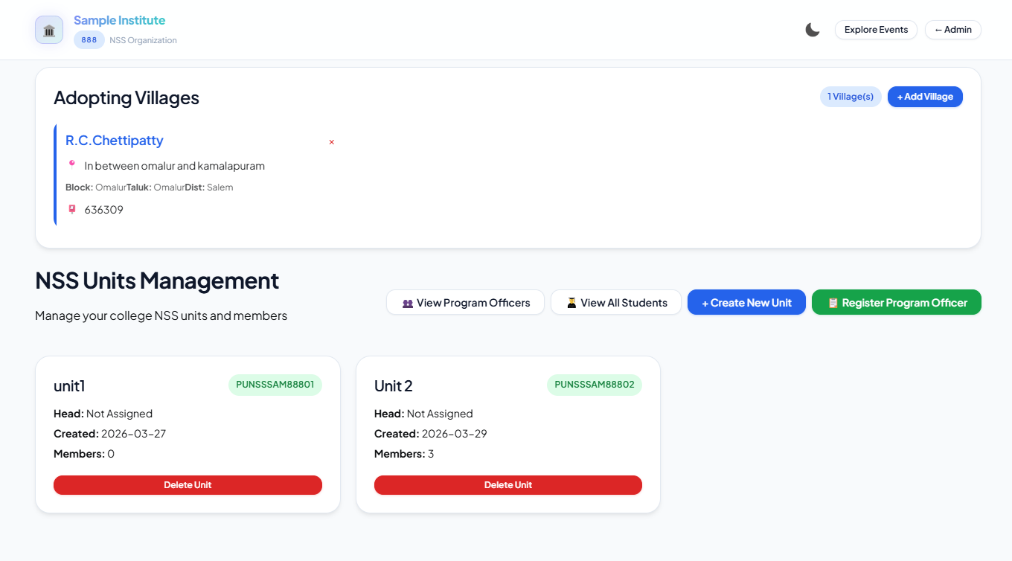
4. Unit Operations & Volunteer Management Module
- Local Unit Control: Enables Unit Heads to manage their specific group of assigned volunteers independently.
- Volunteer Lifecycle Tracking: Oversees everything from the initial enrolment of students to their active participation in social services.
- Unit-specific Analytics: Generates participation summaries and activity logs for internal unit evaluation.

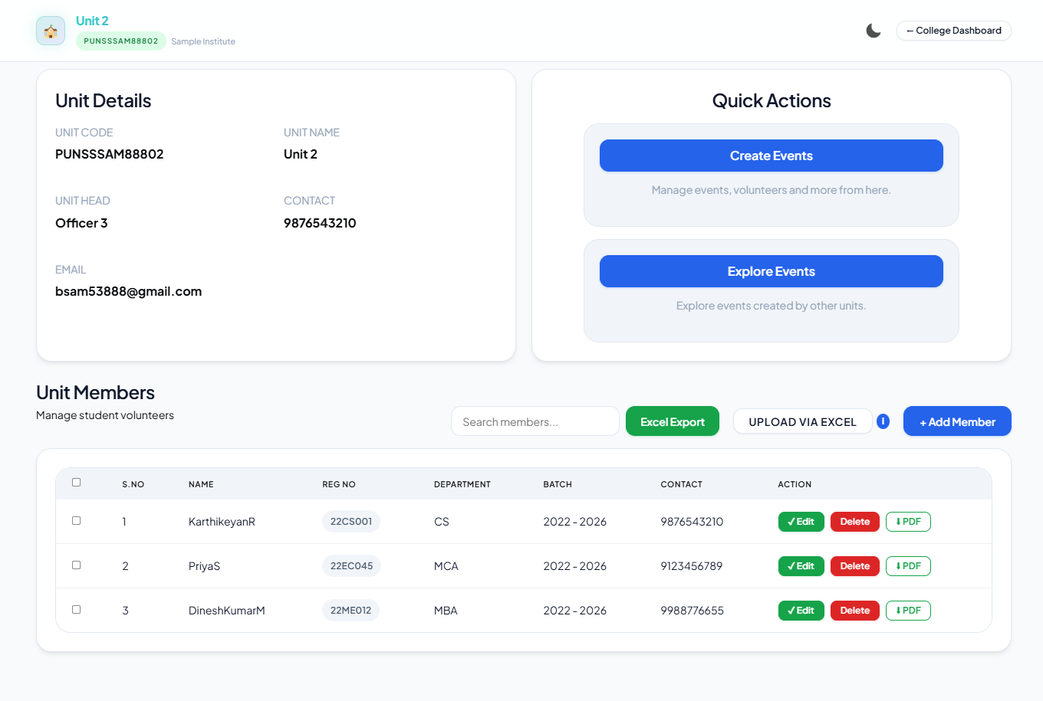

5. Student Enrolment & Demographic Module
- Digital Enrolment Workflow: A comprehensive digital form system that captures student bios, academic data, and contact information.
- Demographic Analysis: Features the specialized "Community Filtering" system to analyze volunteer diversity based on caste and community categories (OC, BC, MBC, SC, ST).
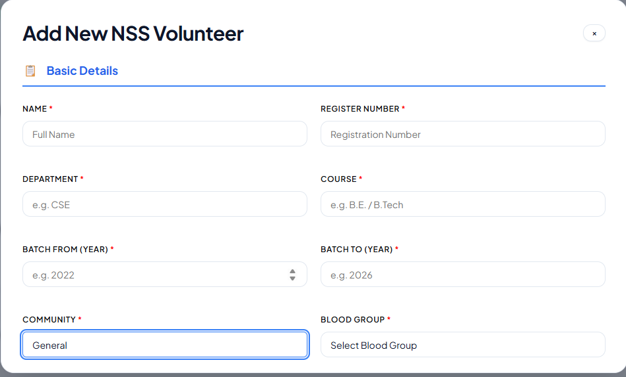
- Record Sorting: Implements advanced sorting algorithms to organize student records by institution and unit numbers.

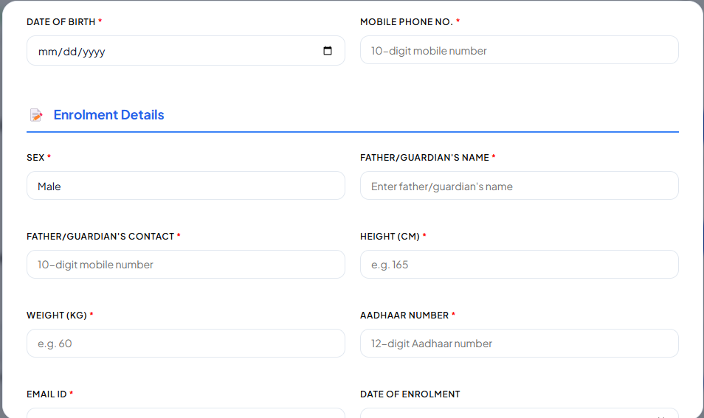
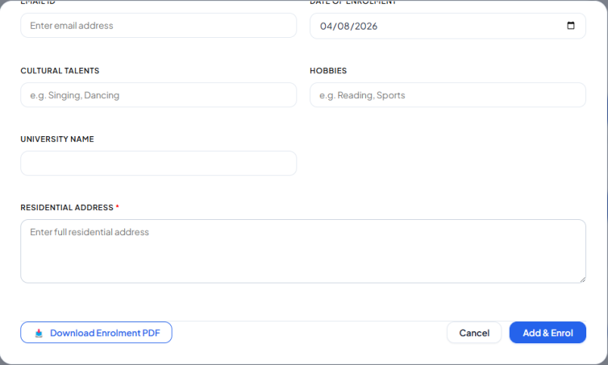

6. Event Management & Field Activity Module
- Outreach Documentation: Allows coordinators to schedule events, camps, and awareness programs.
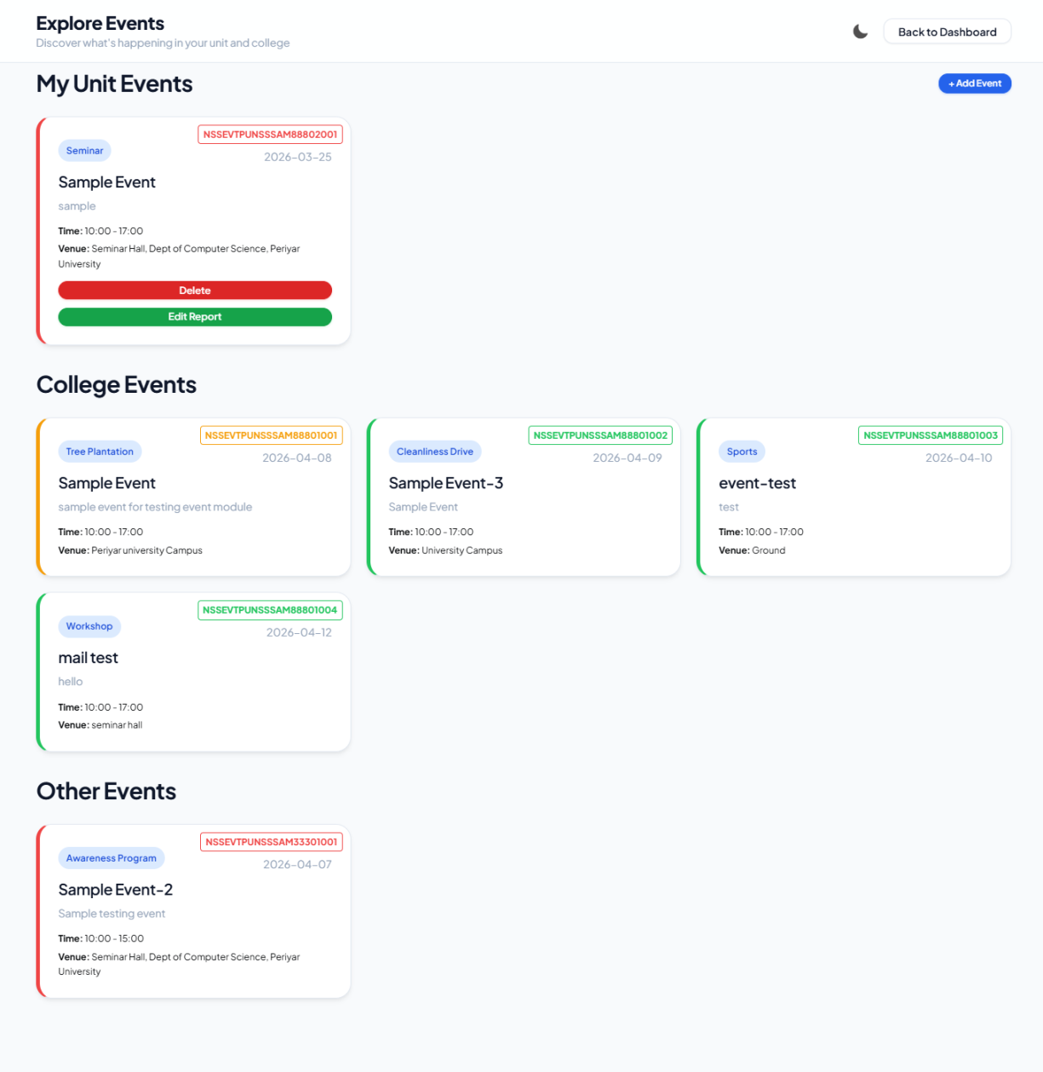
- Multimedia Reporting: Supports high-resolution image uploads for event galleries and detailed activity report submission for validation.

7. Automated Document & Reporting Module
- Dynamic PDF Engine: Uses JS-driven templates to instantly generate official Government-standard Pro-forma and Enrolment forms.
- Bulk Data Export: Features a one-click "Export to Excel" functionality for all administrative lists, facilitating easy offline record-keeping and audit trails.


- Bulk Data Import: Provides a one-click “Import from Excel” feature that allows administrators to upload pre-formatted Excel sheets using a given template, enabling the addition of multiple student records at once quickly and efficiently.

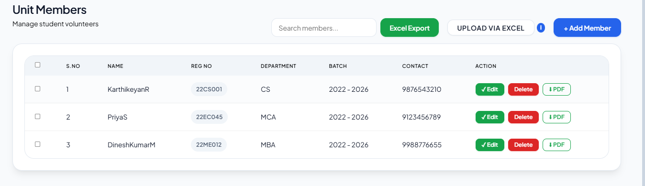

4. TESTING AND IMPLEMENTATION
Testing is an important phase in the development of the Periyar University NSS Portal to ensure that the system works correctly and efficiently. It is carried out to identify and fix errors before deployment. Different types of testing are performed to validate system functionality, performance, and security. The testing process ensures that all modules operate as expected under various conditions. Overall, it helps in delivering a reliable and user-friendly application.

Functional Testing
Functional testing is performed to verify that all core features of the system work as expected. The user registration process is tested to ensure unique credentials and secure password handling. Unit creation and management functionalities are validated based on defined constraints. The complete event lifecycle, including creation, updates, participation, and report submission, is thoroughly tested. This ensures that each module performs its intended function correctly.

Integration Testing
Integration testing ensures smooth interaction between different modules and external services. The communication between frontend and backend APIs is tested for accurate data transfer. Email notification services are verified to ensure alerts are sent correctly to users. Data export features such as Excel and PDF generation are tested to confirm proper formatting and data integrity. This testing guarantees that all integrated components work together seamlessly.

UI/UX Testing
UI/UX testing is conducted to ensure the system is user-friendly and visually consistent. The application is tested across different devices such as desktops, mobiles, and tablets to verify responsiveness. User interface elements like forms, buttons, and dashboards are checked for proper alignment and usability. Theme support, including light and dark modes, is also tested for readability and consistency. This improves overall user experience and accessibility.

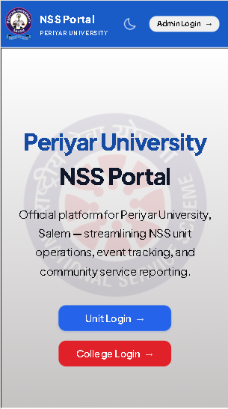
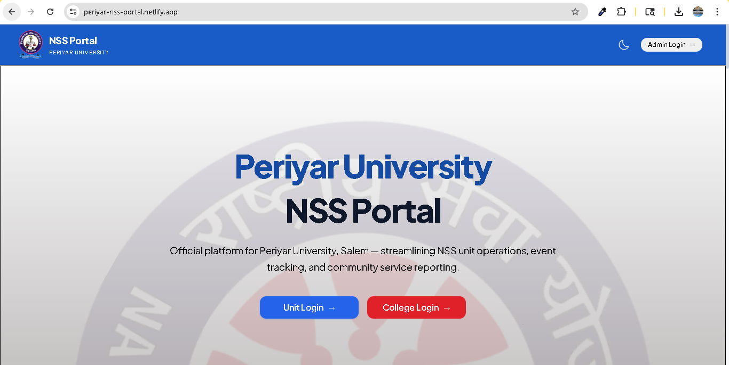

Performance Testing

Performance testing is carried out to evaluate the system’s responsiveness and stability under different conditions. The application is tested with multiple users and large datasets to ensure smooth operation. Loading time, data processing speed, and system responsiveness are monitored. Optimizations are applied to maintain fast performance even with increased usage. This ensures reliability in real-world scenarios.

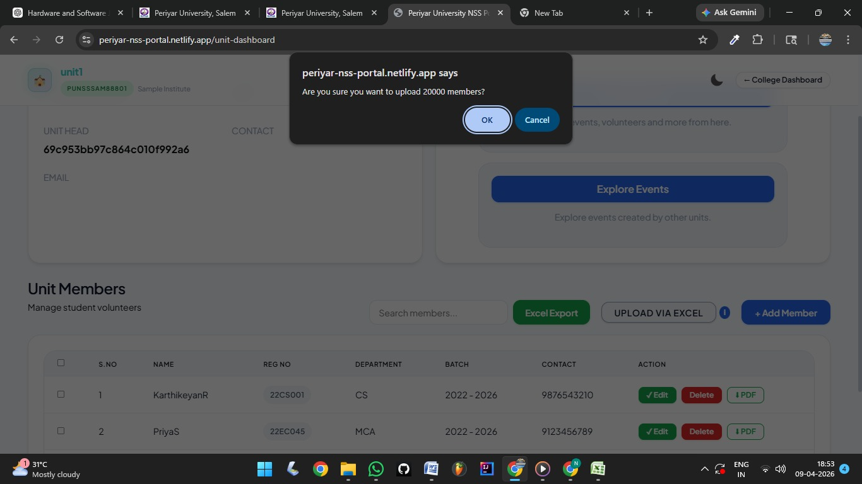
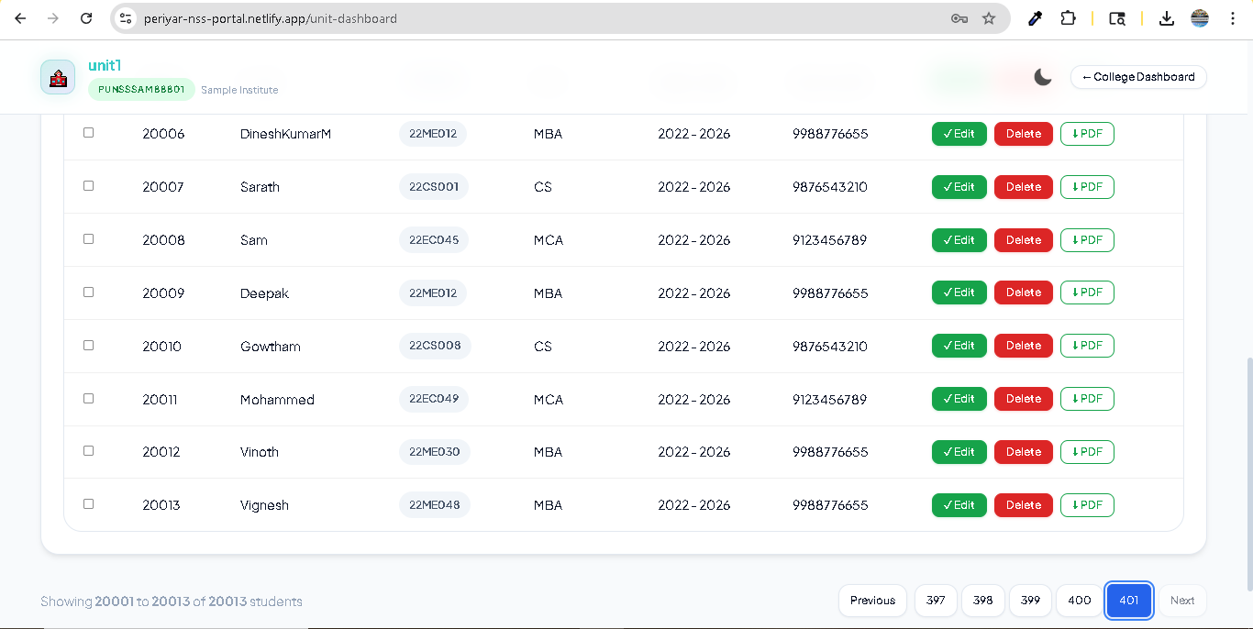
The system was evaluated by importing a large dataset of around 20,000 student records at once. Although the data was successfully uploaded, a performance issue occurred while displaying the student information due to the large volume of data.
To resolve this issue, pagination was implemented, which limits the number of records displayed per page. This significantly improved performance and ensured smooth data retrieval and user experience. The solution effectively handled large-scale data without affecting system efficiency.

Security Testing
Security testing is implemented to protect user data and system integrity. Authentication mechanisms are tested to ensure only authorized users can access the system. Token-based security is verified for protected routes and sensitive operations. Data encryption techniques are checked to safeguard user credentials. This ensures the system remains secure against unauthorized access and threats.
IMPLEMENTATION AND DEPLOYMENT
IMPLEMENTATION PHASE
The implementation phase involves the development and integration of all modules of the Periyar University NSS Portal. During this phase, the system is built using a structured approach where frontend, backend, and database components are developed and connected. All features such as user authentication, volunteer management, event handling, and reporting are implemented based on the system design. Proper coding standards and validation techniques are followed to ensure accuracy and efficiency. Continuous testing is also carried out during this phase to identify and fix errors.
DEPLOYMENT PHASE
The Periyar University NSS Portal was deployed using modern cloud platforms to ensure accessibility and reliability. The frontend was hosted on Netlify, while the backend services were deployed using Render for efficient server-side operations. The database was managed using MongoDB Atlas, ensuring secure and scalable data storage. All components were deployed directly from GitHub, enabling continuous integration and easy updates. This approach ensures high availability, performance, and simplified maintenance.
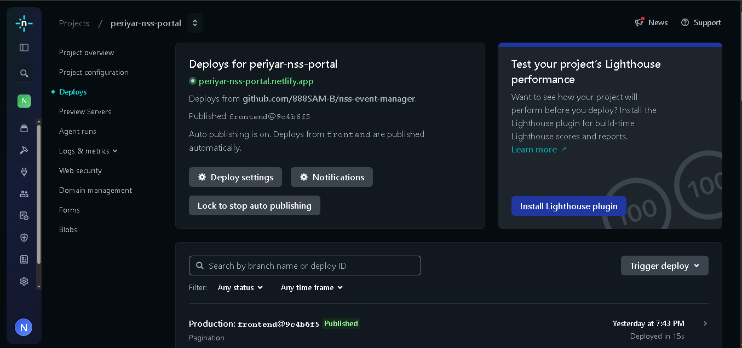

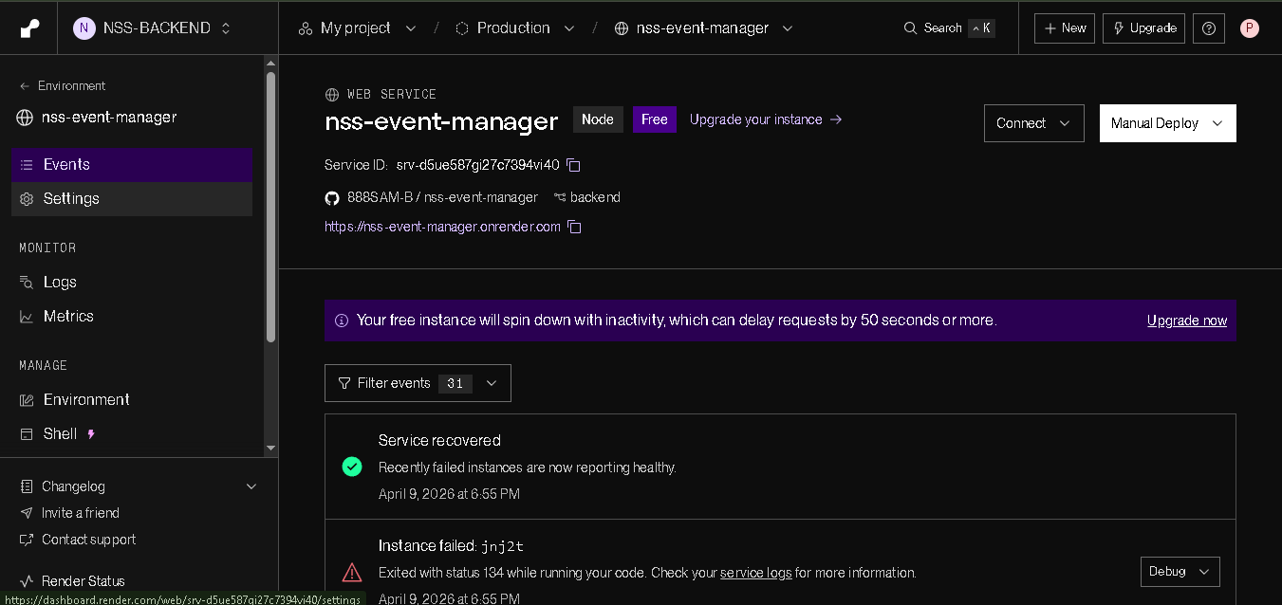

5.CONCLUSION
The Periyar University NSS Portal is a comprehensive web-based solution designed to modernize and streamline the management of National Service Scheme activities. It replaces traditional manual and paper-based processes with a centralized digital platform, enabling efficient handling of volunteer enrollment, event management, attendance tracking, and report generation. This significantly reduces manual effort, minimizes errors, and improves overall data accuracy and management.
The system follows a role-based access structure, allowing Admin, College, and Unit users to perform their responsibilities in a secure and organized manner. It is structured into key modules such as Authentication & Secure Access, Administrator Command, College Administration, Unit Operations & Volunteer Management, Student Enrolment & Demographic, Automated Document & Reporting, and Event Management & Field Activity, ensuring efficient system functionality.
The application is developed using modern technologies such as React for the frontend, Node.js and Express for the backend, and MongoDB Atlas for database management, providing a scalable and high-performance environment. The platform also enhances communication through automated notifications and offers a user-friendly interface with structured dashboards.
Overall, the system improves transparency, coordination, and efficiency, making it a reliable and future-ready solution for managing NSS activities.

6.BIBLIOGRAPHY

Web References
- Official MongoDB Documentation – https://www.mongodb.com/docs/
- React Documentation – https://react.dev/
- Node.js Documentation – https://nodejs.org/en/docs/
- Express.js Documentation – https://expressjs.com/
- Mongoose Documentation – https://mongoosejs.com/docs/
- Chart.js Documentation – https://www.chartjs.org/docs/
- Netlify Documentation – https://docs.netlify.com/
- Render Documentation – https://render.com/docs/
- MongoDB Atlas Documentation – https://www.mongodb.com/atlas/docs/
- GitHub Documentation – https://docs.github.com/

Book References
- Web Development with Node and Express – Ethan Brown
- Learning React – Alex Banks & Eve Porcello
- MongoDB: The Definitive Guide – Kristina Chodorow
- JavaScript: The Good Parts – Douglas Crockford
- Eloquent JavaScript – Marijn Haverbeke

A.DATA FLOW DIAGRAM

B.TABLE STRUCTURE

MEMBER TABLE
Field Name | Type | Description
name | String | Member name
regNo | String | Register number
dept | String | Department
course | String | Course name
community | String | Community category
contact | String | Phone number
bloodGroup | String | Blood group
dob | String | Date of birth
batchFrom | String | Batch start year
batchTo | String | Batch end year
unitId | ObjectId (Unit) | Reference to Unit
collegeId | ObjectId (User) | Reference to College
fatherName | String | Father name
fatherPhone | String | Father contact
sex | String | Gender
height | String | Height
weight | String | Weight
aadhaar | String | Aadhaar number
enrolmentDate | String | NSS enrolment date
culturalTalents | String | Talents
hobbies | String | Hobbies
address | String | Address
enrolmentNo | String | NSS enrolment number
remarks | String | Remarks
universityName | String | University name
email | String | Email
isEnrolled | Boolean | Enrolment status

UNIT TABLE
Field Name | Type | Description
name | String | Unit name
head | Mixed (ProgramOfficer) | Unit head
contact | String | Contact number
mail | String | Email
password | String | Hashed password
members | ObjectId[] (Member) | List of members
unitNumber | String | NSS unit number
createdDate | String | Created date
events | Array | Events list
collegeId | ObjectId (User) | College reference

USER (COLLEGE) TABLE
Field Name | Type | Description
userName | String | Login username
password | String | Hashed password
insName | String | Institution name
location | String | Location
block | String | Block
taluk | String | Taluk
district | String | District
pincode | String | Pincode
universityName | String | University
events | Array | Events
code | String | Unique code
units | ObjectId[] (Unit) | Units under college
adoptingVillages | Array | Village details

PROGRAM OFFICER TABLE
Field Name | Type | Description
name | String | Officer name
designation | String | Designation
department | String | Department
unit | String | Unit
college | String | College
image | String | Photo
dob | String | DOB
community | String | Category
email | String | Email
mobile | String | Phone
address | String | Address
block | String | Block
taluk | String | Taluk
district | String | District
pincode | String | Pincode
dateOfAppointment | String | Appointment date
teachingExperience | String | Experience
qualification | String | Qualification
seminars | String[] | Seminars
etiCompleted | String | ETI completed
nssExperience | String[] | NSS experience
specialTalent | String[] | Talents
collegeId | ObjectId (User) | College reference
officerID | String | Unique ID
createdAt | Date | Created date

EVENT TABLE
Field Name | Type | Description
name | String | Event name
description | String | Description
category | String | Event type
singleDay | Boolean | Single/multi-day
date | String | Single day date
dateFrom | String | Start date
dateTo | String | End date
timeFrom | String | Start time
timeTo | String | End time
venue | String | Venue
images | Array | Image URLs
brochure | String | Brochure file
eventCode | String | Unique code
unitId | ObjectId (Unit) | Unit reference
attendees | ObjectId[] (Member) | Participants
collegeId | ObjectId (User) | College reference

Report Sub-Table  Field Name Type  conductedOnDate Boolean  participantsCount Number  collegesCount Number  outcome String  reportFile String  reportPhotos Array  submittedAt Date | Adopting Villages Sub-Table  Field Name Type  name String  address String  block String  taluk String  district String  pincode String

C.SAMPLE CODING
const express = require('express');
const mongoose = require('mongoose');
require('dotenv').config();
const jwt = require('jsonwebtoken');
const cors = require("cors");
const bcrypt = require('bcryptjs');
const verifyToken = require('./middleware/auth');
if (process.env.BREVO_API_KEY) {
console.log(' Brevo Email service is configured');
} else {
console.warn(' BREVO_API_KEY is not set in environment variables');
}

const sendEmailViaBrevo = async ({ from, to, subject, html, bcc }) => {
const formatEmail = (email) => {
if (typeof email === 'object') return email;
return { email };
};

const toArr = Array.isArray(to) ? to.map(formatEmail) : (to ? [{ email: to }] : []);
const bccArr = Array.isArray(bcc) ? bcc.map(formatEmail) : (bcc ? [{ email: bcc }] : []);

const payload = {
sender: formatEmail(from || process.env.EMAIL_USER || 'noreply@example.com'),
subject: subject,
htmlContent: html,
};

if (toArr.length > 0) payload.to = toArr;

if (toArr.length === 0 && bccArr.length > 0) {
payload.to = [formatEmail(from || process.env.EMAIL_USER || 'noreply@example.com')];
}

if (bccArr.length > 0) payload.bcc = bccArr;

const response = await fetch('https://api.brevo.com/v3/smtp/email', {
method: 'POST',
headers: {
'Accept': 'application/json',
'api-key': process.env.BREVO_API_KEY,
'Content-Type': 'application/json'
},
body: JSON.stringify(payload)
});

if (!response.ok) {
const contentType = response.headers.get('content-type');
let errData = await response.text();
if (contentType && contentType.includes('application/json')) {
try { errData = JSON.parse(errData); } catch (e) { }
}
const error = new Error(`Brevo API Error: ${typeof errData === 'object' ? JSON.stringify(errData) : errData}`);
error.code = response.status;
throw error;
}
const data = await response.json();
return { response: '250 Message queued', messageId: data.messageId || 'unknown' };
app.listen(PORT, () => {
console.log(`Server is running on http://localhost:${PORT}`);
});

D.SAMPLE INPUT
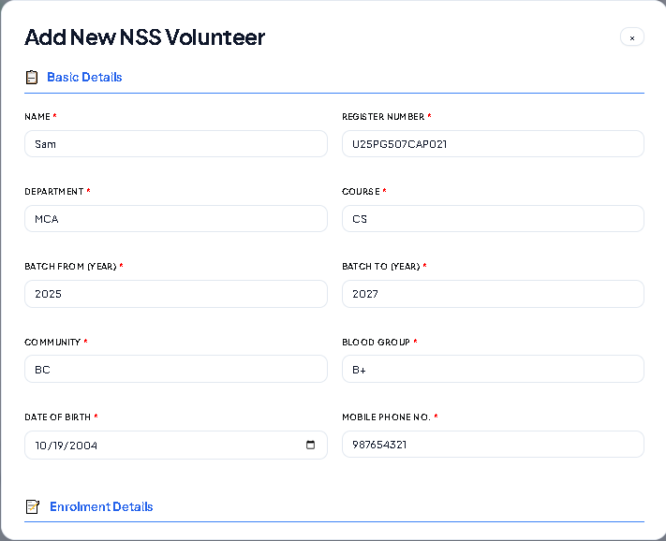

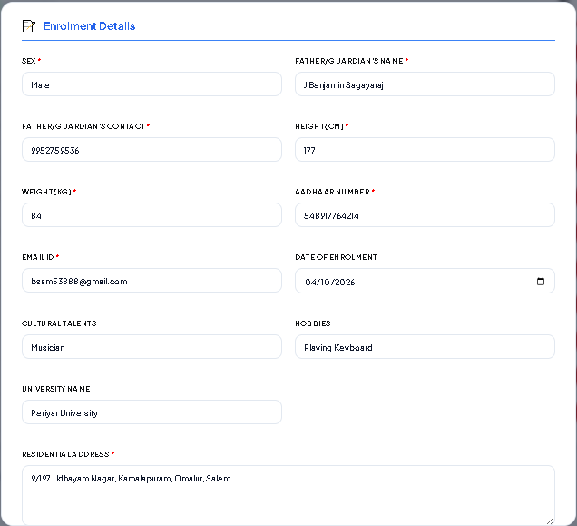

E.SAMPLE OUTPUT
