SOURCE CODE

import numpy as np
import pandas as pd
import random
dataset={
"Emp_id":["Emp0"+str(i) for i in range(1,501)],
"salary":[random.randint(10000,100000) for i in range(500)]
}
d=pd.DataFrame(dataset)
d.to_csv('DataSet.csv',index=False)
print(d["salary"].mean())
print(d["salary"].median())
print(d["salary"].var())
print(d["salary"].std())
print(d["salary"].mode()[0])

OUTPUT
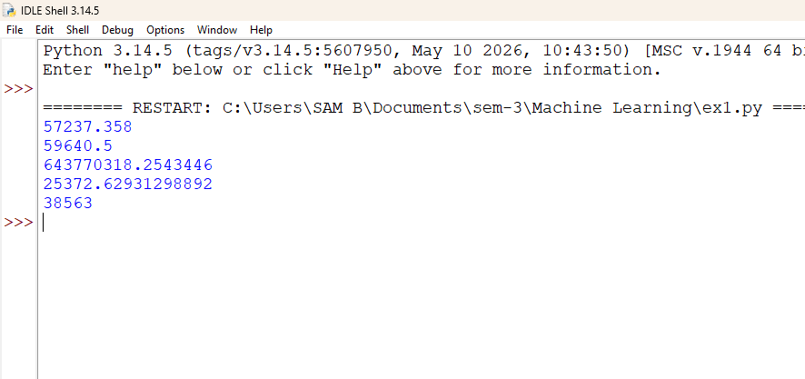

SOURCE CODE
import pandas as pd
import numpy as np
from sklearn.datasets import load_diabetes
from sklearn.model_selection import train_test_split
from sklearn.metrics import r2_score, mean_squared_error
from sklearn.linear_model import LinearRegression
import matplotlib.pyplot as plt
data=load_diabetes()
dataset=pd.DataFrame(data.data, columns=data.feature_names)
dataset['target']=data.target
print(dataset.head(20))
X=dataset[['bmi']]
y=dataset['target']
X_train,X_test,y_train,y_test=train_test_split(X,y,test_size=0.2,random_state=42)
model=LinearRegression()
model.fit(X_train,y_train)
prediction=model.predict(X_test)
mse=mean_squared_error(y_test,prediction)
rmse=np.sqrt(mse)
r2s=r2_score(y_test,prediction)
plt.scatter(y_test,prediction)
plt.plot([min(y_test),max(y_test)],[min(y_test),max(y_test)],color='red')
plt.show()
X=dataset.drop('target',axis=1)
y=dataset['target']
X_train,X_test,y_train,y_test=train_test_split(X,y,test_size=0.2,random_state=42)

model=LinearRegression()
model.fit(X_train,y_train)
prediction=model.predict(X_test)
mse=mean_squared_error(y_test,prediction)
rmse=np.sqrt(mse)
r2s=r2_score(y_test,prediction)
plt.scatter(y_test,prediction)
plt.plot([min(y_test),max(y_test)],[min(y_test),max(y_test)],color='red')
plt.show()

OUTPUT
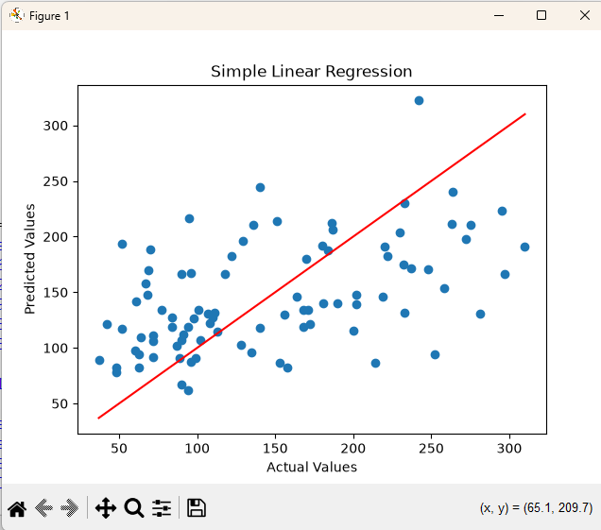
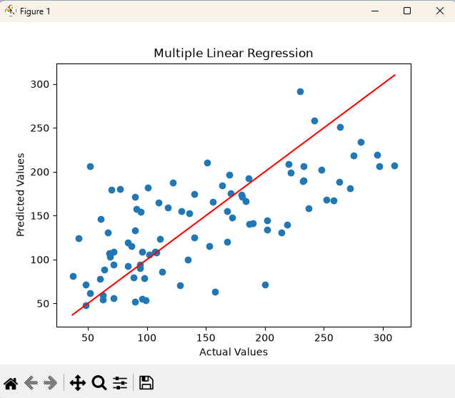

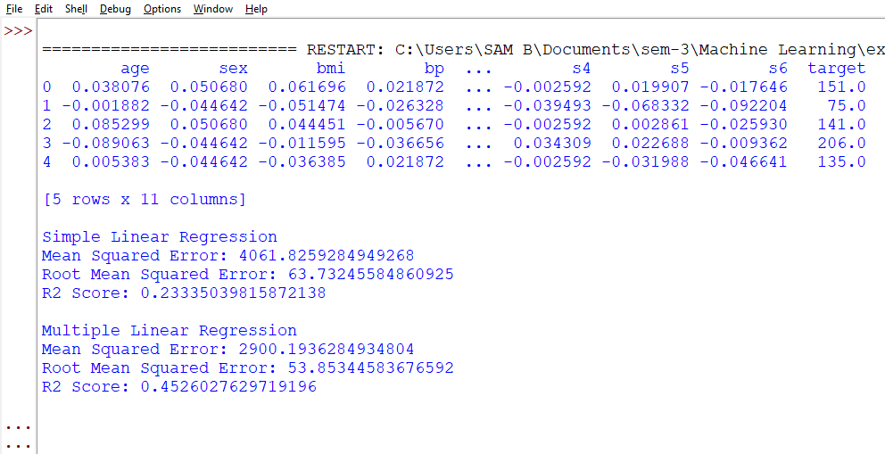

SOURCE CODE
import numpy as np
import pandas as pd
import matplotlib.pyplot as plt
from sklearn.datasets import load_breast_cancer
from sklearn.metrics import classification_report
from sklearn.model_selection import train_test_split
from sklearn.linear_model import LogisticRegression

datainit = load_breast_cancer()
df = pd.DataFrame(datainit.data, columns=datainit.feature_names)
X = df[['mean radius']]
df['target'] = datainit.target
y = df['target']

X_train, X_test, y_train, y_test = train_test_split(
X, y,
test_size=0.2,
random_state=42
)
model = LogisticRegression()
model.fit(X_train, y_train)
pred = model.predict(X_test)
print("Prediction probabilities:")
print(model.score(X_test, y_test))
print(classification_report(y_test, pred))
plt.scatter(X['mean radius'], y, label='Actual Data')
X_val = pd.DataFrame(
np.linspace(X['mean radius'].min(), X['mean radius'].max(), 100),
columns=['mean radius']
)
y_val = model.predict_proba(X_val)[:, 1]
plt.plot(X_val, y_val, label='Logistic Curve')
plt.xlabel("Mean Radius")
plt.ylabel("Probability of Benign")
plt.title("Logistic Regression - Breast Cancer")
plt.legend()
plt.grid(True)
plt.show()

OUTPUT
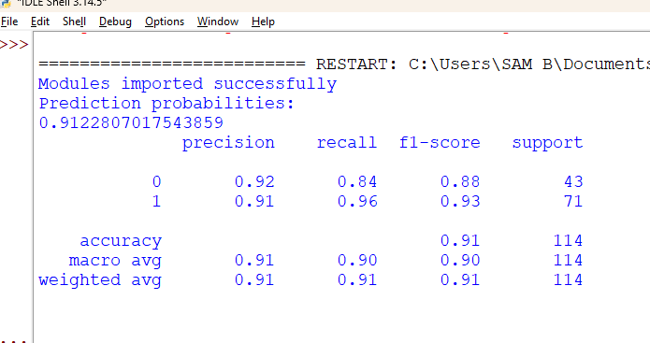

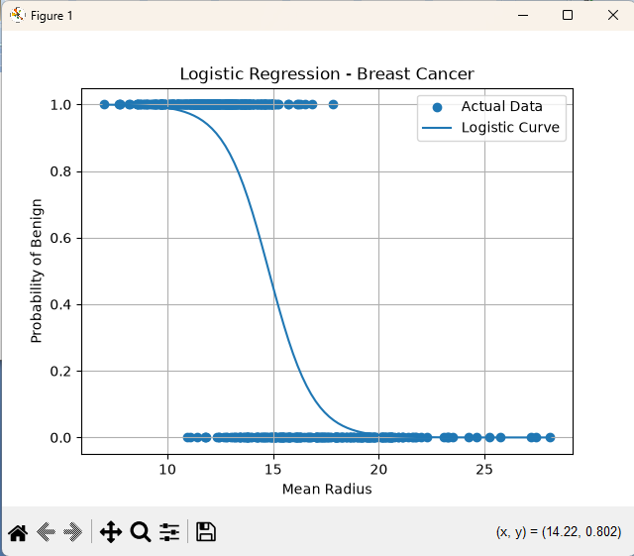

SOURCE CODE
import numpy as np
import matplotlib.pyplot as plt
from sklearn.datasets import load_iris
from sklearn.model_selection import train_test_split
from sklearn.svm import SVC
from sklearn.metrics import accuracy_score, precision_score, recall_score, f1_score

iris = load_iris()
X = iris.data
y = iris.target
y = np.where(y == 0, 0, 1)
X_train, X_test, y_train, y_test = train_test_split(X, y, test_size=0.3, random_state=42)
kernels = ['linear', 'poly', 'rbf', 'sigmoid']
accuracy = []
precision = []
recall = []
f1 = []

for k in kernels:
svm = SVC(kernel=k, random_state=42)
svm.fit(X_train, y_train)
y_pred = svm.predict(X_test)
acc = accuracy_score(y_test, y_pred)
pre = precision_score(y_test, y_pred)
rec = recall_score(y_test, y_pred)
f = f1_score(y_test, y_pred)
accuracy.append(acc)
precision.append(pre)
recall.append(rec)
f1.append(f)
print("Kernel:", k)
print("Accuracy:", round(acc, 4))
print("Precision:", round(pre, 4))
print("Recall:", round(rec, 4))
print("F1 Score:", round(f, 4))

x = np.arange(len(kernels))
width = 0.2
plt.bar(x - 0.3, accuracy, width, label='Accuracy')
plt.bar(x - 0.1, precision, width, label='Precision')
plt.bar(x + 0.1, recall, width, label='Recall')
plt.bar(x + 0.3, f1, width, label='F1 Score')
plt.xlabel("SVM Kernels")
plt.ylabel("Score")
plt.title("SVM Kernel Performance")
plt.xticks(x, kernels)
plt.legend()
plt.grid(axis='y')
plt.show()

OUTPUT
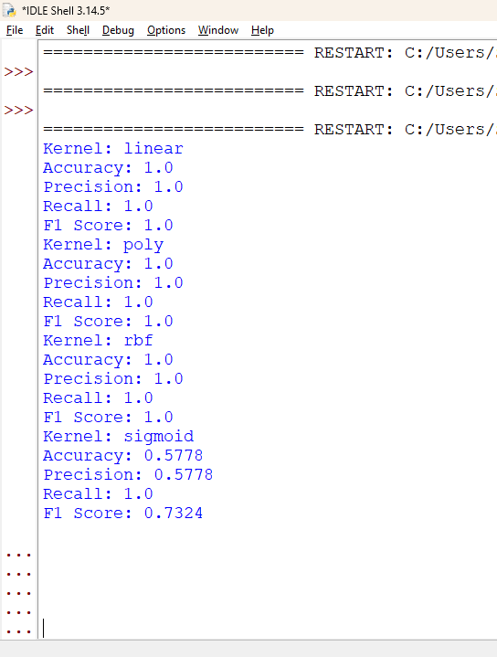

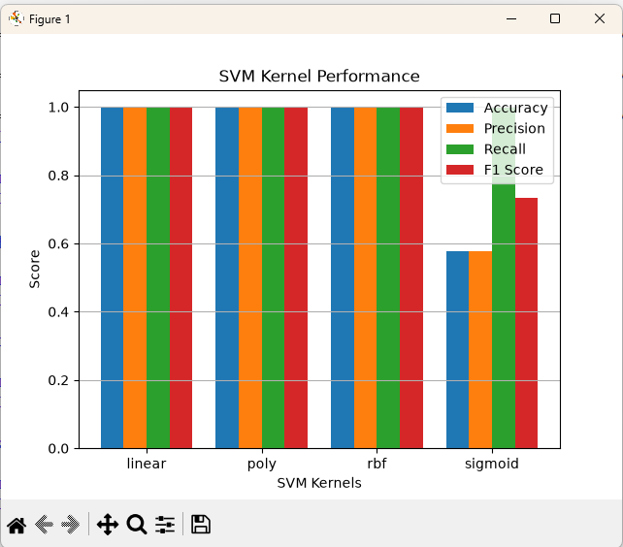

SOURCE CODE
import numpy as np
import pandas as pd
import matplotlib.pyplot as plt
from sklearn import datasets
from sklearn import metrics
from sklearn.neighbors import KNeighborsClassifier
from sklearn.naive_bayes import GaussianNB
iris = datasets.load_iris()
df = pd.DataFrame(np.c_[iris.data, iris.target], columns=iris.feature_names + ['target'])
print(df.head())
plt.scatter(df.iloc[:, 2], df.iloc[:, 3], c=df['target'])
plt.xlabel("Petal Length (cm)")
plt.ylabel("Petal Width (cm)")
plt.title("Iris Dataset")
plt.show()
knn = KNeighborsClassifier(n_neighbors=6)
knn.fit(iris.data, iris.target)
knn_pred = knn.predict(iris.data)
print("KNN Accuracy:", knn.score(iris.data, iris.target))
print("KNN Confusion Matrix:\n", metrics.confusion_matrix(iris.target, knn_pred))
nb = GaussianNB()
nb.fit(iris.data, iris.target)
nb_pred = nb.predict(iris.data)
print("Naive Bayes Accuracy:", nb.score(iris.data, iris.target))
print("Naive Bayes Confusion Matrix:\n", metrics.confusion_matrix(iris.target, nb_pred))

OUTPUT
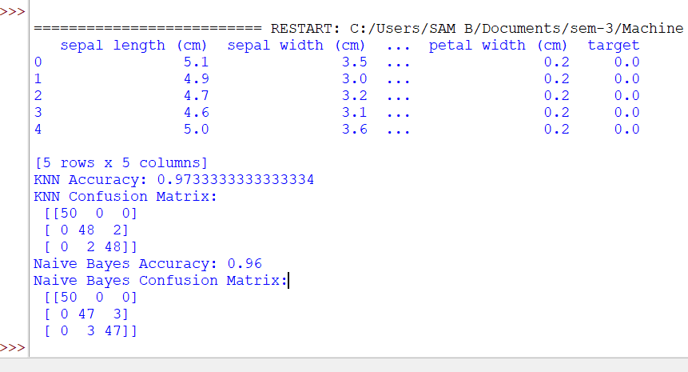

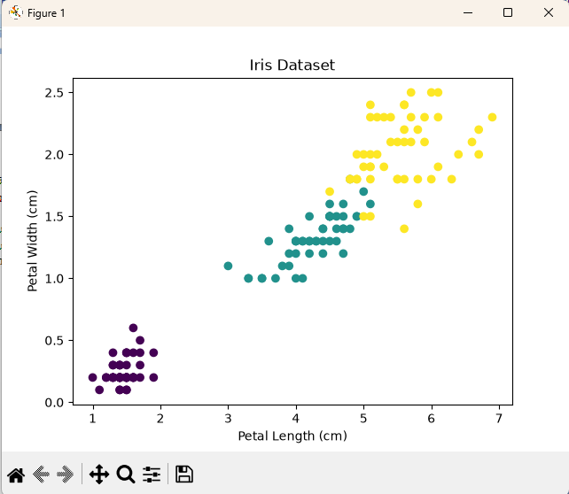

SOURCE CODE
import matplotlib.pyplot as plt
from sklearn.datasets import load_iris
from sklearn.model_selection import train_test_split, GridSearchCV
from sklearn.tree import DecisionTreeClassifier, plot_tree
from sklearn.metrics import accuracy_score
iris = load_iris()
X = iris.data
y = iris.target
X_train, X_test, y_train, y_test = train_test_split(X, y, test_size=0.2, random_state=42)
dt = DecisionTreeClassifier(random_state=42)
parameters = {
'criterion': ['gini', 'entropy'],
'max_depth': [2, 3, 4, 5]
}
grid = GridSearchCV(dt, parameters, cv=5)
grid.fit(X_train, y_train)
print("Best Parameters:", grid.best_params_)
model = grid.best_estimator_
y_pred = model.predict(X_test)
print("Accuracy:", accuracy_score(y_test, y_pred))
plt.figure(figsize=(12, 8))
plot_tree(model, filled=True, feature_names=iris.feature_names, class_names=iris.target_names, rounded=True)
plt.title("Decision Tree Classification")
plt.show()

OUTPUT

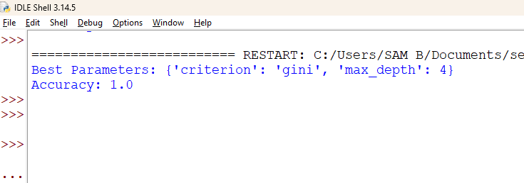

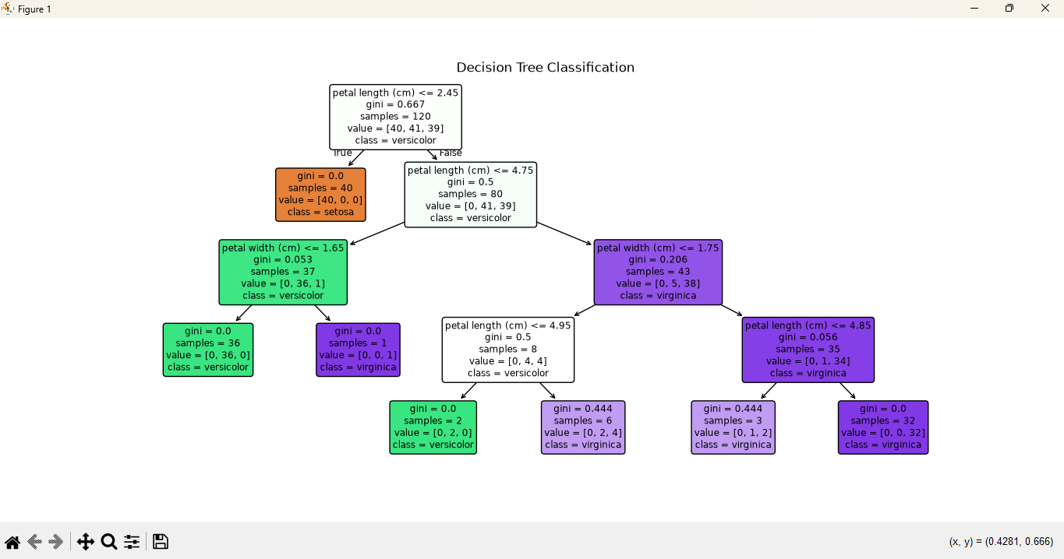

SOURCE CODE
import numpy as np
import matplotlib.pyplot as plt
from sklearn.datasets import load_iris
from sklearn.cluster import KMeans

iris = load_iris()
X = iris.data

kmeans = KMeans(n_clusters=3, random_state=42, n_init=10)
kmeans.fit(X)
labels = kmeans.labels_
centers = kmeans.cluster_centers_
print("Type of X:", type(X))
print("Shape of X:", X.shape)
print("Type of Cluster Labels:", type(labels))
print("Shape of Cluster Labels:", labels.shape)
print("Type of Cluster Centers:", type(centers))
print("Shape of Cluster Centers:", centers.shape)

plt.scatter(X[:, 0], X[:, 1], c=labels)
plt.scatter(centers[:, 0], centers[:, 1], c='red', marker='x', s=200)
plt.xlabel("Sepal Length (cm)")
plt.ylabel("Sepal Width (cm)")
plt.title("K-Means Clustering")
plt.show()

OUTPUT
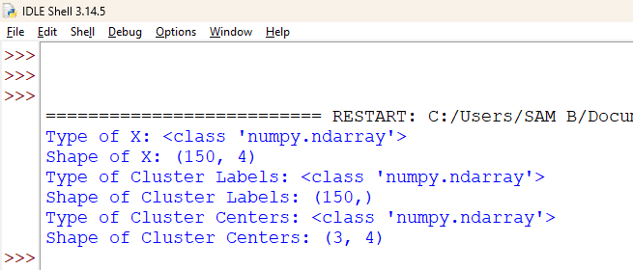

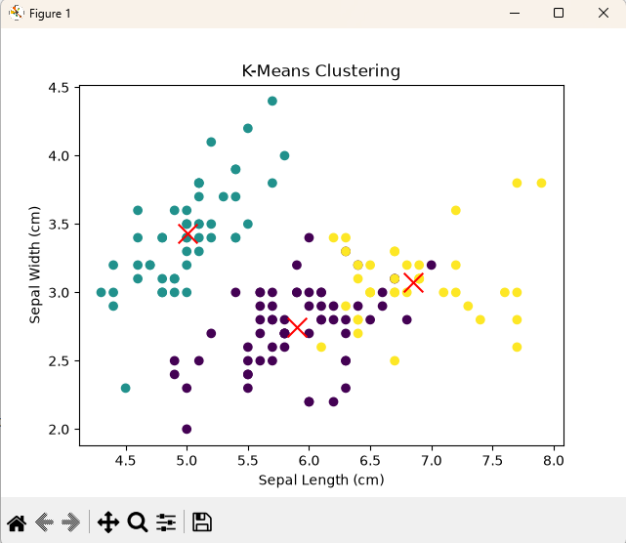

SOURCE CODE
import tensorflow as tf
from tensorflow.keras import layers, Sequential
from tensorflow.keras.datasets import cifar10
from tensorflow.keras.utils import to_categorical
import matplotlib.pyplot as plt
(X_train, y_train), (X_test, y_test) = cifar10.load_data()
X_train = X_train / 255.0
X_test = X_test / 255.0
y_train = to_categorical(y_train, 10)
y_test = to_categorical(y_test, 10)
model = Sequential([
layers.Conv2D(32, (3, 3), activation='relu', input_shape=(32, 32, 3)),
layers.MaxPooling2D((2, 2)),
layers.Conv2D(64, (3, 3), activation='relu'),
layers.MaxPooling2D((2, 2)),
layers.Conv2D(64, (3, 3), activation='relu'),
layers.Flatten(),
layers.Dense(64, activation='relu'),
layers.Dense(10, activation='softmax')
])
model.compile(optimizer='adam', loss='categorical_crossentropy', metrics=['accuracy'])
history = model.fit(X_train, y_train, epochs=5, batch_size=64, validation_split=0.1)
loss, accuracy = model.evaluate(X_test, y_test)
print("Test Accuracy:", accuracy)
plt.plot(history.history['accuracy'])
plt.plot(history.history['val_accuracy'])
plt.xlabel("Epoch")
plt.ylabel("Accuracy")
plt.legend(["Training", "Validation"])
plt.title("Model Accuracy")
plt.show()
plt.plot(history.history['loss'])
plt.plot(history.history['val_loss'])
plt.xlabel("Epoch")
plt.ylabel("Loss")
plt.legend(["Training", "Validation"])
plt.title("Model Loss")
plt.show()

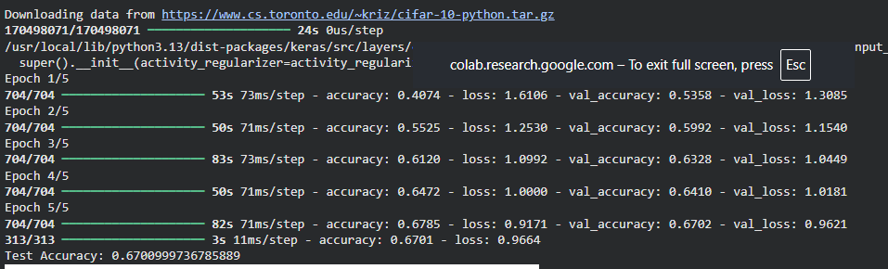
OUTPUT

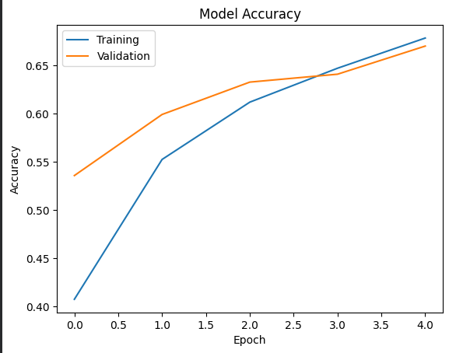

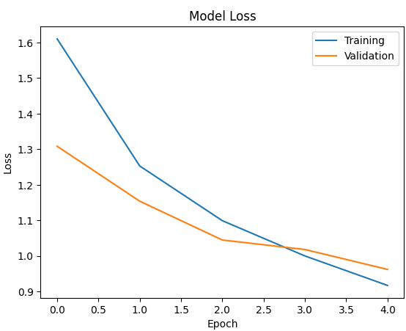

SOURCE CODE
import tensorflow as tf
from tensorflow.keras import layers, Model
from tensorflow.keras.datasets import mnist
import matplotlib.pyplot as plt
(X_train, _), (X_test, _) = mnist.load_data()
X_train = X_train.reshape(-1, 784).astype("float32") / 255.0
X_test = X_test.reshape(-1, 784).astype("float32") / 255.0
input_img = tf.keras.Input(shape=(784,))
encoded = layers.Dense(32, activation="relu")(input_img)
decoded = layers.Dense(784, activation="sigmoid")(encoded)
autoencoder = Model(input_img, decoded)
autoencoder.compile(optimizer="adam", loss="binary_crossentropy")
autoencoder.fit(X_train, X_train, epochs=5, batch_size=256, validation_data=(X_test, X_test))
decoded_imgs = autoencoder.predict(X_test)
plt.figure(figsize=(15, 4))
for i in range(10):
plt.subplot(2, 10, i + 1)
plt.imshow(X_test[i].reshape(28, 28), cmap="gray")
plt.axis("off")
plt.subplot(2, 10, i + 11)
plt.imshow(decoded_imgs[i].reshape(28, 28), cmap="gray")
plt.axis("off")
plt.show()

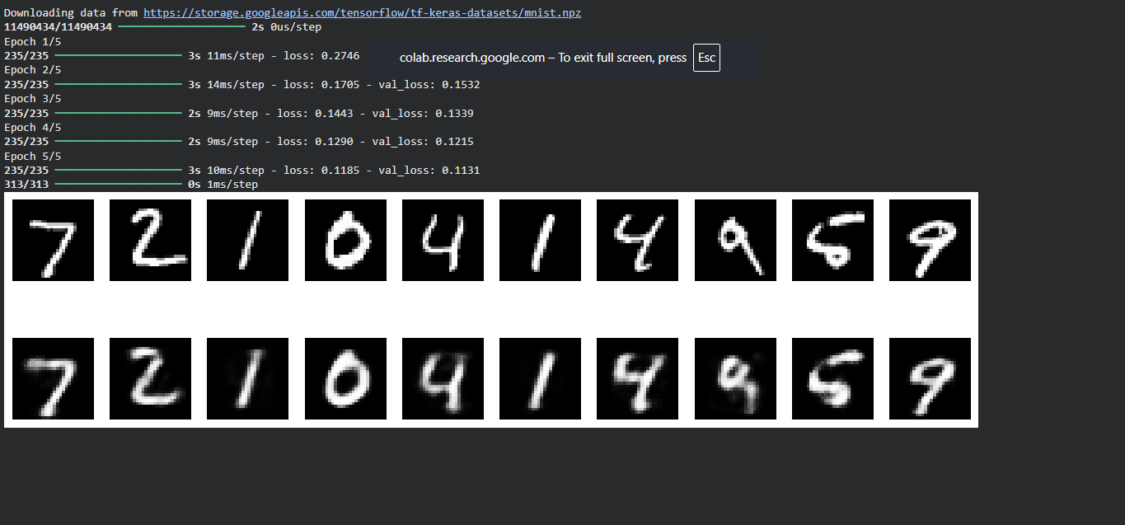
OUTPUT

SOURCE CODE
import tensorflow as tf
from tensorflow.keras import layers, models
from tensorflow.keras.datasets import imdb
from tensorflow.keras.preprocessing import sequence
import matplotlib.pyplot as plt

max_features = 10000
maxlen = 100
(X_train, y_train), (X_test, y_test) = imdb.load_data(num_words=max_features)
X_train = sequence.pad_sequences(X_train, maxlen=maxlen)
X_test = sequence.pad_sequences(X_test, maxlen=maxlen)
model = models.Sequential([
layers.Embedding(max_features, 128, input_length=maxlen),
layers.LSTM(128),
layers.Dense(1, activation='sigmoid')
])
model.compile(
optimizer='adam',
loss='binary_crossentropy',
metrics=['accuracy']
)

history = model.fit(
X_train,
y_train,
epochs=5,
batch_size=32,
validation_split=0.1
)
loss, accuracy = model.evaluate(X_test, y_test)
print("Test Accuracy:", accuracy)

plt.plot(history.history['accuracy'])
plt.plot(history.history['val_accuracy'])
plt.xlabel("Epoch")
plt.ylabel("Accuracy")
plt.legend(["Training", "Validation"])
plt.title("Model Accuracy")
plt.show()

plt.plot(history.history['loss'])
plt.plot(history.history['val_loss'])
plt.xlabel("Epoch")
plt.ylabel("Loss")
plt.legend(["Training", "Validation"])
plt.title("Model Loss")
plt.show()

OUTPUT
