DEVOPS – UDEMY CLASS
Section- 1: Introduction.
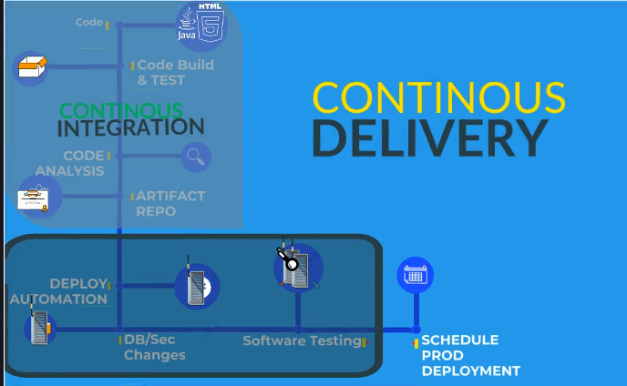
Section- 2: Prerequisites info & setup.
- 7) Tools prerequisites information
GitHub - hkhcoder/vprofile-project (basic project download)
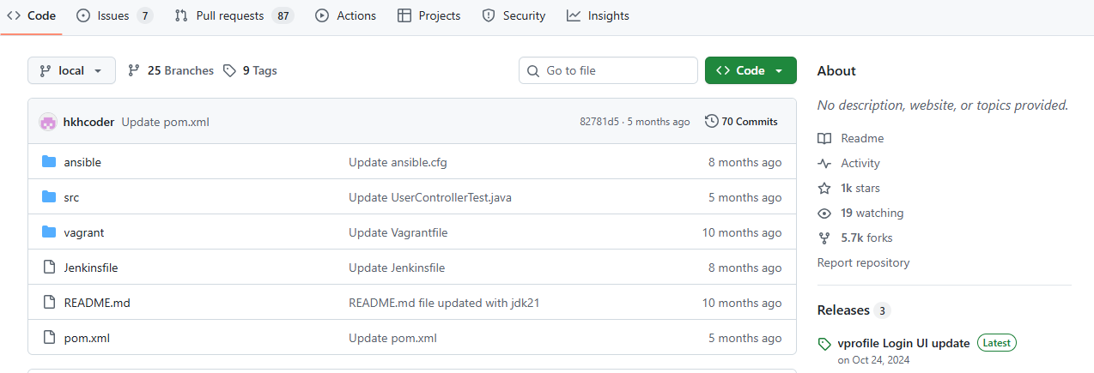
The below tools need to install in our local system.
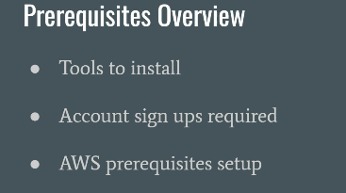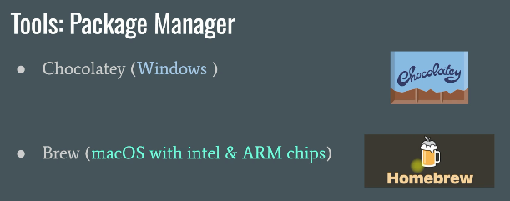
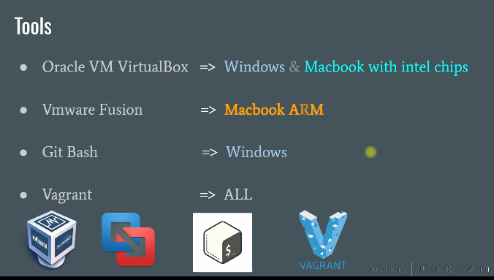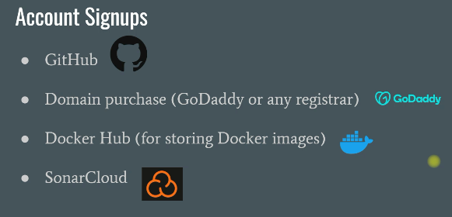
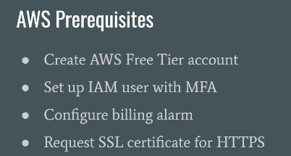
- 8. Chocolatey for Windows
Installation = Chocolatey Software | Installing Chocolatey
Packages = Chocolatey Software | Packages

- In this video installation of chocolatey and in that installing the other required software’s.

- 9. Homebrew for MacOS
- Installation of homebrew.
Link Homebrew — The Missing Package Manager for macOS (or Linux)
- 10. Installing Software’s
Link https://github.com/hkhcoder/vprofile-project.git
Document provided = Prereqs_doc_2_10.pdf
We have installed the below softwares by using the chaco commands its having in the above link.
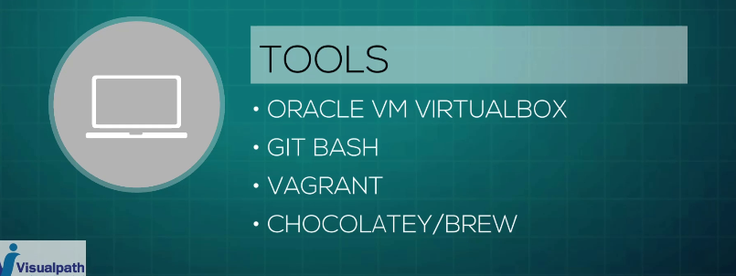

- 11. Tools Prerequisites for Centos 9, RHEL9 & Rocky Linux.
Installing Virtualbox
Open Terminal and execute below commands
- sudo yum update
- sudo yum install patch gcc kernel-headers kernel-devel make perl wget -y
- sudo reboot

Login, open terminal and execute below commands
- sudo wget http://download.virtualbox.org/virtualbox/rpm/el/virtualbox.repo -P /etc/yum.repos.d
- sudo yum install VirtualBox-7.1 -y

Installing Vagrant
Open Terminal and execute below commands
- sudo dnf update -y
- sudo dnf config-manager --add-repo=https://rpm.releases.hashicorp.com/RHEL/hashicorp.repo
- sudo dnf install vagrant -y

Install VScode
Open Terminal and execute below commands
- sudo rpm --import https://packages.microsoft.com/keys/microsoft.asc
- echo -e "[code]\nname=Visual Studio Code\nbaseurl=https://packages.microsoft.com/yumrepos/vscode\nenabled=1\ngpgcheck=1\ngpgkey=https://packages.microsoft.com/keys/microsoft.asc" | sudo tee /etc/yum.repos.d/vscode.repo > /dev/null
- dnf check-update
- sudo dnf install code -y

Install git
Open Terminal and execute below commands
dnf install git -y

Install JDK & Maven
Open Terminal and execute below commands
- dnf install java-17-openjdk java-17-openjdk-devel -y
- dnf install maven-openjdk17 -y

- 12. Tools Prerequisites for Ubuntu 24

Install Virtualbox
Open Terminal and Execute below mentioned commands.
- sudo apt update
- sudo apt install curl wget gnupg2 lsb-release -y
- curl -fsSL https://www.virtualbox.org/download/oracle_vbox_2016.asc|sudo gpg --dearmor -o /etc/apt/trusted.gpg.d/vbox.gpg
- curl -fsSL https://www.virtualbox.org/download/oracle_vbox.asc|sudo gpg --dearmor -o /etc/apt/trusted.gpg.d/oracle_vbox.gpg

- $ echo "deb [arch=amd64] http://download.virtualbox.org/virtualbox/debian $(lsb_release -sc) contrib" | sudo tee /etc/apt/sources.list.d/virtualbox.list

- sudo apt update
- sudo apt install -y linux-headers-$(uname -r) dkms
- sudo apt install virtualbox-7.1 -y

- sudo usermod -aG vboxusers $USER
- newgrp vboxusers

Install Vagrant
Open Terminal and Execute below mentioned commands.
- wget -O- https://apt.releases.hashicorp.com/gpg | gpg --dearmor | sudo tee /usr/share/keyrings/hashicorp-archive-keyring.gpg
- echo "deb [signed-by=/usr/share/keyrings/hashicorp-archive-keyring.gpg] https://apt.releases.hashicorp.com $(lsb_release -cs) main" | sudo tee /etc/apt/sources.list.d/hashicorp.list
- sudo apt update
- sudo apt install vagrant -y
- sudo apt install libarchive-dev libarchive-tools -y

Install Git
Open Terminal and Execute below mentioned commands.
sudo apt install git -y

Install jdk17
sudo apt-get install openjdk-17-jdk -y

Install Maven
sudo apt-get install maven -y

Install VSCode
- sudo apt-get install wget gpg -y
- wget -qO- https://packages.microsoft.com/keys/microsoft.asc | gpg --dearmor > packages.microsoft.gpg
- sudo install -D -o root -g root -m 644 packages.microsoft.gpg /etc/apt/keyrings/packages.microsoft.gpg
- echo "deb [arch=amd64,arm64,armhf signed-by=/etc/apt/keyrings/packages.microsoft.gpg] https://packages.microsoft.com/repos/code stable main" |sudo tee /etc/apt/sources.list.d/vscode.list > /dev/null
- rm -f packages.microsoft.gpg
- sudo apt install apt-transport-https -y
- sudo apt update
- sudo apt install code -y

Install Sublime Text
$ sudo apt update
$ sudo apt install dirmngr gnupg apt-transport-https ca-certificates software-properties-common
$ curl -fsSL https://download.sublimetext.com/sublimehq-pub.gpg | sudo apt-key add -
$ sudo add-apt-repository "deb https://download.sublimetext.com/ apt/stable/"
$ sudo apt install sublime-text -y

- 13. Signups
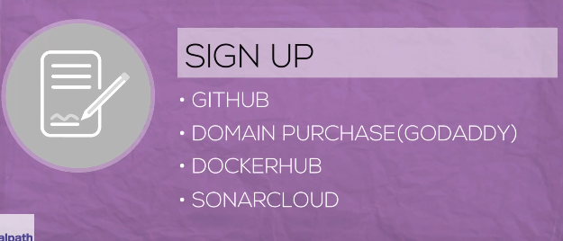
- Created new account for github.
- Creating godaddy account.
- Purchasing a domain.
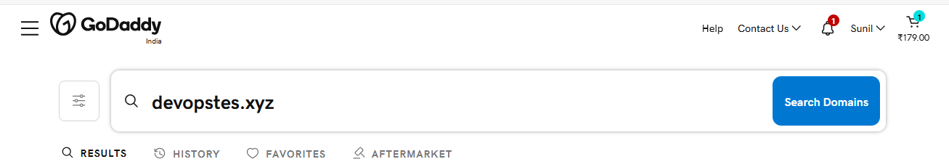
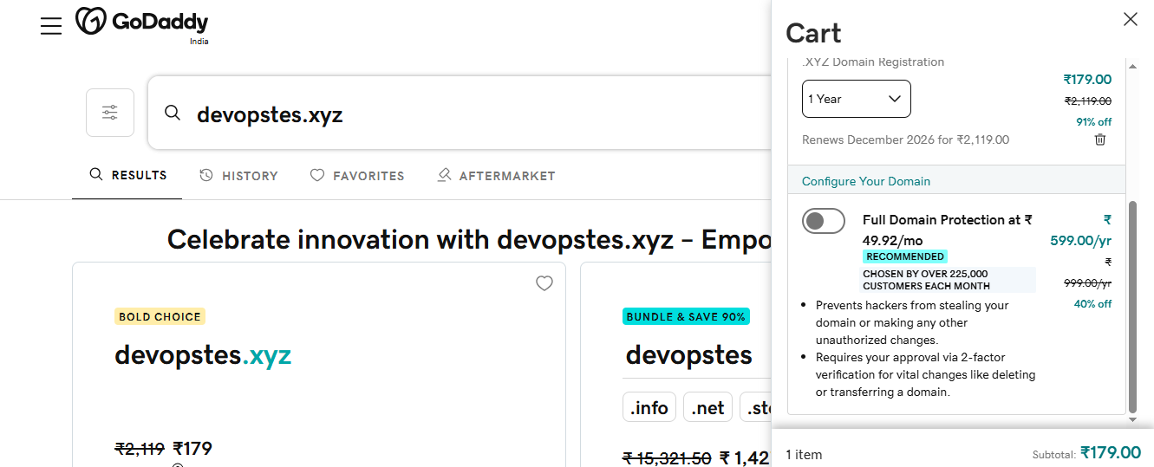
- Creating docukerhub account.
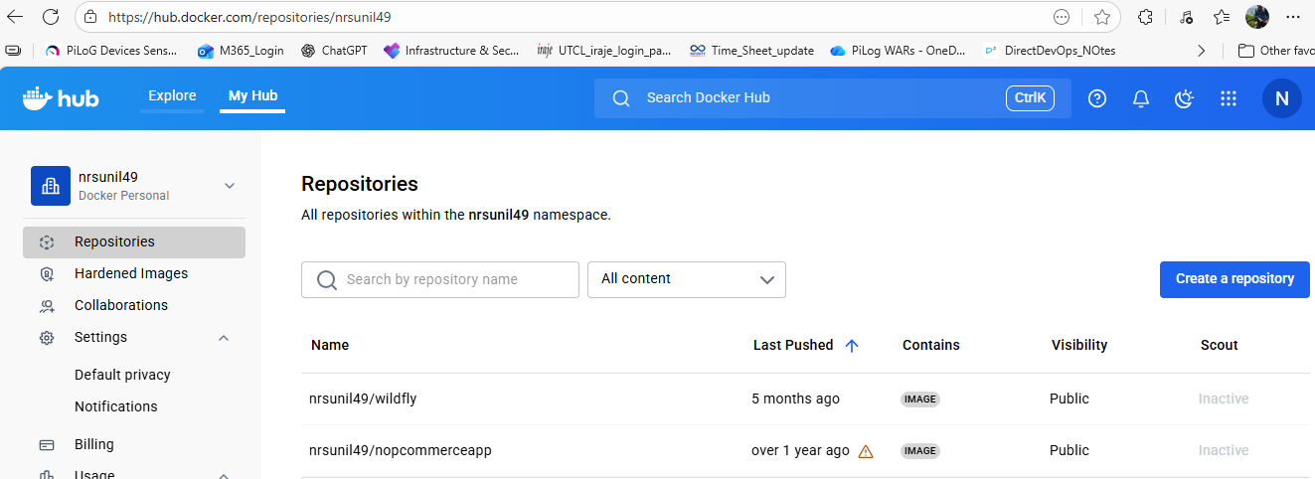
- 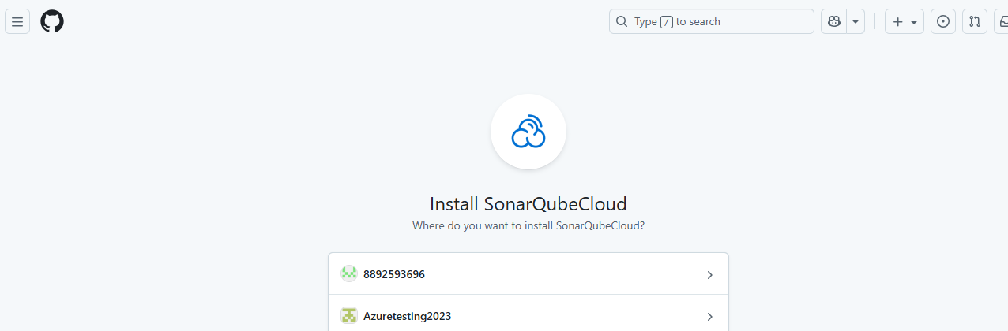

- 14. AWS Setup
- Creating AWS account for root user.
- Creating IAM user with administrator access.
- Adding MFA for both users.
- Explaining about billings.
- Creating billing alarms.
- Creating public certification in certificate manager.
- The above all just normal explanation.

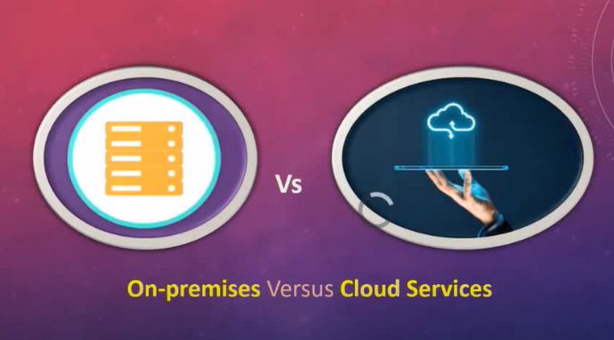
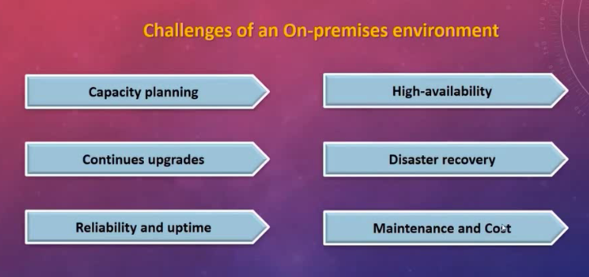
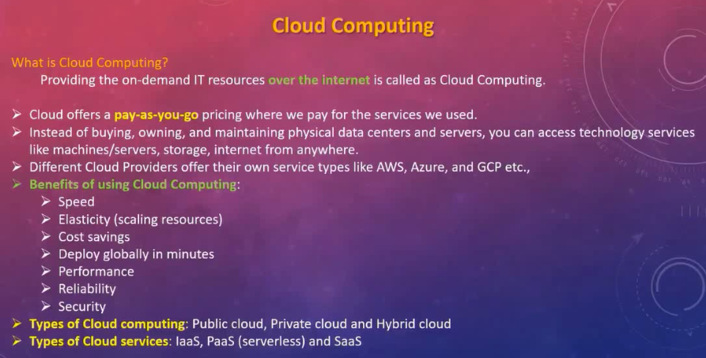
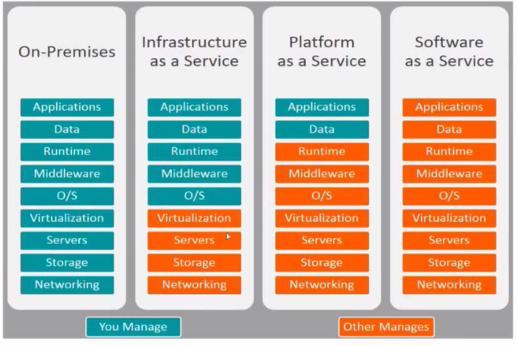

Explained about AWS account creation & IAM services in AWS
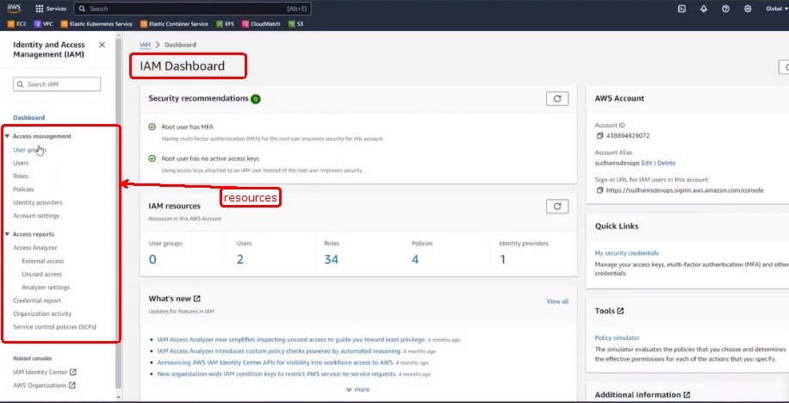
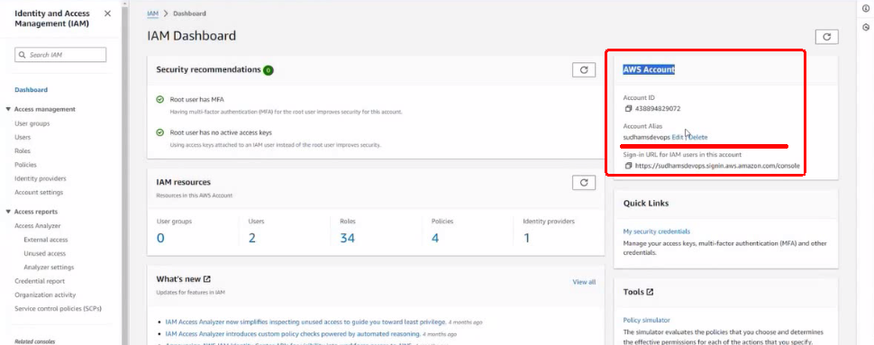
Explained about Creating IAM user from root user, & permission to iam user, MFA & alias name for account ID.
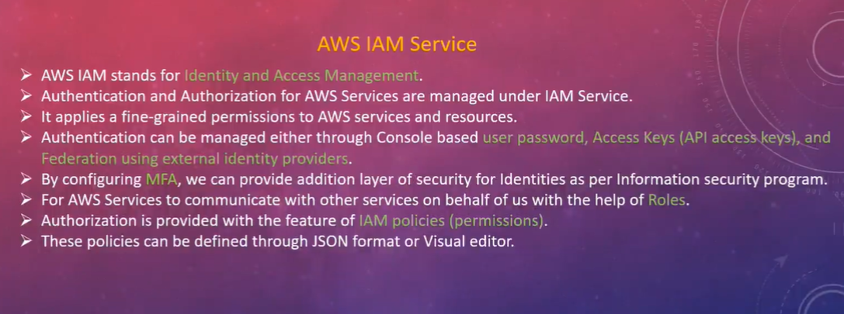
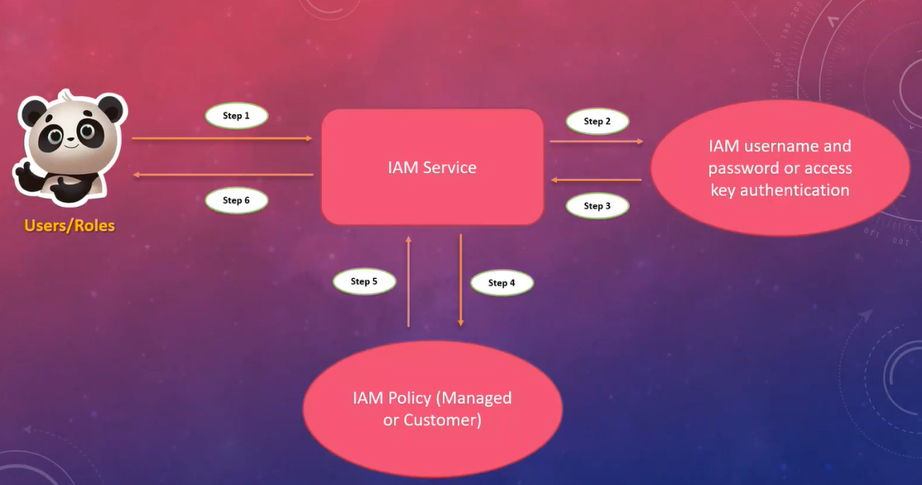
Dashboard of AWS
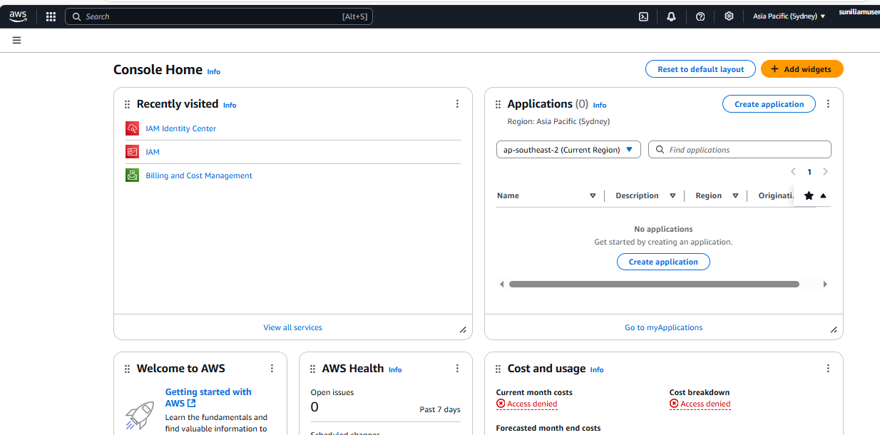
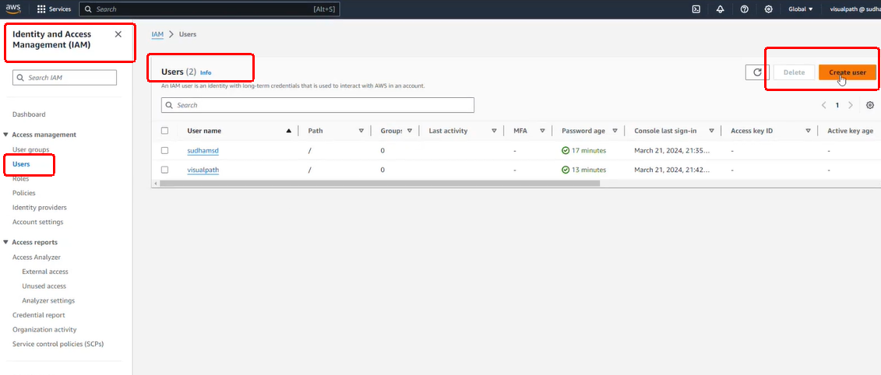
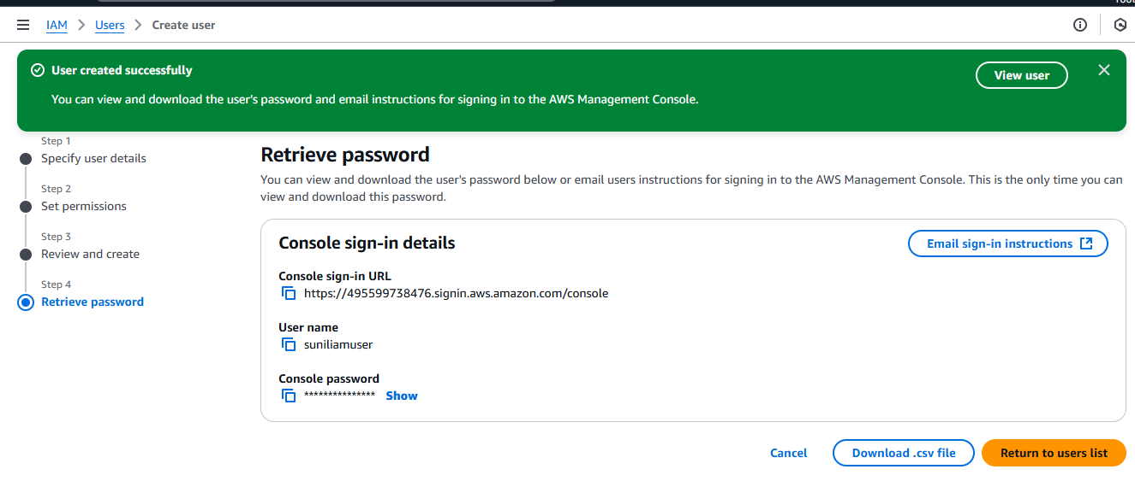
We need to copy the user’s name & password whatever shown in the above, this is the only one time we can view https://495599738476.signin.aws.amazon.com/console
suniliamuser
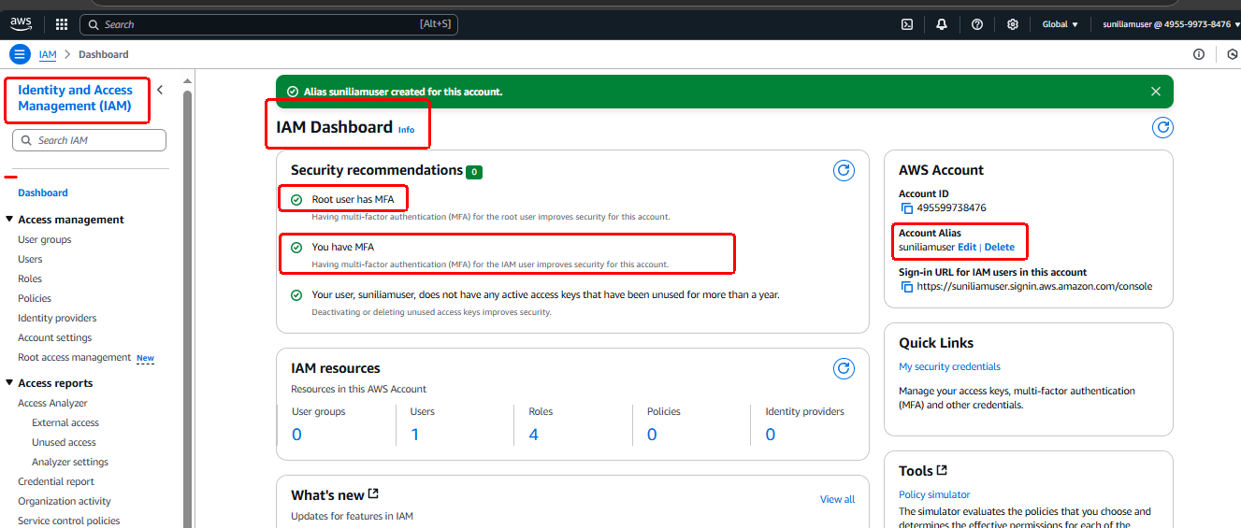

- Creating IAM user without any permission as below screenshot.
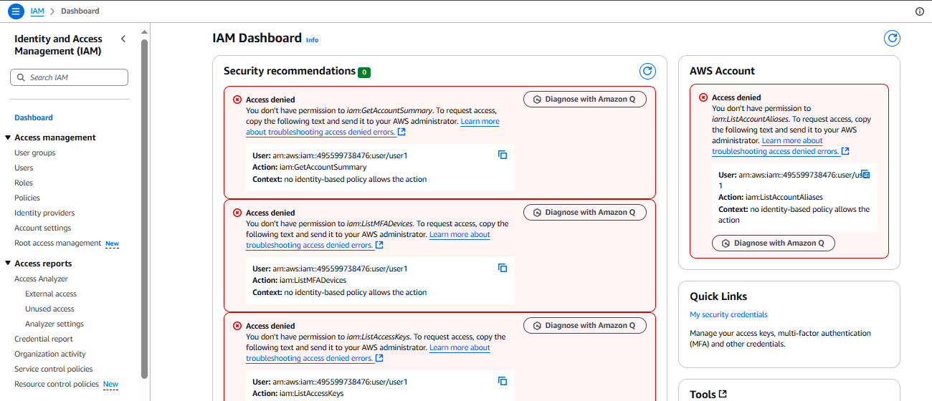
- 15. Outro

Section- 3: VM Setup.
16. Welcome to virtualization
17. What is Virtualization
What is Virtualization
Introduction to Virtualization
In this lecture, we will discuss what virtualization is. Understanding virtualization will help you grasp concepts such as cloud computing, containers, and Docker.
One physical computer can perform the job of multiple computers. This is not about multitasking but about running multiple operating systems simultaneously and in parallel on a single computer.
Before Virtualization
Before virtualization existed, it was not possible to run multiple operating systems on one computer. Software, services, and applications such as Tomcat, Apache HTTP Server, or MySQL databases required dedicated servers to run. At that time, the only option was physical computers, like the one you might be using right now to watch this video.
Data centers housed much larger computers, and the prevailing idea was one service per server. More precisely, one main service equaled one server. This approach ensured isolation; for example, if your database server was running, you would not run a web server or web service on the same machine. Running multiple main services on one server was like "putting all our eggs in one basket," which could lead to catastrophic failures.
Servers were always over-provisioned, meaning if 8 GB of RAM was needed, 12 GB would be allocated. The IT team would over-provision servers to avoid running out of resources. However, server resources were mostly underutilized. This over-provisioning resulted in significant capital and operational expenditures related to physical servers, including procurement, stacking, racking, operating system installation, and maintenance.
For example, if a project had ten services, it required at least ten servers, and for high availability, a minimum of twenty servers or more. This made running IT projects a substantial challenge.
Introduction of Virtualization by VMware
VMware introduced the concept of virtualization by creating tools that allowed one computer to run multiple operating systems. This enabled isolation by running multiple operating systems on a single computer and running all services on top of these operating systems. Thus, services were isolated from each other.
You might wonder if this is still "putting multiple eggs in one basket." However, physical computers can be clustered together to distribute virtual machines, addressing this concern.
Virtualization partitions physical resources into virtual resources. To set up and run an operating system, you need a physical computer. With virtualization, you can create multiple virtual computers within a physical machine. Think of these virtual machines as "baby computers" living inside the physical machine. These virtual machines are isolated from each other because each has its own operating system. This discussion focuses on server virtualization and virtual machines, though other types such as network and storage virtualization also exist.
Architecture of Virtualization
The architecture typically consists of the physical hardware at the base, a software tool called a hypervisor on top of it, and virtual machines created by the hypervisor. Each virtual machine has its own operating system and runs applications or main services. This setup ensures isolation between services.
Terminologies
- Host OS: The operating system of the physical machine. For example, the OS on your laptop or desktop.
- Guest OS: The operating system running inside a virtual machine. Virtual machines are sometimes called guest machines.
- VM: Short for virtual machine.
- Snapshot: A way to back up a virtual machine. Although we say "machine," a virtual machine is essentially a set of files that can be backed up easily. Every virtualization technology supports snapshots.
- Hypervisor: The software tool that enables virtualization by allowing the creation of virtual machines.
Types of Hypervisors
There are two types of hypervisors:
- Type 1 (Bare Metal Hypervisor): Runs directly on the physical computer, similar to an operating system. Examples include VMware ESXi and Xen Hypervisor. This type is used in production environments and dedicates the physical machine solely to virtualization.
- Type 2 (Hosted Hypervisor): Runs as software installed on an existing operating system, such as Windows, macOS, or Linux. This type is used for learning and testing purposes. Examples include Oracle VM VirtualBox and VMware Server.
The first diagram represents a Type 1 hypervisor setup: the computer runs the hypervisor directly, which manages virtual machines with their own operating systems and applications. Type 1 hypervisors can be clustered to distribute virtual machines across multiple hypervisors, providing high availability. If one hypervisor fails, others can take over running the virtual machines.
The Type 2 hypervisor runs as software on top of an existing operating system. This setup is suitable for learning and testing, allowing you to create virtual machines on your personal computer.
A note on Microsoft's Hyper-V: although it might appear to be a Type 2 hypervisor, it is actually a Type 1 hypervisor.
In the next lecture, we will explore how to perform virtualization and create virtual machines on a computer. We will also automate this setup. These exercises will help you practice Linux and other upcoming tools in this course.
Key Takeaways
- Virtualization allows one physical computer to run multiple isolated operating systems simultaneously.
- Before virtualization, each main service required a dedicated physical server, leading to underutilized resources and high costs.
- Hypervisors enable virtualization and come in two types: Type 1 (bare metal) for production and Type 2 (hosted) for learning and testing.
- Virtual machines can be backed up using snapshots, and clustering hypervisors enhances availability and resource distribution.
(explained about types of hypervisors, how it works)
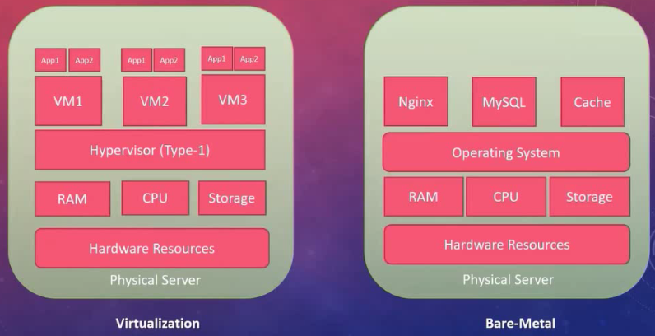
- Hypervisor is a software to create a virtual machine on a physical server.
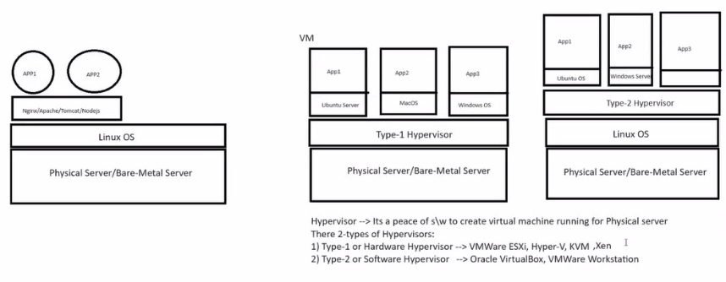
✅ Bare-Metal
Bare-metal means running an operating system or application directly on the physical server hardware — no virtualization layer is involved.
✅ Virtualization
Virtualization means running multiple virtual machines (VMs) on a single physical server using a software layer called a hypervisor.

- 18. Introduction

- Introduction of linux machine.

- 19. VM-Manually (Windows & MacOS Intel chip)
- VM-box installation and configure.
- Explained completely how to install ubuntu linux OS in VM-box.
- 20. VM-Automatically (Windows & MacOS Intel chip)
VM Automation with Vagrant on Windows & MacOS Intel Chip
Introduction to Vagrant
In this lecture, we will discuss a tool called Vagrant. We use this tool to manage virtual machines automatically. In short, Vagrant is a VM automation tool that manages the lifecycle of virtual machines, including creating, making changes, and cleaning up.
Vagrant is not a replacement for any hypervisor such as VMware or Oracle VM VirtualBox. Instead, it operates on top of these tools, utilizing them to create and manage virtual machines.
Problems Solved by Vagrant
When managing virtual machines manually, several issues arise. Starting with OS installation, there are many steps involved in installing an operating system on a virtual machine. This process is time-consuming, and if multiple VMs are involved, the time multiplies accordingly. Moreover, manual steps increase the chance of human error.
Automation, including Vagrant, addresses these problems by reducing human errors. While managing one or two VMs manually might be feasible, managing five or six VMs or replicating the setup on another computer becomes challenging. Documentation can help, but it is still cumbersome.
How Vagrant Works
Vagrant eliminates the need for OS installation by using VM images called boxes, which are ready-made virtual machines stored on Vagrant Cloud. These boxes are freely available and can be downloaded and stored locally. From a single box, you can create as many VMs as needed.
All VM settings such as RAM, CPU, and IP addresses are configured in a text file named Vagrantfile. This file can be opened and edited to make changes. Additionally, Vagrant supports provisioning, which means executing commands on the VM after the OS boots, such as setting up servers or installing software. These commands can be specified in the Vagrantfile and executed automatically.
Common Vagrant Commands
- vagrant init <boxname>: Initializes a new Vagrant environment with the specified box.
- vagrant up: Creates and powers on the VM.
- vagrant ssh: Logs into the VM via SSH.
- vagrant halt: Powers off the VM.
- vagrant destroy: Deletes the VM.
We will explore these commands in detail.
Vagrant Architecture
The workflow involves creating a Vagrantfile containing VM information. When you run vagrant up, Vagrant reads the Vagrantfile and checks if the box image is available locally. If not, it downloads the box from Vagrant Cloud. Then, it contacts the hypervisor (default is Oracle VM VirtualBox) to create the VM. You can create one or many VMs using Vagrant.
Other commands include vagrant reload to reboot the VM and apply changes from the Vagrantfile, and vagrant ssh to log into Linux VMs. These commands simplify VM management.
Setting Up Vagrant Environment
First, create a folder on your computer to store Vagrant files. For Windows, you can create a folder in the F drive, for example, /f/vagrant-vms. Mac OS users can create a folder on the Desktop using ~/Desktop/vagrant-vms.
Use the command mkdir /f/vagrant-vms on Windows or mkdir ~/Desktop/vagrant-vms on Mac OS to create the folder. Then navigate into this folder using cd /f/vagrant-vms or cd ~/Desktop/vagrant-vms respectively.
Inside the vagrant-vms folder, create two subfolders named centos and ubuntu using mkdir centos and mkdir ubuntu. These folders will hold the respective VM configurations.
Initializing a CentOS VM
Navigate into the centos folder using cd centos. To initialize a Vagrant environment, you need to find a suitable box name from Vagrant Cloud. Search for "CentOS 9" on Vagrant Cloud and select a box that supports VirtualBox, such as eurolinux-vagrant/centos-stream-9.
Copy the exact box name and run the command vagrant init <boxname> in the centos folder. This creates a Vagrantfile in the folder. You can view its contents using cat Vagrantfile. The file contains configuration details including the box name.
If you make a mistake in the box name, you can edit the Vagrantfile using any text editor and correct it. Save the file after editing.
Bringing Up the CentOS VM
Run vagrant up in the centos folder to create and start the VM. If you encounter errors related to security contexts or hardening, these are often caused by antivirus software. Disable your antivirus completely and disconnect any VPN or proxy servers before retrying.
Vagrant downloads the box from Vagrant Cloud if not already present locally, then creates the VM. You can verify the downloaded boxes using vagrant box list and check the VM status with vagrant status.
You can also open Oracle VirtualBox to see the VM named centos_default created by Vagrant. Avoid making changes directly in VirtualBox to prevent inconsistencies.
Accessing the VM
Use vagrant ssh to log into the VM. The prompt changes to indicate you are inside the VM with the username vagrant. You can run commands like whoami to verify the current user and pwd to check the current directory inside the VM.
To switch to the root user, use sudo -i. The prompt changes accordingly. Use exit to log out from root and again exit to log out from the VM.
Managing VM Power
To power off the VM, use vagrant halt. Check the VM status again with vagrant status to confirm it is powered off. To power it on again, use vagrant up. The VM will start without downloading the box again if it is already present locally.
To reboot the VM and apply any changes made in the Vagrantfile, use vagrant reload. Note that changing the box name requires deleting and recreating the VM.
Always execute Vagrant commands from the folder containing the Vagrantfile to ensure proper operation.
Deleting and Recreating VMs
To delete a VM, use vagrant destroy. Confirm the deletion by typing Y. After deletion, vagrant status will show that the VM is not created. You can recreate the VM anytime by running vagrant up again.
Any changes made inside the deleted VM will be lost. When recreating, the box is already present locally, so Vagrant imports it without downloading again.
Listing Boxes and Managing Multiple VMs
Use vagrant box list to see all downloaded boxes on your computer. You can create multiple VMs using different boxes and folders.
Setting Up Ubuntu VM
Navigate to the ubuntu folder and search for an Ubuntu box on Vagrant Cloud, such as ubuntu/jammy. Initialize the environment with vagrant init <boxname> and bring up the VM using vagrant up.
Check the VM status with vagrant status. To see the status of all VMs on your system, use vagrant global-status. If there are stale entries, clean them with vagrant global-status --prune.
Navigating Between Folders
Use cd .. to move one level up in the directory structure. Use tab completion to quickly navigate to folders like ubuntu or centos.
Logging Into Ubuntu VM
Use vagrant ssh to log into the Ubuntu VM. Use sudo -i to switch to the root user and exit to log out from root and the VM.
Powering Off and On VMs
Use vagrant halt to power off the VM. Always ensure you are in the correct folder containing the Vagrantfile before running Vagrant commands. Use vagrant up to power on the VM again.
Avoid making changes directly in VirtualBox, such as powering off or on the VM manually, as Vagrant will not be aware of these changes and may report incorrect VM status.
Cleaning Up Old VMs
If you have old manually created VMs that you no longer need, you can delete their files to avoid confusion. Ensure you do not delete the Vagrant-managed VMs unless intended.
Summary of Commands Covered
- mkdir <folder>: Create a folder.
- cd <folder>: Change directory.
- pwd: Print working directory.
- ls: List folder contents.
- vagrant init <boxname>: Initialize Vagrant environment.
- cat Vagrantfile: View Vagrantfile contents.
- vagrant up: Create and start VM.
- vagrant status: Check VM status.
- vagrant ssh: Log into VM.
- vagrant halt: Power off VM.
- vagrant reload: Reboot VM and apply changes.
- vagrant destroy: Delete VM.
- vagrant box list: List downloaded boxes.
- vagrant global-status: Show status of all VMs.
- vagrant global-status --prune: Clean stale VM entries.
Final Notes
Practice creating and managing VMs using Vagrant with different boxes and folders. Keep the two VMs created in this lecture for use in the Linux section. If you destroy them, you can recreate them using vagrant up. Always power off VMs before shutting down your computer to avoid issues.
Key Takeaways
- Vagrant is a VM automation tool that manages the lifecycle of virtual machines using existing hypervisors like Oracle VirtualBox.
- It eliminates manual OS installation by using pre-built VM images called boxes from Vagrant Cloud.
- VM configurations and provisioning commands are managed through a text file named Vagrantfile.
- Common Vagrant commands include vagrant init, vagrant up, vagrant ssh, vagrant halt, vagrant reload, and vagrant destroy for efficient VM management.

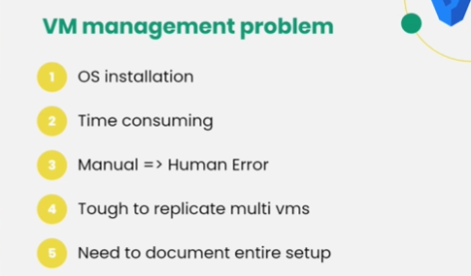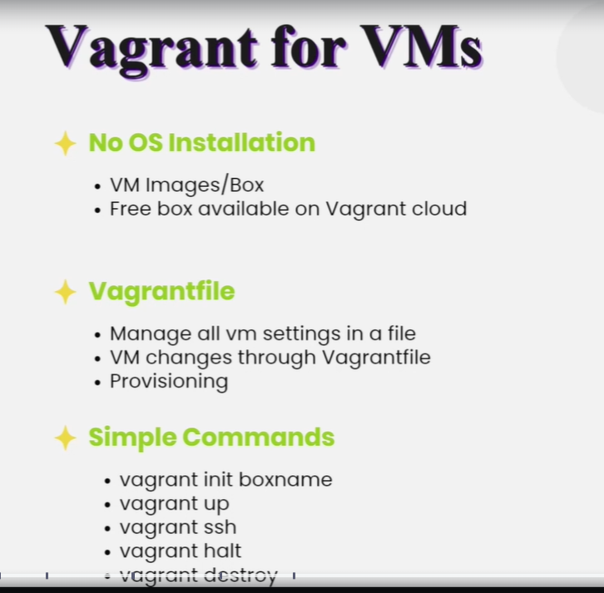

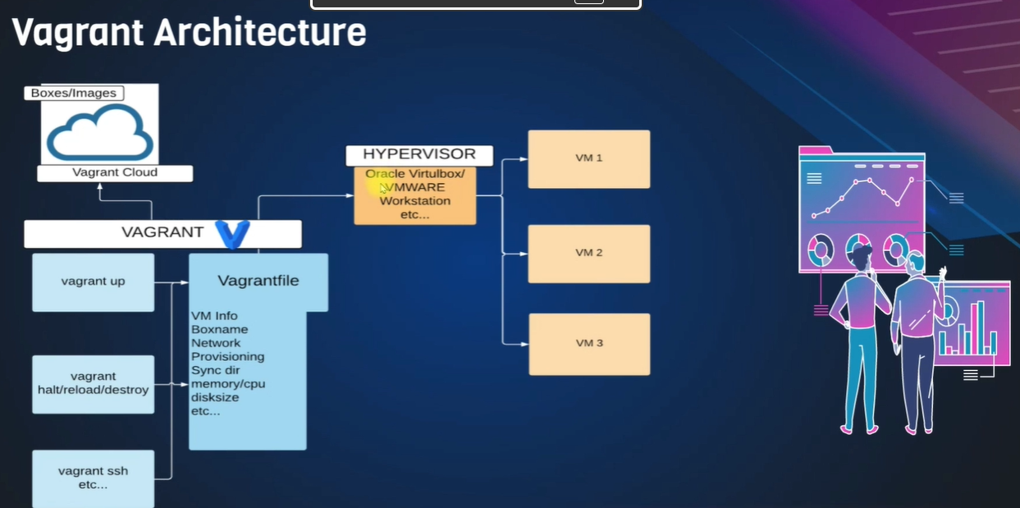

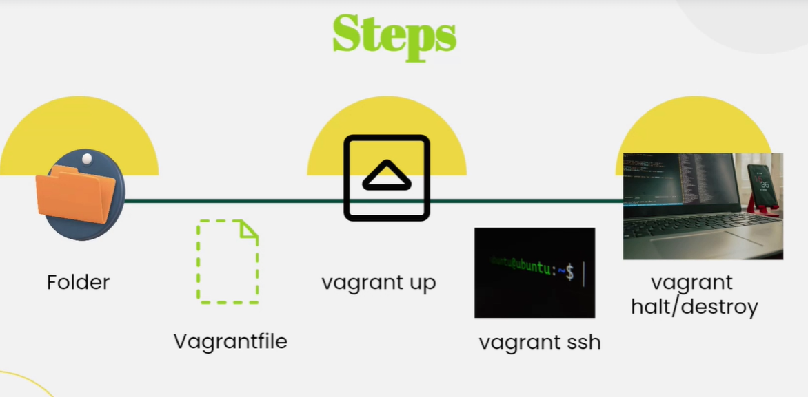
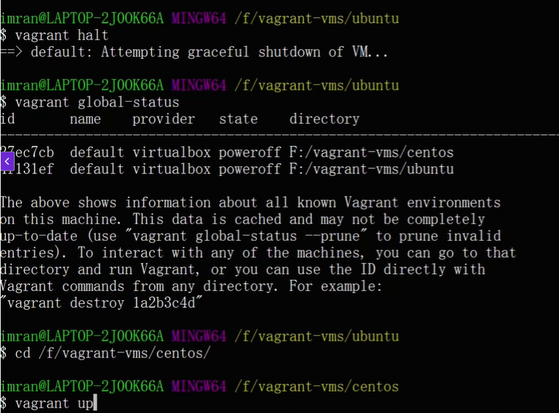
-- Vagrant uses.

- OS installation = vagrant init OS-image
- Start = vagrant up
- Stop = vagrant halt
- Delete machine. = vagrant destroy
- To connect ssh server = <username> ssh
Without any manual installation of OS in VMBox everything will install automatically by using commands in Vagrant.

- 21. VM on MacOS M1 chip

- This is only for MacOS user.

Section- 4: Linux.
- 23. Introduction to Linux
- Intro to linux
- Basic CLI commands
- Understanding files in linux
- Filters & Redirection
- Users & Group
- Sudo
- Software management
- Services & Processes
- Good to know commands
- Server Management

- Provided PDF linux documentation.

- 24. Commands and File systems
- 25. More Commands ( mkdir, cp, mv, touch etc)
- 26. Vim editor
- 27. File Types
- 28. Filters
- Sed -i ‘s/presenttext/replacingtext/g’ filename (replace the words in file)
- Sed ‘s/presenttext/replacingtext/g’ filename (print the words in file output)
- grep -i text filename (displace text matches)
- Stop
- 29. Redirections
- 30. Users and Groups
- 31. File permissions
- 32. Sudo
- 33. Package Management
- 34. Services
- 35. Processes
- Top, ps aux
- Play
- 36. Archiving
- 37. Ubuntu commands
- 38. Linux Commands
- 39. Outro

- “All the above classes are noted in the PDF document, along with the provided Linux commands.”

Section- 5: GIT.
What is Git?
Git is a distributed version control system known for its ease of use, speed, and support for non-linear development.
It is fully distributed, allowing every user to have a complete copy of the repository. Git can handle large projects and is easy to use, providing powerful features.
Cloud providers offer remote Git repositories, such as GitHub, Bitbucket, AWS CodeCommit, Azure Repos, and Google Cloud Source Repositories.
Introduction to Git and Version Control Systems
Welcome to this section about Git, the version control system. Git is one of the most famous developer tools. If you are wondering why we are learning it, let me give you two good reasons.

First, you will be working with developers when they make changes to their code. You will be responsible for fetching that code, building it, testing it, and deploying it to servers. To do all this, you need to communicate with developers and understand the language they speak.

Second, as a DevOps professional, you will be writing a lot of text-based data like scripts, automation code, and many other text-related files. To manage these effectively, you will need to regularly use a version control system.

What We Will Learn in This Section
- What is a version control system and why we should use it.
- The difference between centralized and distributed version control systems.
- Understanding Git as a distributed version control system.
- Creating and working on Git repositories.
- Performing versioning with Git.
- Exploring GitHub, a remote Git repository and cloud-based home for many Git repositories.
- Learning various Git concepts and commands.
- GitHub SSH login and connecting local Git repositories to GitHub via SSH.
- Introduction to GitHub Copilot, an AI tool from Git that makes development easier and more enjoyable.
In this section, we will set up GitHub Copilot. In the next section, we will explore GitHub Copilot and other topics further.

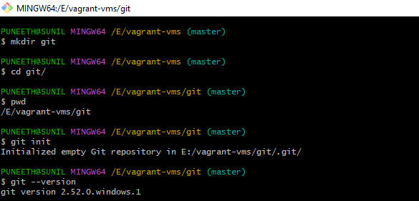
- Login to github.
- Create new repository.
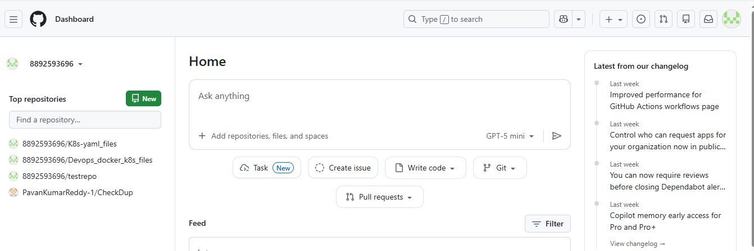
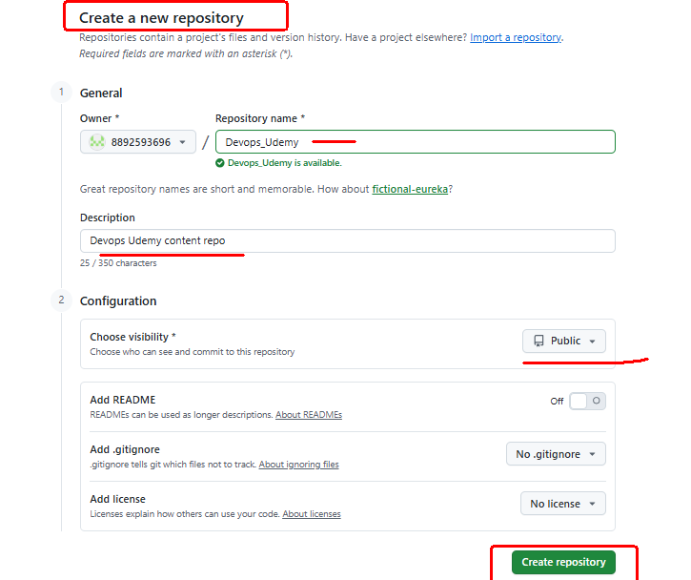

…or create a new repository on the command line
echo "# Devops_Udemy" >> README.md
git init
git add README.md
git commit -m "first commit"
git branch -M main
git remote add origin https://github.com/8892593696/Devops_Udemy.git
git push -u origin main

…or push an existing repository from the command line
git remote add origin https://github.com/8892593696/Devops_Udemy.git
git branch -M main
git push -u origin main

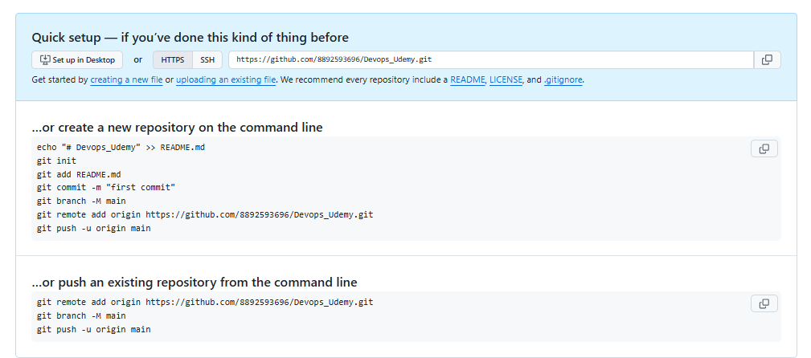
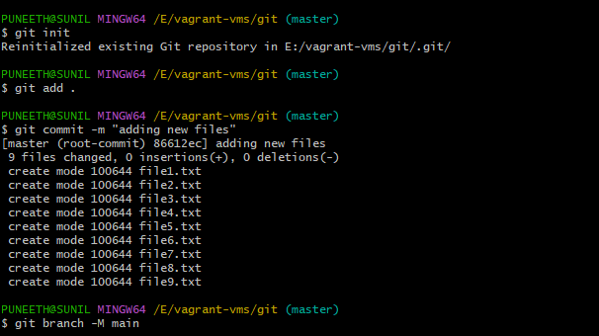

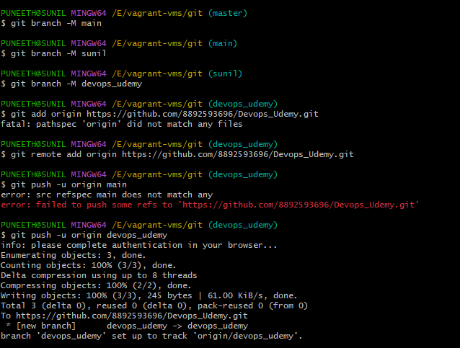
- 42. Branches & More
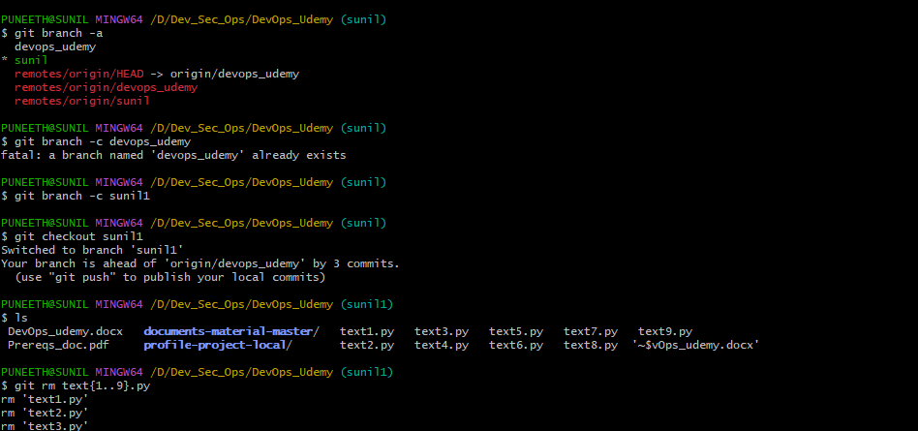

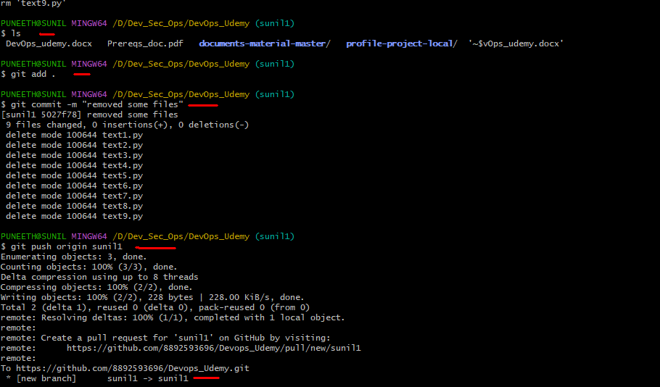

$ git branch -a (it will show all branches)
$ git branch -c sunil1 (creating new branch)
$ git checkout sunil1 (Switched to branch 'sunil1')
$ git rm text{1..9}.py (deleting files)
$ git add . (add changes from your working directory to the staging area, preparing them for the next commit.)
$ git commit -m "removed some files" (committing the changes)
$ git push origin sunil1 (pushing to repo.)

