 | Sports Massage Consultation Maintenance

Client name |  | Date

S – SUBJECTIVE ASSESSMENT
Screening form completed and reviewed ☐ Any change in health or medication since? ☐ No ☐ Yes Details:

Reason for visit (client’s words)
Goals for treatment

Previous care / treatment | Y / N | When | Outcome / what helped
Massage
Physiotherapy
Chiropractor
Osteopath
Other (GP, scans, medication)

Pain / body chart – client or therapist marks the area(s) using the key

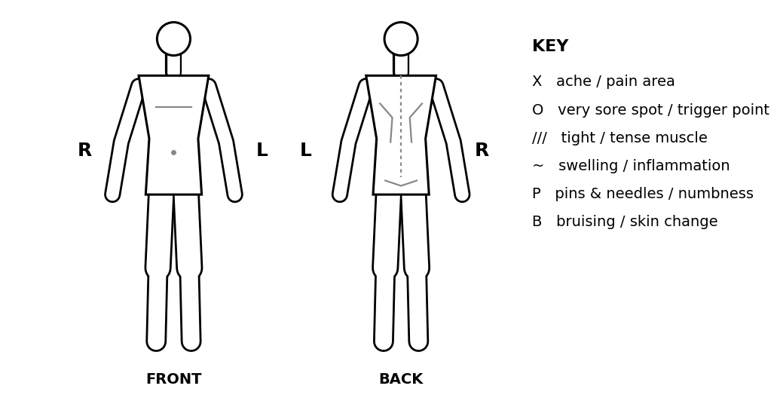

S – Subjective: the story of the problem (SOCRATES-F)
Letter | Ask | Client’s answer
S – Site | Where exactly? One area or more? (mark on chart)
O – Onset | How long has it been present?  ☐ Sudden ☐ Gradual  Mechanism – how / what caused it (method or trauma)?
C – Character | What does it feel like?  ☐ Ache ☐ Sharp / shooting  ☐ Burning / stinging ☐ Tight ☐ Stiff  ☐ Weak ☐ Pins & needles
R – Radiation | Does it spread or travel anywhere?  Any neck / arm / leg symptoms?
A – Associated | Other symptoms?  Do they occur individually or together? Does one trigger another?
T – Time course | Constant or intermittent? Any pattern through the day / after an activity?  Worse at night? Affects sleep?  Changed over time?
E – Exacerbating / easing | What aggravates (sitting, standing, sleeping, activity, movement)?  What eases (heat, rest, stretching, medication)? Anything else?
S – Severity | 0 = no pain, 10 = almost unbearable  0 1 2 3 4 5 6 7 8 9 10 | Now ___ /10 At worst ___ /10 At best ___ /10
F – Function | Does it limit work, sport or home activities?

Social / work
Work & posture | Job, hours seated / on feet, screen use:
Exercise / sport | Type, how often, recent changes:
Lifestyle | Sleep, water intake, stress, alcohol, smoking:

Consent to assessment: I confirm the information I have given is true and complete to the best of my knowledge, and I know of no condition that would prevent me having a sports massage. The assessment (observation, palpation and active movement testing) has been explained to me, my questions have been answered, and I consent to it being carried out by the therapist named below. I understand I may need to remove some clothing, and that I can stop at any time.
Client signature (assessment) |  | Date
Therapist signature |  | Date
O – OBJECTIVE ASSESSMENT
Direct the assessment at the area(s) identified in S. Active range of movement only at Level 3 – comfortable movement patterns.
View | What to check | Findings (note R / L)
Lateral | Head position – line of gravity (LOG) through earlobe, chin parallel to ground
Lateral | Shoulders – LOG through acromion; protracted / rounded?
Lateral | Spinal curves – cervical, thoracic, lumbar (kyphosis / lordosis / flat)
Lateral | Pelvis – ASIS and PSIS parallel (anterior / posterior tilt)
Lateral | Knees – LOG through middle of joint (hyperextended / flexed)
Lateral | Feet – LOG through apex of arch (high arches / flat feet)
Posterior | Head and ears – neutral, level, not tilted or rotated
Posterior | Shoulders level; scapulae flat, medial borders ~3 fingers from spine (winging?)
Posterior | Keyholes – gaps between arms and trunk similar size
Posterior | Spine – any lateral curve (scoliosis)?
Posterior | Hips level, gluteal creases even, PSIS parallel
Posterior | Knees level and straight
Posterior | Feet / ankles – Achilles similar thickness and direction; foot position
Both | Muscle bulk – compare R and L, calves up to shoulders and arms

Observation
Posture / alignment & muscle imbalance (R v L)
Swelling / inflammation / skin colour / bruising
Movement patterns & compensations (gait, how they move on / off couch)
Palpation
Skin – temperature (hot / cold), moisture (clammy), texture
Muscle tension / tone / bulk (R v L)
Soreness / discomfort / trigger points (mark on chart)
Swelling, lumps, tissue quality

O – Active range of movement (active)
Key: ✓ = full active ROM, no pain P = pain EOR = pain at end of range R = restricted W = weak C = compensation (L = left, R = right)
Movement | L | R |  | Movement | L | R
NECK |  |  |  | SPINE
Flexion |  |  |  | Flexion
Extension |  |  |  | Extension
Lateral flexion |  |  |  | Lateral flexion
Rotation |  |  |  | Rotation
SHOULDER |  |  |  | HIP
Flexion |  |  |  | Flexion
Extension |  |  |  | Extension
Abduction |  |  |  | Abduction
Adduction |  |  |  | Adduction
Horizontal abduction |  |  |  | Internal rotation
Horizontal adduction |  |  |  | External rotation
Internal rotation |  |  |  | Circumduction
External rotation |  |  |  | KNEE
Circumduction |  |  |  | Flexion
ELBOW |  |  |  | Extension
Flexion |  |  |  | Rotation
Extension |  |  |  | ANKLE
FOREARM |  |  |  | Dorsiflexion
Pronation |  |  |  | Plantarflexion
Supination |  |  |  | Inversion
WRIST |  |  |  | Eversion
Flexion
Extension

ROM – other notes

Special test (directed at area found in S) | L | R | Result / notes

A – ASSESSMENT: summary of findings & aims
Summary of findings (from S and O)
Agreed aim(s) of treatment
Confirmed with client | ☐ Yes – client agrees to the aims

P – PLAN: treatment plan & consent
Symptom or finding | Proposed action

Area(s) to be treated
Techniques & anticipated results | Techniques:  Anticipated results:
Massage medium | ☐ Oil ☐ Wax / cream ☐ Powder ☐ None Allergy checked ☐
Clothing to be removed / draping
Time frame | ____ mins (course notes: 30 / 45 / 60 – delete as appropriate)
Other recommendations

Questions / concerns
Response
Questions / concerns
Response

Consent to treatment: The proposed sports massage treatment, as set out above, has been explained to me, including the areas to be treated, the techniques, the massage medium, the time frame, and which clothing needs to be removed (I will be draped). My questions and concerns, as recorded above, have been answered to my satisfaction. I understand the therapist is not a clinician and does not diagnose; that no result is guaranteed; and that there can be side effects (see aftercare). I will tell the therapist if my health changes. I can withdraw consent at any time and treatment will stop. I give my informed consent for the treatment.
Client signature (treatment) |  | Date
Therapist signature |  | Date
TREATMENT RECORD
Techniques used | ☐ Effleurage ☐ Petrissage ☐ Frictions ☐ Compressions ☐ Tapotement ☐ Trigger point release ☐ Passive stretching ☐ Other:
Areas treated & order
Pressure / speed / depth – how varied
Client position & draping
Start – finish time
Client feedback during treatment (verbal / visual)

POST-MASSAGE ASSESSMENT & FEEDBACK
Pain / discomfort now (0–10) | Before: ____ /10 After: ____ /10
Re-test of movement / palpation
Client feedback (comfort, pressure, what helped)
Any adverse reaction | ☐ None ☐ Yes:
My evaluation – what worked / what to improve

AFTERCARE & SIDE EFFECTS
Aftercare advice given (tick when discussed):
☐ Avoid strenuous activity for 24 hours ☐ Keep hydrated ☐ Avoid heavy meals for 3 hours ☐ Avoid heat or sunlight
☐ Stretches / exercises to do at home: ______________________________ ☐ Lifestyle / ergonomic advice: ________________
☐ Possible side effects explained – the most common is some discomfort or soreness for about 24–48 hours, not everyone gets it. Contact me if symptoms worsen, persist or anything unusual happens.
☐ Opportunity for questions given

