 | Sports Massage Consultation  Pre-event

Client name |  | Date
Mobile |  | Email
ICE – Name |  | ICE - Number

S – SUBJECTIVE ASSESSMENT

Event / sport & level
Date & time of event – how long until it starts?
Warm-up plan & usual pre-event routine
Goal of massage | ☐ Loosen / prime muscles ☐ Reduce tension ☐ Calm nerves / relax ☐ Other:
Previous pre-event massage & response
Current niggles, injuries or tight areas (mark on chart)
Painkillers / anti-inflammatories taken? (can mask pain) | ☐ No ☐ Yes:
Last meal & fluids
Discomfort now (0–10) | 0 1 2 3 4 5 6 7 8 9 10 Now ___ /10
Anything else I should know

Pain / body chart – client or therapist marks the area(s) using the key
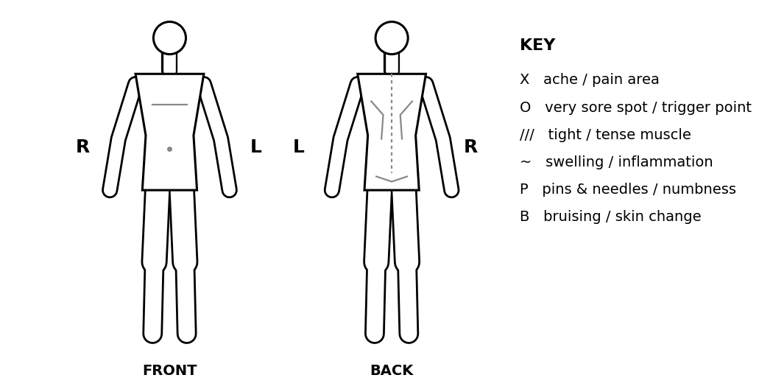

Consent to assessment: I confirm the information I have given is true and complete to the best of my knowledge, and I know of no condition that would prevent me having a sports massage. The assessment (observation, palpation and active movement testing) has been explained to me, my questions have been answered, and I consent to it being carried out by the therapist named below. I understand I may need to remove some clothing, and that I can stop at any time.
Client signature (assessment) |  | Date
Therapist signature |  | Date
O – OBJECTIVE ASSESSMENT
Observation
Posture / alignment & muscle imbalance (R v L)
Swelling / inflammation / skin colour / bruising
Movement patterns & compensations (gait, how they move on / off couch)
Palpation
Skin – temperature (hot / cold), moisture (clammy), texture
Muscle tension / tone / bulk (R v L)
Soreness / discomfort / trigger points (mark on chart)
Swelling, lumps, tissue quality

Key: ✓ = full active ROM, no pain P = pain EOR = pain at end of range R = restricted W = weak C = compensation (L = left, R = right)
Joint tested | Movement | L | R | Notes (pain, weakness, compensation)
Movements: Neck – flex, ext, lat flex, rot | Shoulder – flex, ext, abd, add, horiz abd/add, int/ext rot, circumduction | Elbow – flex, ext | Forearm – pron, sup | Wrist – flex, ext | Spine – flex, ext, lat flex, rot | Hip – flex, ext, abd, add, int/ext rot, circumduction | Knee – flex, ext, rot | Ankle – dorsi/plantarflexion, inversion, eversion

A – ASSESSMENT: summary of findings & aims
Summary of findings (from S and O)
Agreed aim(s) of treatment
Confirmed with client | ☐ Yes – client agrees to the aims

P – PLAN: treatment plan & consent
Symptom or finding | Proposed action

Area(s) to be treated
Techniques & anticipated results | Effleurage / petrissage / tapotement – areas and aim:  Anticipated results:
Massage medium | ☐ Oil ☐ Wax / cream ☐ Powder ☐ None Allergy checked ☐
Clothing to be removed / draping
Time frame | ☐ 10 ☐ 15 ☐ 20 mins
Other recommendations

Questions / concerns
Response
Questions / concerns
Response

Consent to treatment: The proposed sports massage treatment, as set out above, has been explained to me, including the areas to be treated, the techniques, the massage medium, the time frame, and which clothing needs to be removed (I will be draped). My questions and concerns, as recorded above, have been answered to my satisfaction. I understand the therapist is not a clinician and does not diagnose; that no result is guaranteed; and that there can be side effects (see aftercare). I will tell the therapist if my health changes. I can withdraw consent at any time and treatment will stop. I give my informed consent for the treatment.
Client signature (treatment) |  | Date
Therapist signature |  | Date
TREATMENT RECORD
Techniques used | ☐ Effleurage ☐ Petrissage ☐ Tapotement
Areas treated & order
Pressure / speed / depth – how varied
Client position & draping
Start – finish time
Client feedback during treatment (verbal / visual)

POST-MASSAGE ASSESSMENT & FEEDBACK
Pain / discomfort now (0–10) | Before: ____ /10 After: ____ /10
Re-test of movement / palpation
Client feedback (comfort, pressure, what helped)
Any adverse reaction | ☐ None ☐ Yes:
My evaluation – what worked / what to improve

AFTERCARE & SIDE EFFECTS
Aftercare advice given (tick when discussed):
☐ Avoid strenuous activity for 24 hours ☐ Keep hydrated ☐ Avoid heavy meals for 3 hours ☐ Avoid heat or sunlight
☐ Stretches / exercises to do at home: ______________________________ ☐ Lifestyle / ergonomic advice: ________________
☐ Possible side effects explained – the most common is some discomfort or soreness for about 24–48 hours, not everyone gets it. Contact me if symptoms worsen, persist or anything unusual happens.
☐ Opportunity for questions given ☐ Any Questions

