 | Sports Massage Consultation  Post-event

Client name |  | Date
Mobile |  | Email
ICE – Name |  | ICE - Number

S – SUBJECTIVE ASSESSMENT
Event / sport, duration & intensity
Time since event finished
Conditions (heat, cold, terrain)
Symptoms now | ☐ Muscle soreness ☐ Tightness ☐ Cramp ☐ Fatigue ☐ Headache  ☐ Dizziness ☐ Nausea / vomiting ☐ Confusion ☐ Severe cramp  If dizziness, confusion, vomiting or severe cramp: do not treat – seek help / refer.
Injury during event? (pain, swelling, bruising, loss of movement)
Fluids & food since event / cool-down done?
Areas worked hardest / most sore (mark on chart)
Discomfort now (0–10) | 0 1 2 3 4 5 6 7 8 9 10 Now ___ /10
Previous post-event massage & response
Goal of massage | ☐ Ease soreness ☐ Aid recovery ☐ Relax ☐ Other:
Anything else I should know

Pain / body chart – client or therapist marks the area(s) using the key
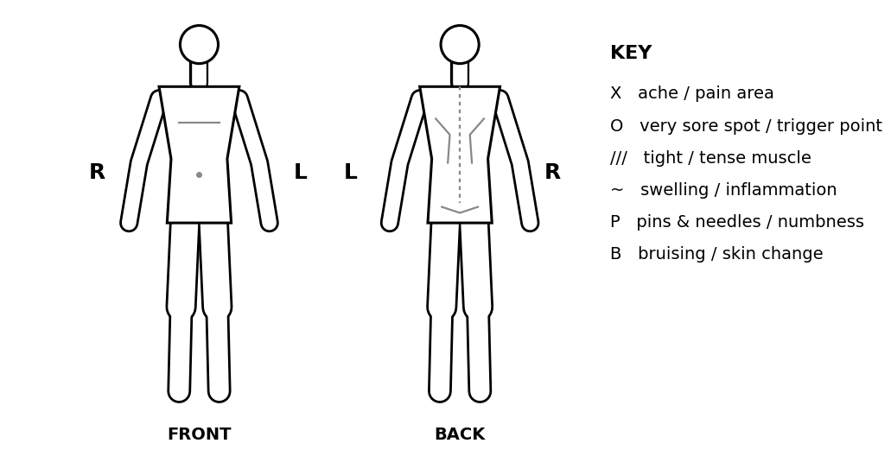

Consent to assessment: I confirm the information I have given is true and complete to the best of my knowledge, and I know of no condition that would prevent me having a sports massage. The assessment (observation, palpation and active movement testing) has been explained to me, my questions have been answered, and I consent to it being carried out by the therapist named below. I understand I may need to remove some clothing, and that I can stop at any time.
Client signature (assessment) |  | Date
Therapist signature |  | Date
O – OBJECTIVE ASSESSMENT
Quick, relevant assessment of the areas used in the event. Active ROM only; stop if painful.
Observation
Posture / alignment & muscle imbalance (R v L)
Swelling / inflammation / skin colour / bruising
Movement patterns & compensations (gait, how they move on / off couch)
Palpation
Skin – temperature (hot / cold), moisture (clammy), texture
Muscle tension / tone / bulk (R v L)
Soreness / discomfort / trigger points (mark on chart)
Swelling, lumps, tissue quality

Key: ✓ = full active ROM, no pain P = pain EOR = pain at end of range R = restricted W = weak C = compensation (L = left, R = right)
Joint tested | Movement | L | R | Notes (pain, weakness, compensation)
Movements: Neck – flex, ext, lat flex, rot | Shoulder – flex, ext, abd, add, horiz abd/add, int/ext rot, circumduction | Elbow – flex, ext | Forearm – pron, sup | Wrist – flex, ext | Spine – flex, ext, lat flex, rot | Hip – flex, ext, abd, add, int/ext rot, circumduction | Knee – flex, ext, rot | Ankle – dorsi/plantarflexion, inversion, eversion

A – ASSESSMENT: summary of findings & aims
Summary of findings (from S and O)
Agreed aim(s) of treatment
Confirmed with client | ☐ Yes – client agrees to the aims

P – PLAN: treatment plan & consent
Symptom or finding | Proposed action

Area(s) to be treated
Techniques & anticipated results | Techniques incl. passive stretches (which muscles) – areas and aim:  Anticipated results:
Massage medium | ☐ Oil ☐ Wax / cream ☐ Powder ☐ None Allergy checked ☐
Clothing to be removed / draping
Time frame | ☐ 20 ☐ 25 ☐ 30 mins
Other recommendations

Questions / concerns
Response
Questions / concerns
Response

Consent to treatment: The proposed sports massage treatment, as set out above, has been explained to me, including the areas to be treated, the techniques, the massage medium, the time frame, and which clothing needs to be removed (I will be draped). My questions and concerns, as recorded above, have been answered to my satisfaction. I understand the therapist is not a clinician and does not diagnose; that no result is guaranteed; and that there can be side effects (see aftercare). I will tell the therapist if my health changes. I can withdraw consent at any time and treatment will stop. I give my informed consent for the treatment.
Client signature (treatment) |  | Date
Therapist signature |  | Date
TREATMENT RECORD
Techniques used | ☐ Effleurage ☐ Petrissage ☐ Frictions ☐ Passive stretching:
Areas treated & order
Pressure / speed / depth – how varied
Client position & draping
Start – finish time
Client feedback during treatment (verbal / visual)

POST-MASSAGE ASSESSMENT & FEEDBACK
Pain / discomfort now (0–10) | Before: ____ /10 After: ____ /10
Re-test of movement / palpation
Client feedback (comfort, pressure, what helped)
Any adverse reaction | ☐ None ☐ Yes:
My evaluation – what worked / what to improve

AFTERCARE & SIDE EFFECTS
Aftercare advice given (tick when discussed):
☐ Avoid strenuous activity for 24 hours ☐ Keep hydrated ☐ Avoid heavy meals for 3 hours ☐ Avoid heat or sunlight
☐ Stretches / exercises to do at home: ______________________________ ☐ Lifestyle / ergonomic advice: ________________
☐ Possible side effects explained – the most common is some discomfort or soreness for about 24–48 hours, not everyone gets it. Contact me if symptoms worsen, persist or anything unusual happens.
☐ Opportunity for questions given

