Task: Jumping values A number sequence is in increasing order. Give the count of places where there is a jump in the sequence: Ai+1-Ai>1.

Specification:

Input：n∈N，value:[1……length]∈ $N^{n}$

Output：count∈N

Precondition：1≤n≤100，∀[i] (1≤i≤n):1≤values[i] ≤1000

Postcondition:count= $\sum_{i=1}^{n}{1}$

Value[i]-value[i-1]>0

Pattern:counting

Algorithm

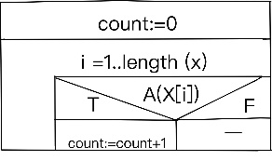

|  |  |  |
| --- | --- | --- |
| pattern |  | task |
| length(x) | → | n |
| count | → | count |
| X[] | → | value[] |
| A(x[i]) | → | Value[i]-value[i-1]>0 |

Code:

using System;

using System.Collections;

namespace ConsoleApp4

{

internal class Program

{

static void Main(string[] args)

{

string input = Console.ReadLine();

int length = Convert.ToInt32(input.Split("")[0]);

int[] values = new int[length];

int cnt = 0;

for (int i = 0; i < length; i++)

{

values [i] = Convert.ToInt32(Console.ReadLine());

}

for (int i = 0; i < values.Length; i++)

{

if (values[i] - values[i-1] >1)

cnt++;

}

Console.Write(cnt);

}

}

}