„Programming”
Big Project
Made by: Lu Yingjie
Neptun code: AF35AN
E-mail: yingjielu2002@163.com
Course code: ???
Teacher’s name: vincze Dorottya
2022. December 19.

Content
User documentation 4
Task 4
Runtime environment 4
Usage 4
Starting the program 4
Program input 4
Program output 4
Sample input and output 5
Possible errors 5
Developer documentation 6
Task 6
Specification 6
Developer environment 7
Source code 7
Solution 7
Program parameters 7
The structure of the program 7
Structure of functions 7
The algorithm of the program 8
The code 8
Testing 10
Valid test cases 10
Invalid test cases 11
Further development options 11
User documentation

Task
A ticket inspector of the Budapest-Székesfehérvár train logged the number of passengers getting on and off at each of the stops. (There are no people getting off at Budapest, and no people getting on at Székesfehérvár. No people get on after getting off.) Write a program that tells whether it is economical to operate the train if a passenger pays N HUF for each traveled stop, and it costs M HUF to operate the train between 2 stops.
Runtime environment
Programs running on .NET system. An operating system capable of running cs files (eg. Visual studio).
Usage
Starting the program
The program can be found in the archive file, Program.cs. You can launch the program by double-clicking on the Program.cs file.
Program input
The program reads the input data from the keyboard in the following order:
# | Data | Explanation
1. | length | The count of the stops(1≤S≤1000).
2. | pays | The number of pay per stop (0<pays≤100).
3. | coststops | The spend on operation (1≤coststops≤100000).
4. | On[i] | The count of people getting on (0≤ΟΝ≤800)
…… | ……
5. | Off[i] | The count of people getting off (0≤οff ≤800)
…… | ……
Program output
The program writes out should contain 1 if it is economic to operate the train, and 0 if not
Sample input and output
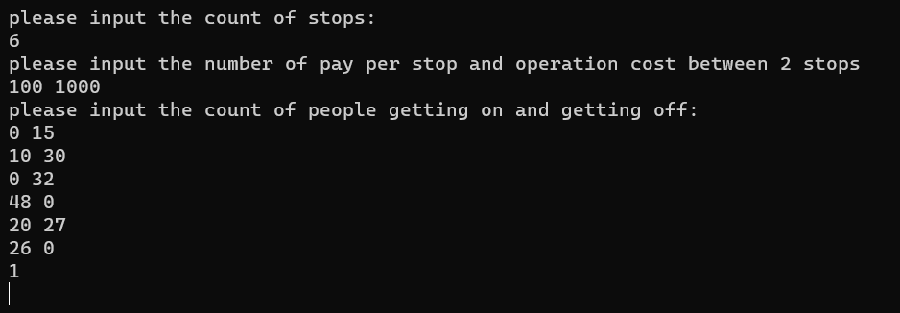

Possible errors
The input should be given based on the sample. If count of stops is not an integer, or is not in the range 1..1000, this will cause a problem.
If passenger has to pay per stop is not a number, or is not in the range 0..100, this will also cause a problem.
If operation cost between 2 stops is not a number, or is not in the range 1..100000, this will also cause a problem.
If the number of people getting on or getting off at a stop is not a number, or is not in the range 0..800, this will also cause an error
If an error occurs, the program will display an error message or ask for a repeat entry.

Sample of running in the case of invalid data:
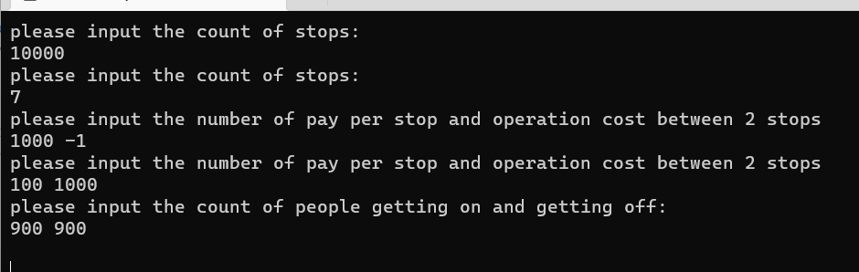

Developer documentation
Task
A ticket inspector of the Budapest-Székesfehérvár train logged the number of passengers getting on and off at each of the stops. (There are no people getting off at Budapest, and no people getting on at Székesfehérvár. No people get on after getting off.) Write a program that tells whether it is economical to operate the train if a passenger pays N HUF for each traveled stop, and it costs M HUF to operate the train between 2 stops.
Specification
Input: length∈N，on[1...length] ∈Nlength ,off[1...length] ∈Nlength
pays∈N，coststops∈N.
Output: count∈N
Precondition: 1≤length≤1000;0<pays≤100;1≤coststops≤100000
( 1≤length≤1000):0≤on[i] ≤800,0≤off[i] ≤800
Postcondition:
( 1≤length≤1000):0≤on[i] ≤800：sum = on[i] * pays ;

Count:=

Developer environment
An operating system capable of running cs files (eg. Visual studio).
Source code
All the sources can be found in the B3 folder (after extraction). The folder structure used for development:
File | Explanation
Program.cs | Executable code
B3test.txt | input test file1
B3test.txt | Output test file
B3.docx | documentation (this file)
Solution
Program parameters
Contants
length : Integer(Console read) [the count of stops]
pays : Integer(Console read) [the number of passenger has to pay per stop]
coststops : Integer(Console read) [the number of operation cost]

Types
ON = Array(1..length:Integer)
Off = Array(1..length:Integer)
Variables
length : Integer
pays : Integer
coststops : Integer
ON[i] : ON
Off[i] : off
The structure of the program
The modules used by the program, and their locations:
Program.cs – the program, in the source folder
Main funcation -Entry to the program
Structure of functions
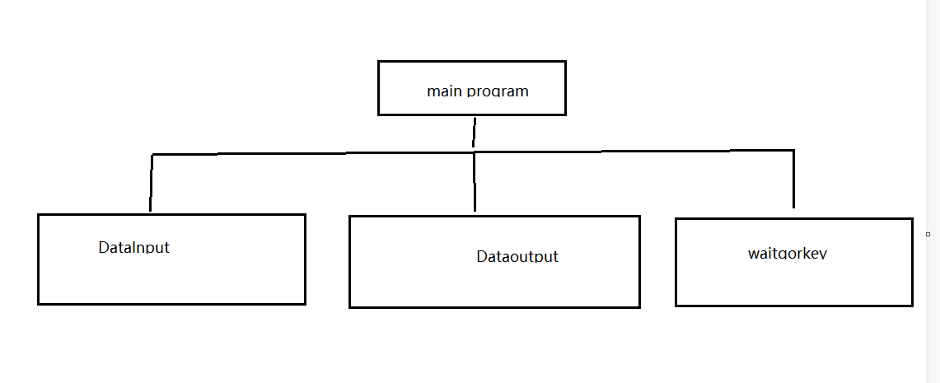

The algorithm of the program

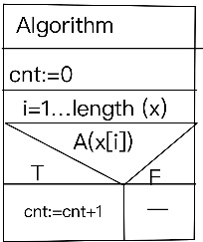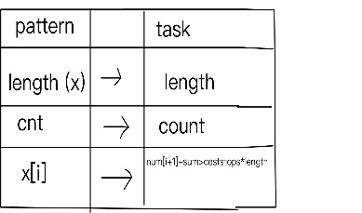

Main:
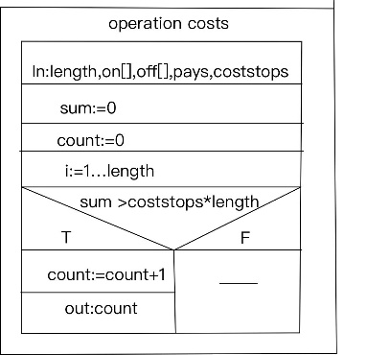
The code
The content of the program.ca file:
using System;
namespace B3
{
internal class Program
{
static void Main(string[] args)
{
int count = 0;
int length = 0;
int sum = 0;
int pays = 0;
int coststops = 0;
do
{
Console.WriteLine("please input the count of stops:");
length = int.Parse(Console.ReadLine());
} while (length<=1||length>=1000);
do {
Console.WriteLine("please input the number of pay per stop and operation cost between 2 stops");
string all = Console.ReadLine();
pays = Convert.ToInt32(all.Split(' ')[0]);
coststops = Convert.ToInt32(all.Split(' ')[1]);
} while (pays>100||pays<=0&&coststops>100000||coststops<1);
int[] on=new int[length];
int[] off=new int[length];
Console.WriteLine("please input the count of people getting on and getting off: ");
for (int i = 0; i < length; )
{
string input = Console.ReadLine();
on[i] = Convert.ToInt32(input.Split(' ')[0]);
off[i] = Convert.ToInt32(input.Split(' ')[1]);
sum = on[i] * pays + sum;
if (on[i] >= 0 || on[i] <= 800 && off[i] >= 0 || off[i] <= 800)
{
i++;
}
}
if (sum > (coststops * length))
{
count++;
Console.WriteLine(count);
}
else
{
Console.WriteLine(count);
}
Console.ReadKey();
}
}
}

Testing
Valid test cases
      - test case: in1.txt
Input – length
please input the count of stops:
7
Output
      - test case: in2.txt
Input –the number of pay per stop and operation cost between 2 stops
please input the count of stops:
7
please input the number of pay per stop and operation cost between 2 stops
100 1000
Output
      - test case: in3.txt
Input –the count of people getting on and getting off
please input the count of stops:
7
please input the number of pay per stop and operation cost between 2 stops
100 1000
please input the count of people getting on and getting off:
0 15
10 30
0 32
48 0
20 27
26 0
Output
1
Invalid test cases
      - test case
Input – wrong length
Length=-1

Output
Asking again:
please input the count of stops:
length=
      - test case
Intput – wrong height
Length=7
Pays=1000 or coststops=-1
Output
Asking again:
please input the number of pay per stop and operation cost between 2 stops
pays= coststops=

6. test case
Input – wrong length
Length=7
Pays=100 coststops=1000
On[i]=-1 off[i]=-3
Output
Asking again:
please input the count of people getting on and getting off:
on[i]= off[i]=

Further development options
- Data to be read from file
- Detection of wrong file input, writing out the location and ID# of error
- Capability to run multiple times after each other

