**Group No: 3**

**Original group mark: 77**

**Name: Kunling Dai**

**QM number: 190013563**

Dear Lectures,

After reflecting the situation of group 1-6 through class representatives, we received the feedback of Professor Luca.

We agree with Luca that the TA's scoring has systematic errors. Due to our TA's misunderstanding of the grading system, we received about 20 points less than the other TA's. Therefore, we would like to ask the teacher in charge of this module to make the final judgment.

**Main Reasons for Review Request**

1. Instead of reviewing each member’s contributions, she simply gave the team leader an A + and everyone else an A. Some members also performed well but did not score any extra points.
2. By comparison, we found that our group’s feedback had a lot of the same content compared with other groups, apparently copied, and pasted. I do not think the TA is serious about making a specific assessment of each group.
3. Average marks for our 6 teams are around 75, but the average for the other TAs' groups is 20 points higher than ours. We cannot doubt the excellence of the other groups without grounds, but I think it is not easy to get a score of over ninety on the British scale.

**Specific feedback analysis**

1. 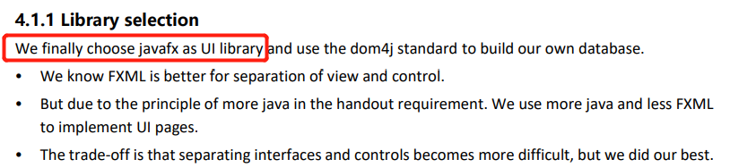TA mentioned: “It would be better to reference the open-source code like javafx.” Actually, we did used javafx and dom4j as main tool and write it clearly in report.
2. 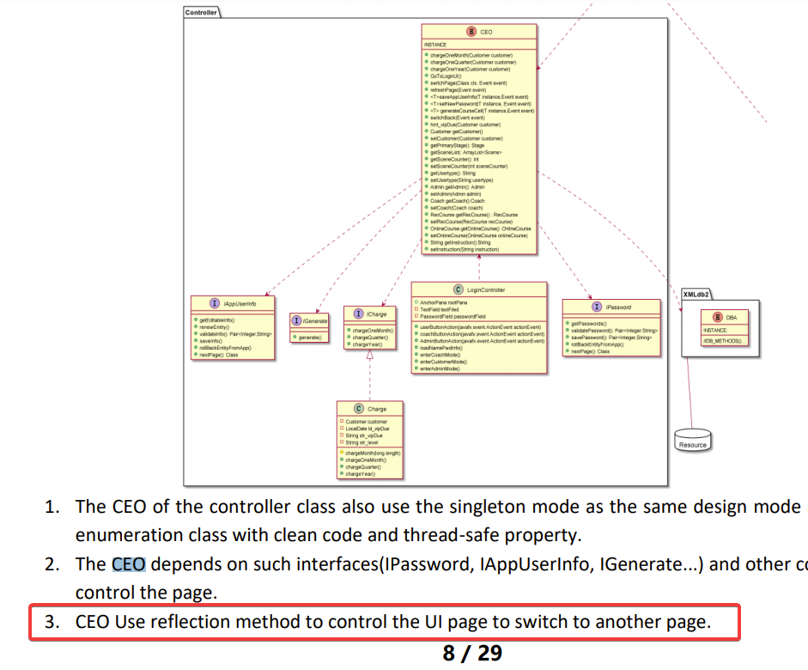TA mentioned: The interactions of the boundary classes is not very clearly in the report.

We suppose that the UI interaction should be and could be described in the user manual. And we did it in the user manual with clear description.

In the report, class diagram of CEO has methods like switchPage (Class cls, Event event), GoToLoginUI()… . (In Appendix, the UML diagram is clear enough to see each method name and attribute.)

I think it is clear about how to implement switch page function by using reflection and can write code.

I do not want to tell details in the page-limited report such as: after clicking the login button you will enter the login page. If your information is correct, you can jump to the user interface. In the user interface, you can click the online course button to jump to the online course page… It seems stupid.

1. 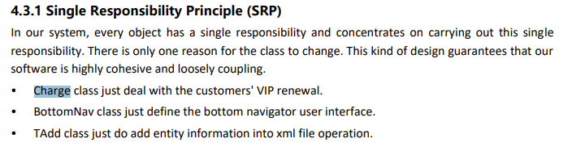TA said: “No evidence to show the single responsibility of the method.”

Three points shows they all do single things rather than mixed much responsibility to one class. I think I have explained the application of SRP.

I do not want to provide evidence by pasting source code to support each design principle because of the page limit. I just give what I think essential and prove a short explanation in DIP, LSP

1. 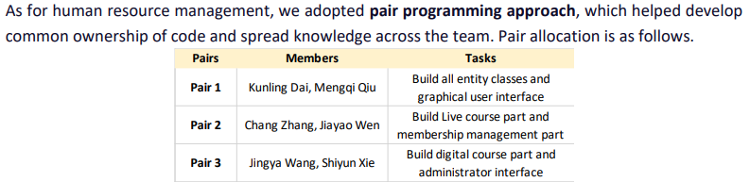TA mentioned “there's room for improvement in each element. For example, there is no table and figure captions.”

But almost every module in our report has more than one picture or table and describes the source or purpose of the picture or table in the text. We do not think the situation described by TA in the example is consistent with the actual report content of our group.

1. 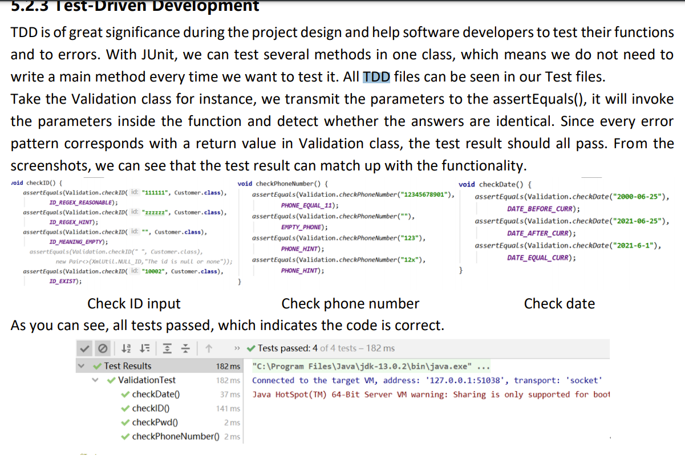As the TA mentioned “It would be better to show how individual classes are tested.”

After learning and practicing, we had a good understanding of testing. We tested our code using all the methods taught in week5: implementation and testing about unit testing and showed the tests of the most important modules in the code (limited by the number of pages in the report) and TDD tests of the remaining modules were included in the commit file.

1. In the feedback, there is a statement "Not always finish the work on time" which shows that TA questioned about the whole management process of the project.

Evidence:

We Updated Our QMHub Homepage with git development workflow:

<https://hub.qmplus.qmul.ac.uk/group/view.php?homepage=ebu6304-2021-software-engin-70>

Or you can check our project work flow on Gitee(based on git, version control)

<https://gitee.com/daikunling/Gym/graph/JavaFxDev>

We follow the timeline given in the handout. Although We forgot to upload the iteration once on QMplus Hub, after reminding, we upload it within one day. We forgot to upload because we were so engrossed in the software development process, but that does not mean we did not finish the work on time.

The evidence of our work is fully recorded on Gitee and Idea IDE with time and team member's name. Besides, in the Group Project Handout, the timeline is just a "suggested" one.

So, we cannot agree that only because we forgot to submit an iteration once on the hub, we were considered to finish the work behind schedule.

**Marking Criteria Discussion**

As we know, EBU6305 Interactive Media & Design Production Course has a programming project with structured feedback. But the grading process of our TA is not visible, we have no way of knowing how we lose 23 marks.

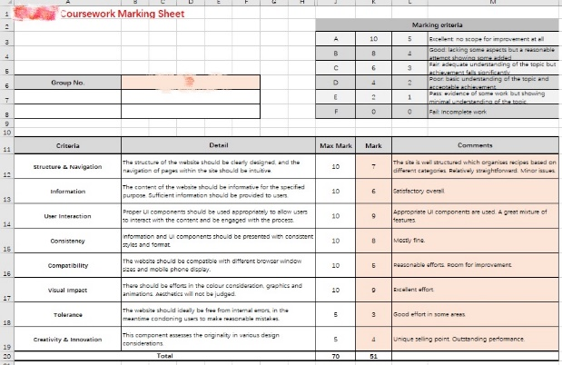

EBU6305 Structured Feedback

**Conclusion**

The difference between the mean score of twenty points of our group 1-6 and the other groups is a systematic error. It could be that our teaching assistants were very strict and the other teaching assistants graded normally. But we think it is more likely that our TA was a little tougher and the other TAs relaxed their standards.

It is impossible to be fair, we just want our teachers to point out the shortcomings in our project, get reasonable treatment, and get guidance from the feedback. We hope you can review our request and provide us a reasonable reply.