MANAGEMENT INFORMATION SYSTEM

LAB EXPERIMENTS

C HAREESH - 192110282

8) Describe major services (functionality) provided by a hospital's reception. Summary**:** Hospital Management System is a large system including several subsystems or modules providing variety of functions. Hospital Reception subsystem or module supports some of the many job duties of hospital receptionist. Receptionist schedules patient's appointments and admission to the hospital, collects information from patient upon patient's arrival and/or by phone.

For the patient that will stay in the hospital ("inpatient") she or he should have a bed allotted in a ward. Receptionists might also receive patient's payments, record them in a database and provide receipts, file insurance claims and medical reports.

**Aim:**

To develop a **UML Use Case Diagram** for the **Hospital Reception System**, illustrating the major functionalities provided by the hospital reception.

**Procedure:**

1. **Identify Key Actors:**
   * **Patient**: Seeks medical services.
   * **Receptionist**: Manages appointments, admissions, and payments.
   * **Doctor**: Receives patient details and medical reports.
   * **Hospital Management System**: Stores and processes patient and payment information.
   * **Insurance Company**: Processes claims.
2. **Define Major Services (Use Cases):**
   * **Patient Use Cases:**
     + Schedule Appointment
     + Register as Inpatient/Outpatient
     + Make Payment
     + Receive Receipt
   * **Receptionist Use Cases:**
     + Manage Appointments
     + Admit Patient and Assign Bed
     + Process Payments and Issue Receipts
     + File Insurance Claims
     + Record Medical Reports
   * **Doctor Use Cases:**
     + View Patient Records
   * **Insurance Company Use Cases:**
     + Process Insurance Claims
3. **Establish Relationships:**
   * The **Patient** interacts with the **Receptionist** to schedule appointments and handle payments.
   * The **Receptionist** manages hospital admissions and assigns beds for inpatients.
   * The **Receptionist** records medical reports and submits insurance claims to the **Insurance Company**.
   * The **Doctor** accesses patient records for treatment.
   * The **Hospital Management System** stores patient details, payment records, and medical reports.

**Output:**

**Use case diagram**

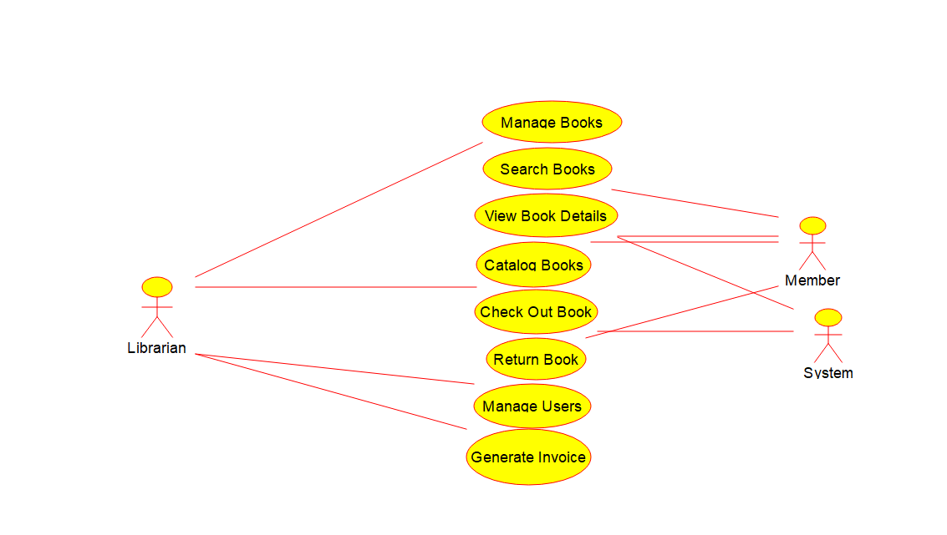

**Result:**

A **UML Use Case Diagram** will be created based on the above analysis.