MANAGEMENT INFORMATION SYSTEM

LAB EXPERIMENTS

C HAREESH - 192110282

9) A college has more than thousand security persons, who are instructed to give duties at different places within the campus. Additionally, they also maintain a routine, which contains all information, such as Date, Duty Start Time, Duty End Time, and Place.  Most importantly, all the places are covered by at least one security person. If a security person takes leave, manual entry is done against that person. Finally, at the end of a month, the security persons get paid for their duties, while considering the number of leaves as well. You can see that the manual calculation/operation is a heavy task for the security manager. Therefore, the objective is to build an Online security management system using class diagram through which entire security system within the campus can be controlled in an efficient manner

**Aim:**

To develop a **UML Class Diagram** for an **Online Security Management System** to efficiently manage the security personnel, their schedules, leave records, and salary calculations.

**Procedure:**

1. **Identify Key Classes:**
   * **Security Person**: Represents a security guard with attributes like ID, name, assigned duty, and leave records.
   * **Duty Schedule**: Stores details of duty assignments, including date, start time, end time, and place.
   * **Leave Record**: Tracks leave applications and approvals.
   * **Salary**: Calculates the monthly salary based on duties completed and leaves taken.
   * **Security Manager**: Manages security personnel, assigns duties, approves leaves, and processes salaries.
   * **Place**: Represents locations that must be guarded, ensuring full coverage.
2. **Define Attributes and Methods:**
   * **Security Person**
     + Attributes: ID, Name, Contact, Assigned Duty, Leaves Taken
     + Methods: Request-Leave(), View Schedule()
   * **Duty Schedule**
     + Attributes: Date, Start Time, End Time, Place, Assigned Security Person
     + Methods: Assign Duty(), Update Schedule()
   * **Leave Record**
     + Attributes: Security Person-ID, Leave Date, Approval Status
     + Methods: Apply Leave(), Approve Leave()
   * **Salary**
     + Attributes: Security Person-ID, Basic Pay, Deductions, Net Salary
     + Methods: Calculate Salary()
   * **Security Manager**
     + Attributes: ID, Name, Contact
     + Methods: Assign Duties(), Approve Leaves(), Process Salaries()
   * **Place**
     + Attributes: Place-ID, Location Name
     + Methods: Assign Security()
3. **Establish Relationships:**
   * A **Security Person** is assigned to a **Duty Schedule**.
   * A **Duty Schedule** is linked to a **Place** to ensure coverage.
   * A **Security Person** can request **Leave Record**, which must be approved by the **Security Manager**.
   * The **Security Manager** assigns duties and processes salaries based on duty records and leave deductions.

**Output:**

**Class diagram**

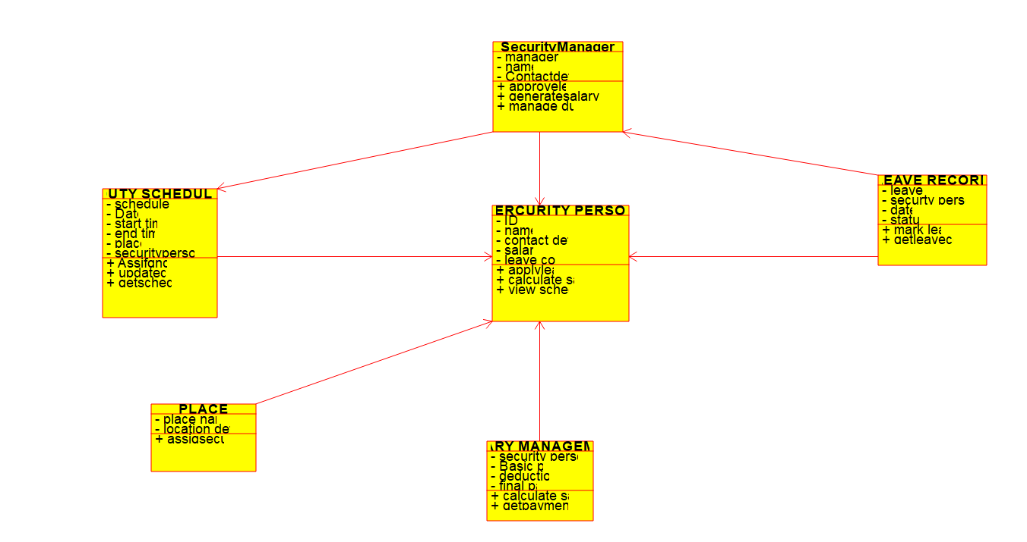

**Result:**

A **UML Class Diagram** will be created to visualize the **Online Security Management System**.