Milestone: Version 1.0: ERD Diagram
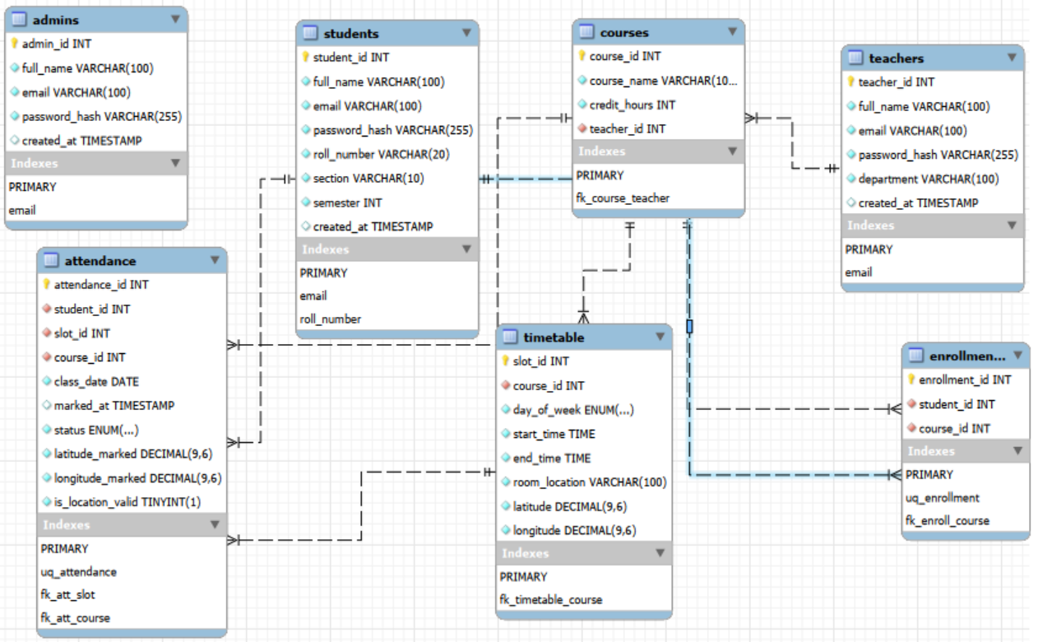

Milestone: Version 1.0: Schema
📋 Tables Overview

| # | Table | Purpose |
|---|-------|---------|
| 1 | `admins` | System administrators |
| 2 | `teachers` | Teacher accounts + login |
| 3 | `students` | Student accounts + login |
| 4 | `courses` | Courses linked to teachers |
| 5 | `enrollments` | Which student is in which course |
| 6 | `timetable` | Weekly class slots with GPS location |
| 7 | `attendance` | Attendance record per student per class per date |

1. `admins`

| Column | Type | Constraints | Description |
|--------|------|-------------|-------------|
| `admin_id` | INT | PK, AUTO_INCREMENT | Unique admin ID |
| `full_name` | VARCHAR(100) | NOT NULL | Admin's name |
| `email` | VARCHAR(100) | UNIQUE, NOT NULL | Login email |
| `password_hash` | VARCHAR(255) | NOT NULL | Bcrypt hashed password |
| `created_at` | TIMESTAMP | DEFAULT NOW() | Account creation time |

The admins table is used to store information about the system administrators who manage the Smart Attendance Management System. This table is important because admins have full control over the platform, including managing users, monitoring attendance records, and maintaining system operations. It also handles secure login authentication through email and encrypted password storage, ensuring only authorized administrators can access administrative features.

2. `teachers`

| Column | Type | Constraints | Description |
|--------|------|-------------|-------------|
| `teacher_id` | INT | PK, AUTO_INCREMENT | Unique teacher ID |
| `full_name` | VARCHAR(100) | NOT NULL | Teacher's name |
| `email` | VARCHAR(100) | UNIQUE, NOT NULL | Login email |
| `password_hash` | VARCHAR(255) | NOT NULL | Bcrypt hashed password |
| `department` | VARCHAR(100) | NOT NULL | Teacher's department |
| `created_at` | TIMESTAMP | DEFAULT NOW() | Account creation time |

The teachers table stores the records and login details of all teachers using the system. This table is important because teachers are responsible for managing courses, monitoring student attendance, and conducting classes. It connects teachers to their assigned courses and helps maintain organized academic management within the system. The table also ensures secure authentication using unique emails and hashed passwords.

3. `students`

| Column | Type | Constraints | Description |
|--------|------|-------------|-------------|
| `student_id` | INT | PK, AUTO_INCREMENT | Unique student ID |
| `full_name` | VARCHAR(100) | NOT NULL | Student's name |
| `email` | VARCHAR(100) | UNIQUE, NOT NULL | Login email |
| `password_hash` | VARCHAR(255) | NOT NULL | Bcrypt hashed password |
| `roll_number` | VARCHAR(20) | UNIQUE, NOT NULL | University roll number |
| `section` | VARCHAR(10) | NOT NULL | Class section e.g. BSSE-B |
| `semester` | INT | NOT NULL | Current semester |
| `created_at` | TIMESTAMP | DEFAULT NOW() | Account creation time |

The students table contains the personal and academic information of students enrolled in the institution. This table is essential because it identifies each student uniquely through roll numbers and stores login credentials for attendance marking and system access. It also keeps track of the student’s section and semester, which helps in organizing courses, attendance records, and enrollment data efficiently.
4. `courses`

| Column | Type | Constraints | Description |
|--------|------|-------------|-------------|
| `course_id` | INT | PK, AUTO_INCREMENT | Unique course ID |
| `course_name` | VARCHAR(100) | NOT NULL | Course name |
| `credit_hours` | INT | NOT NULL | Credit hours |
| `teacher_id` | INT | FK → teachers | Assigned teacher |

**Relationship:** One teacher → Many courses

The courses table stores all course-related information offered in the system. This table is important because it connects academic subjects with their assigned teachers and acts as the foundation for enrollments, timetables, and attendance records. Each course has its own unique identity, making it easier to manage class schedules and student participation in different subjects.

5. `enrollments`

| Column | Type | Constraints | Description |
|--------|------|-------------|-------------|
| `enrollment_id` | INT | PK, AUTO_INCREMENT | Unique record ID |
| `student_id` | INT | FK → students | The student |
| `course_id` | INT | FK → courses | The course |
| *(student_id, course_id)* | — | UNIQUE | No duplicate enrollments |

**Relationship:** Resolves Many-to-Many between students and courses

The enrollments table manages the relationship between students and courses. This table is very important because a student can enroll in multiple courses, and a course can contain multiple students. It resolves this many-to-many relationship by storing enrollment records separately. The table also prevents duplicate enrollments, ensuring data consistency and accurate course registration.

6. `timetable`

| Column | Type | Constraints | Description |
|--------|------|-------------|-------------|
| `slot_id` | INT | PK, AUTO_INCREMENT | Unique slot ID |
| `course_id` | INT | FK → courses | Which course |
| `day_of_week` | ENUM | NOT NULL | Mon/Tue/Wed/Thu/Fri |
| `start_time` | TIME | NOT NULL | Class start time |
| `end_time` | TIME | NOT NULL | Class end time |
| `room_location` | VARCHAR(100) | NOT NULL | Room name/number |
| `latitude` | DECIMAL(9,6) | NOT NULL | Classroom GPS latitude |
| `longitude` | DECIMAL(9,6) | NOT NULL | Classroom GPS longitude |

**Relationship:** One course → Many timetable slots

The timetable table stores the weekly schedule of classes for each course. This table is important because it defines when and where a class takes place, including the classroom GPS coordinates used for location-based attendance verification. It helps the system organize class timings, avoid scheduling conflicts, and validate whether students are physically present in the correct classroom during attendance marking.

7. `attendance`

| Column | Type | Constraints | Description |
|--------|------|-------------|-------------|
| `attendance_id` | INT | PK, AUTO_INCREMENT | Unique record ID |
| `student_id` | INT | FK → students | Who marked attendance |
| `slot_id` | INT | FK → timetable | Which class slot |
| `course_id` | INT | FK → courses | Which course |
| `class_date` | DATE | NOT NULL | Actual date (e.g. 2025-04-26) |
| `marked_at` | TIMESTAMP | DEFAULT NOW() | Exact time of marking |
| `status` | ENUM | NOT NULL | Present / Absent / Late |
| `latitude_marked` | DECIMAL(9,6) | NOT NULL | Student's GPS latitude |
| `longitude_marked` | DECIMAL(9,6) | NOT NULL | Student's GPS longitude |
| `is_location_valid` | BOOLEAN | NOT NULL | Within allowed radius? |
| *(student_id, slot_id, class_date)* | — | UNIQUE | One record per student per class per day |

**Relationship:** Links students + timetable (Many-to-Many resolved)

The attendance table stores the actual attendance records of students for each class session. This is one of the most important tables in the system because it tracks student presence, absence, or lateness for every course and timetable slot. It also records GPS coordinates and validates whether the student marked attendance within the allowed classroom radius. The table ensures accurate attendance management and prevents duplicate attendance entries for the same class on the same date.

Relationship | Type |
|---|---|
| Teacher → Courses | One-to-Many |
| Student ↔ Courses | Many-to-Many (via enrollments) |
| Course → Timetable slots | One-to-Many |
| Student ↔ Timetable | Many-to-Many (via attendance) |

🔑 Key Constraints Summary

| Table | Primary Key | Foreign Keys | Unique Constraints |
|---|---|---|---|
| admins | admin_id | — | email |
| teachers | teacher_id | — | email |
| students | student_id | — | email, roll_number |
| courses | course_id | teacher_id | — |
| enrollments | enrollment_id | student_id, course_id | (student_id, course_id) |
| timetable | slot_id | course_id | — |
| attendance | attendance_id | student_id, slot_id, course_id | (student_id, slot_id, class_date) |

