Tables:
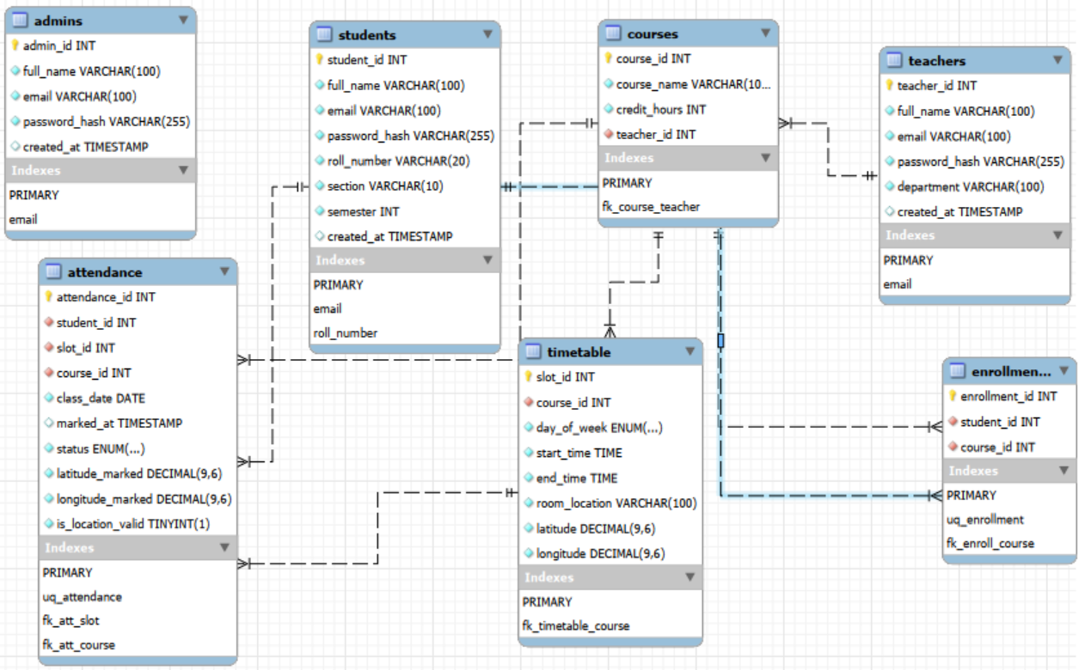

Normalization (1st, 2nd, 3rd):
A table is in 1st normal form if:
- Each attribute has a single value
- Each row is unique
A table is in 2nd normal form if:
- If it is already in 1st normal form
- All attributes are fully dependent on the PK
A table is in 3rd normal form if:
- If it already in 2nd normal form (automatically in 1st nf)
- Non-key attributes do not depend on other non-key attributes

admins Table
- 1NF: All attributes contain atomic values such as one email, one password, and one name per admin. No repeating groups exist.
- 2NF: All non-key attributes fully depend on the primary key admin_id.
- 3NF: No transitive dependency exists because all attributes depend only on admin_id.

teachers Table
- 1NF: Each column stores single values only, such as one department and one email for each teacher.
- 2NF: All non-key attributes are fully dependent on teacher_id.
- 3NF: Non-key attributes do not depend on other non-key attributes; all depend only on teacher_id.

students Table
- 1NF: Student information such as roll number, section, and semester is stored in atomic form without repeating values.
- 2NF: All student details fully depend on the primary key student_id.
- 3NF: No transitive dependency exists because all attributes directly depend on student_id.

courses Table
- 1NF: Each course record contains atomic values like one course name and one teacher assignment.
- 2NF: All non-key attributes fully depend on course_id.
- 3NF: Teacher information is stored separately in the teachers table, removing transitive dependency.

enrollments Table
- 1NF: Each row represents one student-course enrollment only.
- 2NF: The enrollment relationship fully depends on the primary key enrollment_id.
- 3NF: No non-key attribute depends on another non-key attribute because the table only stores relationship data.

timetable Table
- 1NF: Timetable records store atomic values such as one day, one start time, and one location.
- 2NF: All timetable attributes fully depend on slot_id.
- 3NF: No transitive dependency exists because all attributes depend directly on slot_id.

attendance Table
- 1NF: Each attendance entry contains single values such as one status and one GPS location per record.
- 2NF: All attendance details fully depend on attendance_id.
- 3NF: Student, course, and timetable details are stored in separate tables, so no transitive dependency exists in the attendance table.

