Being as close as we are to California, it’s not uncommon to hear about earthquakes. Big, small, last year, 10+ years ago, you hear it all, but the big thing you hear about is, when’s the ‘big one’ coming. It’s because of this question, I’ll be researching earthquake detection and how wave phenomena assists.

The specific technology I’ll be researching that is associated with earthquake detection will be the seismometer. The seismometer detects earthquakes by using wave phenomena produced by the earthquake. For simplicity, wave phenomena will now be called seismic waves.

Seismic waves are broken into a few pieces, with the three most common being:

P (Primary/Compressional) waves
S (Secondary/Traverse) waves
Surface waves

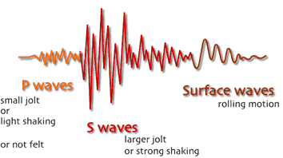

The P wave is the faster of the three waves, indicating that is should arrive first to any seismometer. This wave works in a ‘compression’ like fashion. As the wave carries in one direction, the ground will push in that same direction, but also retract, much like an accordion. These waves can also pass through solid objects, like mountains and, well, the earth (it’s also said that animals ‘feel’ this wave, which can explain how they sense earthquakes before the actual shake happens).

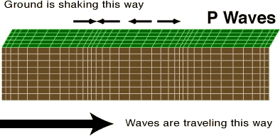

The second is the S wave, is the slower between it and the primary. This type of wave moves in a more up and down rhythm, as opposed to the forward/backward fashion of the first wave, and they can’t travel through water. Because of this, the earth itself moves up and down, causing the majority of destruction in the event of an earthquake.

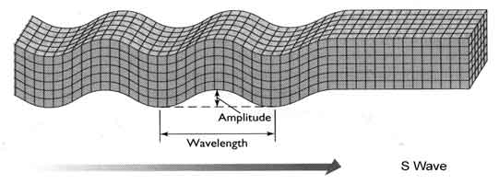

And the third is the surface wave. This wave is actually broken into two of it’s own waves, Love and Rayleigh surface waves, and as the other two travel through objects, surface waves only travel along the surface of the earth (hence the ‘surface’ name), and cause the actual damage in an earthquake. They also travel slower than the other two. Love waves move in a side to side method which can cause damage to structures. Rayleigh are more like small ocean ripples or wave humps on the earth’s surface.

Love: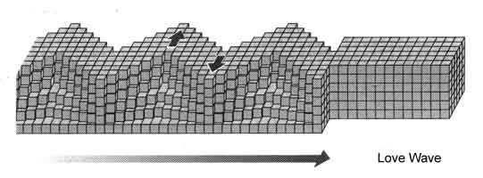

Rayleigh:
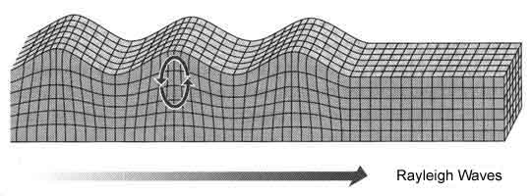

Now that those have been explained, let’s discuss how they both work with a seismometer to measure earthquakes.

First, what is a seismometer. The simplest explanation is this: It’s an instrument that consists of a fixed base, and a hanging weighted object with a pen attached within. If the ground/earth shakes, the base shakes, it and the paper (seismograph: graphical representation of the shake) will move. As the weighted object will stays, the pen on the weighted object will mark the seismograph. This is the basis of a seismometer.

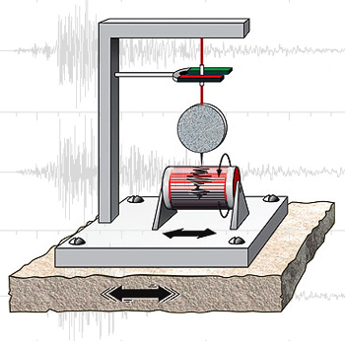

To understand how a seismometer understands waves, we need to understand the basic physics of a seismic wave. There is a high point (crest), low point (trough), the point from crest to center (amplitude) and the crest to crest measurement (wavelength).

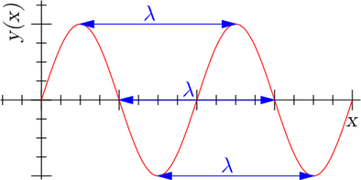

When an earthquake happens, the first to come out is the primary wave. This will be followed by the secondary wave. As the speed between the two are different, it will help in determining where the earthquake is, and the measurement of that earthquake. If the primary is followed by the secondary quickly, it’s close. If the time is more spread apart, then the further the quake is.

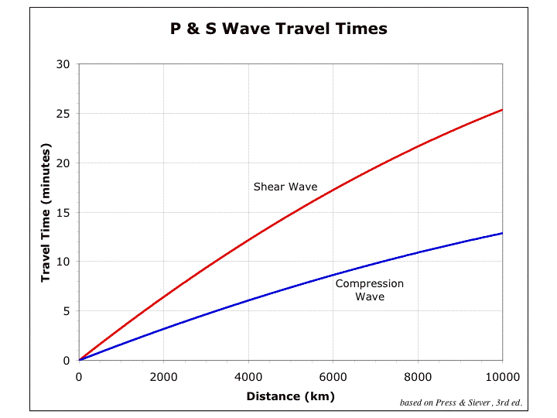

In the example above, the primary is the blue line, the secondary is the red. At the 10 minute marker, the first wave is around the 7k distance point. However, the secondary wave is still around the 3200km distance point, and won’t hit 7km until around 20 minutes. This is due to the compression wave traveling around the speed of around 6km/s (this can easily be altered due to how many surfaces it’s traveled through), where the secondary wave travels around 3-4km/s.

This wave information is recorded by seismometers, onto seismographs, where the earthquake can be documented as to where it is, and how big it is.

But how are these actually measured? Over the years, many methods have been used, with the most common now being the Richter Scale (in truth, this is the most common, although the Moment Magnitude Scale is the more preferred scale). This scale measures the amplitude of surface movement (surface wave). As shown earlier, the crest to center within the wavelength is the amplitude. The bigger this is, the bigger the quake basically is. The mathematics can be a bit confusing, so here’s some explanation. The distance of the quake is determined by the p and s waves. This S-P interval and the amplitude of the surface wave are calculated together to determine the magnitude of the actual earthquake. It’s stated all over that this scale is logarithmic, meaning that an increase of one is multiplied by ten. Meaning, a 4.0 is ten times bigger than a 3.0.

And that concludes my report on the seismometer and how it uses seismic wave phenomena to measure earthquakes.

Sources:
https://earthquake.usgs.gov/learn/glossary/?term=P%20wave
http://allshookup.org/quakes/wavetype.htm
https://www.britannica.com/science/seismometer
https://sciencing.com/differences-between-waves-8410417.html
https://en.wikipedia.org/wiki/Seismometer
http://www.columbia.edu/~vjd1/earthquakes.htm
https://courses.lumenlearning.com/geophysical/chapter/seismic-waves/

