C++2: Lesson 10 – Interview
Page
1

- Add summary at the top, documentation at the bottom and comments where necessary.
- Recordings and interviews are an exception, but they should be included in your submission code.
- Cite the source of your information.
- Refrain from including anything you don’t fully understand.
1 |  | 100 points  5-min challenge: you will get full credit after you reproduce your work during a class or interview. Use a Binary Tree to count the total number of leaf nodes  steps:  1. Create the following tree structure using TreeNode pointers.  2. Implement a recursive function that returns the number of leaf node.  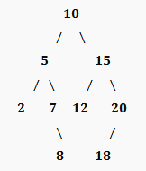  *Do not edit your recordings. The act of editing is considered a form of cheating.
 |  | File(s) to submit | All appropriate .h and/or .cpp source code files as required for the program(s) and .png images of output (e.g. C210_1.h, C210_1.cpp, C210_1.png)  Clickable YouTube link

