C++2: Lesson 9 – Lab Project

- Add summary at the top and comments where necessary.
- Recordings and interviews are an exception, but they should be included in your submission code.
- Cite the source of your information.
- Refrain from including anything you don’t fully understand.
2 | 100 points  Analyze the textbook Tower of Hanoi algorithm and modify it to accept three user inputs:  - Number of disks to be moved.  - Starting rod  - Destination rod  Constraints:  - There are only three rods: A, B, and C. (A is the starting rod)  - The algorithm should correctly move the specified number of disks from the starting rod to the destination rod, following the Tower of Hanoi rules.  Task:  - Implement the modified algorithm.  - Test your implementation with 5 disks as input.  *Learn and play the game online:  🔗 https://www.mathsisfun.com/games/towerofhanoi.html
 | Sample output | Move disk 1 from A to B  Move disk 2 from A to C  Move disk 1 from B to C  …  Total *** moves were made to move all 5 disks from A to C
 | File(s) to submit | All appropriate .h and/or .cpp source code files as required for the program(s) and .png images of output (e.g. C209_2.cpp, C209_2.png)
3 | 100 points  You need to visit four cities (A, B, C, and D) exactly once and return to the starting city A. The goal is to determine the shortest possible route that allows you to visit all cities while minimizing the total travel distance.  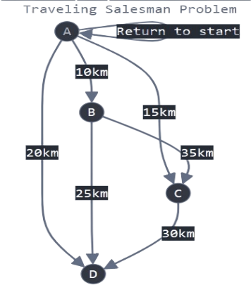  Distance Matrix:  A → B: 10 km  A → C: 15 km  A → D: 20 km  B → C: 35 km  B → D: 25 km  Hints for Solving the Shortest Route Problem  🔹 Base Condition:  - Stop when all cities have been visited.  - Return to the starting city.  - Compute the total travel cost.  🔹 Recursive Condition:  - Loop through all cities.  - If a city is unvisited, mark it as visited.  - Move to that city and add its travel cost.  - Recursively call the function for the next city.  - After returning, backtrack to explore other routes.  🔹 Systematic Approach:  - List all possible routes since there are only 4 cities.  - Total number of routes: 3! = 6 possible arrangements for (B, C, D) after starting at A.  - For each route, calculate the total distance using the distance matrix.  - Add up distances segment by segment from A through all cities and back to A.  - Enumerate and compare possible paths:  - A → B → C → D → A  - A → B → D → C → A  - A → C → B → D → A  - A → C → D → B → A  - A → D → B → C → A  - A → D → C → B → A  - Ensure the return to A is always included in each calculation.  - Compare all six total distances to determine the shortest route.
 | Sample output | Optimal Route: A → ** → ** → ** → A  Minimum Distance: ** km
 | File(s) to submit | All appropriate .h and/or .cpp source code files as required for the program(s) and .png images of output (e.g. C209_3.cpp, C209_3.png)

