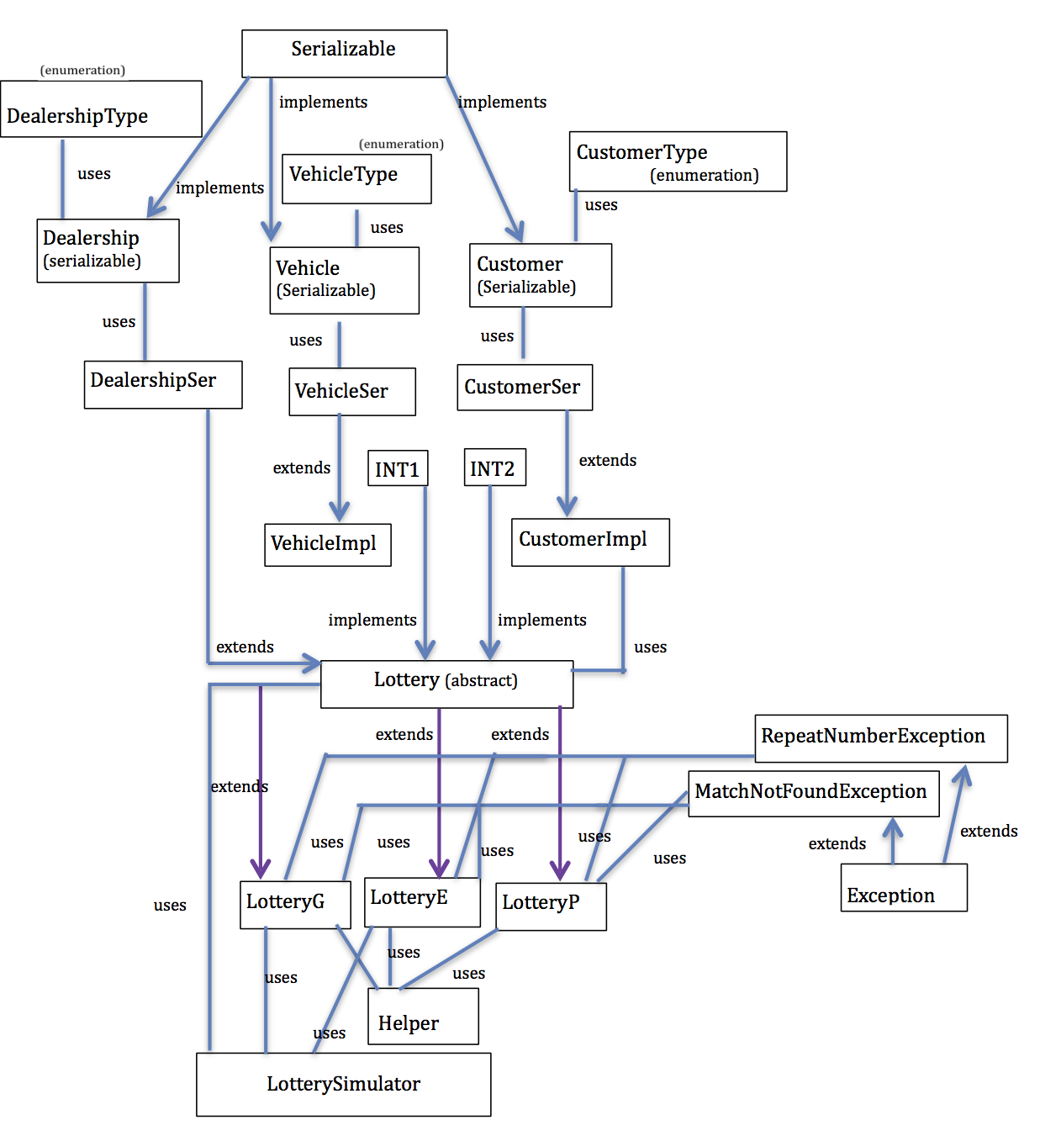Ashwin Jeyaseelan

uses

uses

uses