# Student Book Presentation

With a partner from any section, sign up for a chapter presentation at this link: <https://docs.google.com/spreadsheets/d/1iW_GJjqObja2Q886Od8t_BAA312n9th6xLWEA11aAXk/edit?usp=sharing>.

Two person team selects the book chapter they will present. You are to read the chapter and create a PowerPoint Presentation covering the content of the chapter(s). At the conclusion of the presentation you need to include 3 review questions, at least 4 review questions if you cover 2 chapters, and 6 review questions is you cover 3 chapters.

Time limit is 10 minutes exactly. Come ahead of time prepared for the presentation to start right away. All team members need to talk during the event.

From these questions I will draw the material for the Final Exam.

## Grading

The presentation is worth 100 points (per team member).

|  |  |  |
| --- | --- | --- |
| Points | Category | Grading |
| 20 | Review Questions | Are the proper amount present? |
| 20 | Introduction | 20 - 15 - 10 - 5 - 0 scale |
| 20 | Content of presentation | 20 - 15 - 10 - 5 - 0 scale |
| 20 | Conclusion | 20 - 15 - 10 - 5 - 0 scale |
| 20 | Time of presentation | 20 - 15 - 10 - 5 - 0 scale |

Grading Rubric: How the presentation will be graded

## Books

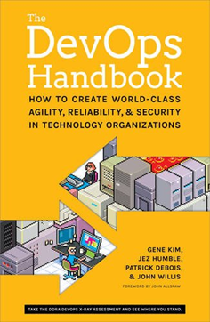

*DevOps Handbook

* DevOps Handbook - How to Create World-Class Agility, Reliability, & Security in Technology Organizations
* Gene Kim, Patrick Debois, John Willis, Jez Humble,
* ISBN-13: 9781942788003
* Publisher: IT Revolution Press
* <http://www.barnesandnoble.com/w/the-devops-handbook-gene-kim/1121371901?ean=9781942788003>

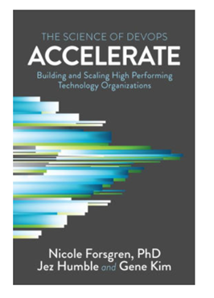

*Accelerate - The Science of DevOps

* Accelerate: The Science of Lean Software and DevOps: Building and Scaling High Performing Technology Organizations by Nicole Forsgren, PhD, Jez Humble, Gene Kim
* ISBN-13: 9781942788331
* Publisher: IT Revolution Press
* [https://www.barnesandnoble.com/w/accelerate-nicole-forsgren-phd/1127477199?ean=9781942788331#/](https://www.barnesandnoble.com/w/accelerate-nicole-forsgren-phd/1127477199?ean=9781942788331#/ " Accelerate Book Order form")

## Chapters by Dates

|  |  |  |
| --- | --- | --- |
| Session | Date | Topic HW Reading |
| 1 | January 14 | Course Introduction |
| 2 | January 21 | Introduction to Tooling & Project Management & Communication |
| 3 | January 28 | Presentations: The Three Ways Ch 1-2 |
| 4 | February 04 | Presentations: Where to Start Ch 3-4 |
| 5 | February 11 | Presentations: Where to Start Ch 5-6 |
| 6 | February 18 | Presentations: Technical Practices of Flow Ch 7-10 |
| 7 | February 25 | Presentations: Technical Practices of Flow Ch 11-13 |
| 8 | March 03 | Presentation: Technical Practices of Feedback Ch 14-18 |
| 9 | March 10 | Presentation: Technical Practices of Learning Ch 19-21 |
| - | March 17 | NO CLASS: Spring Break |
| 10 | March 24 | Presentation: Technical Practices of InfoSec Ch 22-23 |
| 11 | March 31 | Presentation: Accelerate Ch 1-3 |
| 12 | April 07 | Presentation: Accelerate Ch 4-5 |
| 13 | April 14 | Presentation: Accelerate Ch 6-7 |
| 14 | April 21 | Presentation: Accelerate Ch 8-9 |
| 15 | April 28 | Presentation: Accelerate Ch 10-11 & 16 |
| 16 | May 4th–May 10th | Final Exam |

## Deliverable

Each team member submit your PowerPoint to BlackBoard. Name the file: **ITMT-430-Accelerate-X** or **ITMT-430-DevOps-X** with X being the chapter number(s).