CARE Prep #8 Name:_________________________________________
Course: PSWR 1044 Professional Foundations
Ethics, Advocacy, Culture & Conflict Resolution
Instructions: Answer the following questions. Please answer the following questions in your own handwriting. Submit your work exactly as instructed to receive marks.

C — Connect
Question: Explain the difference between ethics, morals, values, and beliefs.
Answer:
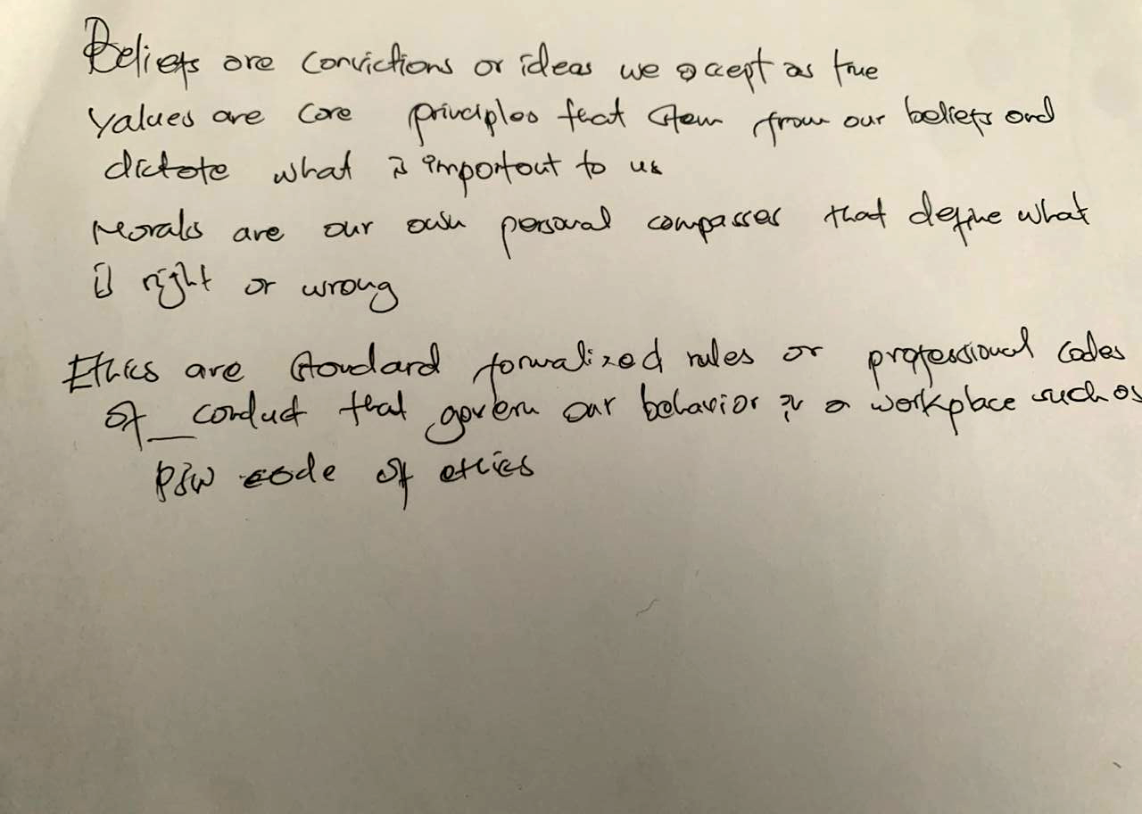
__________________________________________________________________________________
__________________________________________________________________________________
__________________________________________________________________________________

A — Apply
A client refuses a bath and says, “It’s against my cultural practices to bathe at this time of day.” Describe how you would respond in a way that respects autonomy, culture, and ethical practice while still meeting the client’s care needs.
Answer:
___________________________________________________________________________________________________________________________________________________________________________________________________________________________________________________________________________________________________________________________

R — Reference Terms

Term: Advocacy | Definition: ____________________________________________________________________________________________________________________________________________________________________________________________________________________________________________________________
Term: Autonomy & Conflict Resolution | Definition: ____________________________________________________________________________________________________________________________________________________________________________________________________________________________________________________________

E — Essential Knowledge
Question List two barriers that may prevent a PSW from advocating for a client, and explain why effective communication is essential in resolving workplace conflict.
Answer:
1.
______________________________________________________________________________________________________________________________
2. ____________________________________________________________________________________
____________________________________________________________________________________

