|  |
| --- |
| Toyon Research Corporation |
| Lab 3: Output QPSK |
| Chilipepper Tutorial Projects |

|  |
| --- |
| Version 0.3  5/14/2013 |

Table of Contents

Introduction 3

Procedure 3

Objectives 3

Generate HDL Code 4

1.1 MATLAB Functions 4

1.2 MATLAB Test bench 9

1.3 HDL Coder Project 11

Create and Export Simulink Models 13

2.1 Modify Tone Simulink Design 13

2.2 Create MCU Simulink Design 15

2.3 Create DAC driver Simulink Design 16

Configure Cores and Export Design 18

3.1 Needed IP Cores 18

3.2 Configuring the TX Port 19

3.3 Configuring the DAC Driver Port 19

3.4 Configuring the MCU Port 19

3.5 Configuring the Clock Generator IP Core 20

3.6 Pin Assignments 21

Create software project 24

4.1 Creating a new C Project 24

4.2 Debugging with SDK, iMPACT and ChipScope Pro 25

4.3 Debugging with SDK 26

Testing and Design Verification 27

5.1 Verification with ChipScope Pro 27

5.2 MATLAB Analysis 29

Appendix A MATLAB Core Functions 31

Appendix B MATLAB Test Bench 34

Lab 3: Output QPSK

# Introduction

This lab will show you how to transmit a QPSK Waveform on an FPGA Mezzanine Card (FMC) radio board using the Xilinx Zed Board FPGA and the Toyon Chilipepper FMC. The Digital to Analog Conversion (DAC) used to transmit the signal will take place on the Chilipepper board. The Creation and Modulation of the waveform will be done using hardware on the FPGA following the “Black Box” approach used in previous labs. The FMC initialization and microcontroller (MCU) signal control will be handled in software using the Xilinx Software Development Kit (SDK). Finally, the testing of results will be done using ChipScope and MATLAB. This lab assumes prior knowledge of the workings of HDL Coder as well as the Xilinx EDK environment. It is recommended that you complete the previous labs before completing this lab.

This lab is created using:

* MATLAB 2012b
* Xilinx ISE Design Suite 14.3 with EDK and System Generator
* Windows 7, 64-bit

## Procedure

This lab is organized into a series of steps, each including general instructions and supplementary steps, allowing you to take advantage of the lab according to your experience level.

This lab consists of the following basic steps:

* Generate HDL code from MATLAB functions
* Create and export Simulink models using System Generator
* Configure your created PCores and export the design into SDK
* Create software to run your design
* Test and verify your results

## Objectives

After completing this lab, you will be able to:

* Modulate a signal using hardware on the FPGA
* Create a Simulink model to implement a FIFO buffer
* Transmit a QPSK Waveform using the Chilipepper FMC
* Create a software application to test your design
* Verify your results in ChipScope and analyze them using MATLAB

Generate HDL Code Step 1

This section will show you how to create your MATLAB function and test bench files as well as the process for generating the HDL code used in the Simulink model.

## 1.1 MATLAB Functions

Your MATLAB functions will eventually become a core that will be synthesized into hardware. The algorithm describes the operations in each clock cycle, and processes data on a sample-by-sample basis. This lab requires several MATLAB functions all used in conjunction to generate and transmit the QPSK waveform. The first function used is shown in Figure 1-1.



Figure 1‑‑: MATLAB function to Create i and q channel outputs.

This function is primarily used to call other functions which create the waveforms, and format the output before sending it to the DAC.

1. Create a directory for the project under C:\QPSK_Projects\Project_3.
2. Create a new **MATLAB function** with the contents of Figure 1-1.
3. **Save** this function as qpsk_tx.m inside the project directory.

While this function does not play a huge role in creating the modulated signal, it calls other functions which do, the first of which is the function qpsk_tx_byte2sym.m which can be seen in **Appendix A**. The primary purpose of this function is to properly format binary data into symbols which can be transmitted using QPSK. Reviewing the function shows that there are several important aspects to the algorithm, some of which are mentioned below

1. Create a new **MATLAB function** with the contents of Appendix A.
2. The algorithm uses an internal TX_FIFO buffer to store bytes waiting to be transmitted.
3. Initially, nothing is transmitted, and the algorithm simply fills its buffer with data needing to be transmitted.
4. Once all data has been received (indicated by the tx_en_in) the algorithm sends a string of overhead bits consisting of pad bits and header bits.
5. Lastly the algorithm sends the data in its buffer until the buffer is empty, and then activates the tx_done output
6. Save this function as qpsk_tx_byte2sym.m inside the project directory

There is a function called within the qpsk_tx_byte2sym which is used to select a bit to transmit. This function is called mybitget and as seen from the algorithm, it is called twice; once for the i channel and once for the q channel. These bits are then combined by creating a complex number in which i represents the real portion of the number and q the imaginary portion and eventually transmitted as a single waveform. By sending the i and q channel bits simultaneously in this way, the overall transmission requires only sending four two-bit sequences for any given byte. Each two-bit sequence can create one of four different signals, called symbols. The mybitget function is shown in Figure 1-2.



Figure 1‑2: MATLAB Function to select bits for QPSK Symbol creation.

QPSK takes advantage of these two-bit symbols, by using 1 bit to modulate a sine wave and the other bit to modulate a cosine wave. Before modulation, each zero bit is changed from a 0 to a negative 1 (also called a non-return to zero or NRZ signal). The 2 sinusoids are then combined into a single waveform just before being transmitted. The result of the modulation and combining the waveforms causes the phase of the signal to vary according to the table below. The resultant phase possibilities are shown in the right most table. In addition, a plot of each of the symbols on a complex plane (also called a scatter plot) can be seen in Figure 1-3.

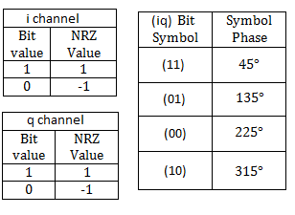

Table -1: The left most tables show NRZ bit values, while the rightmost table shows the symbol phase values.

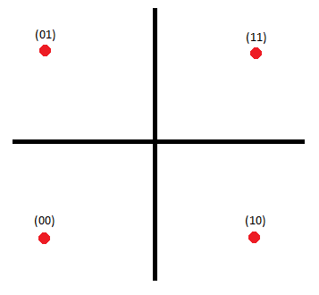

Figure 1‑3: Scatter plot of the QPSK symbols.

1. Create a new **MATLAB function** with the contents of Figure 1-2.
2. **Save** this function as mybitget.m inside the project directory.

The next function used to format the transmit data is called qpsk_srrc. The purpose of this function is to apply a square-root-raised-cosine filter (SRRC) which is used for pulse shaping. This allows for the transmission of the QPSK waveform with a minimal amount of inter symbol interference. The MATLAB function is shown in Figure 1-4 below, and as you can see it uses a variable called SRRC to filter the buffer containing the symbol data. This variable is a look up table (LUT) that was created using the MATLAB function shown in Figure 1-5.



Figure 1‑4: MATLAB function used to filter the transmit data.



Figure 1‑5: MATLAB function to create square-root-raised-cosine filter.

Observing the function in Figure 1-5 reveals how the filter was created in MATLAB and what its parameters are: such as the order and in this case the transition band.

1. Create 2 new **MATLAB function** with the contents of Figure 1-4 and 1-5.
2. **Save** these functions as qpsk_srrc.m and make_srrc_lut.m respectively inside the project directory.

In addition to the LUT required to filter the transmitted data, there is a second LUT which is used to send a header for the QPSK packet. This Header is most commonly used to assist with correctly receiving the transmitted packet. The header used for this lab is called the “Kasami sequence” and it is a sequence of bits (NRZ in this case) which is proven to have very good cross-correlation properties. This means that when using correlation to correctly detect this sequence at the receiver (in the presence of white Gaussian noise) it is highly likely that this sequence can be detected without error. The code to create the LUT is shown in Figure 1-6.



Figure 1‑6: MATLAB function to create Kasami Sequence header for QPSK Packet

1. Create a new **MATLAB function** with the contents of Figure 1-6.
2. **Save** this function as make_train_lut inside the project directory.

## 1.2 MATLAB Test bench

The last MATLAB code required for this core is the test bench script. This script is required for HDL generation, but also allows you to test the functionality of the MATLAB algorithm. The code used for this script is shown in Appendix B. There is a variable called sim in the script which allows you to either load QPSK data from ChipScope or simulate a transmitted QPSK signal in MATLAB and analyze the results. Setting it to 1 simulates the waveform, 0 loads it from a ChipScope prn file.

In addition to the sim variable, there is also a function which is called from within the script called CreateAppend16BitCRC. This function is shown in Figure 1-7. The purpose of this function is to append the 16Bit CRC to the end of the QPSK packet when simulating the packet creation within the test bench. For the actual packet transmission, this process is handled using code run on the MCU.



Figure 1‑7: MATLAB function to append a 16 Bit CRC to the QPSK packet.

1. Create a new **MATLAB script** with the contents of Appendix B.
2. **Save** this script as qpsk_tx_tb.m inside the project directory
3. Create a new **MATLAB function** with the contents of Figure 1-7.
4. **Save** this function as CreateAppend16BitCRC.m inside the project directory
5. **Run** the test bench script in MATLAB (verify the project directory is in the MATLAB PATH variable) to test the algorithm and the lookup tables. You may have to run the make_trig_lut.m and make_srrc_lut.m functions first to create the lookup tables.

Feel free to change the simulation ASCII message to experiment with different characters and lengths. In addition it may be helpful to view a scatter plot of the resultant waveform to verify the phase angles of the QPSK symbols.

**Note**

1. Once you have verified that your algorithm is correct, proceed to the next step of the lab.

## 



If you don’t have the Communications System Toolbox installed, you may get an error message about using the bi2de function. If this occurs, use the alternative given in figure 1.8

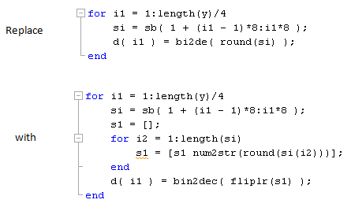

Figure 1‑8: Work around for decimal conversion with no Communications System Toolbox



Additionally, without the Communications System Toolbox you cannot create the Kasami Sequence. In this case, download the TB_i and TB_q m files separately, and remove the make_train_lut reference from the test bench script

## 1.3 HDL Coder Project

Using the same steps outlined in the previous labs, create a new HDL coder project called transmit_qpsk. Add your MATLAB function qpsk_tx.m and your test bench script qpsk_tx_tb.m to the **MATLAB Function** and **MATLAB Test Bench** categories respectively. Your file dependency Tree for the qpsk project should look like Figure 1-9 below.



The sim parameter in your test bench script should be set to 1 before you add it to the HDL coder project! You should also comment out the line which loads ChipScope data (xlLoadChipScopeData) as it may cause file path errors.

1. Once inside the workflow advisor screen, configure the **Clocks & Ports** settings as well as the **Black Box Generator** settings (See lab 0).
2. Right-click **Propose Fixed-Point Types,** and select **Run to Selected Task.** For this Lab, most of the proposed types do not require changes. However in the qpsk_tx_byte2sym function, changes your settings to resemble the ones shown in Figure 1-10.

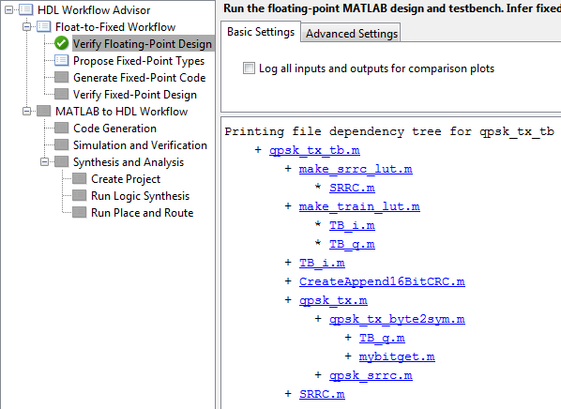

1‑9: Project File dependency for HDL Coder project

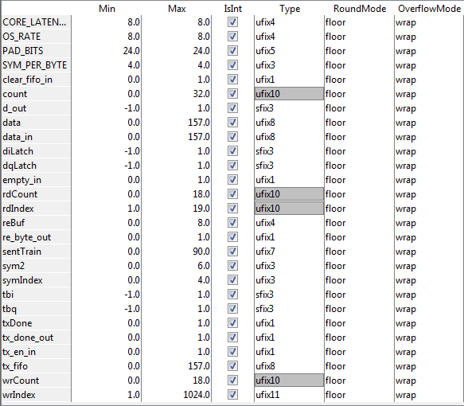

Figure 1‑10: Variable types for the qpsk_tx_byte2sym MATLAB Algorithm

1. Once you have corrected the **Type** setting for all your variables, right-click **Code Generation,** and select **Run to Selected Task**. A Simulink model containing your design should appear after the task is completed.

Create and Export Simulink Models Step 2

This section will show you how to customize your Simulink Models to generate the QPSK waveform and control the Chilipepper MCU and DAC.

## 2.1 Modify Tone Simulink Design

1. As in the previous labs, you first need to copy and paste the contents of the design into a **new** **Simulink Model**. Call this new model tx.slx, and **save** it into the **Sysgen** **folder**.
2. Once you have created your new model, add blocks from the Xilinx blockset library to create a model similar to the one shown in Figure 2-1. Configure the blocks using the following.
   1. The assert block should be configured to assert the rate **explicitly**, with sample rate 1.
   2. Convert 1 should have a **Boolean** output type.
   3. Configure the **From FIFO** block as follows: **Shared memory name** tx_fifo; **Ownership** Owned elsewhere; **Memory type** Block RAM; **Performance Options** Standard FIFO; **Depth** 16; **BITS of precision to use for % full port** 1.
   4. Convert 2 should have a **Fixed-point** output type, **unsigned** with 1 bit and **no binary points.** Set the Quantization and Overflow to **Truncate** and **Wrap** respectively.
   5. The constant is a **Fixed-point** **unsigned** 0 constant with 1 bit and **no binary points**. It is a **sampled** constant with a period of 1.
   6. The two **From Registers** should have the names changed to those shown in the figure. They are **owned** and **initialized elsewhere** with a sample period of 1. Additionally both registers are **Fixed-point** and **unsigned** with 1 bit and no binary points.
   7. The counter is a Free running up counter with an initial value of 0 and a step of 1. Set it as an **unsigned** value with **single bit precision**, **no binary points**, and **explicit period** one.
   8. Convert 3 converts the value of this counter to **Boolean** with **0 Latency**.
   9. The To Register should also have its named changed to the one shown in the figure. It is **locally owned and initialized** with a value of 0. Specify the output type as **unsigned**, **Fixed-point**, and 1 bit with 0 binary points.
   10. The blinky subsystem is the same one used from the previous labs
   11. Lastly, the ChipScope block should have **8 trigger ports**, 0 display settings, **1 match unit** with a basic match type, and can use the **trigger ports as data**. Set the depth of the capture to **4096** and select both checkboxes under Implementation.

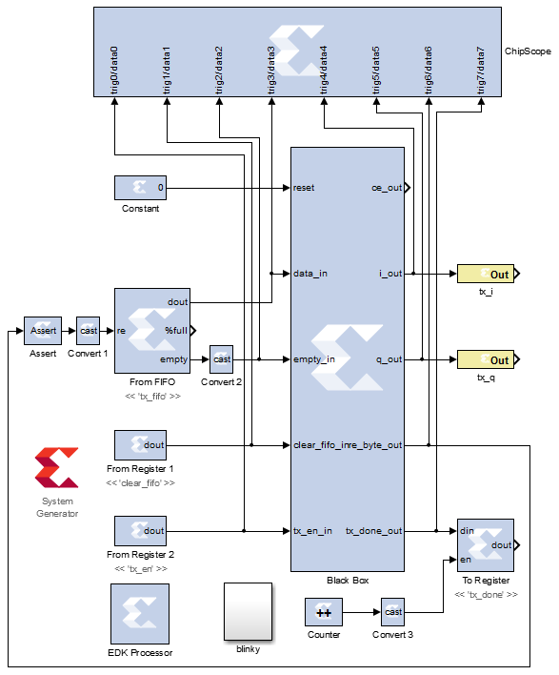

Figure 2‑1: Simulink model for tx.slx

1. Now configure the **System Generator** using the same method used in the previous labs. **Save** the design, and **modify** the cfg file to find the files in your new directory structure.

Make sure you sync the EDK Processor to the memory mapped registers using the method used in the previous labs

**Note**



## 2.2 Create MCU Simulink Design

The [Simulink model](https://github.com/rcagley/Chilipepper/tree/master/Labs/Lab_3/sysgen)**[1]** in Figure 2-2 will be used for the control signals to and from the **MCU**. This is the same model used in the previous labs.

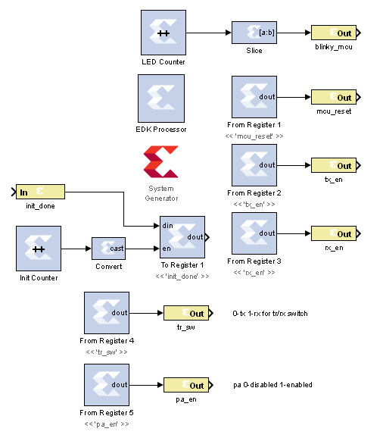

Figure 2‑2: Simulink model for MCU control

1. **Configure** this model and the system generator the same as in previous labs, and **save** the design. Name the file **mcu.slx** or something similar using the appropriate directory structures.

## 2.3 Create DAC driver Simulink Design

The [Simulink model](https://github.com/rcagley/Chilipepper/tree/master/Labs/Lab_3/sysgen)**[2]** In Figure 2-3 will be used for creating the signals which interface to the DAC. This is the same model used in Lab 2.

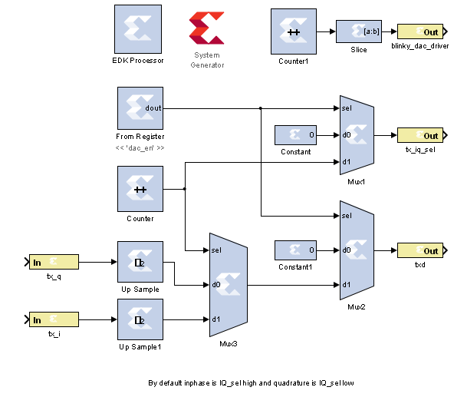

Figure 2‑3: Simulink model for DAC control

1. **Configure** this model and the system generator the same as in previous labs, and **save** the design. Name the file **dac_driver.slx** or something similar using the appropriate directory structures.

Refer to the previous labs to **Create a New Blank EDK Project**. Be sure to follow the directory structure used. Once your project is created, **export** each model 1 by 1 into the newly created EDK project. Verify your **Compilation Settings** are correct and refer to previous labs as a reference if needed. Once each Simulink model has been exported successfully, you’re ready to configure your FPGA design.

Configure Cores and Export Design Step 3

This section will show you how to integrate your PCores into your FPGA design using EDK. There are several components that must be configured for the design of this project. A quick list of the cores needed is given below. Refer to previous labs for information on how to add cores to the design.



## 3.1 Needed IP Cores

* TX PCore created in Simulink
* DAC Driver PCore created in Simulink
* MCU PCore created in Simulink
* Clock Generator IP Core
* AXI_UART (Lite) Core
* GPIO Cores for LEDs, Switches and Buttons
* Processing System IP Core
* AXI Interconnect IP Core

In addition, several of these cores will require external ports. Be sure that you have access to modifying the external port settings. Refer to Figure 3-1 Below.

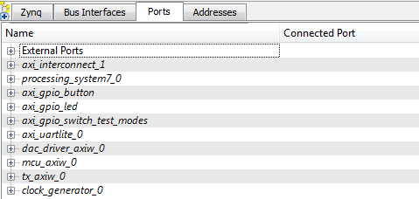

Figure 3‑1: EDK project ports list

## 3.2 Configuring the TX Port

Configure the port as the following.

1. The blinky_tx pin should be sent to the external ports.
2. The tx_i and tx_q lines should connect to the tx_i and tx_q lines on the DAC driver.

## 3.3 Configuring the DAC Driver Port

The DAC Driver port in this lab should be configured identically to the DAC Driver port in lab 1.

## 3.4 Configuring the MCU Port

The MCU port in this lab should be configured identically to the MCU port in the previous labs.

## 3.5 Configuring the LEDs GPIO Port

This port will be used later in SDK to verify the functionality of the transmitter.

1. Add an AXI General Purpose IO to the design. Check the box to Enable Channel 2 and give each channel a width of 1 bit. Name the port axi_gpio_led or something similar.
2. Expand the IO_IF section of the GPIO, and assign the GPIO_IO and GPIO2_IO pins to external ports. The other pins can be left blank.

## 3.6 Configuring the Switch GPIO Port

This port will be used later in SDK to change the transmit mode.

1. Add an AXI General Purpose IO to the design. Leave both boxes unchecked and give channel 1 a width of 2 bits. Name the port axi_gpio_switch_test_modes or something similar.
2. Expand the IO_IF section of the GPIO, and assign the GPIO_IO pin to an external port. The other pins can be left blank.

## 3.7 Configuring the Button GPIO Port

This port will be used later in SDK to transmit packets individually.

1. Add an AXI General Purpose IO to the design Check the box to Support Interrupts. Give channel 1 a width of 1 bit and check the box for Channel 1 to be input only. Name the port axi_gpio_button or something similar.
2. Expand the IO_IF section of the GPIO, and assign the GPIO_IO_I pin to an external port. The other pins can be left blank.

## 3.8 Configuring the Clock Generator IP Core

The Clock Generator is used in this project to distribute the appropriate clock signals to each of the PCores, as well as any external hardware which may require a clock signal. For this project, the Clock Generator is sourced from the 40 MHz pll_clk_out on the Chilipepper radio board (as described in the **Chilipepper user’s guide**). This signal is then distributed to 4 other devices; 3 PCores (TX, MCU and DAC) and the TX_CLK signal which latches data from the FPGA to the DAC on the radio board.

1. **Double click** the Clock Generator PCore and **configure** the settings as follows

* Input Clock Frequency of **40Mhz**
* CLKFBIN Required Frequency of **40Mhz** with **no Clock Deskew**
* CLKFBOUT Required Frequency of **40Mhz**, Required Group **PLLE0**, and **Buffered True**
* CLKOUT0 Required Frequency of **20MHz**, 0Phase, **PLLE0** group and **Buffered true**
* CLKOUT1 Required frequency of **40Mhz**, 0Phase, **PLLE0** group and **Buffered true**
* CLKOUT2 Required Frequency of **20MHz**, 0Phase, **PLLE0** group and **Buffered true**
* CLKOUT3 Required Frequency of **40MHz**, 0Phase, **PLLE0** group and **Buffered true**

Now that the settings are configured you should have several clocks in your clock generator list.

1. **Connect** the pins according to the following.

* CLKIN External Ports
* CLKOUT0 tx::sysgen_clk
* CLKOUT1 dac_driver::sysgen_clk
* CLKOUT2 mcu::sysgen_clk
* CLKOUT3 External Ports
* CLKFBIN CLKFBOUT
* RST net_gnd
* LOCKED External Port

Your Clock Generator port should look similar to Figure 3-2 below.

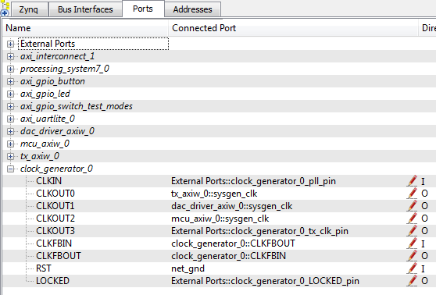

Figure 3‑2: Clock Generator port configuration

## 3.6 Pin Assignments

Once the clock generator is configured correctly, the sysgen clock for the other cores should be set as well. The last step is to setup the **pin assignments** for the external ports.

1. **Rename** the pins of the external ports so they are easily identifiable. Figure 3-3 shows the names used in this demo, however you don’t have to use the same naming convention.
2. Fill in the pin out information for your design using Figure 3-3 below as a reference.



Figure 3‑3: EDK project pin assignments



Verify that the **orientation** of the TXD pins is set correctly. If you follow the pin list in the figure above, you must **reverse** the TXD pins in the external ports assignment section. This is done using the same method used in Lab 0 Section 5.2 for the LEDs.

At the time of this tutorial, Xilinx had a [documented issue](http://www.xilinx.com/support/answers/51739.htm)[3] with AXI-bus generation for Simulink PCores targeting the Zynq FPGA. Refer to this issue for more information. As in Lab 0 section 5.2, this bug must be corrected for our project. The steps to perform are identical to those in the previous labs; however they must be performed for **both** of the PCores used in this lab.

Once the fix is applied, you’re ready to generate your bitstream file! Select the **Export Design** button from the navigator window on the left. Click the **Export and Launch SDK** button. This process may take awhile.

Create software project Step 4

Once the design is compiled and exported, you’ll be greeted with a screen asking you where you would like to store your software project. It is very helpful to create the workspace folder in the same directory as your Sysgen and EDK folders. Doing this will keep all relevant files in the same location.



## 4.1 Creating a new C Project

This section will show you how to create a C program to test your QPSK project. There are several source files[4] which are required to support your software application. Some of the files are created when you create your new C project and do not need to be modified. A list of the files which are not created automatically and/or need to be modified is listed below with a link to download them.

1. [main.c](https://github.com/rcagley/Chilipepper/blob/master/Labs/Lab%203/workspace/hello_world/src/helloworld.c) – This file is created when you create your Hello World template project. (see previous labs). It has been renamed from HelloWorld.c to main.c appropriately. It should be modified to look similar to the file found on the website.
2. [Chilipepper.c](https://github.com/rcagley/Chilipepper/blob/master/Labs/Lab%203/workspace/hello_world/src/Chilipepper.c) – This file needs to be created. There are three main functions associated with this file. The first function is Chilipepper_Initialize, which is handled similarly to the previous labs. The next is Chilipepper_AppendCrc which handles adding the CRC to the end of the packet. The last important function within this file is Chilipepper_WriteTestPacket which handles creating a packet to transmit based on a user input string.
3. [Chilipepper.h](https://github.com/rcagley/Chilipepper/blob/master/Labs/Lab%203/workspace/hello_world/src/Chilipepper.h) – This file holds the function prototypes for the Chilipepper.c functions.
4. In addition to the files given, you also need to include a Math library which contains the pow function that is used when creating the CRC.
   1. Right click on your project, and select C/C++ Build Settings.
   2. Under ARM gcc linker, select Libraries.
   3. Click the  button in the Libraries (-l) section, and type ‘m’ then hit ok. This adds the math library needed to use this function. Hit apply and Ok to return to your project.

## 4.2 Debugging with SDK, iMPACT and ChipScope Pro

Once your program is written and compiled you are ready to test the design! This is done by programming the FPGA with your hardware descriptions defined in the bit file generated in EDK, and running your software on top of this design.

1. Connect the Chilipepper to the FPGA board and verify all cables are connected properly and the jumper settings are correct. Verify this by using the *Chilipepper user guide* and the *ZED Board Hardware users guide* as a reference. Also See Lab 0 for details on Jumper Configuration.
2. Once the FPGA and radio board are connected correctly, turn on the board.
3. Open iMPACT in the ISE Design tools.
4. Select no if Impact asks you to load the last saved project.
5. Select yes to allow iMPACT to automatically create a new project for you. If you receive any connection errors, verify your USB or JTAG programmer cables are connected properly.
6. Select the Automatic option for the JTAG boundary scan setting and click ok.
7. Hit yes to assign configuration files. Bypass the first file selection, but for the second selection, browse to the location of your system.bit file. It should be inside the “Implementation” folder of your EDK project folder.
8. Select ok on the next screen verifying that the board displayed is your Zynq xc7z020 board. It should look similar to Figure 4-1 below.
9. Right click on the xc7z020 board icon (should be on the right), select program and hit ok.

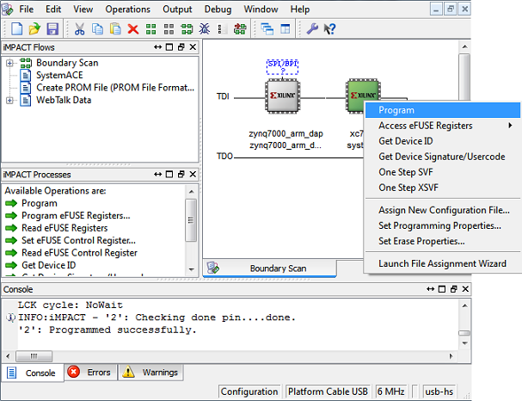

4‑1: iMPACT configuration screen

## 4.3 Debugging with SDK

If the hardware design is correct, you should see the LEDs start blinking on the board, as well as a blue light indicating the program was successful. You can now return to the SDK project screen to test your software.

1. Test it by **right clicking** the hello_world project folder and selecting **Debug As** 🡪 **Launch on Hardware**.
2. You should now be taken to a screen which shows the first init_platform function as highlighted. You can now start the software program by clicking the  (play) button in the top menu.

If the software initialization worked, you should see a green light on the Chilipepper.

Testing and Design Verification Step 5

## 5.1 Verification with ChipScope Pro

There are several methods available for verifying the QPSK transmission. This lab focuses on verification using ChipScope Pro, as well as exporting to MATLAB for further analysis. In addition, if you have multiple boards available, you can also verify the transmission by receiving the QPSK packet on your second board (more is covered on this topic in future labs).

1. To verify the received signal, you will need to open **ChipScope Pro Analyzer**. Be sure that the JTAG cable is connected to the FPGA board properly (or the 6 pin output of the Chilipepper).
2. Once the program opens, click the  (open cable) button to open your JTAG connection to the board. If your jumpers are configured correctly, you should see the following devices on the cable.

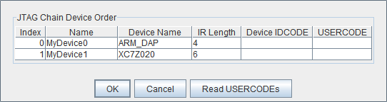

1. Select ok to get to the Analyzer main screen. Open the file menu and select **Import**.
2. Click **Select New File**, and browse to the location of your ChipScope **CDC file**, which is located in the Sysgen/netlist folder of your project directory. This file was created for you when you generated your PCores from your Simulink Model design. It tells the ChipScope program how to interpret the data it is receiving from the JTAG port.
3. Next double click on the **bus plot** option in the New Project menu in the top left hand side of the screen. This will open a window which allows you to view a signal **value vs. time** plot of your waveforms.
4. Under Data Port in the Signals Dev menu on the left side of the screen, right click on the trig4/data4 and trig5/data5 ports, and change their **bus radix** to **signed decimal**. Click OK to accept the default decimal values.
5. On the Bus Plot screen, you can change the color of each of the signals to get a better view of each individual signal. Click the **check box** next to any of the signals you wish to see on the plot.
6. Click the **play button** in the top menu bar to display the signal. Additionally you can set up triggering options for periodic or continuous playback of the received signal. Your received signal should look similar to Figure 5-1 below.

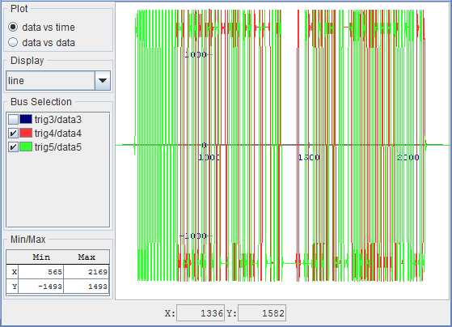

5‑1: both i and q channels of the QPSK waveform in ChipScope Pro

If you changed the message within your C program, your waveform may look slightly different than the one shown here, however you should have the same header padding which can be seen at the front portion of the waveform. It may be helpful to flip the switch to allow for continuous packet transmission (down position) when trying to catch the packet in ChipScope.

## 5.2 MATLAB Analysis

Now that you have verified the transmitted signal, you can get a pretty good idea of what your QPSK waveform looks like in the time domain. However, ChipScope allows you to export the data received directly into MATLAB for further analysis.

1. Before we export the data, we need to format it as best we can using the triggering options within ChipScope.
   1. To start, under **Trigger Setup**, set the **depth** of the capture to **4096**. Your depth may be longer if you created a long test message, however this should be fine for the Hello World example presented here.
   2. For this example, we will set our **trigger** to occur when **trig2/data2** is **not equal to zero**. This occurs anytime the FIFO buffer is not empty, and indicates that we are sending data to the buffer to be transmitted.
   3. In the **Match** section of **Trigger Setup**, change the triggering function for **Match** Unit **M2** to <> and the Value to one.
   4. In the **Trig** section, make sure your condition is active, and set the **Condition** equation to **M2**.
2. Now when you hit play, your QPSK data should be near the beginning of your capture.

The MATLAB test bench function will search for any QPSK signal in the variables exported. Be sure that only one broadcast of your ASCII string is within you capture of ChipScope to prevent possible data interference in MATLAB.

**Note**

1. It will be helpful later in your MATLAB code if you rename your **Data Port variables**. Right click on the **trig4/data4** and **trig5/data5** Ports, and **change the names** to something more descriptive, such as tx_i and tx_q respectively. If needed, you can use the Simulink model to find which signal each port has.

Confirm that the names you used for the i and q channel data ports in ChipScope match the names of the i and q channel variables in the MATLAB Test Bench script crated earlier.

**Note**

1. Open the file menu and select **Export**.
2. Click the **ASCII** radio box, select **Bus Plot Buses** under Signals to export, and then click **export**.
3. It is recommended that you save this file into the project directory with your MATLAB files. Call it something descriptive such as **TX.prn**.
4. To test the data in MATLAB, run your test bench script by first navigating to your project directory (this is necessary to load the prn file correctly).
5. Run the test bench with the sim parameter set to 0. You should see your message output with a plot in MATLAB of the QPSK waveform.



Experiment with other ASCII strings in your C code to verify the timing of the buffers. If you notice that your message is incomplete, it’s possible you could be overloading your FIFO buffer before you have a chance to load your message to transmit.

1. MATLAB Core Functions

MATLAB function qpsk_tx_byte2sym.m







1. MATLAB Test Bench

MATLAB script qpsk_tx_tb.m





1. This model can be downloaded from https://github.com/rcagley/Chilipepper/tree/master/Labs/Lab_3/sysgen
2. This model can be downloaded from https://github.com/rcagley/Chilipepper/tree/master/Labs/Lab_3/sysgen
3. Issue can be found at http://www.xilinx.com/support/answers/51739.htm
4. The source files can be found at https://github.com/rcagley/Chilipepper/tree/master/Labs/Lab_3/workspace/hello_world/src