|  |
| --- |
| Toyon Research Corporation |
| Lab 8: Processor Integration |
| Chilipepper Tutorial Projects |

|  |
| --- |
| Version 0.1  5/24/2013 |

Table of Contents

Introduction 3

Procedure 3

Objectives 3

Generate HDL Code 4

1.1 MATLAB Functions 4

1.2 MATLAB Test Bench 5

1.3 RX HDL Coder Project 5

Export Simulink models 10

2.1 Create MCU Simulink Design 10

2.2 Create Receiver Simulink Design 11

2.3 Create ADC driver Simulink Design 13

2.4 DC Offset Core 15

Configure Cores and Export Design 17

3.1 Needed IP Cores 17

3.2 Configuring the Pcore Ports 18

3.3 Pin Assignments 18

Create software project 20

4.1 Creating a new C Project 20

4.2 Adding Supporting files 21

4.3 Loading Hardware Platform with iMPACT 22

4.4 Debugging with SDK 24

Testing and Design Verification 25

5.1 Verification with Terminal 25

Appendix A Core MATLAB rx Function 26

Appendix B MATLAB Frequency Offset Correction 28

Appendix C MATLAB Timing Offset Correction 30

Appendix D MATLAB Correlation Function 32

Appendix E main.c 36

Lab 8: Processor Integration

# Introduction

This lab will extend the previous labs and allow you to interface your receive core to the Xilinx MicroBlaze Processor. The Focus of this integration will be on sending a message via button press on the FPGA using Lab 3, receiving the transmitted QPSK waveform on a second FPGA using lab 7, and outputting this message directly to a Terminal by extending the lab 6 SDK project. The lab will assume the message was received using a second Chilipepper board however if you do not have two boards, you can extend lab 3 by allowing a user to input a message to the Tx core via terminal, export the transmitted QPSK waveform using ChipScope, and use MATLAB to analyze the transmitted message. Both the transmit and receive core created in the previous labs will be used in this lab, and prior knowledge of the workings of HDL Coder as well as the Xilinx EDK environment is assumed. It is recommended that you complete the previous labs before completing this lab.

This lab is created using:

* MATLAB 2013a
* Xilinx ISE Design Suite 14.4 with EDK and System Generator
* Windows 7, 64-bit

## Procedure

This lab is organized into a series of steps, each including general instructions and supplementary steps, allowing you to take advantage of the lab according to your experience level.

This lab consists of the following basic steps:

* Create and export Simulink models using System Generator
* Configure your created PCores and export the design into SDK
* Create software to run your design
* Test and verify your results

## Objectives

After completing this lab, you will be able to:

* Create a Simulink model to interface your PCore to the MicroBlaze Processor
* Send and Receive a QPSK Waveform using the Chilipepper FMC
* Send output to the MicroBlaze Processor Serial Port
* Create a software application to test your design
* Verify your results in ChipScope and analyze them using MATLAB

Generate HDL Code Step 1

This section will show you how to create your MATLAB function and test bench files as well as the process for generating the HDL code used in the Simulink model.

## 1.1 MATLAB Functions

Your MATLAB functions will eventually become a core that will be synthesized into hardware. The algorithm describes the operations in each clock cycle, and processes data on a sample-by-sample basis. This lab builds on the MATLAB algorithm used in Lab 7 and adds processor integration with the FPGA MicroBlaze. This is an important step towards allowing for the FPGA code created in SDK to have full control over the underlying workings of the transmit and receive algorithms written in MATLAB. To add this functionality to the existing receiver algorithm, we need to make several small changes to the MATLAB files used in the previous labs. The first function we must modify is the qpsk_rx function used in the previous labs. This function was at the core of our qpsk receiver and allowed us to call other important functions such as those used for timing and frequency correction. The modified version of this function is shown in appendix A. This function is almost identical to the one used in the previous lab, we have simply added several signals which allow for more control of the inner working of each function.

1. Create a directory for the project under C:\QPSK_Projects\Project_8.
2. Create a MATLAB directory within the main project directory.
3. Create a new **MATLAB function** with the contents of Appendix A.
4. **Save** this function as qpsk_rx.m inside the project directory.

The first function called by rx_qpsk which needs to be modified is qpsk_rx_foc. This function simply needs to add an input parameter which can be used to reset the frequency offset to zero after a packet has been fully received. The new function is shown in Appendix B.

1. Create a new **MATLAB function** with the contents of Appendix B.
2. Save this function as qpsk_rx_foc.m inside the MATLAB project directory

The next function we will modify is qpsk_rx_toc. Just like the previous modification, the timing estimate needs to be reset after a packet has been received successfully. The new function is shown in Appendix C

1. Create a new **MATLAB function** with the contents of Appendix C.
2. Save this function as qpsk_rx_foc.m inside the MATLAB project directory

The last function called by rx_qpsk that needs a slight modification is the qpsk_rx_correlator function created in Lab 7. Like the previous two modification, we will add an input to allow for more control over the functionality of the algorithm. In this case however, it is used primarily to let the correlator know when it can start decoding and sending bits, as the MCU is ready to receive them and transfer them out the serial port. If the MCU is not ready, the correlator should not attempt to decode the signal to find a packet. In addition, there are a few signals added to allow the correlator to communicate to the processor when it has finished its byte translation, and also how many bytes are ready to be transferred into the buffer. The new function is shown in Appendix D.

1. Create a new **MATLAB function** with the contents of Appendix D.
2. Save this function as qpsk_rx_correlator.m inside the MATLAB project directory.

**Note**

Optionally you can download any of these MATLAB files from the GitHub[1] Repo.

## 1.2 MATLAB Test Bench

Now that you have made the modifications to the algorithm needed for processor integration, we need to modify our test bench script slightly to send and receive these new signals.

1. Create a new **MATLAB function** with the contents of Appendix E.
2. Save this function as qpsk_tb.m inside the MATLAB project directory.

This function doesn’t do much in terms of testing the integration portion of the design, but running it should at least verify that there are no errors in your MATLAB functions. Once you verify that you’re able to decode the simulated message, you’re ready to compile your design in HDL coder.

## 1.3 RX HDL Coder Project

Using the same steps outlined in the previous labs, create a new HDL coder project called rx_qpsk. Add your MATLAB function qpsk_rx.m and your test bench script qpsk_tb.m to the **MATLAB Function** and **MATLAB Test Bench** categories respectively.

Once you open your Workflow Advisor, you should be greeted with a screen similar to Figure 1-4 which allows you to define input types for your function. You can also allow them to be auto-defined by simply selecting run, and letting MATLAB analyze your design. For the inputs listed for the qpsk_rx function, the auto-defined types are fine.

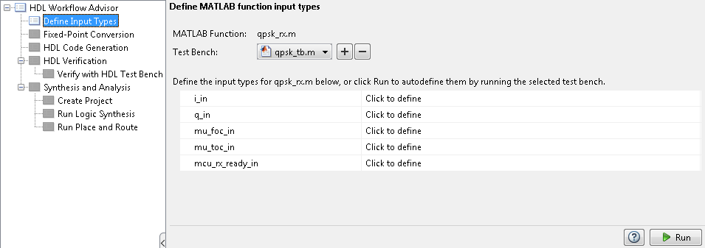

Figure 1‑4: HDL Code Generation Workflow Advisor

1. Open Workflow Advisor and select “Run” to define the input types.
2. Click on Fixed-Point Conversion and select run this task. This process may take awhile.

Once the process is completed, you should receive a popup that says “Validation succeeded”. This means that MATLAB has successfully analyzed your design and selected fixed point types to replace the floating point arithmetic required in your algorithm. However, not all of the automatic selections are sufficient for our FPGA design; therefore several of the conversions will need to be modified.

1. Using the function dropdown menu at the top of the HDL Code Generation screen, select each of the functions in the design and make the following modifications.

Many of the Fixed-Point conversions are the same as those used in the previous labs. For your convenience, this lab only shows the Functions which have more input/output variables than the previous labs, and whose proposed types need to be modified. Refer to the previous lab for information on all other proposed types.

**Note**

**qpsk_rx**

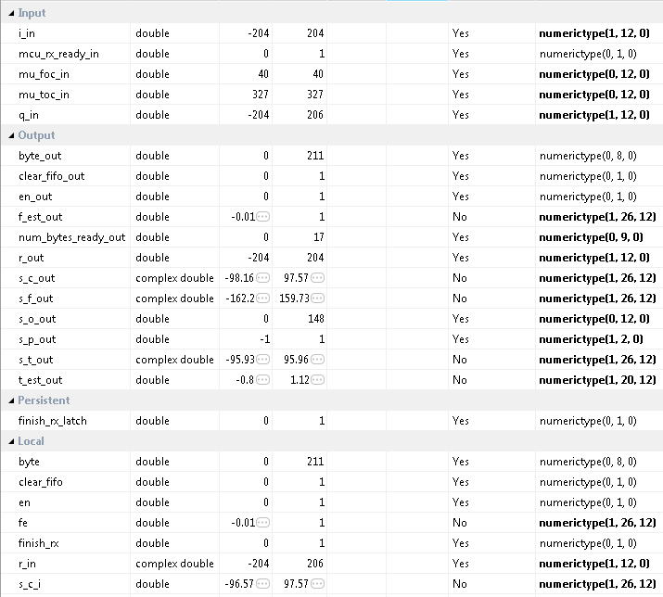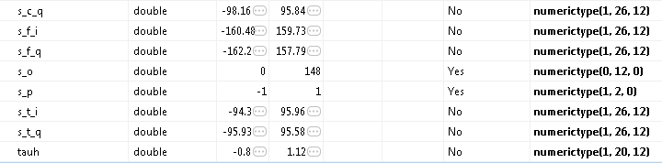

**qpsk_rx_correlator**

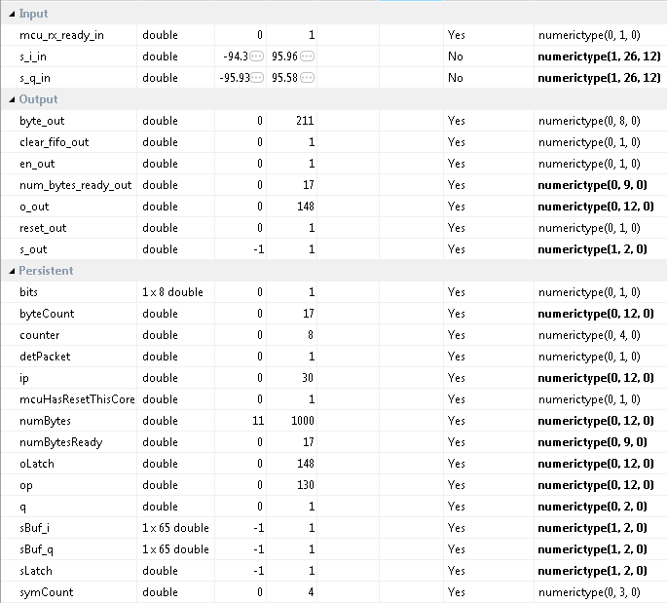

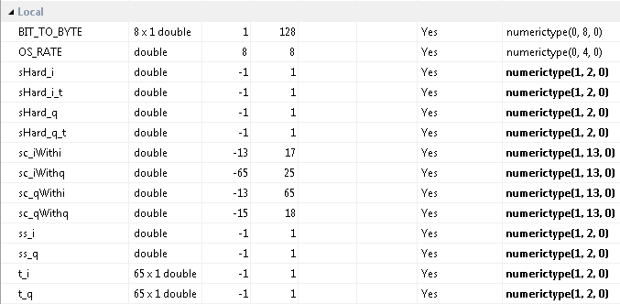

Once all modifications have been made, select “Validate Types” in the top right area of the top toolbar to verify the design for your modified Fixed-Point conversions. Again, once the process is complete, you should get a message saying Validation Succeeded.

1. Select Validate Types to verify the new design
2. Click on HDL Code Generation and modify the settings according to the previous labs. There is no pipelining required for this project. Right Click and select run this task to generate your Xilinx Block Box Design.
3. Once created, copy the black box and System generator Blocks to a new Model just as in the previous labs.
4. Save the new model as rx.slx into the sysgen directory “Lab_7\sysgen”.
5. Copy the qpsk_rx_FixPt_xsgbbxcfg.m file into your Sysgen folder just as in the previous labs.
6. Create the hdl folder inside the Sysgen folder and copy your vhd files into this directory. Make sure you modify the previously copied m file to point to the new location of the vhd files.

Export Simulink models Step 2

This section will show you which of the previously created Simulink Models will be used for this lab. It is assumed you have completed the previous labs and have already created the needed Simulink models.

## 2.1 Create MCU Simulink Design

The **Simulink model[2]** in Figure 2-1 will be used for the control signals to and from the **MCU**.

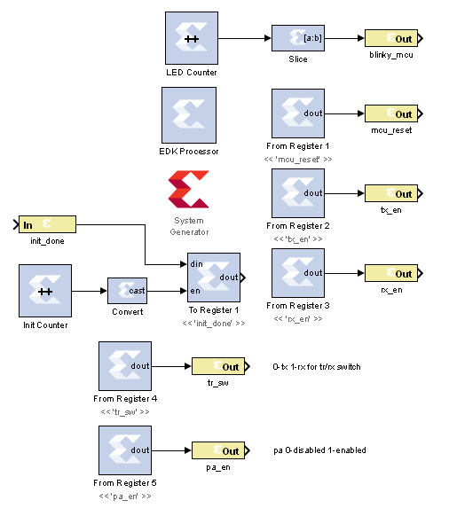

Figure 2‑1: Simulink model for MCU control

1. **Configure** this model and the system generator the same as in Lab 1, and **save** the design into the Sysgen folder. Name the file **mcu.slx** or something similar.

## 

## 2.2 Create Receiver Simulink Design

The **Simulink model[3]** In Figure 2-2 will be used for receiving the ADC output and decoding the QPSK waveform.

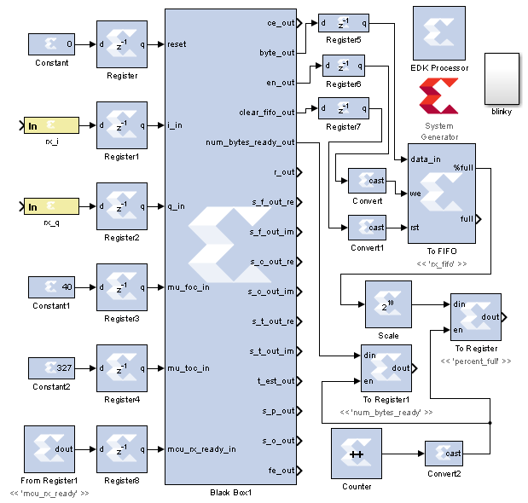

Figure 2‑2: Simulink model for receiving DC Offset output

1. **Modify** the Simulink model rx.slx created earlier to look similar to Figure 2.2. The model is very similar to the one used in the previous labs.
2. The Convert blocks should all be configured as a Boolean output type.
3. The To FIFO should have the settings shown in Figure 2-3.

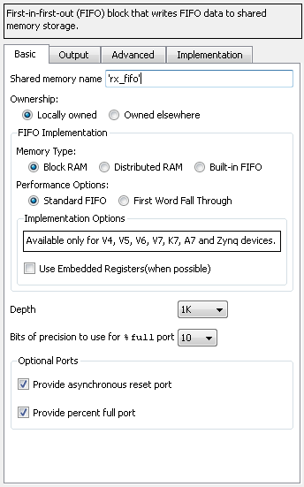

Figure 2‑3: Settings for the To FIFO block

1. The scale factor block should be set to 10.
2. Setup the counter as an unsigned 1 bit single step size free running up counter so that it will simply toggle on and off.
3. **Save** the design into the Sysgen folder. **Be sure to move and modify the cfg file as well to find the files in your new directory structure.** Name the file **rx.slx** or something similar.

## 2.3 Create ADC driver Simulink Design

The **Simulink model[4]** In Figure 2-4 will be used for creating the signals which drive the **ADC** on Chilipepper.

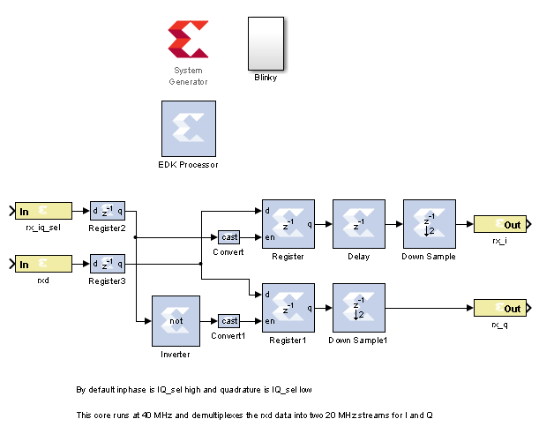

Figure 2‑4: Simulink model for ADC control

1. **Create** a new Simulink model and add the components from the Simulink blockset.
2. The white box labeled “Blinky” is simply a subsystem of the **Counter** **Slice** and LED **Gateway Out** blocks. The Blocks used for this subsystem are shown in Figure 2-5. Configure the Blinky subsystem identically to the other LED out systems in the previous labs.

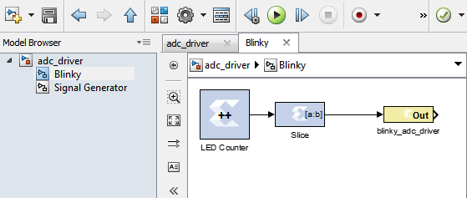

Figure 2‑5: Blinky Subsystem

## DC Offset Core

The last **Simulink model** [5]needed for this FPGA design is the DC Offset model created in a previous lab. For your reference this model is shown in Figure 2-6 below.

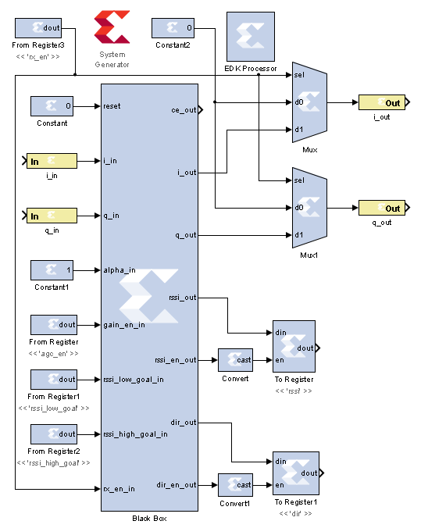

Figure 2‑6: Simulink model for receiving ADC output and applying DC Offset Correction

1. Copy the DC_Offset Simulink files into your new project directory.

Be sure to copy the vhd and config files to the new directory. You may use the Simulink files on the GitHub Repo as a reference. Additionally, you can open the old DC_Offset Simulink model and reconfigure its Pcore settings to point to the new EDK project directory, then recreate it.

**Note**

**Note**

Refer to Lab 0 Step 3 to **Create a New Blank EDK Project**. Be sure to follow the directory structure used. Once your project is created, **export** each model 1 by 1 into the newly created EDK project. Be sure your **Compilation Settings** are correct as shown in Lab 0 Section 4.1. Once each Simulink model has been exported successfully, you’re ready to configure your FPGA design.

Configure Cores and Export Design Step 3

This section will show you how to integrate your PCores into your FPGA design using EDK. There are several components that must be configured for the design of this project. A quick list of the cores needed is given below. Refer to lab 0 sections 4.3 and 5.1 for information on how to add cores to the design.



## 3.1 Needed IP Cores

* ADC Driver PCore created in Simulink
* MCU PCore created in Simulink
* rx PCore created in Simulink
* DC Offset PCore created in Simulink
* Clock Generator IP Core
* Processing System IP Core
* AXI Interconnect IP Core
* GPIO Cores for LEDs
* AXI_UART (Lite) Core

In addition, several of these cores will require external ports. Be sure that you have access to modifying the external port settings. Refer to Figure 3-1 Below.

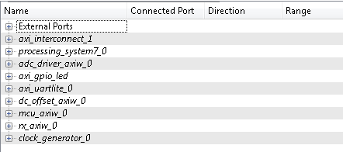

Figure 3‑1: EDK project ports list

## 3.2 Configuring the Pcore Ports

Each of the ports used in this lab can be configured exactly as the previous labs design. Refer to Lab 5 for more information on individual port configuration.

## 3.3 Pin Assignments

Once the ports are configured correctly, the sysgen clock for the cores should be set as well. The last step is to setup the **pin assignments** for the external ports.

1. Rename the pins of the external ports so they are easily identifiable. Figure 3-2 shows the names used in this demo, however you don’t have to use the same naming convention.
2. Open the **Project** tab.
3. Double-click on the **UCF File: data\system.ucf** from this panel, to open the constraints file.
4. Fill in the pin out information for your design using Figure 3-2 below as a reference.



Be sure that the **orientation** of the RXD pins is set correctly. If you follow the pin list in the figure above, you must **reverse** the RXD pins in the external ports assignment section. This is done using the same method used in Lab 0 Section 5.2 for the LEDs.

1. Prior to EDK version 14.4, Xilinx had a [documented issue](http://www.xilinx.com/support/answers/51739.htm)[6] with AXI-bus generation for Simulink PCores targeting the Zynq FPGA. Refer to this issue for more information. As in Lab 0 section 5.2, this bug must be corrected if your **EDK version** is **14.3 or lower**. The steps to perform are identical to those in the previous labs; however they must be performed for **all** of the PCores used in this lab.
2. Select the **Export Design** button from the navigator window on the left. Click the **Export and Launch SDK** button. This process may take awhile.



Figure 3‑2: EDK project pin assignments

Create software project Step 4

Once the design is compiled and exported, you’ll be greeted with a screen asking you where you would like to store your software project. It is very helpful to create the workspace folder in the same directory as your Sysgen and EDK folders. Doing this will keep all relevant files in the same location.



## 4.1 Creating a new C Project

This section will show you how to create a C program to test your FPGA design. The primary objectives of this program are to receive a QPSK waveform and communicate through a UART with the Terminal to output the received message.

It would be helpful if you have completed the Embedded System Design tutorial in the *ZedBoard AP SoC Concepts Tools and Techniques Guide*. Refer to Lab 1 for more information on the MCU signal control using C code within SDK.

**Note**

1. Select **File 🡪 New 🡪 Project**.
2. Select **Xilinx 🡪 Application Project,** and hit next.
3. Name the project qpsk_rx or something similar and leave the other settings at their defaults. Hit next.
4. Select **Hello World** from the **Select Project Template** section.
5. Click **Finish**. You should now see your hello_world.c file in your project src folder, as well as a **board support package** (bsp) folder. Feel free to rename this file to main.c or something more appropriate.
6. **Double click** the file to open it and **replace** all of its contents with the code in Appendix E.



If your SDK project cannot find your include files such as “xuartlite.h” and “xparameters.h” you can add these include files manually by selecting Xilinx Tools from the top menu and selecting Repositories. Under Global Repositories, click New and select your EDK project directory. See here [7]for more information

## 4.2 Adding Supporting files

In addition to the main c file, you need the library files for the Chilipepper board. The 2 required files for this Lab are Chilipepper.c and Chilipepper.h and can be found on the githib repo. Place these files in the src directory of your project workspace.

1. [Chilipepper.c](https://github.com/rcagley/Chilipepper/blob/master/Labs/Lab%203/workspace/hello_world/src/Chilipepper.c) – This file is the primary library file for the Chilipepper board. It contains functions for modifying the MCU registers as well as basic helper functions for tasks such as initialization, transmitting, and receiving.
2. [Chilipepper.h](https://github.com/rcagley/Chilipepper/blob/master/Labs/Lab%203/workspace/hello_world/src/Chilipepper.h) – This file holds the function prototypes for the Chilipepper.c functions.

In addition to the Library files, you also need to include a Math library which contains the pow function that is used when creating the CRC. See Lab 3 section 4.1 for more information on how to add the Math Library to your project.

**Note**

The Chilipepper.c library file is configured for both TX and RX cores as well as a UART to talk to the on board MCU and configure its settings. To use the library file properly, you must specify which of these features you will use. To do this, modify lines 8-13 of the Chilipepper.c file to define a variable for the cores you will be using. Your code should resemble the following, as we will be using all cores except the TX_DRIVER and DAC_DRIVER cores for this Lab.





If you are still not able to compile your C design due to include errors, you may need to tell SDK where your PCore drivers are stored. If you click on Xilinx Tools **🡪** Repositories, you can specify (in Global Repositories) where the EDK directory of your project is. (This will need to be changed for each new project)

## 4.3 Loading Hardware Platform with iMPACT

Once your program is written and compiled you are ready to test the design! This is done by programming the FPGA with your hardware descriptions defined in the bit file generated in EDK, and running your software on top of this design. For this lab, you can verify your design by connecting two Chilipepper boards together using an attenuator. On one board, you should run the latest version of Lab 3 which allows you to either send a single packet via button press, or multiple packets using the switch on the FPGA.

1. Connect the Chilipepper to the FPGA board and verify all cables are connected properly and the jumper settings are correct. Verify this by using the *Chilipepper user guide* and the *ZED Board Hardware users guide* as a reference. Also See Lab 0 for details on Jumper Configuration.
2. Once the FPGA and radio board are connected correctly, turn on the board.
3. Open iMPACT in the ISE Design tools.
4. Select no if Impact asks you to load the last saved project.
5. Select yes to allow iMPACT to automatically create a new project for you. If you receive any connection errors, verify your USB or JTAG programmer cables are connected properly.
6. Select the Automatic option for the JTAG boundary scan setting and click ok.
7. Hit yes to assign configuration files. Bypass the first file selection, but for the second selection, browse to the location of your system.bit file. It should be inside the “Implementation” folder of your EDK project folder.
8. Select ok on the next screen verifying that the board displayed is your Zynq xc7z020 board. It should look similar to Figure 4-2 below.
9. Right click on the xc7z020 board icon (should be on the right), select program and hit ok.

If you are running lab 3 from a second PC, you will need to repeat this process for the second board using the Lab 3 system.bit file. Alternatively, you can run Lab 3 directly from the SD card by loading a standard SD card with the Boot.bin file for lab 3, which can be found on the github repo.

**Note**

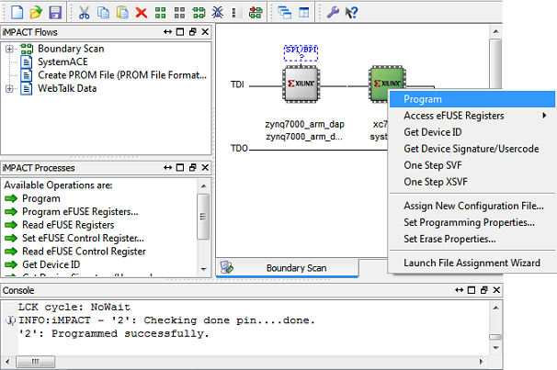

4‑2: iMPACT configuration screen

To load Lab 3 via SD card:

1. Place the file on the SD card, and place the card inside the SD slot of the FPGA.
2. Configure the jumpers on the FPGA as shown in Figure 4-3.
3. Turn on the board, and the program should load after about 30 seconds. Check for the blue light, indicated the load was successful.

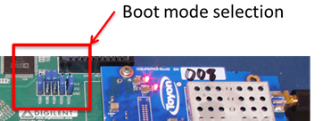

Figure 4‑3: Jumper configuration needed to load a project via SD card

## 4.4 Debugging with SDK

If the hardware design is correct, you should see the LEDs start blinking on the board, as well as a blue light indicating the program was successful. You should also see the LED blinking on the second FPGA indicating the Lab 3 project is working properly. You can now return to the SDK project screen to test your software.

1. Test it by **right clicking** the project name folder and selecting **Debug As** 🡪 **Launch on Hardware**.
2. You should now be taken to a screen which shows the first pointer initialization as highlighted. You can now start the software program by clicking the  (play) button in the top menu.

If the software initialization worked, you should see a green light on the Chilipepper as well as LED0 and LED1 blinking alternatively.

Testing and Design Verification Step 5

## 5.1 Verification with Terminal

Once you have both labs running successfully, the next step is to verify functionality by connecting the FPGA which is running your Lab 8 design to a terminal to view the received QPSK packet.

1. Connect your FPGA to the PC using a micro USB cable. The cable should be plugged into the UART port on the FPGA, shown in Figure 5-1 below.

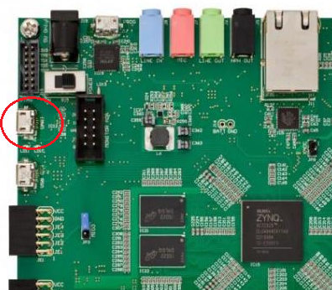

Figure 5‑: Circled in this figure is the UART port of the Xilinx Zed Board FPGA.

1. With the board powered on, open up a hyper terminal window such as Tera Term, and configure it with the following settings

**Baud: 115200; Data: 8 bit; No Parity;1 Stop bit; No Flow Conrol.**

Notice that the baud rate used is configured in the SetupPeripherals function in our main.c function created earlier. The other settings are all defaults for the XUartPs port.

1. Once the terminal is configured, you should be able to view your hello world packets by clicking the button on the Lab 3 Demo. In addition, if you flip the switch for continuous packet transmission, you shoud see several hello world packets on your terminal output.
2. Core MATLAB rx Function

MATLAB function qpsk_rx.m





1. MATLAB Frequency Offset Correction

MATLAB function qpsk_rx_foc.m





1. MATLAB Timing Offset Correction

MATLAB function qpsk_rx_toc.m





1. MATLAB Correlation Function

MATLAB function qpsk_rx_correlation.m







1. main.c

SDK function main.c





1. The MATLAB files can be found at https://github.com/Toyon/Chilipepper/tree/master/Labs/Lab_8/MATLAB
2. This model can be downloaded from https://github.com/Toyon/Chilipepper/tree/master/Labs/Lab_8/sysgen
3. This model can be downloaded from https://github.com/Toyon/Chilipepper/tree/master/Labs/Lab_8/sysgen
4. This model can be downloaded from https://github.com/Toyon/Chilipepper/tree/master/Labs/Lab_8/sysgen
5. This model can be downloaded from https://github.com/Toyon/Chilipepper/tree/master/Labs/Lab_8/sysgen
6. Issue can be found ay http://www.xilinx.com/support/answers/51739.htm
7. See http://www.xilinx.com/support/answers/35443.htm