**

**UNIVERSITY-BANGLADESH**

**Report Cover Sheet**

|  |  |  |  |  |
| --- | --- | --- | --- | --- |
| Report Title: | Virtual Tour of Dhaka and Beyond. | | | |
| Report No: | Final Report | | Date of Submission: |  |
| Course Title: | Computer Graphics | | | |
| Course Code: | CSC4118 | | Section: | D |
| Semester: | Fall | 2024-25 | Course Teacher: | Aneem Al Ahsan Rupai |

**Declaration and Statement of Authorship:**

1. I/we hold a copy of this Assignment/Case-Study, which can be produced if the original is lost/damaged.
2. This Assignment/Case-Study is my/our original work and no part of it has been copied from any other student’s work or from any other source except where due acknowledgement is made.
3. No part of this Assignment/Case-Study has been written for me/us by any other person except where such collaboration has been authorized by the concerned teacher and is clearly acknowledged in the assignment.
4. I/we have not previously submitted or currently submitting this work for any other course/unit.
5. This work may be reproduced, communicated, compared and archived for the purpose of detecting plagiarism.
6. I/we give permission for a copy of my/our marked work to be retained by the Faculty for review and comparison, including review by external examiners.
7. I/we understand that Plagiarism is the presentation of the work, idea or creation of another person as though it is your own. It is a formofcheatingandisaveryseriousacademicoffencethatmayleadtoexpulsionfromtheUniversity. Plagiarized material can be drawn from, and presented in, written, graphic and visual form, including electronic data, and oral presentations. Plagiarism occurs when the origin of them arterial used is not appropriately cited.
8. I/we also understand that enabling plagiarism is the act of assisting or allowing another person to plagiarize or to copy my/our work.

*\* Student(s) must complete all details except the faculty use part.*

** Please submit all assignments to your course teacher or the office of the concerned teacher.

|  |  |
| --- | --- |
| Group Name/No.: | 01 |

|  |  |  |  |  |
| --- | --- | --- | --- | --- |
| **Serial No** | **Name** | **ID** | **Program** |  |
| 8 | ESHTAB RAK MAHMUD | 21-45387-3 | BSc [CSE] |  |
| 9 | BADHON NATH JOY | 21-45390-3 | BSc [CSE] |  |
| 10 | NAZMUS SAKIB | 21-45391-3 | BSc [CSE] |  |
| 11 | NADIM BIN HOSSAIN | 21-45448-3 | BSc [CSE] |  |
| 13 | REJUANUL ISLAM | 21-45484-3 | BSc [CSE] |  |

|  |  |  |
| --- | --- | --- |
| ***Faculty use only*** | | |
| FACULTYCOMMENTS | **Marks Obtained** |  |
|  |
|  |
|  | **Total Marks** |  |
|  |
|  |

**Table of Contents:**

1. Introduction-----------------------------03
2. Graph------------------------------------04
3. List of Objects------------------------- 06
4. List of Functions-----------------------09
5. List of Animation Functions---------11
6. Contribution----------------------------12
7. Conclusion------------------------------12

**Title:** Virtual Tour of Dhaka and Beyond.

**Introduction:**

**Objective:**

To create an immersive 2D animation with five interconnected scenes showcasing Dhaka city, a tunnel, a hill view, and a tourist spot, incorporating animated metro trains, vehicles, moving clouds, a flowing river, day-night/weather transitions, and interactive controls using a keyboard and mouse.

**Scenes Overview:**

1. **Dhaka Metro Scene:** Animated metro train, cars in road, day/night/rain transition, keyboard to control train speed.
2. **Dhaka City Scene:** Vehicles, streetlights, moving clouds, moving plane day/night transition.
3. **Tunnel Scene:** Tunnel, mountains, fountain, light shifts, keyboard to control vehicles.
4. **Hill View Scene:** A scenic hill landscape with a flowing river, a moving train, day-night transitions, keyboard-controlled train speed, and mouse interaction for environmental adjustments.
5. **Tourist Spot Scene:** Cable cars, visitors, moving vehicles, trees, a river, and day-snowfall transitions, with keyboard-based scene transitions and mouse-controlled car speed adjustment.

**Features:**

* Smooth transitions (day/night/rain/snowfall, location shifts).
* Interactive controls (keyboard and mouse).
* Realistic animations and lighting effects.

**Tools:** C++ with OpenGL

**Project Graph:**Scene 1:

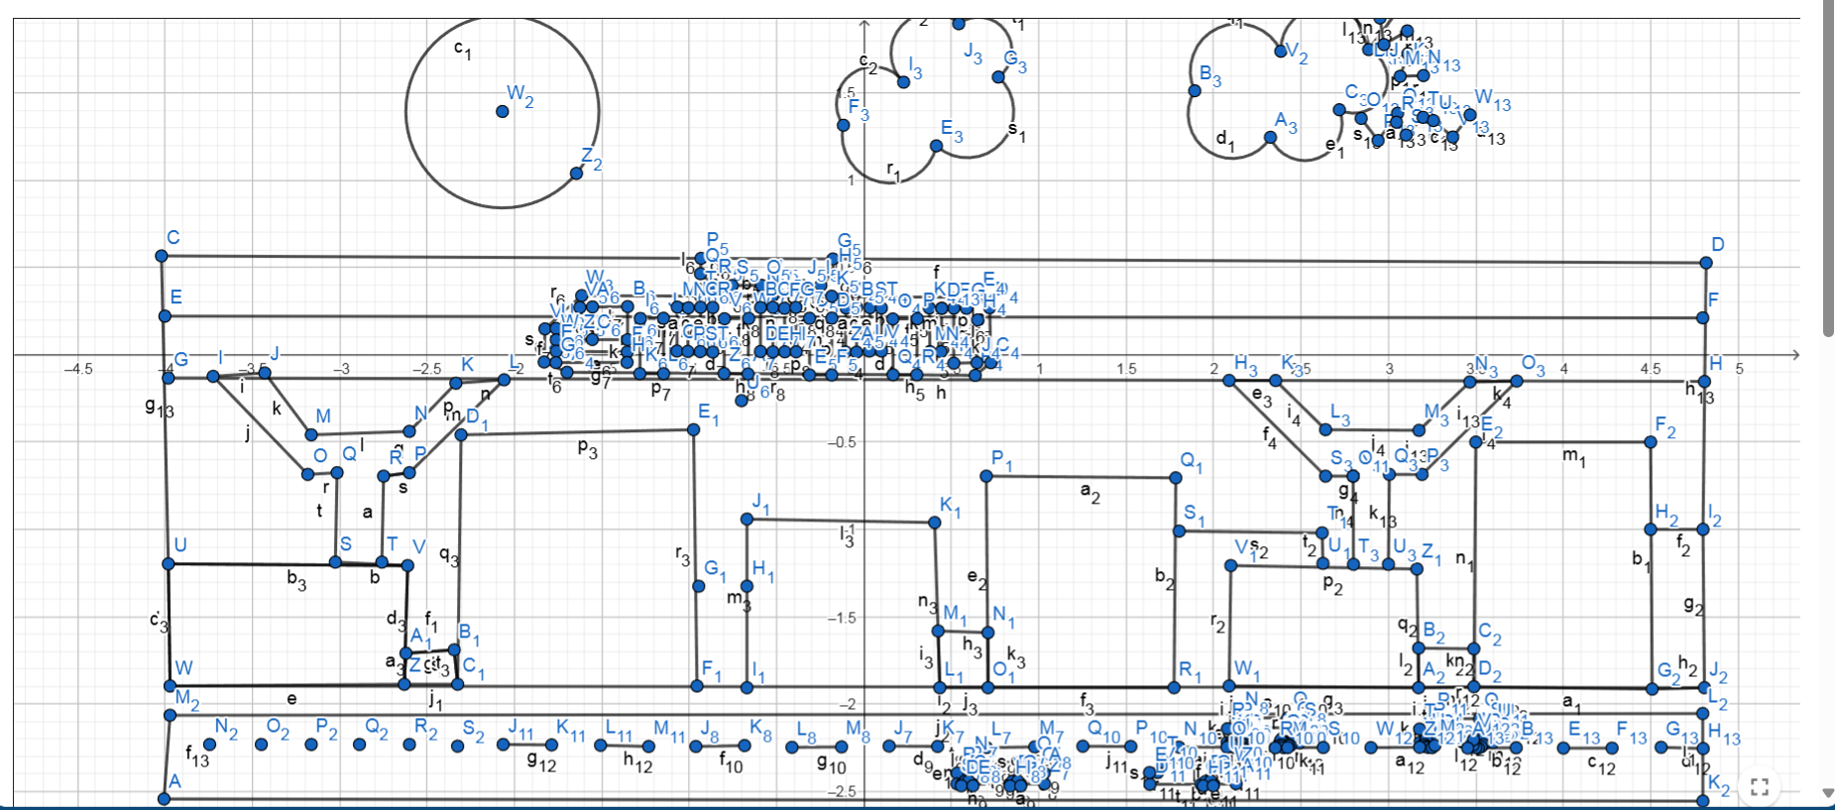

Scene 2**:**

Scene 3:

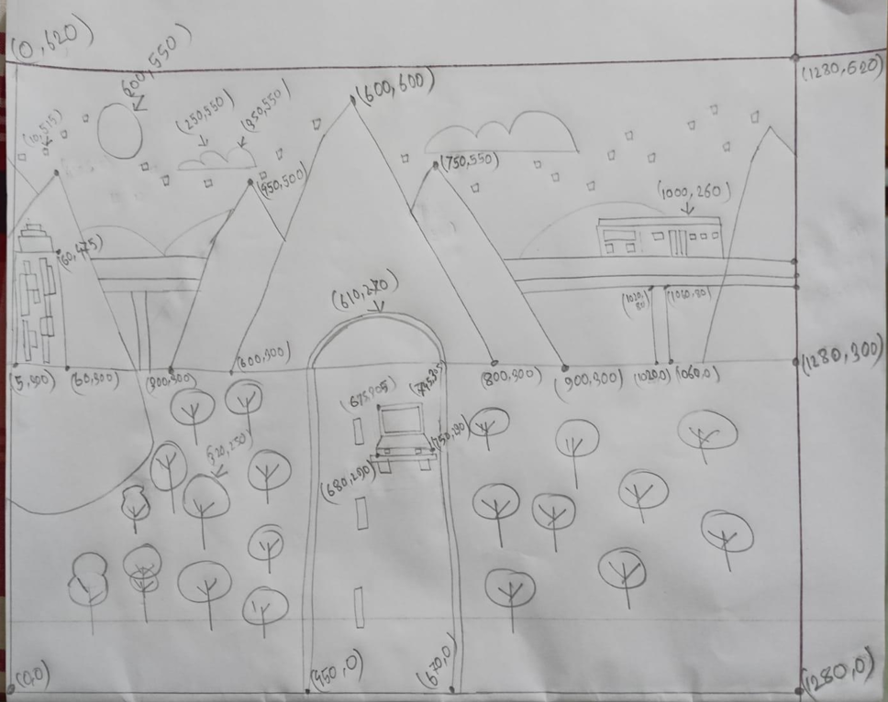

Scene 4:

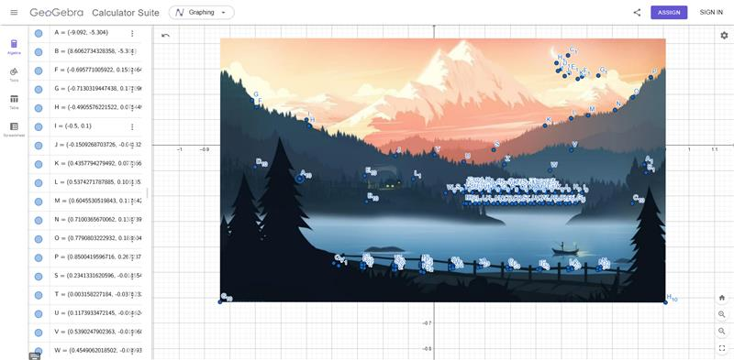

Scene 5:

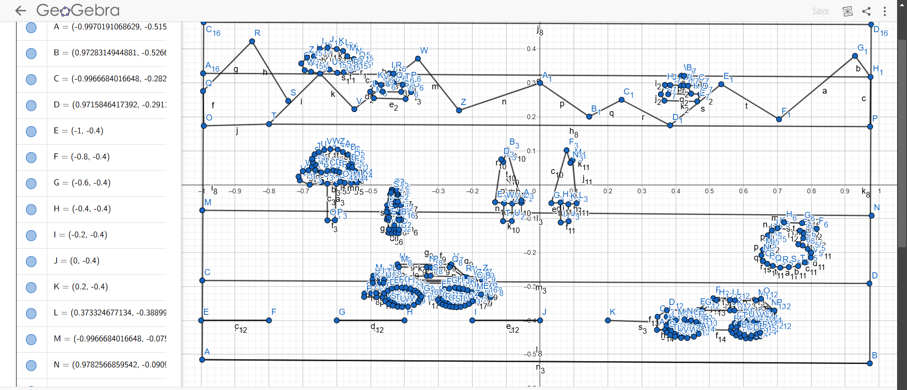

**List of Objects:**

**Scene -01**

|  |  |  |
| --- | --- | --- |
| **SL#** | **Object ID** | **Obeject Name** |
| 1 | Train | Metro Rail |
| 2 | Cloud1 | Cloud |
| 3 | Cloud2 | Cloud |
| 4 | Caru | Car |
| 5 | Card | Car |
| 6 | Sun | Sun |
| 7 | Moon | Moon |
| 8 | Wheel | Car wheel |
| 9 | Bird | Bird |
| 10. | Bird2 | Bird |
| 11. | Rain | Rain |

**Scene -02**

|  |  |  |
| --- | --- | --- |
| **SL#** | **Object ID** | **Object Name** |
|  | Sky1 | Sky |
| 1 | Sun1 | Sun |
| 2 | Moon1 | Moon |
| 3 | Hill1 | Hill |
| 4 | Soil1 | Soil |
| 5 | Ground1 | Ground |
| 6 | Road1 | Road |
| 7 | Small Tree1 | Small Tree |
| 8 | Small Tree2 | Small Tree |
| 9 | Small Tree3 | Small Tree |
| 10 | Small Tree4 | Small Tree |
| 11 | Small Tree5 | Small Tree |
| 12 | Small Tree6 | Small Tree |
| 13 | Small Tree7 | Small Tree |
| 14 | Small Tree8 | Small Tree |
| 15 | Small Tree9 | Small Tree |
| 16 | Small Tree10 | Small Tree |
| 17 | Small Tree11 | Small Tree |
| 18 | Small Tree12 | Small Tree |
| 19 | Small Tree13 | Small Tree |
| 20 | Small Tree14 | Small Tree |
| 21 | Small Tree15 | Small Tree |
| 22 | Small Tree16 | Small Tree |
| 23 | Small Tree17 | Small Tree |
| 24 | Small Tree18 | Small Tree |
| 25 | Big Tree1 | Big Tree |
| 26 | Big Tree2 | Big Tree |
| 27 | Big Tree3 | Big Tree |
| 28 | College1 | College |
| 29 | Hospital1 | Hospital |
| 30 | House1 | House |
| 31 | Private Car1 | Private Car |
| 32 | Train1 | Train |
| 33 | Bus1 | Bus |
| 34 | Plane1 | Plane |
| 35 | Rail Line1 | Rail Line |

**Scene -03**

|  |  |  |
| --- | --- | --- |
| **SL#** | **Object ID** | **Object Name** |
| 1 | sun1 | sun |
| 2 | moon1 | moon |
| 3 | jeep1 | Jeep |
| 4 | train1 | Train |
| 5 | road1 | road |
| 6 | mountain1, mountain2, mountain3 | mountains |
| 7 | fountain mountain1, fountain mountain2 | mountains |
| 8 | right mountain1, right mountain2 | mountains |
| 9 | clouds1, clouds2, clouds3 | clouds |
| 10 | stars1 | stars |
| 11 | tree1, tree2, tree3, tree4 | Tree |
| 12 | fountain1 | fountain |
| 13 | bridge1 | bridge |
| 14 | pond1 | pond |

**Scene -04**

|  |  |  |
| --- | --- | --- |
| **SL#** | **Object ID** | **Object Name** |
| 1 | WeatherN | Weather |
| 2 | Stars | Stars |
| 3 | MoonN | Moon |
| 4 | MountainForestN | Mountain Forest |
| 5 | BlueLakeN | Blue Lake |
| 6 | Stone | Stone |
| 7 | Train | Train |
| 8 | TrainBridge | Train Bridge |
| 9 | SideOfBlueLake | Side of Blue Lake |
| 10 | CoverBridgeN | Cover Bridge |
| 11 | FishingBoat | Fishing Boat |

**Scene -05**

|  |  |  |
| --- | --- | --- |
| **SL#** | **Object ID** | **Object Name** |
| 1 | Wire1 | Wire |
| 2 | River1 | river |
| 3 | Tree1 | tree |
| 4 | Tree2 | tree |
| 5 | Tree3 | tree |
| 6 | Tree4 | tree |
| 7 | Human1 | human |
| 8 | Human2 | human |
| 9 | Human3 | human |
| 10 | Human4 | human |
| 11 | Suv1 | suv |
| 12 | Car1 | car |
| 13 | snow_fall | snowfall |
| 14 | sky19 | sky |
| 15 | snowsky19 | Snow sky |
| 16 | Cloud1 | cloud |
| 17 | Cloud2 | cloud |
| 18 | Cloud3 | cloud |
| 19 | skatingroad | Skating road |
| 20 | snowSkatingroad | Snow skating road |
| 21 | road19 | road |
| 22 | Hills1 | hills |
| 23 | snowhills | Snow hills |
| 24 | Cable1 | Cable car |
| 25 | Cable2 | Cable car |
| 26 | snowman | snowman |

**List of Functions:**

**Scene -01**

|  |  |  |
| --- | --- | --- |
| **SL#** | **Object Name** | **Function Name** |
| 1 | Metro Rail | void train() |
| 2 | Cloud | void cloud1(), void cloud2() |
| 3 | Car | void Caru(),void card() |
| 4 | Birds | void bird() |
| 5 | Sun | void sun() |
| 6 | Moon | void moon() |
| 7 | Rain | void rain() |

**Scene -02**

|  |  |  |
| --- | --- | --- |
| **SL#** | **Object Name** | **Function Name** |
| 1 | Sky | sky() |
| 2 | Sun | sun() |
| 3 | Moon | moon() |
| 4 | Hill | hill() |
| 5 | Soil | soil() |
| 6 | Ground | ground() |
| 7 | Road | road() |
| 8 | Small Tree | tree1() |
| 9 | Big Tree | tree2() |
| 10 | College | college() |
| 11 | Hospital | hospital() |
| 12 | House | house() |
| 13 | Private Car | privatecar() |
| 14 | Bus | bus() |
| 15 | Rail Line | railLine() |
| 16 | Train | train() |
| 17 | Plane | plane() |

**Scene -03**

|  |  |  |
| --- | --- | --- |
| **SL#** | **Object Name** | **Function Name** |
| 1 | Stars | drawStars() |
| 2 | Train | drawTrain() |
| 3 | Bridge | drawBridge() |
| 4 | Tree | drawTree() |
| 5 | Clouds | drawClouds() |
| 6 | Mountain | drawMountain() |
| 7 | Right Mountain | drawRightMountain() |
| 8 | Fountain Mountain | drawFountainMountain() |
| 9 | Cave | drawCave() |
| 10 | Jeep | drawJeep() |
| 11 | Sun Moon | drawSunMoon() |
| 12 | Back Mountains | drawBackMountains() |
| 13 | Tree Bunch | drawTreeBunch() |
| 14 | WaterFall | drawWaterFall() |
| 15 | Pond | drawPond() |

**Scene -04**

|  |  |  |
| --- | --- | --- |
| **SL#** | **Object Name** | **Function Name** |
| 1 | Weather | |  | | --- | | WeatherN() | |
| 2 | Stars | |  | | --- | | Stars() | |
| 3 | Moon | |  | | --- | | MoonN() | |
| 4 | Mountain Forest | |  | | --- | | MountainForestN() | |
| 5 | Blue Lake | |  | | --- | | BlueLakeN() | |
| 6 | Stone | |  | | --- | | Stone() | |
| 7 | Train | |  | | --- | | Train() | |
| 8 | Train Bridge | |  | | --- | | TrainBridge() | |
| 9 | Side of Blue Lake | |  | | --- | | SideOfBlueLake() | |
| 10 | Cover Bridge | |  | | --- | | CoverBridgeN() | |
| 11 | Fishing Boat | |  | | --- | | FishingBoat() | |

**Scene -05**

|  |  |  |
| --- | --- | --- |
| **SL#** | **Object Name** | **Function Name** |
| 1 | Wire | wire() |
| 2 | river | river() |
| 3 | flow | flow() |
| 4 | tree | tree() |
| 5 | human | human() |
| 6 | suv | suv() |
| 7 | car | car() |
| 8 | Snow fall | snow_fall() |
| 9 | sky | sky19() |
| 10 | Snow sky | snowsky19() |
| 11 | Cloud | Cloud() |
| 12 | Skating road | skatingroad() |
| 13 | Snow skating road | snowSkatingroad() |
| 14 | road | road19() |
| 15 | hills | hills() |
| 16 | Snow hills | snowhills() |
| 17 | Cable car | cable() |
| 18 | Cable car | cable2() |
| 19 | snowman | snowman() |

**List of Animation Functions:**

**Scene -01**

|  |  |  |  |
| --- | --- | --- | --- |
| **SL#** | **Animation Function ID** | **Animation function** | **Object/Scene** |
| 1 | Timer Function | glutTimerFunc() | Movement of Train, cloud, car, bird |
| 2 | HandleKeypress | void handleKeypress() | Stop the train, rain, stop the rain, day & night transition |
| 3 | handleMouse | void handleMouse() | Train speed increase and decrese by using left & right |

**Scene -02**

|  |  |  |
| --- | --- | --- |
| **SL#** | **Animation Function ID** | **Animation Function** |
| 1 | privateCarMove1 | privatecarMove() |
| 2 | busMove1 | my_keyboard(), busMOve() |
| 3 | trainMove1 | trainMove() |
| 4 | planeMove1 | planeMove() |
| 5 | mouseInterection1 | mouse() |
| 6 | keyboardInterection1 | my_keyboard() |
| 7 | nightTransition1 | my_keyboard() |
| 8 | dayTransition | my_keyboard() |

**Scene -03**

|  |  |  |  |
| --- | --- | --- | --- |
| SL# | Animation Function ID | Animation Function | Object/Scene |
| 1 | Animation_1 | update() | train |
| 2 | Animation_2 | update() | jeep |
| 3 | Animation_3 | update() | cloud |
| 4 | Animation_4 | handleKeypressE() | day/night, fountain, train, jeep |

**Scene -04**

|  |  |  |  |
| --- | --- | --- | --- |
| **SL#** | **Animation Function ID** | **Animation Function** | **Object/Scene** |
| 1 | FishingBoat | FishingBoat() | boat |
| 2 | trainUpdate | Update() | Train |
| 3 | Keyboard interaction | HandelKeypressN() | Scene Transition |
| 4 | Mouse interaction | handleMouseN() | Train speed |

**Scene -05**

|  |  |  |  |
| --- | --- | --- | --- |
| SL# | Animation Function ID | Animation Function | Object/Scene |
| 1 | weather_update | weather_update() | Weather update |
| 2 | updateVehicals | updateVehicals() | Suv and car |
| 3 | updateHuman | updateHuman() | Human |
| 4 | updateFlow | updateFlow() | river |
| 5 | handleMouse | handleMouse() | Left: car speed Increase  Right: car speed decrease |
| 6 | handleKeypress | handleKeypress() | s: weather toggle |
| 7 | update_cloud | update_cloud() | Cloud |

**Contribution:**

|  |  |  |  |
| --- | --- | --- | --- |
| Member Name | Implemented Scene | Implemented Animation Functions | Percentage of Contribution |
| ESHTAB RAK MAHMUD | Scene 3 | All functions of Scene 3 | 20% |
| BADHON NATH JOY | Scene 5 | All functions of Scene 5 | 20% |
| NAZMUS SAKIB | Scene 4 | All functions of Scene 4 | 20% |
| NADIM BIN HOSSAIN | Scene 2 | All functions of Scene 2 | 20% |
| REJUANUL ISLAM | Scene 1 | All functions of Scene 1 | 20% |

**Conclusion:**

The development of this 2D animation successfully showcases five interconnected scenes representing Dhaka city and its surroundings, integrating key elements such as metro trains, vehicles, tunnels, hills, rivers, and tourist attractions. Each scene features smooth animations, interactive controls via keyboard and mouse, and dynamic transitions between day, night, and various weather conditions. The inclusion of realistic movements, structured environments, and immersive visuals enhances user engagement and provides an interactive experience. Overall, this project demonstrates the effective application of computer graphics techniques to create a visually compelling and interactive animation, offering a unique representation of urban and natural landscapes.