

**AMERICAN INTERNATIONAL UNIVERSITY-BANGLADESH**

**FACULTY OF SCIENCE & TECHNOLOGY**

**DEPARTMENT OF COMPUTER SCIENCE & ENGINEERING**

**INTRODUCTION TO DATABASE**

**FALL 2022-2023**

**SECTION: P**

**PROJECT REPORT ON**

**SIM MANAGEMENT SYSTEM**

**UNDER THE GUAIDENCE OF**

**ARGHO DAS**

**SUBMITTED BY:**

|  |  |
| --- | --- |
| NAME | ID |
| HOSSAIN, SAKIB | 21-45388-3 |
| JOY, BADHON NATH | 21-45390-3 |
| ISLAM, TANJIB-UL | 21-45393-3 |
| HOSSEN, SHAHRIAR | 22-46525-1 |

DATE OF SUBMISSION: 26/12/2022

**TABLE OF CONTENTS:**

|  |  |
| --- | --- |
| TOPICS | PAGE NO |
| 1. Title page | 1 |
| 1. Table of contents | 2 |
| 1. Introduction | 3 |
| 1. ER- Diagram | 4 |
| 1. Normalization | 5-11 |
| 1. Table creation | 12-23 |
| 1. Sequence | 24-27 |
| 1. View | 28-29 |
| 1. Tables | 30-34 |
| 1. Joining | 35-36 |
| 1. Constraints | 37 |

**Introduction**

This database project will help SIM management system to enables security personnel to gather, manage, optimize, and use security data to identify threats and vulnerabilities, and take action to protect the organization.

**Scenario:** The SIM management system allows many customers to register only once. Many customers can register during the registration process. A customer is identified by his/her NID. Customers also have a name, date of birth and address. Customer name includes first and last name and customer address includes city and country. Customers can purchase SIMS. SIMS are identified by serial number. SIMS vary by SIM type, SIM number. SIMS can also have various issues. Customers must do registration. A registration is identified by a registration ID and includes the name of the registered customer and the date of registration. A registered customer name also includes first and last name. All customers are managed by many employees. Employee is identified by employee ID. Employees also haSve a name, salary, years of experience, hire date, address, and may have multiple phone numbers. An employee's name includes first and last name. All employees will manage everything related to SIMS. Each employee works for a manager identified by a manager ID. Every manager has an address, manager name, salary and can have multiple phone numbers. A manager's name includes first and last name. Every employee and manager have a department. A department has a department ID and a department name.

**ER- Diagram**

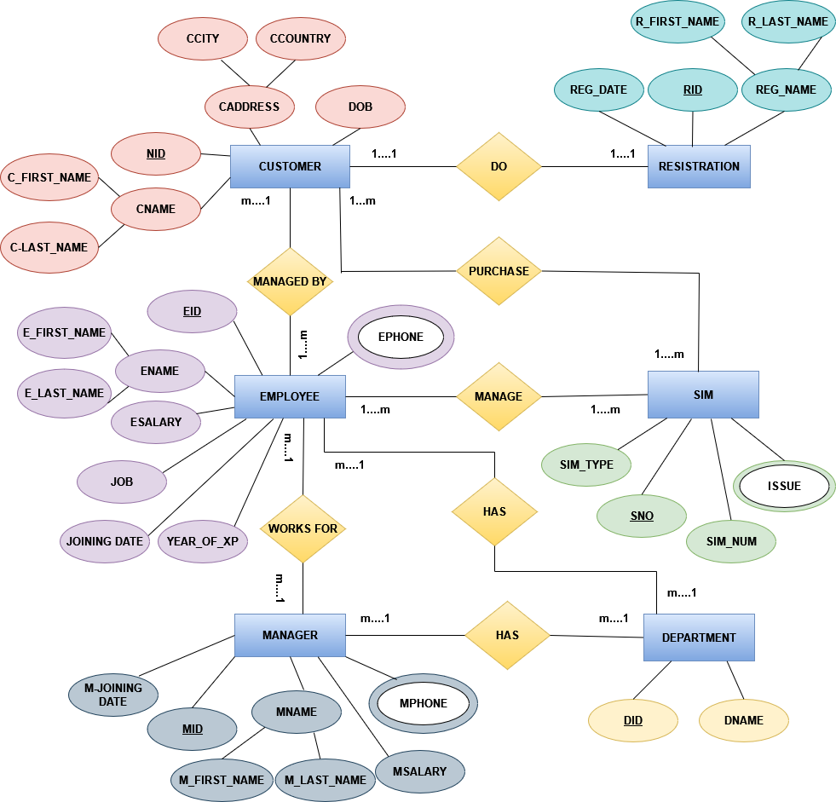

**Normalization**

**Do:**

**(CUSTOMER and RESISTRATION)**

**UNF:**

1ST: NID, C_FIRST_NAME, C_LAST_NAME, CCITY, CCOUNTRY, DOB, RID, REG_DATE, R_FIRST_NAME, R_LAST_NAME.

**1NF:**

1ST: NID, RID, C_FIRST_NAME, C_LAST_NAME, CCITY, CCOUNTRY, DOB, REG_DATE, R_FIRST_NAME, R_LAST_NAME.

(NO MULTIVALUED ATTRIBUTE)

**2NF:**

1ST: NID, C_FIRST_NAME, C_LAST_NAME, CCITY, CCOUNTRY, DOB

2ND: RID, REG_DATE, R_FIRST_NAME, R_LAST_NAME.

3RD: NID, RID

**3NF:**

1ST: NID, C_FIRST_NAME, C_LAST_NAME, CCITY, DOB

2ND: RID, REG_DATE, R_FIRST_NAME, R_LAST_NAME.

3RD: CCITY, CCOUNTRY

4TH: NID, RID

**MANAGED BY:**

**(CUSTOMER AND EMPLOYEE)**

**UNF:** 1ST: NID, C_FIRST_NAME, C_LAST_NAME, CCITY, CCOUNTRY, DOB, EID, E_FIRST_NAME, E_LAST_NAME, ESALARY, JOB, JOINNING_DATE, YEAR_OF_XP, EPHONE

**1NF:**

1ST: NID, EID, EPHONE, C_FIRST_NAME, C_LAST_NAME, CCITY, CCOUNTRY, DOB, E_FIRST_NAME, E_LAST_NAME, ESALARY, JOB, JOINNING_DATE, YEAR_OF_XP

(EPHONE IS A MULTIVALUED ATTRIBUTE)

**2NF:**

1ST: NID, C_FIRST_NAME, C_LAST_NAME, CCITY, CCOUNTRY, DOB

2ND: EID, E_FIRST_NAME, E_LAST_NAME, ESALARY, JOB, JOINNING_DATE, YEAR_OF_XP, EPHONE_ID

3RD: EPHONE_ID, EPHONE

4TH: NID, EID

**3NF:**

1ST: NID, C_FIRST_NAME, C_LAST_NAME, CCITY, DOB

2ND: EID, E_FIRST_NAME, E_LAST_NAME, ESALARY, JOB, JOINNING_DATE, YEAR_OF_XP, EPHONE_ID

3RD: EPHONE_ID, EPHONE

4TH: NID, EID

5TH: CCITY, CCOUNTRY

**PURCHASE:**

**(CUSTOMER AND SIM)**

**UNF:**

1ST: NID, C_FIRST_NAME, C_LAST_NAME, CCITY, CCOUNTRY, DOB, SNO, SIM_TYPE, SIM_NUM, ISSUE

**1NF:**

1ST: NID, SNO, ISSUE, C_FIRST_NAME, C_LAST_NAME, CCITY, CCOUNTRY, DOB, SIM_TYPE, SIM_NUM

(ISSUE IS MULTIVALUED ATTRIBUTE)

**2NF:**

1ST: NID, C_FIRST_NAME, C_LAST_NAME, CCITY, CCOUNTRY, DOB

2ND: SNO, SIM_TYPE, SIM_NUM, ISSUE_ID.

3RD: ISSUE_ID, ISSUE

4TH: NID, SNO

**3NF:**

1ST: NID, C_FIRST_NAME, C_LAST_NAME, CCITY, DOB

2ND: SNO, SIM_TYPE, SIM_NUM, ISSUE_ID.

3RD: ISSUE_ID, ISSUE

4TH: CCITY, CCOUNTRY

5TH: NID, SNO

**MANAGE:**

**(EMPLOYEE AND SIM)**

**UNF:**

1ST: EID, E_FIRST_NAME, E_LAST_NAME, ESALARY, JOB, JOINNING_DATE, YEAR_OF_XP, EPHONE, SNO, SIM_TYPE, SIM_NUM, ISSUE

**1NF:**

1ST: EID, SNO, ISSUE, EPHONE, E_FIRST_NAME, E_LAST_NAME, ESALARY, JOB, JOINNING_DATE, YEAR_OF_XP, SIM_TYPE, SIM_NUM

(ISSUE AND EPHONE ARE MULTIVALUED ATTRIBUTE)

**2NF:**

1ST: EID, E_FIRST_NAME, E_LAST_NAME, ESALARY, JOB, JOINNING_DATE, YEAR_OF_XP, EPHONE_ID

2ND: EPHONE_ID, EPHONE

3RD: SNO, SIM_TYPE, SIM_NUM, ISSUE_ID

4TH: ISSUE_ID, ISSUE

5TH: EID, SNO

**3NF:**

1ST: EID, E_FIRST_NAME, E_LAST_NAME, ESALARY, JOB, JOINNING_DATE, YEAR_OF_XP, EPHONE_ID

2ND: EPHONE_ID, EPHONE

3RD: SNO, SIM_TYPE, SIM_NUM, ISSUE_ID

4TH: ISSUE_ID, ISSUE

5TH: EID, SNO

**WORKS FOR:**

**(EMPLOYEE AND MANAGER)**

**UNF:**

1ST: EID, E_FIRST_NAME, E_LAST_NAME, ESALARY, JOB, JOINNING_DATE, YEAR_OF_XP, EPHONE, MID, M_JOINING_DATE, M_FIRST_NAME, M_LAST_NAME, MSALARY, MPHONE

**1NF:**

1ST: EID, MID, MPHONE, EPHONE, E_FIRST_NAME, E_LAST_NAME, ESALARY, JOB, JOINNING_DATE, YEAR_OF_XP, M_JOINING_DATE, M_FIRST_NAME, M_LAST_NAME, MSALARY

(EPHONE AND MPHONE ARE MULTIVALUED ATTRIBUTE)

**2NF:**1ST: EID, E_FIRST_NAME, E_LAST_NAME, ESALARY, JOB, JOINNING_DATE, YEAR_OF_XP, EPHONE_ID

2ND: EPHONE_ID, EPHONE

3RD: MID, M_JOINING_DATE, M_FIRST_NAME, M_LAST_NAME, MSALARY, MPHONE_ID

4TH: MPHONE_ID, MPHONE

4TH: EID, MID

**3NF:**

1ST: EID, E_FIRST_NAME, E_LAST_NAME, ESALARY, JOB, JOINNING_DATE, YEAR_OF_XP, EPHONE_ID

2ND: EPHONE_ID, EPHONE

3RD: MID, M_JOINING_DATE, M_FIRST_NAME, M_LAST_NAME, MSALARY, MPHONE_ID

4TH: MPHONE_ID, MPHONE

5TH: EID, MID

**HAS:**

**(EMPLOYEE AND DEPARTMENT)**

**UNF:**

1ST: EID, E_FIRST_NAME, E_LAST_NAME, ESALARY, JOB, JOINNING_DATE, YEAR_OF_XP, EPHONE, DID, DNAME

**1NF:**

1ST: EID, DID, EPHONE, E_FIRST_NAME, E_LAST_NAME, ESALARY, JOB, JOINNING_DATE, YEAR_OF_XP, DNAME

(EPHONE IS A MULTIVALUED ATTRIBUTE)

**2NF:**1ST: EID, E_FIRST_NAME, E_LAST_NAME, ESALARY, JOB, JOINNING_DATE, YEAR_OF_XP, EPHONE_ID

2ND: EPHONE_ID, EPHONE

3RD: DID, DNAME

4TH: EID, DID

**3NF:**

1ST: EID, E_FIRST_NAME, E_LAST_NAME, ESALARY, JOB, JOINNING_DATE, YEAR_OF_XP, EPHONE_ID

2ND: EPHONE_ID, EPHONE

3RD: DID, DNAME

4TH: EID, DID

**HAS**

**(MANAGER AND DEPARTMENT)**

**UNF:**

1ST: MID, M_JOINING_DATE, M_FIRST_NAME, M_LAST_NAME, MSALARY, MPHONE, DID, DNAME

**1NF:**

1ST: MID, DID, MPHONE, M_JOINING_DATE, M_FIRST_NAME, M_LAST_NAME, MSALARY, DNAME

(MPHONE IS A MULTIVALUED ATTRIBUTE)

**2NF:**1ST: MID, M_JOINING_DATE, M_FIRST_NAME, M_LAST_NAME, MSALARY, MPHONE_ID

2ND: MPHONE_ID, MPHONE

3RD: DID, DNAME

4TH: MID, DID

**3NF:**

1ST: MID, M_JOINING_DATE, M_FIRST_NAME, M_LAST_NAME, MSALARY, MPHONE_ID

2ND: MPHONE_ID, MPHONE

3RD: DID, DNAME

4TH: MID, DID

**FINAL TABLE:**

1ST: NID, C_FIRST_NAME, C_LAST_NAME, CCITY, DOB

2ND: RID, REG_DATE, R_FIRST_NAME, R_LAST_NAME.

3RD: CCITY, CCOUNTRY

4TH: NID, RID

5TH: EID, E_FIRST_NAME, E_LAST_NAME, ESALARY, JOB, JOINNING_DATE, YEAR_OF_XP, EPHONE_ID

6TH: EPHONE_ID, EPHONE

7TH: NID, EID

8TH: SNO, SIM_TYPE, SIM_NUM, ISSUE_ID.

9TH: NID, SNO

10TH: ISSUE_ID, ISSUE

11TH: EID, SNO

12TH: MID, M_JOINING_DATE, M_FIRST_NAME, M_LAST_NAME, MSALARY, MPHONE_ID

13TH: MPHONE_ID, MPHONE

14TH: EID, MID

15TH: DID, DNAME

16TH: EID, DID

17TH: MID, DID

**TABLE CREATION**

**CUSTOMER:**

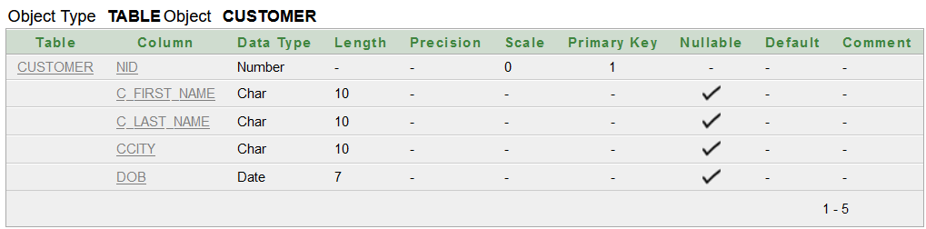

**

**ADDRESS:**

**CUSTOMER_REGISTRATION:**

**EMPLOYEE:**

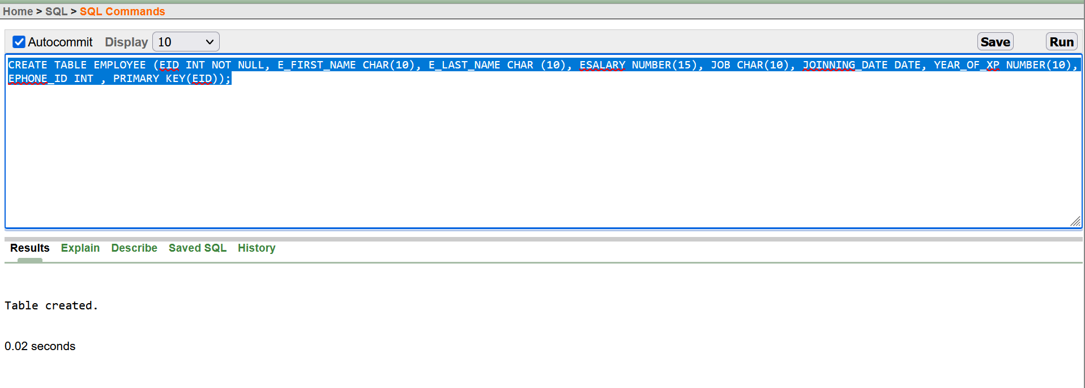

**EMP­_PHONE:**

**EMPLOYEE_CUSTOMER:**

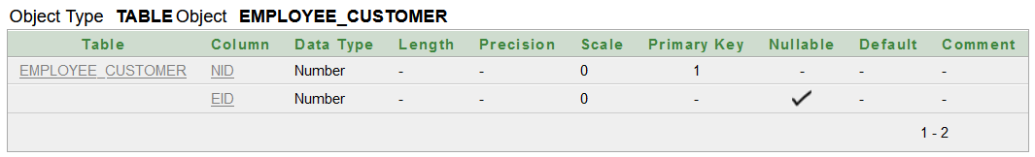

**SIM:**

**ISSUE:**

**CUSTOMER_SIM:**

**EMPLOYEE_SIM:**

**MANAGER:**

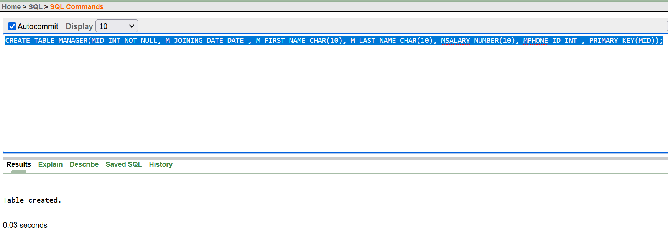

**MGR_PHONE:  
**

**MANAGER_EMPLOYEE:**

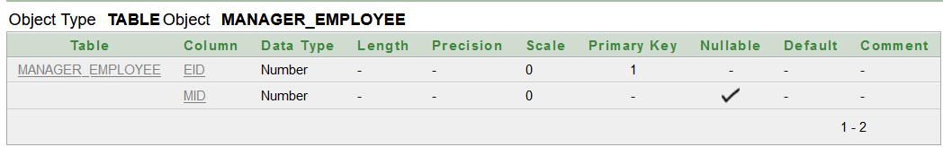

**DEPARTMENT:**

**EMPLOYEE_DEPARTMENT:**

**DEPARTMENT_MANAGER:**

**SEQUENCE:**

1. **REGISTRATIONS:**

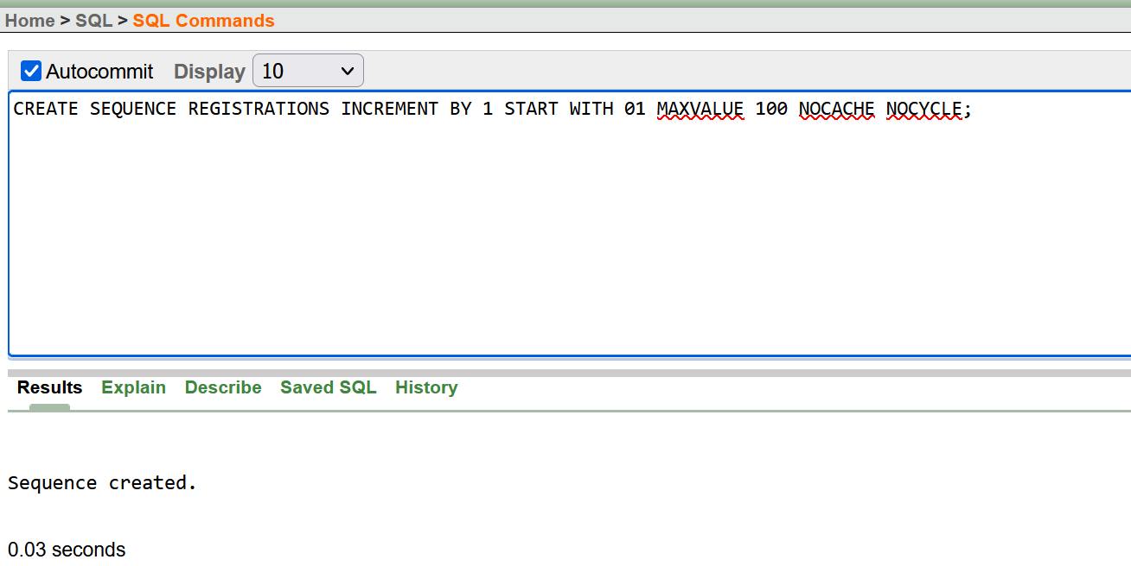

**2.EMPLOYEES:**

**3.EPHONES:**

**4. ISSUES:**

**5. MANAGERS:**

**6. MPHONE_IDS:**

**7. DEPARTMENTS:**

**VIEW:**

1. **SIMPLE VIEW- EMP_VU:**

1. **COMPLEX VIEW- CUS_SIM:**

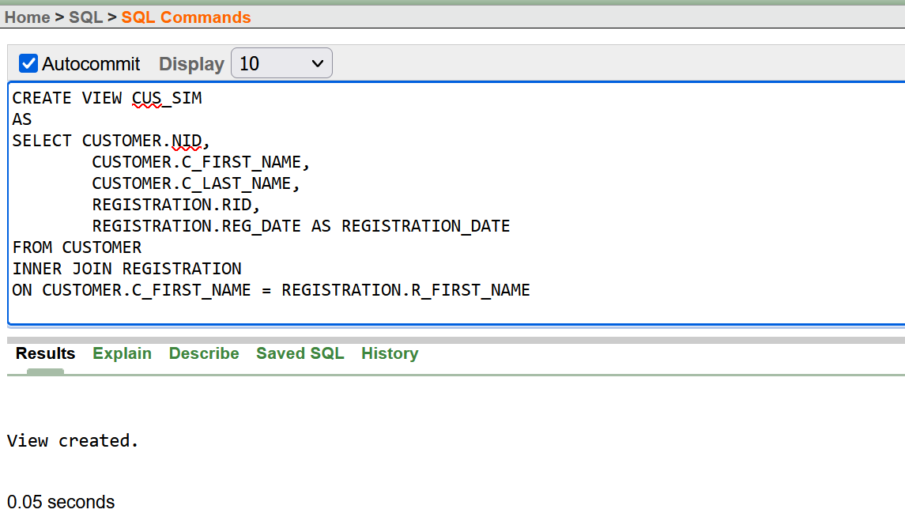

**TABLES:**

1. **CUSTOMER:**

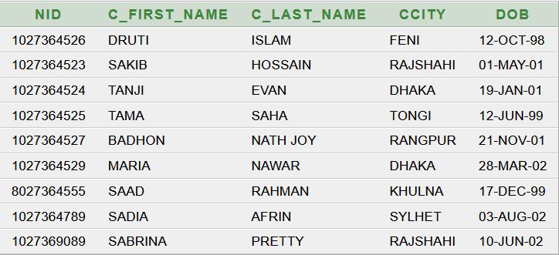

1. **REGISTRATION:**

1. **ADDRESS: 4. CUSTOMER_REGISTRATION:**

**5.EMPLOYEE:**

**6. EMP_PHONE:**

**7. EMPLOYEE_CUSTOMER: 8. SIM:**

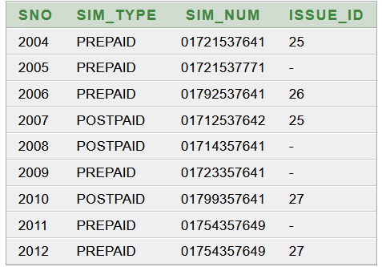

**9. CUSTOMER_SIM: 10. ISSUE:**

**11. EMPLOYEE_SIM:**

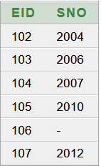

**12. MANAGER:**

**13. MGR_PHONE: 14. MANAGER_EMPLOYEE:**

**15. DEPARTMENT:**

**16. EMPLOYEE_DEPARTMENT:**

**17. DEPARTMENT_MANAGER:**

**JOINING:**

1. **EQUIJOIN:**

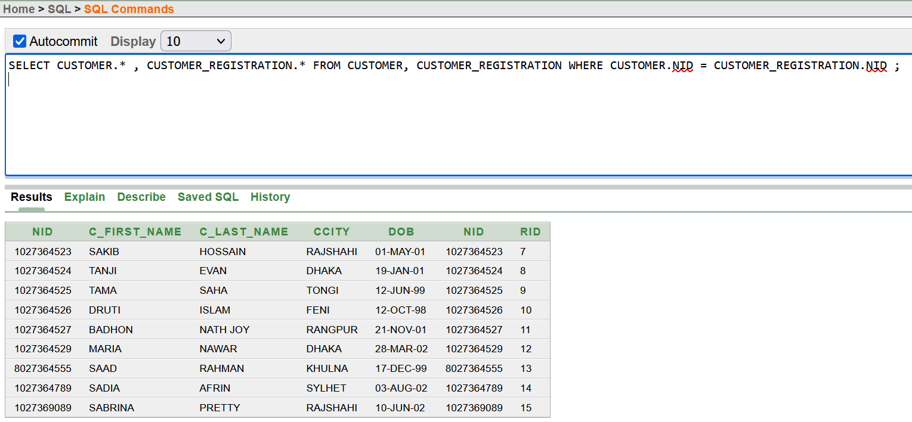

**2. NON-EQUIJOIN:**

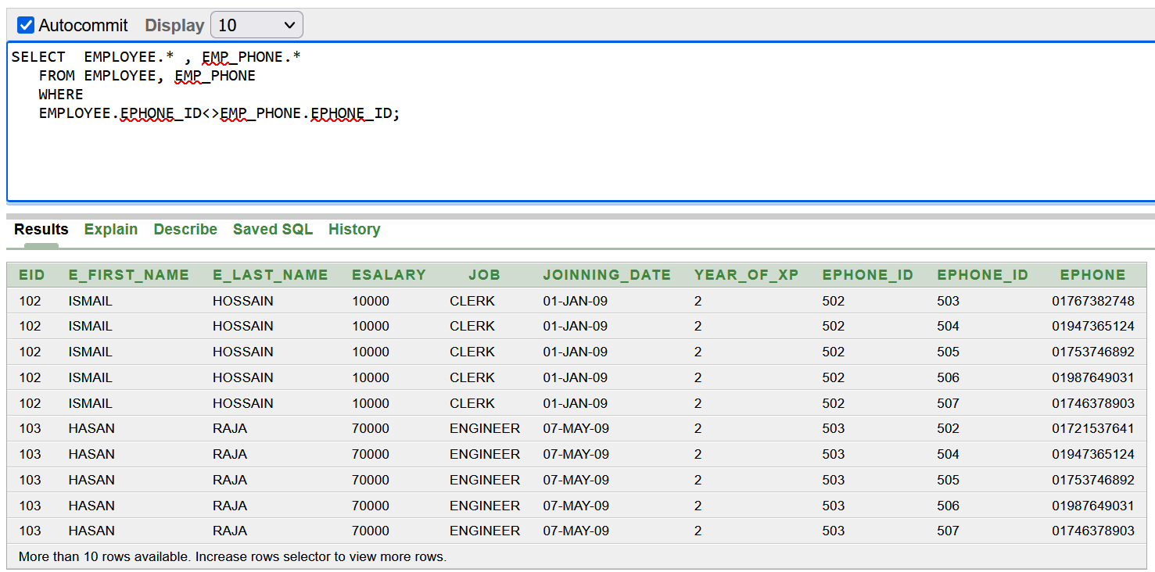

**3.OUTER JOIN:**

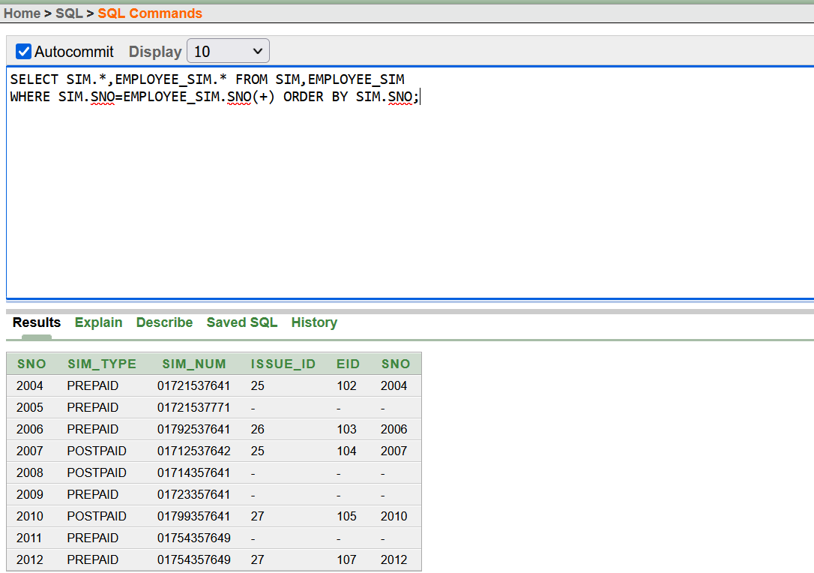

**CONSTRAINTS:**

**CHECK:**

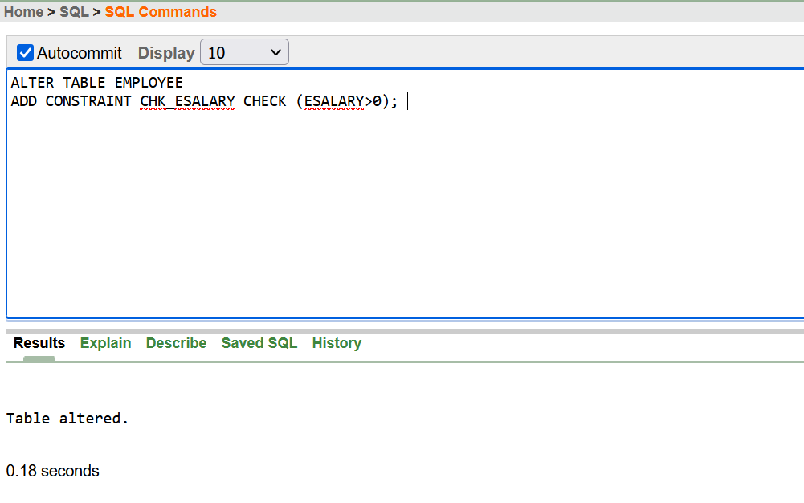

**DEFAULT:**

