S.No | Program Description | Remarks
1 | Program to find the sum of array elements
2 | Program to find the largest element in an array
3 | Program to search an element using linear search in an array
4 | Program to search an element using binary search in an array
5 | Program to sort the elements of an array using bubble and insertion sort
6 | Program to sort the elements of an array using the quick sort algorithm
7 | Program to solve the maximum sub-array problem
8 | Program to display Binary Tree Traversal methods: Pre-order, In-order, and Post-order using recursive algorithms
9 | Program to carry out searching, insertion, and deletion operations in a Binary Search Tree
10 | Program to carry out insertion and deletion operations in an AVL Tree
11 | Program to carry out insertion and deletion in B-trees (with all the cases)
12 | Program to find breadth-first traversals of a given graph
13 | Program to find depth-first traversals of a given graph
14 | Program to find Dijkstra’s shortest path algorithm using a greedy approach
15 | Program to find Prim’s minimum spanning tree algorithm using a greedy approach
16 | Program to implement min-heap and max-heap

Program 1
A program to find the sum of array elements

Code

public static int sumofarrayelements(int[] nums){
int sum =0;
for(int n :nums){
sum+=n;
}
return sum;
}
public static void main(String[] args){
int[] nums = new int[]{2,4,6,2,6,12,45,78};
System.out.println(sumofarrayelements(nums));}

Output
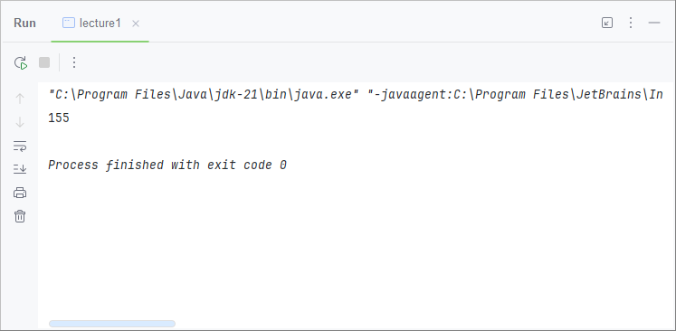

Program 2
Program to find the largest element in array

Code
public static int largestelementinarray(int[] nums){
int max =-(int)(1e9);
for (int n:nums){
if(n>max){max=n;}
}
return max;
}
public static void main(String[] args){
int[] nums = new int[]{2,4,6,2,6,12,45,78};
System.out.println(largestelementinarray(nums));
}

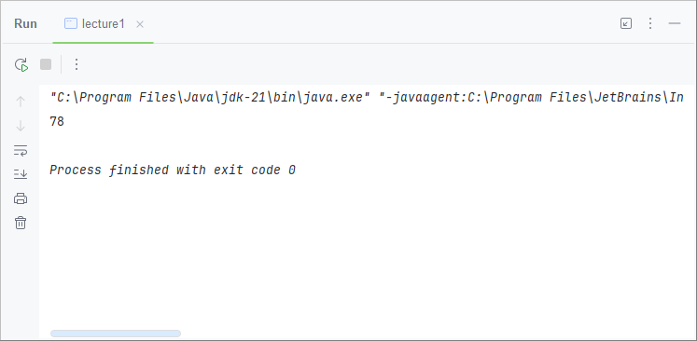
Output

Program 3
Program to search an element using linear search in array

Code
public static int linearsearch(int[] nums, int target){
for (int i = 0; i < nums.length ; i++) {
if(nums[i]==target){return i;}
}
return -1;
}

public static void main(String[] args) {
int[] nums = new int[]{12,23,45,56,65,78,98};
System.out.println(linearsearch(nums, 78));
System.out.println(linearsearch(nums, 88));
}

Output
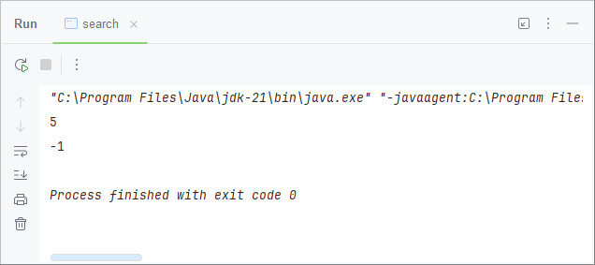

Program 4
Program to search an element using binary search in array

Code
public static int binarysearch(int[] nums,int target){
int left =0;
int right = nums.length-1;
while(right>=left){
int mid = right-(right-left)/2;
if(nums[mid]==target){return mid;}
else if (nums[mid]>target) {right=mid-1;}
else{left=mid+1;}
}
return -1;
}
public static void main(String[] args) {
int[] nums = new int[]{12,23,45,56,65,78,98};
System.out.println(binaryearch(nums, 56));
System.out.println(binarysearch(nums, 99));
}

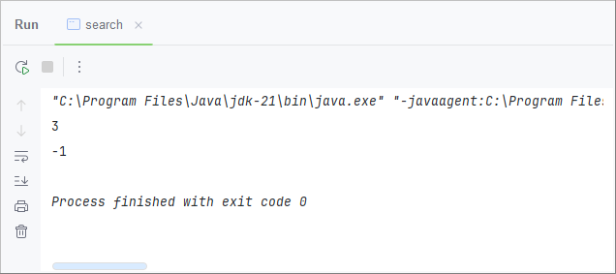
Output
Program 5
Program to sort the element of an array using bubble and insertion sort

Code
public static void bubble(int[] nums){
if(nums.length<2){return;}
for (int i = nums.length-1; i >=0 ; i--) {
for (int j = 0; j <i ; j++) {
if (nums[j+1]<nums[j]){
int temp = nums[j];
nums[j]=nums[j+1];
nums[j+1]= temp;
}
}
}
}
public static void inserted(int[] nums){
for (int i = 1; i < nums.length ; i++) {
for (int j = i-1; j >=0 ; j--) {
if (nums[j+1]<nums[j]){
int temp = nums[j+1];
nums[j+1]=nums[j];
nums[j]=temp;
}else{break;}
}
}
}

public static void main(String[] args) {
int[] nums = new int[]{23,12,56,34,90,54,31,77};
System.out.println(“unsorted array”);
for(int n :nums){
System.out.print(n+",");
}
System.out.println();
bubble(nums);
inserted(nums);
System.out.println(“sorted array”);
for(int n :nums){
System.out.print(n+",");
}

Output
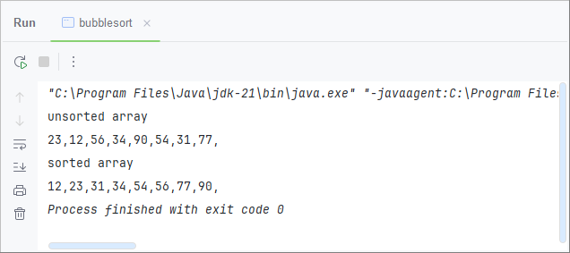

Program 6
A program to find the element of an array using a quick sort algorithm
Code
public class QuickSortThenSearch {
public static void quickSort(int[] array, int low, int high) {
if (low < high) {
int pivotIndex = partition(array, low, high);
quickSort(array, low, pivotIndex - 1);
quickSort(array, pivotIndex + 1, high);
}
}
private static int partition(int[] array, int low, int high) {
int pivot = array[high];
int i = low - 1;
for (int j = low; j < high; j++) {
if (array[j] < pivot) {
i++;
int temp = array[i];
array[i] = array[j];
array[j] = temp;
}
}
int temp = array[i + 1];
array[i + 1] = array[high];
array[high] = temp;

return i + 1;
}
public static boolean binarySearch(int[] array, int element) {
int low = 0, high = array.length - 1;
while (low <= high) {
int mid = low + (high - low) / 2;
if (array[mid] == element) {
return true;
} else if (array[mid] < element) {
low = mid + 1;
} else {
high = mid - 1;
}
}
return false;
}

public static void main(String[] args) {
int[] array = {12, 7, 9, 5, 10, 2, 15};
int target = 10;

System.out.println("Original Array:");
System.out.println(Arrays.toString(array));

quickSort(array, 0, array.length - 1);

System.out.println("Sorted Array:");
System.out.println(Arrays.toString(array));

boolean found = binarySearch(array, target);

if (found) {
System.out.println("Element " + target + " is found in the array.");
} else {
System.out.println("Element " + target + " is not found in the array.");
}
}
}

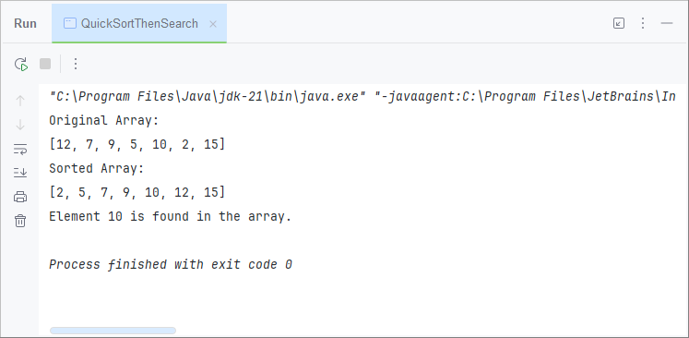
Output

Program 7
A program to solve maximum sub-array problem

Code
public static int subarray(int[] nums){
int sum =0;
int mx =0;
for (int i = 0; i < nums.length ; i++) {
if (sum+nums[i]>=0){sum+=nums[i];}
else{sum=0;}
if (sum>mx){mx=sum;}
}
if (mx==0){
mx=Integer.MIN_VALUE;
for (int j = 0; j < nums.length ; j++) {
mx=Math.max(mx,nums[j]);
}
}
return mx;
}
public static void main(String[] args) {
int[] zaza = new int[]{2,3,-8,7,-1,2,3};
System.out.print(subarray(zaza));
}
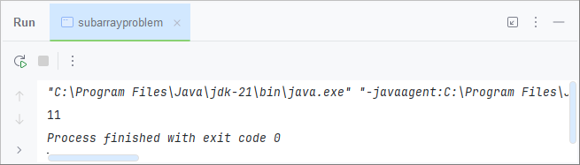
Output

Program 8
A program to display Binary tree traversal methods: Pre-order, In-order, Post-order using recursive algorithm

Code
public class Traversal {
class TreeNode{
int val;
TreeNode left;
TreeNode right;
}
public void inorder(TreeNode root){
if(root==null){return;}
inorder(root.left);
System.out.println(root.val);
inorder(root.right);
}
public void preorder(TreeNode root){
if (root==null){return;}
System.out.println(root.val);
preorder(root.left);
preorder(root.right);
}
public void postorder(TreeNode root){
if(root==null){return;}
postorder(root.left);
postorder(root.right);
System.out.println(root.val);
}
}

Input
1
/ \
2 3
/ \ \
4 5 6
nums = {1, 2, 3, 4, 5, null, 6};
Output

Traversal Type | Order
Inorder | [4, 2, 5, 1, 3, 6]
Preorder | [1, 2, 4, 5, 3, 6]
Postorder | [4, 5, 2, 6, 3, 1]

Program 9
A program to carry out searching, insertion and deletion operation in Binary Search Tree
Code
public class binarysearchtree {
class node {
node left;
node right;
int val;
public node(int val) {
this.val = val;
}
}
node root;
public void insert(int val) {
root = inserter(root, val);
}
private node inserter(node root, int val) {
if (root == null) {
return new node(val);
}
if (root.val > val) {
root.left = inserter(root.left, val);
} else {
root.right = inserter(root.right, val);
}
return root;
}
public node search(int val) {
return searcher(val, root);
}
private node searcher(int val, node root) {
if (root == null) {
return null;
}
if (root.val == val) {
return root;
}
if (root.val > val) {
return searcher(val, root.left);
} else {
return searcher(val, root.right);
}
}
public void delete(int val) {
root = deleter(val, root);
}
private node deleter(int val, node root) {
if (root == null) {
return null;
}
if (root.val == val) {
// Case 1: No child or one child
if (root.left == null) {
return root.right;
}
if (root.right == null) {
return root.left;
}
// Case 2: Two children
node temp = next(root.right);
root.val = temp.val;
root.right = deleter(temp.val, root.right);
} else if (root.val > val) {
root.left = deleter(val, root.left);
} else {
root.right = deleter(val, root.right);
}
return root;
}
private node next(node root) {
node temp = root;
while (temp.left != null) {
temp = temp.left;
}
return temp;
}
public void inOrderTraversal(node root) {
if (root != null) {
inOrderTraversal(root.left);
System.out.print(root.val + " ");
inOrderTraversal(root.right);
}
}
public static void main(String[] args) {
binarysearchtree t = new binarysearchtree();
System.out.println("Inserting elements...");
t.insert(4);
t.insert(3);
t.insert(6);
t.insert(7);
t.insert(5);
System.out.println("Tree after insertion (in-order):");
t.inOrderTraversal(t.root);
System.out.println();
System.out.println("Searching for element 5:");
System.out.println(t.search(5) != null ? "Found" : "Not Found");
System.out.println("Searching for element 10:");
System.out.println(t.search(10) != null ? "Found" : "Not Found");
System.out.println("Deleting element 6...");
t.delete(6);
System.out.println("Tree after deletion of 6 (in-order):");
t.inOrderTraversal(t.root);
System.out.println();
System.out.println("Deleting element 4...");
t.delete(4);
System.out.println("Tree after deletion of 4 (in-order):");
t.inOrderTraversal(t.root);
System.out.println();
}
}

Output
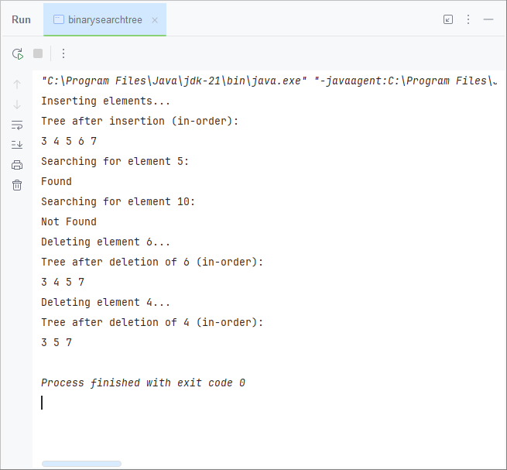

Program 10
Program to carry out insertion and deletion operations in AVL Tree
Code
public class AVL {
Node root;
class Node {
int val;
int height;
Node left;
Node right;
Node(int a) {
this.val = a;
}
}
public void add(int a) {
this.root = insert(a, root);
}
public int height(Node root) {
if (root == null) {
return -1;
} else {
return root.height;
}
}
private Node insert(int a, Node root) {
if (root == null) {
return new Node(a);
}
if (root.val > a) {
root.left = insert(a, root.left);
} else {
root.right = insert(a, root.right);
}
int l = height(root.left);
int r = height(root.right);
root.height = Math.max(l, r) + 1;
return balance(root);
}
private Node balance(Node root) {
if (root == null) {
return null;}
if (height(root.left) - height(root.right) > 1) {
if (height(root.left.left) > height(root.left.right)) {
return Rightrotate(root); // Left-Left case
} else {
root.left = Leftrotate(root.left); // Left-Right case
return Rightrotate(root);
}
} else if (height(root.right) - height(root.left) > 1) {
if (height(root.right.left) > height(root.right.right)) {
root.right = Rightrotate(root.right); // Right-Left case
return Leftrotate(root);
} else {
return Leftrotate(root); // Right-Right case
}
}
return root;
}
private Node Leftrotate(Node parent) {
Node child = parent.right;
parent.right = child.left;
child.left = parent;
child.height = Math.max(height(child.left), height(child.right)) + 1;
parent.height = Math.max(height(parent.left), height(parent.right)) + 1;
return child;
}
private Node Rightrotate(Node parent) {
Node child = parent.left;
parent.left = child.right;
child.right = parent;
child.height = Math.max(height(child.left), height(child.right)) + 1;
parent.height = Math.max(height(parent.left), height(parent.right)) + 1;
return child;
}
public void delete(int val) {
root = deleted(val, root);
}
private Node deleted(int val, Node root) {
if (root == null) {
return null;
}
if (val > root.val) {
root.right = deleted(val, root.right);
} else if (val < root.val) {
root.left = deleted(val, root.left);
} else {
if (root.left == null) {
return root.right;
}
if (root.right == null) {
return root.left;
}
Node suc = findMin(root.right);
root.val = suc.val;
root.right = deleted(suc.val, root.right);
}
int l = height(root.left);
int r = height(root.right);
root.height = Math.max(l, r) + 1;
return balance(root);
}
private Node findMin(Node root) {
while (root.left != null) {
root = root.left;
}
return root;
}
// In-order Traversal for Display
public void inOrderTraversal(Node root) {
if (root != null) {
inOrderTraversal(root.left);
System.out.print(root.val + " ");
inOrderTraversal(root.right);
}
}
public static void main(String[] args) {
AVL tree = new AVL();
System.out.println("Inserting values...");
tree.add(10);
tree.add(20);
tree.add(30);
tree.add(40);
tree.add(50);
tree.add(25);

System.out.println("Tree after insertion (in-order):");
tree.inOrderTraversal(tree.root);
System.out.println();

System.out.println("Deleting values 50 and 30...");
tree.delete(50);
tree.delete(30);

System.out.println("Tree after deletion (in-order):");
tree.inOrderTraversal(tree.root);
System.out.println();
}
}

Output
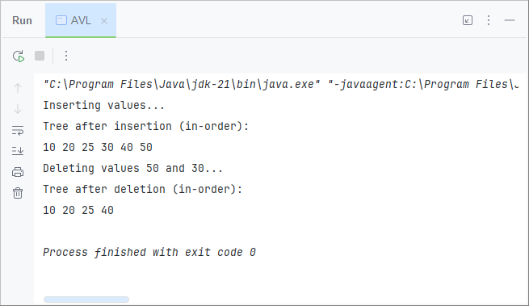

Program 11
A program to carry out insertion and deletion in B trees

Code
class BTreeNode {
int[] keys; // Array of keys
int t; // Minimum degree
BTreeNode[] children; // Array of child pointers
int n; // Current number of keys
boolean isLeaf; // True if leaf node

public BTreeNode(int t, boolean isLeaf) {
this.t = t;
this.isLeaf = isLeaf;
keys = new int[2 * t - 1];
children = new BTreeNode[2 * t];
n = 0;
}

public void traverse() {
for (int i = 0; i < n; i++) {
if (!isLeaf) children[i].traverse();
System.out.print(keys[i] + " ");
}
if (!isLeaf) children[n].traverse();
}

public BTreeNode search(int key) {
int i = 0;
while (i < n && key > keys[i]) i++;
if (i < n && keys[i] == key) return this;
if (isLeaf) return null;
return children[i].search(key);
}

void insertNonFull(int key) {
int i = n - 1;

if (isLeaf) {
while (i >= 0 && keys[i] > key) {
keys[i + 1] = keys[i];
i--;
}
keys[i + 1] = key;
n++;
} else {
while (i >= 0 && keys[i] > key) i--;

if (children[i + 1].n == 2 * t - 1) {
splitChild(i + 1, children[i + 1]);
if (keys[i + 1] < key) i++;
}
children[i + 1].insertNonFull(key);
}
}

void splitChild(int i, BTreeNode y) {
BTreeNode z = new BTreeNode(y.t, y.isLeaf);
z.n = t - 1;

for (int j = 0; j < t - 1; j++) z.keys[j] = y.keys[j + t];
if (!y.isLeaf) for (int j = 0; j < t; j++) z.children[j] = y.children[j + t];

y.n = t - 1;

for (int j = n; j >= i + 1; j--) children[j + 1] = children[j];
children[i + 1] = z;

for (int j = n - 1; j >= i; j--) keys[j + 1] = keys[j];
keys[i] = y.keys[t - 1];
n++;
}

int findKey(int key) {
int idx = 0;
while (idx < n && keys[idx] < key) idx++;
return idx;
}

void remove(int key) {
int idx = findKey(key);

if (idx < n && keys[idx] == key) {
if (isLeaf) removeFromLeaf(idx);
else removeFromNonLeaf(idx);
} else {
if (isLeaf) {
System.out.println("Key " + key + " does not exist in the tree.");
return;
}
boolean flag = idx == n;
if (children[idx].n < t) fill(idx);
if (flag && idx > n) children[idx - 1].remove(key);
else children[idx].remove(key);
}
}

void removeFromLeaf(int idx) {
for (int i = idx + 1; i < n; i++) keys[i - 1] = keys[i];
n--;
}

void removeFromNonLeaf(int idx) {
int key = keys[idx];

if (children[idx].n >= t) {
int pred = getPred(idx);
keys[idx] = pred;
children[idx].remove(pred);
} else if (children[idx + 1].n >= t) {
int succ = getSucc(idx);
keys[idx] = succ;
children[idx + 1].remove(succ);
} else {
merge(idx);
children[idx].remove(key);
}
}

int getPred(int idx) {
BTreeNode cur = children[idx];
while (!cur.isLeaf) cur = cur.children[cur.n];
return cur.keys[cur.n - 1];
}

int getSucc(int idx) {
BTreeNode cur = children[idx + 1];
while (!cur.isLeaf) cur = cur.children[0];
return cur.keys[0];
}

void fill(int idx) {
if (idx != 0 && children[idx - 1].n >= t) borrowFromPrev(idx);
else if (idx != n && children[idx + 1].n >= t) borrowFromNext(idx);
else {
if (idx != n) merge(idx);
else merge(idx - 1);
}
}

void borrowFromPrev(int idx) {
BTreeNode child = children[idx];
BTreeNode sibling = children[idx - 1];

for (int i = child.n - 1; i >= 0; i--) child.keys[i + 1] = child.keys[i];
if (!child.isLeaf) for (int i = child.n; i >= 0; i--) child.children[i + 1] = child.children[i];

child.keys[0] = keys[idx - 1];
if (!child.isLeaf) child.children[0] = sibling.children[sibling.n];
keys[idx - 1] = sibling.keys[sibling.n - 1];
child.n++;
sibling.n--;
}

void borrowFromNext(int idx) {
BTreeNode child = children[idx];
BTreeNode sibling = children[idx + 1];

child.keys[child.n] = keys[idx];
if (!child.isLeaf) child.children[child.n + 1] = sibling.children[0];

keys[idx] = sibling.keys[0];
for (int i = 1; i < sibling.n; i++) sibling.keys[i - 1] = sibling.keys[i];
if (!sibling.isLeaf) for (int i = 1; i <= sibling.n; i++) sibling.children[i - 1] = sibling.children[i];

child.n++;
sibling.n--;
}

void merge(int idx) {
BTreeNode child = children[idx];
BTreeNode sibling = children[idx + 1];

child.keys[t - 1] = keys[idx];
for (int i = 0; i < sibling.n; i++) child.keys[i + t] = sibling.keys[i];
if (!child.isLeaf) for (int i = 0; i <= sibling.n; i++) child.children[i + t] = sibling.children[i];

for (int i = idx + 1; i < n; i++) keys[i - 1] = keys[i];
for (int i = idx + 2; i <= n; i++) children[i - 1] = children[i];

child.n += sibling.n + 1;
n--;
}
}

class BTree {
BTreeNode root;
int t;

public BTree(int t) {
this.t = t;
root = null;
}

public void traverse() {
if (root != null) root.traverse();
}

public BTreeNode search(int key) {
return root == null ? null : root.search(key);
}

public void insert(int key) {
if (root == null) {
root = new BTreeNode(t, true);
root.keys[0] = key;
root.n = 1;
} else {
if (root.n == 2 * t - 1) {
BTreeNode s = new BTreeNode(t, false);
s.children[0] = root;
s.splitChild(0, root);
int i = s.keys[0] < key ? 1 : 0;
s.children[i].insertNonFull(key);
root = s;
} else {
root.insertNonFull(key);
}
}
}

public void remove(int key) {
if (root == null) {
System.out.println("The tree is empty.");
return;
}
root.remove(key);
if (root.n == 0) {
root = root.isLeaf ? null : root.children[0];
}
}
}

public class BTreeDemo {
public static void main(String[] args) {
BTree tree = new BTree(3);

tree.insert(10);
tree.insert(20);
tree.insert(5);
tree.insert(6);
tree.insert(12);
tree.insert(30);
tree.insert(7);
tree.insert(17);

System.out.println("Traversal of the constructed tree:");
tree.traverse();
System.out.println();
}
}

Output
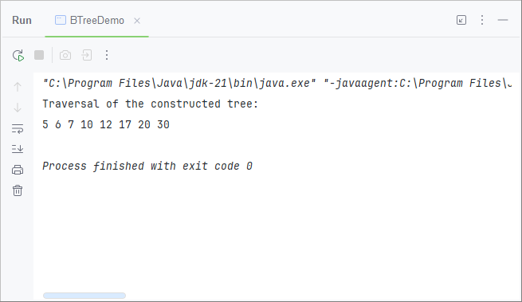

Program 12
A program to find out breadth-first traversals of a given graph.

Code
class Graph {
private int vertices;
private LinkedList<Integer>[] adjacencyList;

public Graph(int vertices) {
this.vertices = vertices;
adjacencyList = new LinkedList[vertices];
for (int i = 0; i < vertices; i++) {
adjacencyList[i] = new LinkedList<>();
}
}

public void addEdge(int source, int destination) {
adjacencyList[source].add(destination);
}

public void BFS(int startVertex) {
boolean[] visited = new boolean[vertices];
Queue<Integer> queue = new LinkedList<>();

visited[startVertex] = true;
queue.add(startVertex);

System.out.println("Breadth-First Traversal starting from vertex " + startVertex + ":");

while (!queue.isEmpty()) {
int currentVertex = queue.poll();
System.out.print(currentVertex + " ");

for (int neighbor : adjacencyList[currentVertex]) {
if (!visited[neighbor]) {
visited[neighbor] = true;
queue.add(neighbor);
}
}
}
System.out.println();
}
}

public class BFSDemo {
public static void main(String[] args) {
Graph graph = new Graph(6);

// Add edges to the graph
graph.addEdge(0, 1);
graph.addEdge(0, 2);
graph.addEdge(1, 3);
graph.addEdge(1, 4);
graph.addEdge(2, 4);
graph.addEdge(3, 5);
graph.addEdge(4, 5);

// Perform BFS starting from vertex 0
graph.BFS(0);
}
}

Output
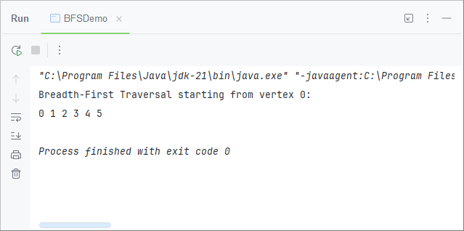

Program 13
A program to find out depth-first traversals of a given graph.

Code
class Graph {
private int vertices;
private LinkedList<Integer>[] adjacencyList;

public Graph(int vertices) {
this.vertices = vertices;
adjacencyList = new LinkedList[vertices];
for (int i = 0; i < vertices; i++) {
adjacencyList[i] = new LinkedList<>();
}
}

public void addEdge(int source, int destination) {
adjacencyList[source].add(destination);
}

public void DFS(int startVertex) {
boolean[] visited = new boolean[vertices];
System.out.println("Depth-First Traversal starting from vertex " + startVertex + ":");
dfsHelper(startVertex, visited);
System.out.println();
}

private void dfsHelper(int vertex, boolean[] visited) {
visited[vertex] = true;
System.out.print(vertex + " ");

for (int neighbor : adjacencyList[vertex]) {
if (!visited[neighbor]) {
dfsHelper(neighbor, visited);
}
}
}
}

public class DFSDemo {
public static void main(String[] args) {
Graph graph = new Graph(6);

// Add edges to the graph
graph.addEdge(0, 1);
graph.addEdge(0, 2);
graph.addEdge(1, 3);
graph.addEdge(1, 4);
graph.addEdge(2, 4);
graph.addEdge(3, 5);
graph.addEdge(4, 5);

// Perform DFS starting from vertex 0
graph.DFS(0);
}
}

Output
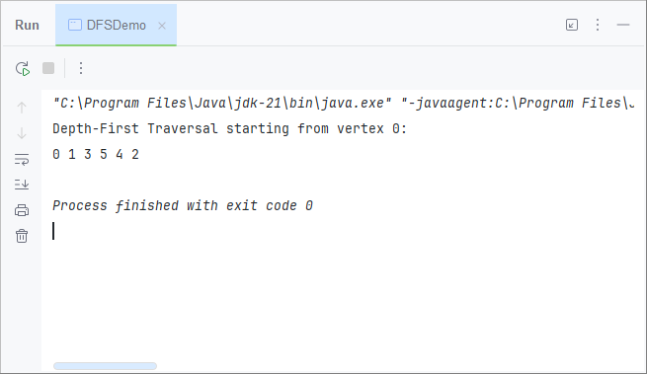

Program 14
A program to find out Dijkstra’s shortest path algorithm using greedy approach.

Code
class DijkstraAlgorithm {
private static int getMinDistanceVertex(int[] distances, boolean[] visited, int vertices) {
int minDistance = Integer.MAX_VALUE;
int minIndex = -1;

for (int i = 0; i < vertices; i++) {
if (!visited[i] && distances[i] < minDistance) {
minDistance = distances[i];
minIndex = i;
}
}

return minIndex;
}

public static void dijkstra(int[][] graph, int source) {
int vertices = graph.length;
int[] distances = new int[vertices];
boolean[] visited = new boolean[vertices];
Arrays.fill(distances, Integer.MAX_VALUE);
distances[source] = 0;

for (int i = 0; i < vertices - 1; i++) {
int currentVertex = getMinDistanceVertex(distances, visited, vertices);
visited[currentVertex] = true;

for (int neighbor = 0; neighbor < vertices; neighbor++) {
if (!visited[neighbor] &&
graph[currentVertex][neighbor] != 0 &&
distances[currentVertex] != Integer.MAX_VALUE &&
distances[currentVertex] + graph[currentVertex][neighbor] < distances[neighbor]) {
distances[neighbor] = distances[currentVertex] + graph[currentVertex][neighbor];
}
}
}

// Print shortest distances
System.out.println("Vertex \t Shortest Distance from Source " + source);
for (int i = 0; i < vertices; i++) {
System.out.println(i + " \t\t " + distances[i]);
}
}

public static void main(String[] args) {
int[][] graph = {
{0, 4, 0, 0, 0, 0},
{4, 0, 8, 0, 0, 0},
{0, 8, 0, 7, 0, 4},
{0, 0, 7, 0, 9, 14},
{0, 0, 0, 9, 0, 10},
{0, 0, 4, 14, 10, 0}
};

int source = 0; // Starting vertex
dijkstra(graph, source);
}
}

Output
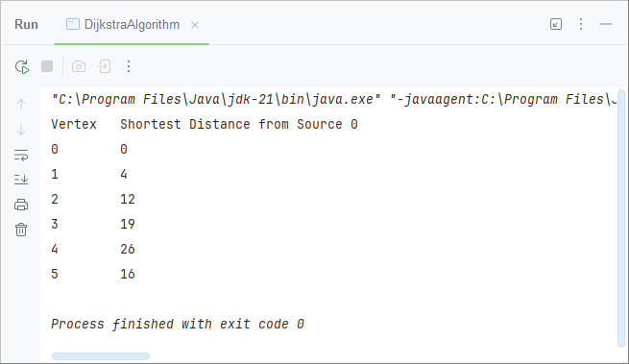

Program 15
A program to find out Prim’s minimum spanning algorithm using greedy approach.

Code
class PrimsAlgorithm {
private static int getMinKeyVertex(int[] key, boolean[] included, int vertices) {
int minValue = Integer.MAX_VALUE;
int minIndex = -1;

for (int i = 0; i < vertices; i++) {
if (!included[i] && key[i] < minValue) {
minValue = key[i];
minIndex = i;
}
}

return minIndex;
}
public static void primMST(int[][] graph) {
int vertices = graph.length;
int[] parent = new int[vertices];
int[] key = new int[vertices];
boolean[] included = new boolean[vertices];
Arrays.fill(key, Integer.MAX_VALUE);
key[0] = 0;
parent[0] = -1;

for (int i = 0; i < vertices - 1; i++) {
int u = getMinKeyVertex(key, included, vertices);
included[u] = true;
for (int v = 0; v < vertices; v++) {
if (graph[u][v] != 0 && !included[v] && graph[u][v] < key[v]) {
parent[v] = u;
key[v] = graph[u][v];
}
}
}
printMST(parent, graph);
}
private static void printMST(int[] parent, int[][] graph) {
System.out.println("Edge \tWeight");
for (int i = 1; i < graph.length; i++) {
System.out.println(parent[i] + " - " + i + "\t" + graph[i][parent[i]]);
}
}

public static void main(String[] args) {
int[][] graph = {
{0, 2, 0, 6, 0},
{2, 0, 3, 8, 5},
{0, 3, 0, 0, 7},
{6, 8, 0, 0, 9},
{0, 5, 7, 9, 0}
};

primMST(graph);
}
}

Output
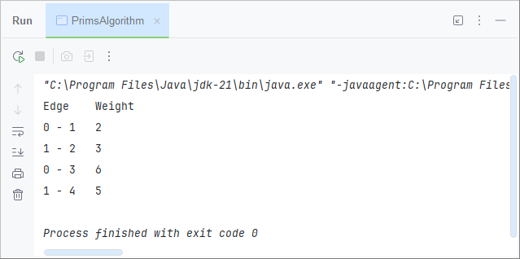

Program 16
A program to implement min head and max head.

Code
class CustomHeap {
private List<Integer> heap;
private boolean isMinHeap;
public CustomHeap(boolean isMinHeap) {
this.heap = new ArrayList<>();
this.isMinHeap = isMinHeap;
}
public void add(int value) {
heap.add(value);
heapifyUp(heap.size() - 1);
}
public int poll() {
if (heap.isEmpty()) throw new NoSuchElementException("Heap is empty");
int top = heap.get(0);
heap.set(0, heap.get(heap.size() - 1));
heap.remove(heap.size() - 1);
heapifyDown(0);
return top;
}
private void heapifyUp(int index) {
int parentIndex = (index - 1) / 2;
if (index > 0 && compare(heap.get(index), heap.get(parentIndex))) {
Collections.swap(heap, index, parentIndex);
heapifyUp(parentIndex);
}
}
private void heapifyDown(int index) {
int leftChild = 2 * index + 1;
int rightChild = 2 * index + 2;
int extremum = index;

if (leftChild < heap.size() && compare(heap.get(leftChild), heap.get(extremum))) {
extremum = leftChild;
}
if (rightChild < heap.size() && compare(heap.get(rightChild), heap.get(extremum))) {
extremum = rightChild;
}

if (extremum != index) {
Collections.swap(heap, index, extremum);
heapifyDown(extremum);
}
}
private boolean compare(int child, int parent) {
return isMinHeap ? child < parent : child > parent;
}
public boolean isEmpty() {
return heap.isEmpty();
}
public void display() {
System.out.println(heap);
}
}

public class CustomHeapDemo {
public static void main(String[] args) {
// Min Heap
CustomHeap minHeap = new CustomHeap(true);
System.out.println("Min Heap:");
minHeap.add(3);
minHeap.add(1);
minHeap.add(6);
minHeap.add(5);
minHeap.add(2);
minHeap.add(4);
while (!minHeap.isEmpty()) {
System.out.print(minHeap.poll() + " ");
}
System.out.println();

// Max Heap
CustomHeap maxHeap = new CustomHeap(false);
System.out.println("Max Heap:");
maxHeap.add(3);
maxHeap.add(1);
maxHeap.add(6);
maxHeap.add(5);
maxHeap.add(2);
maxHeap.add(4);
while (!maxHeap.isEmpty()) {
System.out.print(maxHeap.poll() + " ");
}
}
}

Output
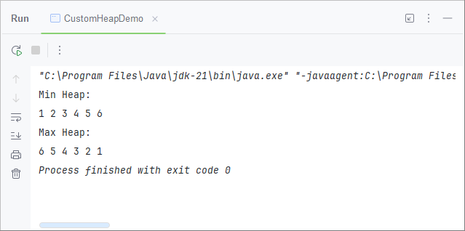

Program 1
A program to find length of string, concatenation of two strings without using inbuilt function

Code
public class StringOperations {
public static int findLength(String str) {
int length = 0;
try {
while (true) {
char c = str.charAt(length);
length++;
}
} catch (IndexOutOfBoundsException e) {
}
return length;
}

public static String concatenateStrings(String str1, String str2) {
char[] result = new char[str1.length() + str2.length()];
int i = 0;
for (i = 0; i < str1.length(); i++) {
result[i] = str1.charAt(i);
}
for (int j = 0; j < str2.length(); j++) {
result[str1.length() + j] = str2.charAt(j);
}
return new String(result);
}

public static void main(String[] args) {
Scanner scanner = new Scanner(System.in);

System.out.print("Enter the first string: ");
String str1 = scanner.nextLine();
System.out.print("Enter the second string: ");
String str2 = scanner.nextLine();
int length = findLength(str1);
System.out.println("Length of the first string: " + length);
String concatenatedString = concatenateStrings(str1, str2);
System.out.println("Concatenated string: " + concatenatedString);
scanner.close();
}
}

Output
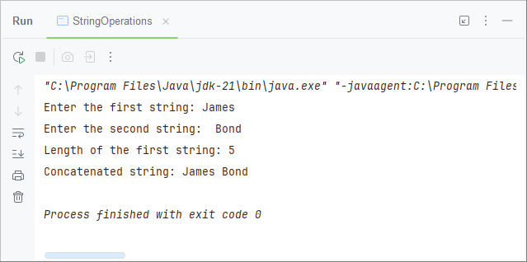

Program 2
A program to print a Symbol Table

Code
public class SymbolTable {
private Map<String, String> table;

public SymbolTable() {
table = new HashMap<>();
}

public void addSymbol(String key, String value) {
table.put(key, value);
}

public void printSymbolTable() {
System.out.println("Symbol Table :");
for (Map.Entry<String, String> entry : table.entrySet()) {
System.out.println("Key: " + entry.getKey() + ", Value: " + entry.getValue());
}
}
public static void main(String[] args) {
SymbolTable symbolTable = new SymbolTable();
symbolTable.addSymbol("x", "10");
symbolTable.addSymbol("y", "20");
symbolTable.addSymbol("z", "30");
symbolTable.printSymbolTable();
}
}

Output

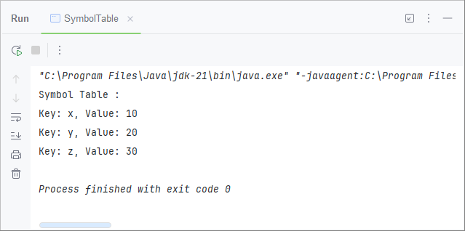

Program 3
A program to implement Pattern Matching
Code
public class PatternMatching {
public static void naivePatternMatch(String text, String pattern) {
int n = text.length();
int m = pattern.length();
for (int i = 0; i <= n - m; i++) {
int j = 0;
while (j < m && text.charAt(i + j) == pattern.charAt(j)) {
j++; }
if (j == m) {
System.out.println("Pattern found at index: " + i);
}
}
}
public static void main(String[] args) {
String text = "ABABABACDABABCABABABACDAB";
String pattern = "ABABCABAB";
System.out.println("Searching for pattern: \"" + pattern + "\" in text: \"" + text + "\"");
naivePatternMatch(text, pattern);
}
}
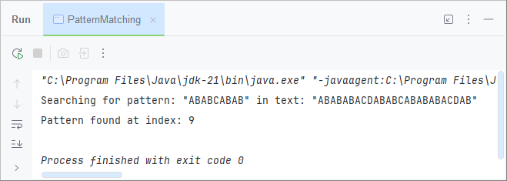
Output

Program 4
A program to validate an email ID/Mobile Number
Code
public class SimpleValidation {
public static boolean validateEmail(String email) {
String emailRegex = "^[a-zA-Z0-9_+&*-]+(?:\\.[a-zA-Z0-9_+&*-]+)*@(?:[a-zA-Z0-9-]+\\.)+[a-zA-Z]{2,7}$";
return email.matches(emailRegex);
}
public static boolean validateMobile(String mobile) {
String mobileRegex = "^(\\+\\d{1,3})?\\d{10}$";
return mobile.matches(mobileRegex);
}
public static void main(String[] args) {
String email = "example@domain.com";
String inemail = "sahil@domain.com,,";
String mobile = "+911234567890";
if (validateEmail(email)) {
System.out.println("Valid email: " + email);
} else {
System.out.println("Invalid email: " + email);
}
if (validateEmail(inemail)) {
System.out.println("Valid email: " + inemail);
} else {
System.out.println("Invalid email: " + inemail);
}
if (validateMobile(mobile)) {
System.out.println("Valid mobile number: " + mobile);
} else {
System.out.println("Invalid mobile number: " + mobile);
}
}
}

Output
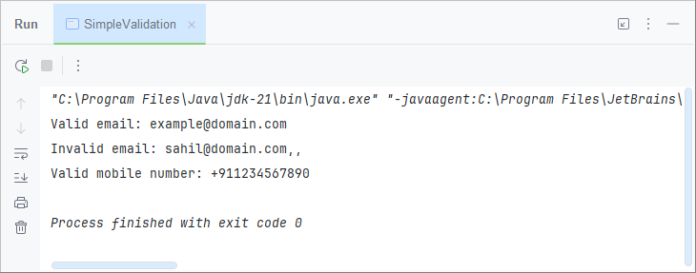

Program 5
A program to check number of single spaces, double spaces and multiple spaces in a given string. Print the resultant string
after replacing double/multiple spaces with single space.

Code
public class Spaces {
public static void main(String[] args) {
String input = "Hello Your Caption Speaking This is Flight 108768 The Weather is beautiful Today ";
int singleSpaceCount = 0;
int doubleSpaceCount = 0;
int multiSpaceCount = 0;
for (int i = 0; i < input.length(); i++) {
if (input.charAt(i) == ' ') {
int spaceCount = 1;
while (i + 1 < input.length() && input.charAt(i + 1) == ' ') {
spaceCount++;
i++;
}
if (spaceCount == 1) {
singleSpaceCount++;
} else if (spaceCount == 2) {
doubleSpaceCount++;
} else if (spaceCount > 2) {
multiSpaceCount++;
}
}
}
String result = input.replaceAll("\\s{2,}", " ").trim();
System.out.println("Single Spaces: " + singleSpaceCount);
System.out.println("Double Spaces: " + doubleSpaceCount);
System.out.println("Multiple Spaces: " + multiSpaceCount);
System.out.println("Resulted String: " + result);
}
}

Output
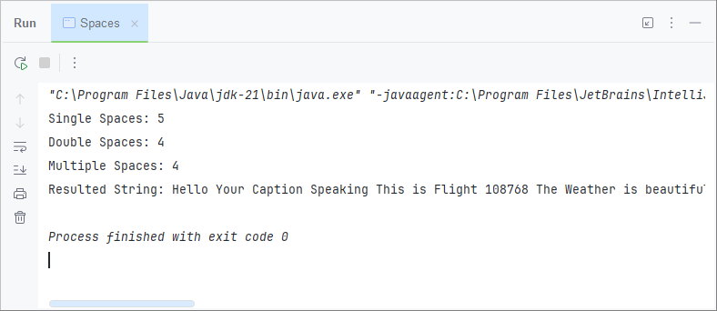

Compiler Construction

S no | Program Description | Remarks
1 | Program to find length of string, concatenation of two strings  without using inbuilt function
2 | Program to print a Symbol Table
3 | Program to implement Pattern Matching
4 | Program to validate an email ID/Mobile Number.
5 | Program to check number of single spaces, double spaces and  multiple spaces in a given string. Print the resultant string  after replacing double/multiple spaces with single space.

Program 1
Program in JAVA to implement print Prime Numbers up to 100.
Code
public class primeno {
public static void firsthundredprimeno() {
Set<Integer> set = new HashSet<>();
int i = 1;
int k = 1;
System.out.print(k + " ");
while (k != 100) {
k++;
boolean m = false;
for (int j : set) {
if (k % j == 0) {
m = true;
break;
}
}
if (m) {
continue;
}
set.add(k);
System.out.print(k + " ");
i++;

}
}

public static void main(String[] args) {
firsthundredprimeno();
}
}

Output
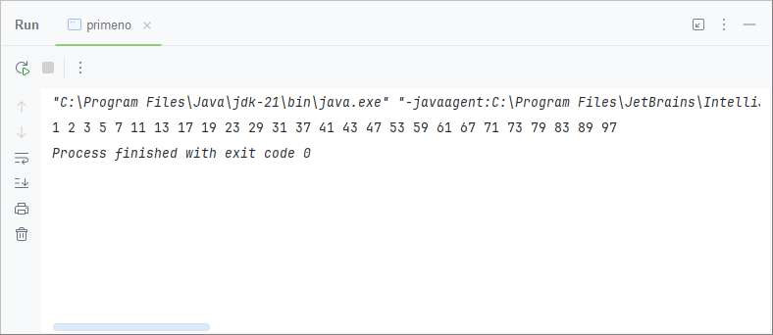

Program 2
Program in JAVA to implement finding whether a number is Armstrong or not.
Code
public class armstrong {
public static boolean armstrongornot(int n){
int pow = (int)Math.log10(n)+1;
int z=n;
int ans =0;
while(z!=0){
int k = 1;
for (int i = 0; i <pow ; i++) {
k*=z%10;
}
ans+=k;
z=z/10;
}
return n==ans;
}

public static void main(String[] args) {

int n = 153;
if(armstrongornot(n)){
System.out.println(n+" is an armstrong no ");
}else{
System.out.println(n+" is not an armstrong no ");
}
}
}

}

Output
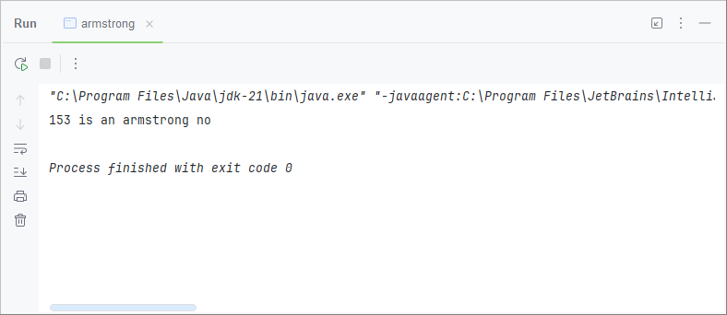

Program 3
Program in Java to implement array reading and writing
on/from console.
Code
public class readandwriteconsole {
public static void main(String[] args) {
Scanner r = new Scanner(System.in);
System.out.println("Enter the length of array ");
int n = r.nextInt();
int[] nums = new int[n];
for (int i = 0; i <n ; i++) {
System.out.println("Enter the value for " +(i+1)+ "th element");
int k = r.nextInt();
nums[i]=k;
}
System.out.println("Your Entered Array Is :");
for (int i = 0; i <n ; i++) {
if(i==n-1){System.out.print(nums[i]);}
else{
System.out.print(nums[i]+",");
}
}
}
}

Output
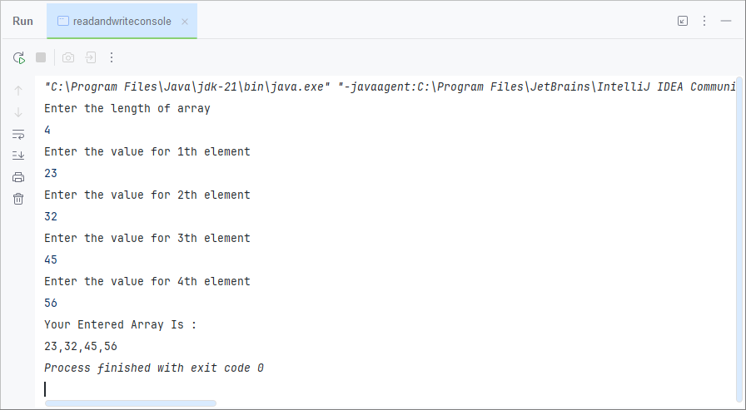

Program 4
Program in Java to implement selection sort using functions
Code
public class selectionsort {
public static void selection(int[] nums){
int n = nums.length;
for (int i = 0; i <n; i++) {
for (int j = i+1; j <n ; j++) {
if(nums[i]>nums[j]){
int temp = nums[i];
nums[i]=nums[j];
nums[j]=temp;
}
}
}
}

public static void main(String[] args) {
int[] nums = new int[]{45,12,9,57,23,89,123,65};
System.out.println("unsorted");
for(int l:nums){
System.out.print(l+" ");
}
selection(nums);
System.out.println();
System.out.println("Sorted");
for(int l:nums){
System.out.print(l+" ");
}
}
}

Output
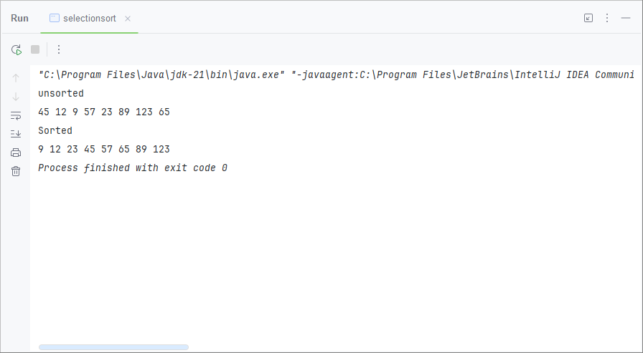

Program 5
Program in Java to implement Bubble Sort using Functions
Code
public static void bubble(int[] nums) {
if (nums.length < 2) {
return;
}
for (int i = nums.length - 1; i >= 0; i--) {
for (int j = 0; j < i; j++) {
if (nums[j + 1] < nums[j]) {
int temp = nums[j];
nums[j] = nums[j + 1];
nums[j + 1] = temp;
}
}
}
}

public static void main(String[] args) {
int[] nums = new int[]{23, 12, 56, 34, 90, 54, 31, 77};
System.out.println("Unsorted array");
for (int n : nums) {
System.out.print(n + ",");
}
System.out.println();
bubble(nums);
System.out.println("Sorted array");
for (int n : nums) {
System.out.print(n + ",");
}
}}

Output
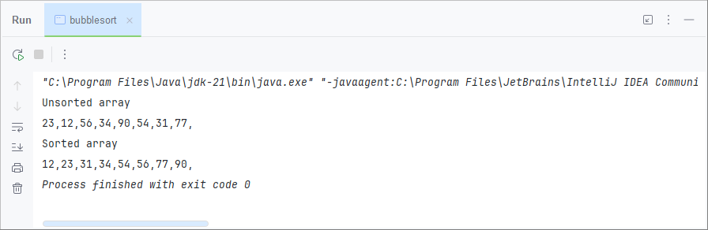

Program 6
Program in Java to implement Insertion sort using
functions.
Code
public class insertionsort {
public static void inserted(int[] nums){
for (int i = 1; i < nums.length ; i++) {
for (int j = i-1; j >=0 ; j--) {
if (nums[j+1]<nums[j]){
int temp = nums[j+1];
nums[j+1]=nums[j];
nums[j]=temp;
}else{break;}
}
}
}

public static void main(String[] args) {
int[] nums = new int[]{23, 12, 56, 34, 90, 54, 31, 77};
System.out.println("Unsorted array");
for (int n : nums) {
System.out.print(n + ",");
}
System.out.println();
inserted(nums);
System.out.println("Sorted array");
for (int n : nums) {
System.out.print(n + ",");
}
}
}

Output
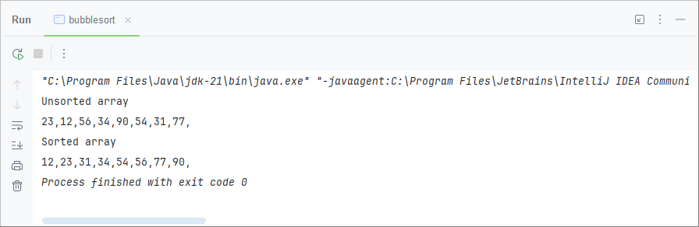

Program 7
Program in Java to implement Matching a Particular
Substring in a String without using inbuilt matching
function(s).
Code
public class Substringchecker {
public static boolean substring(String a ,String b){
if(a.equals(" ")&&b.equals(" ")){return true;}
if(a.equals(" ")||b.equals(" ")){return false;}
int b1=0;
for (int i = 0; i <a.length()&&b1<b.length(); i++) {
if (a.charAt(i)==b.charAt(b1)){b1++;}
else{b1=0;}
}
return b1==b.length();
}
public static void main(String[] args) {
System.out.println(substring("ABCDDDEFCKLOCK","LOCK"));
}
}
Output
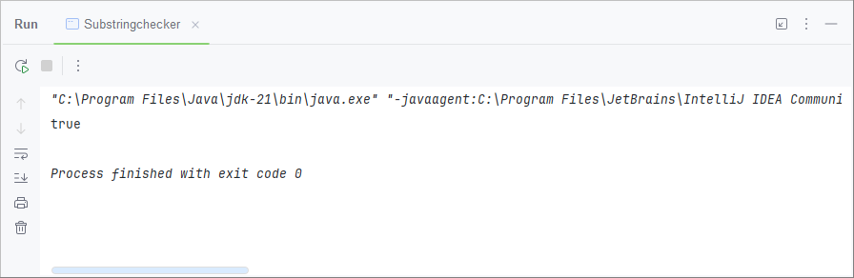

Program 8
Program in Java to implement Garbage Collection Usage in Java.
Code
public class garbagecolle {
@Override
protected void finalize() throws Throwable {
super.finalize();
System.out.println("Garbage Collected");
}
public static void main(String[] args) {
garbagecolle g1 = new garbagecolle();
garbagecolle g2 = new garbagecolle();
g1=g2=null;
System.gc();
}
}

Output
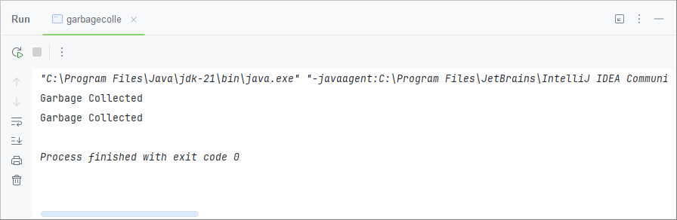

Program 9
Program in Java to implement array of objects and create a student record with details of name, address, contact number and email ID
Code
public class Student {
int rollno;
String name;
String address;
String phno;
String emailid;
Student(int a , String b , String c, String d, String e){
this.rollno=a;
this.name=b;
this.address =c;
this.phno=d;
this.emailid=e;
}
public static void main(String[] args) {
Student[] array = new Student[1];
Student a = new Student(24117,"Ram","123 road","1234567890","example@hostname.com");
array[0]=a;
for (Student z :array){
System.out.print(z.name+" "+z.rollno+" "+z.address+" "+z.phno+" "+z.emailid);
}
}}

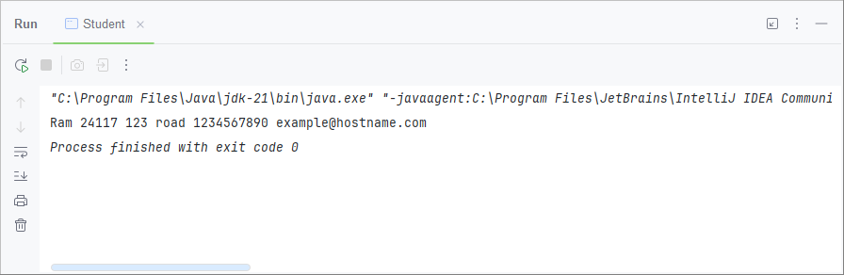
Output

Program 10
Program in Java to implement Single & Multi-level
inheritance.
Code
class Engine{
int cc;
String fueltype;
Engine(int a,String b){
this.cc=a;
this.fueltype=b;
}
}
class Car extends Engine{
int yearofmfg;
Car(int a,int b,String c){
super(b,c);
this.yearofmfg=a;
}
}
class bike extends Engine{
int model;
bike(int a,int b,String c){
super(b,c);
this.model=a;
}
}
class Truck extends Car{
String model;
Truck(String a,int b,int c,String d ){
super(b,c,d);
this.model=a;
}
}
public class inheritanceexample {
public static void main(String[] args) {
Truck chotahathi = new Truck("sumo",2024,12000,"deisel");
System.out.println(chotahathi.model+" Model of Truck");
System.out.println("it was made in "+chotahathi.yearofmfg);
System.out.println(chotahathi.cc+" It has this many cc");
System.out.println(chotahathi.fueltype+" it uses this fuel");
}
}

Output
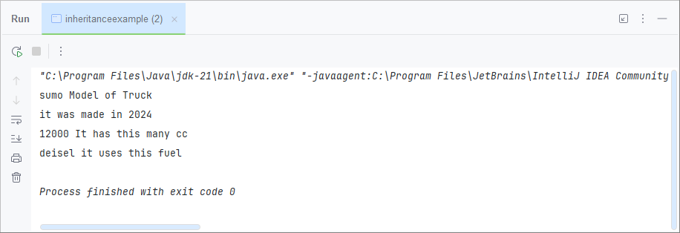

Program 11
Program in Java to implement Abstract Class Usage
Code
public class abstractclaass extends test{
@Override
public int sum(int a, int b) {
return (a+b)*10;
}
public static void main(String[] args) {
abstractclaass a = new abstractclaass();
System.out.println(a.sum(2,3));
System.out.println(a.sum(2,3,0));
}
}
class test2 extends test{
@Override
public int sum(int a, int b) {
return Math.abs(a-b);
}
}
abstract class test{
int a ;
int b ;
abstract public int sum(int a ,int b);
public int sum(int a,int b,int c){
return a+b+c;
}
}

Output
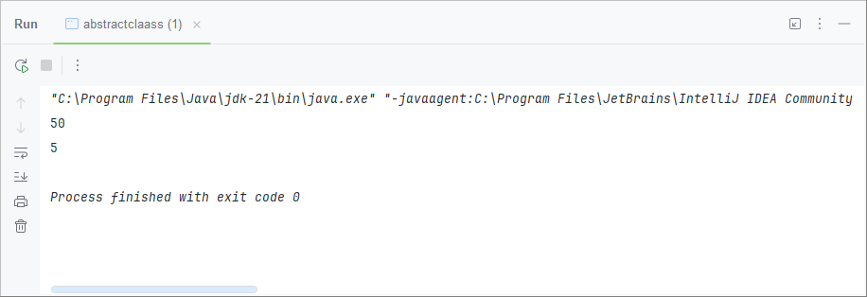

Program 12
Program in Java to implement Interface Usage to implement multiple inheritance.
Code
interface t1{
int sd =8;
static void call(){
System.out.println("i m inside interface t1");
}
void called();
}
interface t2{
static void call(){
System.out.println("i m inside interface t2");
}
}
class t3{
public void call(){
System.out.println("i m inside class t3");
}
}
public class interfaace extends t3 implements t1,t2 {
public static void main(String[] args) {
interfaace t = new interfaace();
System.out.println(sd);
t.called();
t1.call();
t2.call();
}
@Override
public void called() {
System.out.println("called inside main class");
}
}
Output
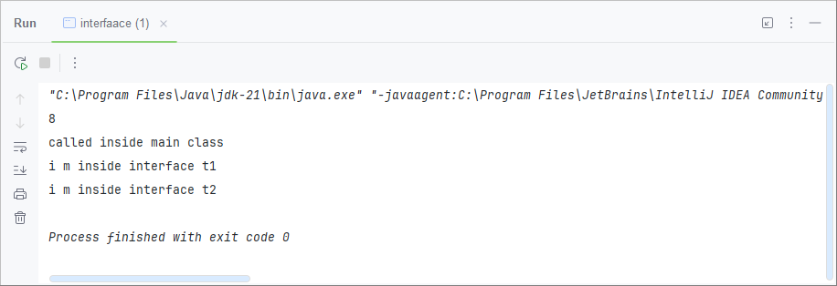

Program 13
Program in Java to implement Packages usage to use one function of a class in another.
Code
package labreport;
import leetcode.onethreefive;
public class packagetest {
public static void main(String[] args) {
System.out.println(onethreefive.isPalindrome("naman"));
}
}

public class onethreefive {
public static boolean isPalindrome(String s) {
// 48-57
// 65-90
// 97-122
int left =0;
int right = s.length()-1;
while(right>left){
int r =(int)s.charAt(right);
int l =(int)s.charAt(left);
if(l==0){left++;}
if(r==0){right--;}
if(l>=65&&l<=90){l=l+32;}
if(r>=65&&r<=90){r=r+32;}
if(!((l>=48&&l<=57)||(l>=97&&l<=122))){left++;continue;}
if(!((r>=48&&r<=57)||(r>=97&&r<=122))){right--;continue;}
if(r!=l){return false;}
else{left++;right--;}
}
return true;
}
}

Output
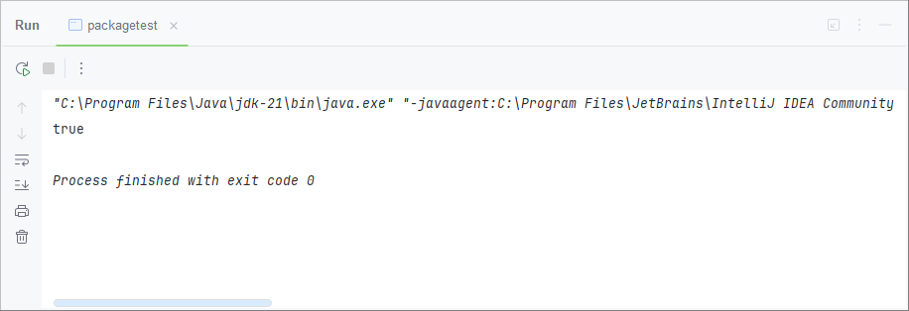

Program 14
Program in Java to implement I/O and file handling
Code
public class FileHandling {
public static void main(String[] args) throws IOException {
FileWriter fw = new FileWriter("sahil.txt");
Scanner sc = new Scanner(System.in);
System.out.println("Enter a string:");
String str = sc.nextLine();
for (int i = 0; i < str.length(); i++) {
fw.write(str.charAt(i));
}
System.out.println("Writing successful!");
fw.close();
FileReader fr = new FileReader("sahil.txt");
int i;
System.out.println("Reading from file:");
while ((i = fr.read()) != -1) {
System.out.print((char) i);
}
System.out.println("\nReading successful!");
fr.close();
}
}

Output
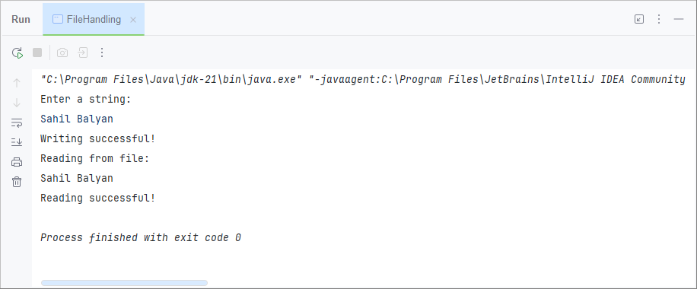

Program 15
Program in Java to implement Exceptions.
Code
class exceptionhandling {
public static void main(String[] args) {
try {
// code that generate exception
int divideByZero = 5 / 0;
System.out.println("Rest of code in try block");
} catch (ArithmeticException e) {
System.out.println("ArithmeticException => " + e.getMessage());
} finally {
System.out.println("The 'try catch' is finished.");
}
}
}

Output

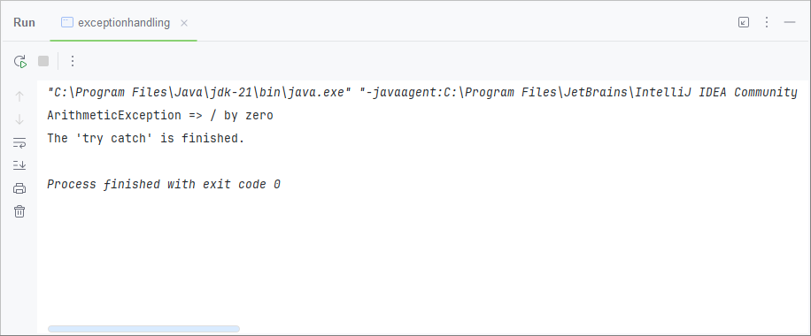

Program 16
Program in Java to implement Multiple Threads
Code
class MyThread extends Thread {
private String threadName;
public MyThread(String name)
{ threadName = name; }
public void run() {
try { for (int i = 1; i <= 5; i++) {
System.out.println(threadName + ": " + i);
Thread.sleep(500);
}
} catch (InterruptedException e)
{System.out.println(threadName + " interrupted."); }
}
public static void main(String[] args) {
MyThread thread1 = new MyThread("Thread 1");
MyThread thread2 = new MyThread("Thread 2");
thread1.start();
thread2.start();
}
}
Output

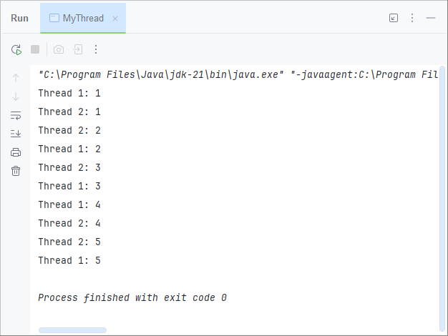

Program 17
Program in Java to implement Event Handlers
Code
import java.awt.*;
import java.awt.event.*;
class AEvent extends Frame implements ActionListener {
TextField textField;
AEvent()
{
textField = new TextField();
textField.setBounds(60, 50, 180, 25);
Button button = new Button("click Here");
button.setBounds(100, 120, 80, 30);
button.addActionListener(this);
add(textField);
add(button);
setVisible(true);
}
public void actionPerformed(ActionEvent e)
{
textField.setText("Button is Pressed ");
}
public static void main(String[] args)
{
AEvent s = new AEvent();
}
}

Output
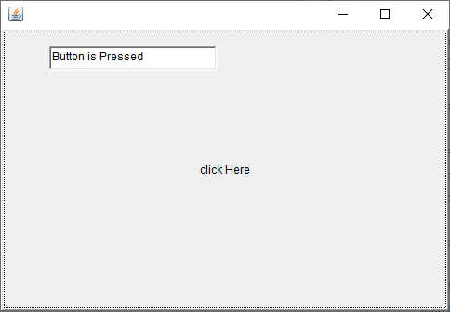

Program 18
Program in Java to implement Mini Calculator
Code
public class Calculator {
public static void main(String[] args)
{
Scanner sc = new Scanner(System.in);
System.out.println("enter the first number =");
int x = sc.nextInt();
System.out.println("enter the second number =");
int y = sc.nextInt();
Scanner op = new Scanner(System.in);
System.out.println("enter the operation you want to perform");
char operation = op.next().charAt(0);
double result;
switch (operation)
{
case '+':
result = x + y;
System.out.println(x + " + " + y + " = " + result);
break;
case '-':
result = x - y;
System.out.println(x + " - " + y + " = " + result);
break;
case '*':
result = x * y;
System.out.println(x + " * " + y + " = " + result);
break;
case '/':
result = x / y;
System.out.println(x + " / " + y + " = " + result);
break;
default:
System.out.println("Invalid operator!");
break;
}
}
}

Output
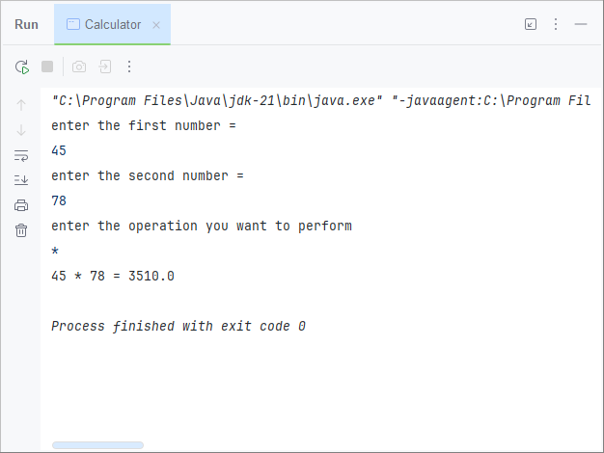

Program 19
Program in Java to define two complex numbers and do the addition and multiplication and print the results
Code
public ComplexNumber(int r, int i) {
this.real = r;
this.image = i;
}
public void showC() {
System.out.print(this.real + "+" + this.image + "i");
}
public static ComplexNumber add(ComplexNumber n1, ComplexNumber n2) { //ADDITION FUNCTION
ComplexNumber res = new ComplexNumber(0, 0);
res.real = n1.real + n2.real;
res.image = n1.image + n2.image;
return res;
}
public static ComplexNumber multiply(ComplexNumber n1, ComplexNumber n2) {
ComplexNumber rest = new ComplexNumber(0, 0);
rest.real = n1.real * n2.real;
rest.image = n1.image * n2.image;
return rest;
}
public static ComplexNumber difference(ComplexNumber n1, ComplexNumber n2) {
ComplexNumber rest1 = new ComplexNumber(0, 0);
rest1.real = n1.real - n2.real;
rest1.image = n1.image - n2.image;
return rest1;
}
public static void main(String arg[]) {
ComplexNumber c1 = new ComplexNumber(4, 5);
ComplexNumber c2 = new ComplexNumber(10, 5);
System.out.print("first Complex number: ");
c1.showC();
System.out.print("\nSecond Complex number: ");
c2.showC();
ComplexNumber res = add(c1, c2);
ComplexNumber rest = multiply(c1, c2);
ComplexNumber rest1 = difference(c1, c2);
System.out.print("\nAddition is :");
res.showC();
System.out.print("\nMultiply is:");
rest.showC();
System.out.print("\nDifference is:");
rest1.showC();
}
}

Output
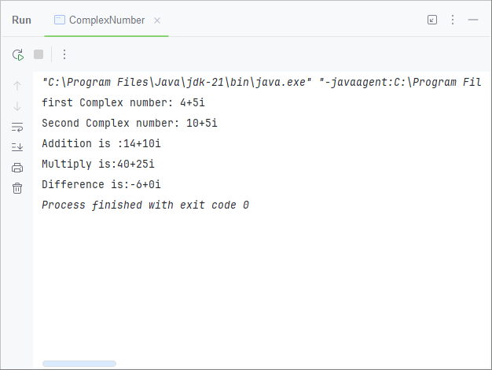

Program 1
Program in C to implement DDA line drawing algorithm.
Code
#include <graphics.h>
#include <math.h>

void ddaLine(int x1, int y1, int x2, int y2) {

int dx = x2 - x1;
int dy = y2 - y1;

int steps = (abs(dx) > abs(dy)) ? abs(dx) : abs(dy);

float xIncrement = dx / (float)steps;
float yIncrement = dy / (float)steps;

float x = x1;
float y = y1;

for (int i = 0; i <= steps; i++) {
putpixel(round(x), round(y), CYAN);
putpixel(round(x), round(y)-1, CYAN);//to make it more visible
putpixel(round(x), round(y)-2, CYAN);

x += xIncrement;
y += yIncrement;
delay(20);
}
}

int main() {
int gd = DETECT, gm;
initgraph(&gd, &gm, "");
int x1 = 200;
int x2 = 400;
int y1 = 200;
int y2 = 400;
ddaLine(x1, y1, x2, y2);
delay(10000);
return 0;
}

Output
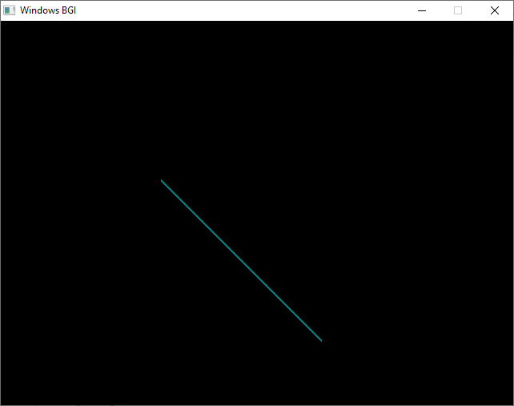

Program 2
Program in C to implement Bresenham’s line drawing
algorithm.
Code
#include <graphics.h>
#include <stdio.h>
#include <stdlib.h>

void drawLine(int x1, int y1, int x2, int y2) {
int dx = abs(x2 - x1);
int dy = abs(y2 - y1);
int sx = (x2 >= x1) ? 1 : -1;
int sy = (y2 >= y1) ? 1 : -1;
int err = dx - dy;
int e2;

while (1) {
putpixel(x1, y1, WHITE);
if (x1 == x2 && y1 == y2) {
break;
}

e2 = 2 * err;
if (e2 > -dy) {
err -= dy;
x1 += sx;
}
if (e2 < dx) {
err += dx;
y1 += sy;
}
}
}

int main() {
int gd = DETECT, gm;
initgraph(&gd, &gm, "");

int x1, y1, x2, y2;
x1=100;
y1=100;
x2=400;
y2=400;
drawLine(x1, y1, x2, y2);
getch();
closegraph();

return 0;
}

Output
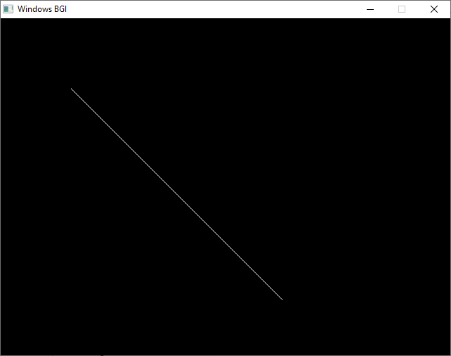

Program 3
Program in C to implement Circle drawing using polynomial approach.
Code
#include <graphics.h>
#include <stdio.h>
#include <math.h>

void drawCircle(int xc, int yc, int r) {
int x = 0;
float y = r;

while (x <= y) {
putpixel(xc + x, yc + round(y), WHITE);
putpixel(xc - x, yc + round(y), WHITE);
putpixel(xc + x, yc - round(y), WHITE);
putpixel(xc - x, yc - round(y), WHITE);
putpixel(xc + round(y), yc + x, WHITE);
putpixel(xc - round(y), yc + x, WHITE);
putpixel(xc + round(y), yc - x, WHITE);
putpixel(xc - round(y), yc - x, WHITE);

x++;
y = sqrt(r * r - x * x);
}
}

int main() {
int gd = DETECT, gm;
initgraph(&gd, &gm, "");

int xc, yc, r;
xc=200;
yc=200;
r=100;

drawCircle(xc, yc, r);

getch();
closegraph();

return 0;}

Output
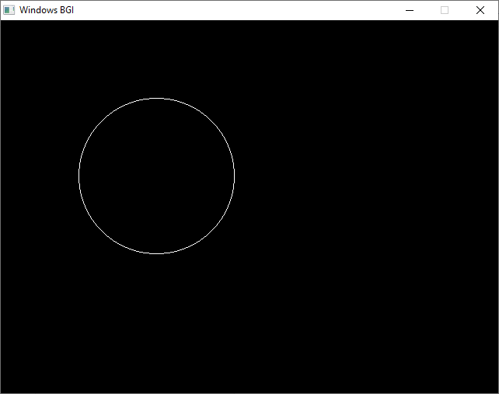

Program 4
Program in C to implement Circle drawing using
Bresenham’s approach.
Code
#include <graphics.h>
#include <stdio.h>

void drawCircle(int xc, int yc, int r) {
int x = 0, y = r, d = 3 - 2 * r;
while (x <= y) {
putpixel(xc + x, yc + y, WHITE);
putpixel(xc - x, yc + y, WHITE);
putpixel(xc + x, yc - y, WHITE);
putpixel(xc - x, yc - y, WHITE);
putpixel(xc + y, yc + x, WHITE);
putpixel(xc - y, yc + x, WHITE);
putpixel(xc + y, yc - x, WHITE);
putpixel(xc - y, yc - x, WHITE);

if (d < 0)
d += 4 * x + 6;
else {
d += 4 * (x - y) + 10;
y--;
}
x++;
}
}

int main() {
int gd = DETECT, gm;
initgraph(&gd, &gm, "");

int xc = 250, yc = 250, radius = 150;
drawCircle(xc, yc, radius);

getch();
closegraph();
return 0;
}

Output
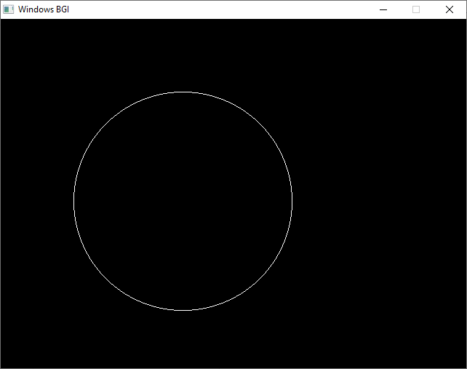

Program 5
Program in C to implement a moving object like car / fan / moving man
Code
#include <graphics.h>
#include <conio.h>

void drawCar(int x, int y) {
// Car body
rectangle(x, y, x + 100, y + 50);
rectangle(x + 20, y - 20, x + 80, y); // Car top
setfillstyle(SOLID_FILL, RED);
floodfill(x + 1, y + 1, WHITE);

// Wheels
circle(x + 25, y + 55, 10);
circle(x + 75, y + 55, 10);
setfillstyle(SOLID_FILL, BLUE);
floodfill(x + 25, y + 55, WHITE);
floodfill(x + 75, y + 55, WHITE);
}

int main() {
int gd = DETECT, gm;
initgraph(&gd, &gm, "");

int x = 0, y = 300;

while (x < getmaxx()) {
cleardevice();
drawCar(x, y);
delay(20);
x += 2;
}

getch();
closegraph();
return 0;}

Output
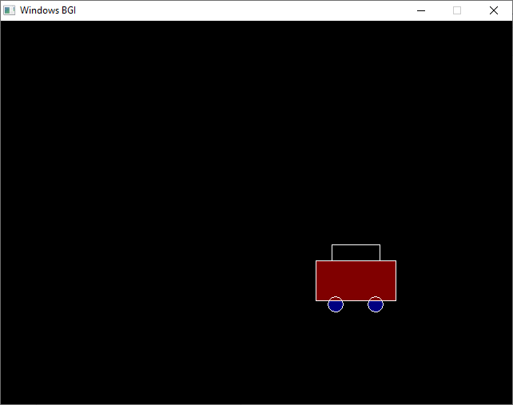

Program 6
Program in C to implement color filling in a closed object
Code
#include <graphics.h>
#include <conio.h>

void boundaryFill(int x, int y, int fillColor, int boundaryColor) {
int currentColor = getpixel(x, y);
if (currentColor != fillColor && currentColor != boundaryColor) {
putpixel(x, y, fillColor);
delay(1/3);
boundaryFill(x + 1, y, fillColor, boundaryColor);
boundaryFill(x - 1, y, fillColor, boundaryColor);
boundaryFill(x, y + 1, fillColor, boundaryColor);
boundaryFill(x, y - 1, fillColor, boundaryColor);
}
}

int main() {
int gd = DETECT, gm;
initgraph(&gd, &gm, "");
rectangle(100, 100, 300, 200);
setcolor(WHITE);
int x = 150, y = 150;
int fillColor = RED;
int boundaryColor = WHITE;
boundaryFill(x, y, fillColor, boundaryColor);
getch();
closegraph();
return 0;
}

Output
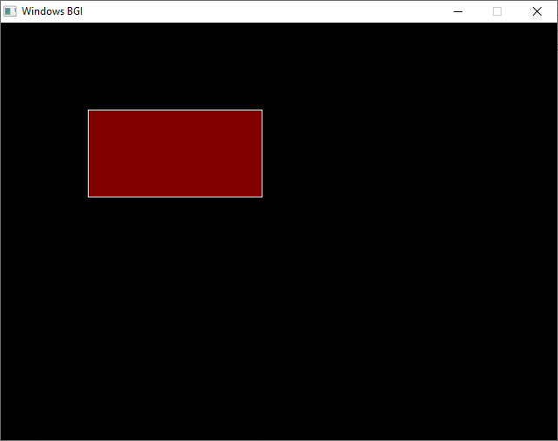

Program 7
Program in C to implement bouncing ball
Code
#include <graphics.h>
#include <conio.h>

void bouncingBall() {
int x = 200, y = 200;
int radius = 20;
int dx = 5, dy = 5;

int maxX = getmaxx();
int maxY = getmaxy();

while (!kbhit()) {
cleardevice();
setcolor(RED);
setfillstyle(SOLID_FILL, RED);
circle(x, y, radius);
floodfill(x, y, RED);

delay(20);
x += dx;
y += dy;

if (x + radius >= maxX || x - radius <= 0) {
dx = -dx;
}
if (y + radius >= maxY || y - radius <= 0) {
dy = -dy;
}
}
}

int main() {
int gd = DETECT, gm;
initgraph(&gd, &gm, "");

bouncingBall();

getch();
closegraph();
return 0;
}

Output
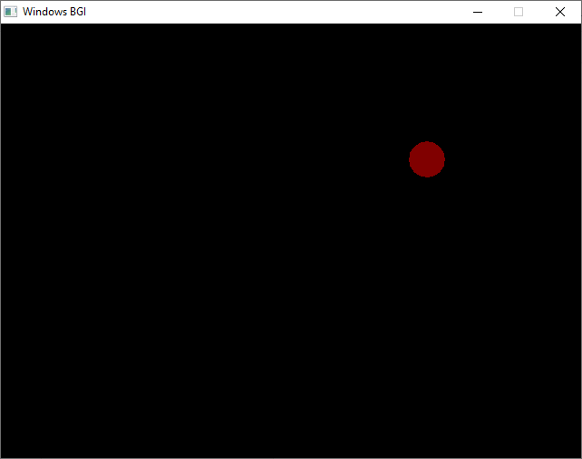

Program 8
Program in C to implement point clipping/line clipping
method.
Code
#include <graphics.h>
#include <stdio.h>

void pointClipping(int x, int y, int xMin, int xMax, int yMin, int yMax) {
if (x >= xMin && x <= xMax && y >= yMin && y <= yMax) {
putpixel(x, y, WHITE);
putpixel(x - 1, y - 1, WHITE);
putpixel(x + 1, y + 1, WHITE);
putpixel(x - 1, y + 1, WHITE); //to make it more visible
putpixel(x + 1, y - 1, WHITE);
putpixel(x, y - 1, WHITE);
putpixel(x, y + 1, WHITE);
putpixel(x - 1, y, WHITE);
putpixel(x + 1, y, WHITE);
printf("Point (%d, %d) is inside the clipping window.\n", x, y);
} else {
printf("Point (%d, %d) is outside the clipping window.\n", x, y);
}
}

int main() {
int gd = DETECT, gm;
initgraph(&gd, &gm, "");

int xMin = 100, yMin = 100, xMax = 300, yMax = 300;
rectangle(xMin, yMin, xMax, yMax);

pointClipping(150, 150, xMin, xMax, yMin, yMax);
pointClipping(50, 50, xMin, xMax, yMin, yMax);

getch();
closegraph();
return 0;
}

Output
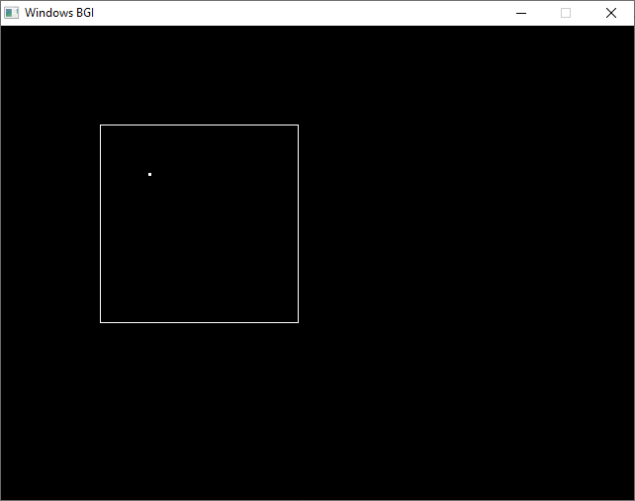

Program 9
Program in C to implement analog clock
Code
#include <graphics.h>
#include <time.h>
#include <math.h>

#define PI 3.14159265358979323846

float degToRad(float degrees) {
return (degrees * PI) / 180.0;
}

void drawHand(int xCenter, int yCenter, int length, float angle, int color) {
int xEnd = xCenter + length * cos(angle);
int yEnd = yCenter - length * sin(angle);
setcolor(color);
line(xCenter, yCenter, xEnd, yEnd);
}

void drawClockFace(int xCenter, int yCenter, int radius) {
setcolor(WHITE);
circle(xCenter, yCenter, radius);

for (int i = 1; i <= 12; i++) {
float angle = degToRad(90 - i * 30);
int x = xCenter + (radius - 20) * cos(angle);
int y = yCenter - (radius - 20) * sin(angle);
char label[3];
sprintf(label, "%d", i);
outtextxy(x - 5, y - 5, label);
}
}

void drawAnalogClock() {
int gd = DETECT, gm;
initgraph(&gd, &gm, "");

int xCenter = 300, yCenter = 300, radius = 150;

while (!kbhit()) {
cleardevice();

drawClockFace(xCenter, yCenter, radius);

time_t currentTime = time(NULL);
struct tm *localTime = localtime(&currentTime);

int hours = localTime->tm_hour % 12;
int minutes = localTime->tm_min;
int seconds = localTime->tm_sec;

float secondAngle = degToRad(90 - seconds * 6);
float minuteAngle = degToRad(90 - (minutes * 6 + seconds * 0.1));
float hourAngle = degToRad(90 - (hours * 30 + minutes * 0.5));

drawHand(xCenter, yCenter, radius - 40, hourAngle, RED);
drawHand(xCenter, yCenter, radius - 20, minuteAngle, GREEN);
drawHand(xCenter, yCenter, radius - 10, secondAngle, BLUE);

delay(1000);
}

closegraph();
}

int main() {
drawAnalogClock();
return 0;
}

Output
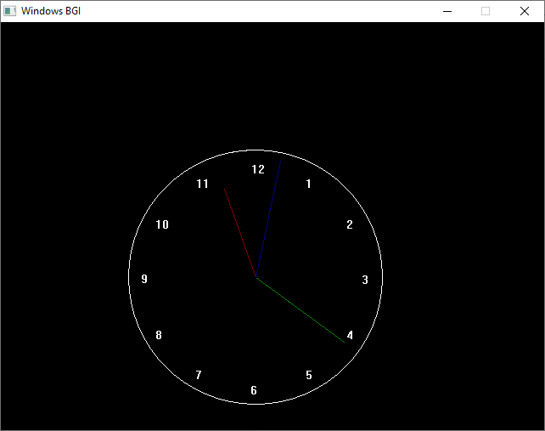

Program 10
Program in C to implement a three dimensional object /
smiley
Code
#include <graphics.h>
#include <conio.h>
#include <stdio.h>

void drawSmiley() {
int x = 300, y = 300;
int faceRadius = 100;
int eyeRadius = 15;

setcolor(YELLOW);
setfillstyle(SOLID_FILL, YELLOW);
circle(x, y, faceRadius);
floodfill(x, y, YELLOW);

setcolor(BLACK);
setfillstyle(SOLID_FILL, BLACK);
circle(x - 35, y - 30, eyeRadius);
floodfill(x - 35, y - 30, BLACK);
circle(x + 35, y - 30, eyeRadius);
floodfill(x + 35, y - 30, BLACK);

setcolor(BLACK);
arc(x, y + 20, 200, 340, 50);
}

int main() {
int gd = DETECT, gm;
initgraph(&gd, &gm, "");

drawSmiley();

getch();
closegraph();
return 0;}

Output
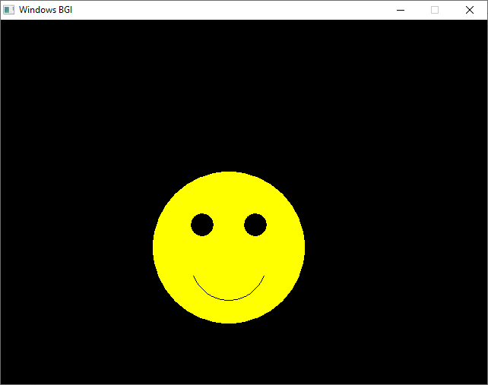

Computer Graphics

S No. | Program | Remarks
1. | Program to implement DDA line Drawing Algorithm.
2. | Program to implement Bresenham’s Line Drawing Algorithm.
3. | Program to implement Circle Drawing using Polynomial Approach.
4. | Program to implement Circle drawing using Bresenham’s Approach.
5. | Program to implement a moving object like car/fan/moving man.
6. | Program to implement colour filling in a closed object.
7. | Program to implement Bouncing Ball.
8. | Program to implement Point Clipping/ Line Clipping Method.
9. | Program to implement Analogue Clock.
10. | Program to implement a 3D (Three Dimensional) Object / Smiley.

