Contents

04/11/2023 – 4 hours 2

06/11/2023 – 3 hours 2

10/11/2023 –2h 14m 4

11/11/2023 4h 6

14/11/2023 - 6h 8

15/11/2023 1h 9

# 04/11/2023 – 4 hours

Today I started off by cloning the starting template for the assignment and getting qemu working on my personal PC. Once done, I then began attempting to use the int 16 bios interrupt. This is the interrupt used to retrieve a keyboard input from a user. At first I was having issues with this as I didn’t fully understand the documentation for the interrupt table. Figure 1 shows the documentation for get keystroke, in order to use this, I had to pass in the value `00` into the AH register. When trying this I got an error which stated that there was a junk “h” after the expression, this is because I had already prefixed the `00` with 0x which denotes that it is a hexadecimal value, so removing the H resolved the problems.

Figure – interrupt documentation for keyboard input

# 06/11/2023 – 3 hours

Figure 2 shows me being able to type the number of the sector to read, this is currently not being used but I am creating the functionality for it. The next stage is to also display the sector number in the message “Contents of sector”, to do this I will be temporarily storing the contents of al inside of the stack, this will allow me to reuse it after the other console logs have been ran.

Figure - keyboard input working

When attempting to use the pushw instruction I ran into an error **“Error: unsupported instruction `push'”,** this is because I was using the %al register which is not supported with this instruction. After reading the lecture slides for week 3 it stated that you can only push the whole register onto the stack, once I changed it to use %ax I no longer received the error.

**Another issue which I have ran into is with the order that I was pushing and popping. I was using the pushw instruction after I call cons_write_crlf so the value in %al was being overwritten by the special characters. To fix the problem I had to use the pushw instruction before I called cons_write_crlf in order to save the correct value (the keyboard input)**

Figure - bug showing the wrong value being popped onto the register

**Figure 4 displays the code used to output the contents of figure 5.**

Figure - The final code for keyboard input and contents of sector message

Figure 5 displays the final output for the code above. The next stage is to start reading the contents off of the disk.

Figure - final output of keyboard input label

# 10/11/2023 –2h 14m

**Today I had a bug where if I had a label under my `contents_of_sector_message` it would output that to screen when it shouldn’t. This can be seen in figure 6.**

Figure - bug showing extra label being print to screen

After much time debugging and trying different things, such as adding a terminator value to the end of the content of sector string (even though .string adds this automatically) I was able to fix the issue. However, I didn’t quite understand why this was happening, so I had a look into it some more and later found that because I was calling cons_writeline without moving a value into %si there was no null terminator, this caused the function to loop go through the wrong memory and access strings which it was not supposed to, the code for this can be seen in figure 7.

Figure – code

To fix the problem in figure 7 I modified the code to include an empty string, which would act as a null terminator to stop the cons_writeline going into the wrong area of memory. I later realised that cons_writeline was for outputting not just a new line, but also the value in %si, so it I could just call cons_write_crlf to output the newline instead of calling cons_writeline, which was for a different purpose.

The next stage was to start reading the disk, the initial code for this gave me some problems as I was just calling cons_write_hex, without passing any information into the register. This can be seen in figure 8.

Figure - cons_write_hex not outputting any data

In order to fix this problem I had a look at the code for outputting hex values, the register which was being used was BX. To get some initial output I moved the bytes that were inside of the memory address “0xD000” into the BL register. I then got the output in figure 9.

Figure - values being read from disk

Figure 10 displays an issue which I am having with my code. Currently, after attempting to output the next set of data onto the screen after the initial value of EB I am getting the wrong data. It appears that I am incrementing the value instead of the index.

Figure - wrong output displayed.

# 11/11/2023 4h

I working yesterday and didn’t manage to fix the issue I had. After coming back today I thought about how the cons_write label worked, using SI to loop through each character in a string. I am looking into implementing this sort of method for looping over the values that have been read from disk.

Figure 11 shows my attempt at using the SI register. Before getting this output I verified that the first iteration of the code output the correct value of “EB”. However, when trying to implement my loop any value after the first iteration was completely wrong, and also the same every time. At first I was completely clueless as to why this was happening, but as I went through each line I remembered a previous issue which I had earlier in the project which caused my “contents of sector x” message to break. When calling cons_write_hex and cons_write the SI register is overwritten with the value inside of BX (Figure 12). This means that on the next iteration of the loop the value would be completely wrong, since it had been overwritten. The fix for this issue was to push the contents of SI onto the stack whilst cons_write_hex was running.

Figure - wrong values being displayed

Figure

Figure 13 displays the correct output on the screen, the idea using %SI worked. However, the 2nd value in the output is different to what it shows in HXD. The value should be 20 but it says 3B. After looking at HXD some more I found a search function. I put the value EB 3B inside of the box and it found the values (figure 14). After looking at the offset it became clear that this data was part of a different block, to fix this problem I edited the first block to read to `0` and then I got the correct output in my console. The output can be seen in figure 15.

Figure - correct output

Figure

Figure

# 14/11/2023 - 6h

Today I made a lot of progress which I am very happy with. I had quite a few bugs which I ran into, some of them took quite a long time to fix.

An issue which I had from the last coding session I did was that the output would stop when the data on the disk was the value “00”, this can be seen in figure 15. The cause of this was due to me comparing the value inside of %bx. My thought was if the bytes are 0 then there is nothing left to read, but I did not consider what would happen if the disk was empty. The fix for this issue was to use %dl as a counter to check how many bytes have been read, this can be seen in figure 16.

Figure

The next step I took was to ensure that only 16 bytes per line was being displayed, to do this I made use of the CX register to keep a count of how many bytes had been written to the screen. This can be seen in figure 17. Every iteration of the read_disk_loop that happens %cx is incremented. If the value of cx is 16 then it calls a label which writes a new line and resets CX back to 0. This is repeated until all bytes have been read.

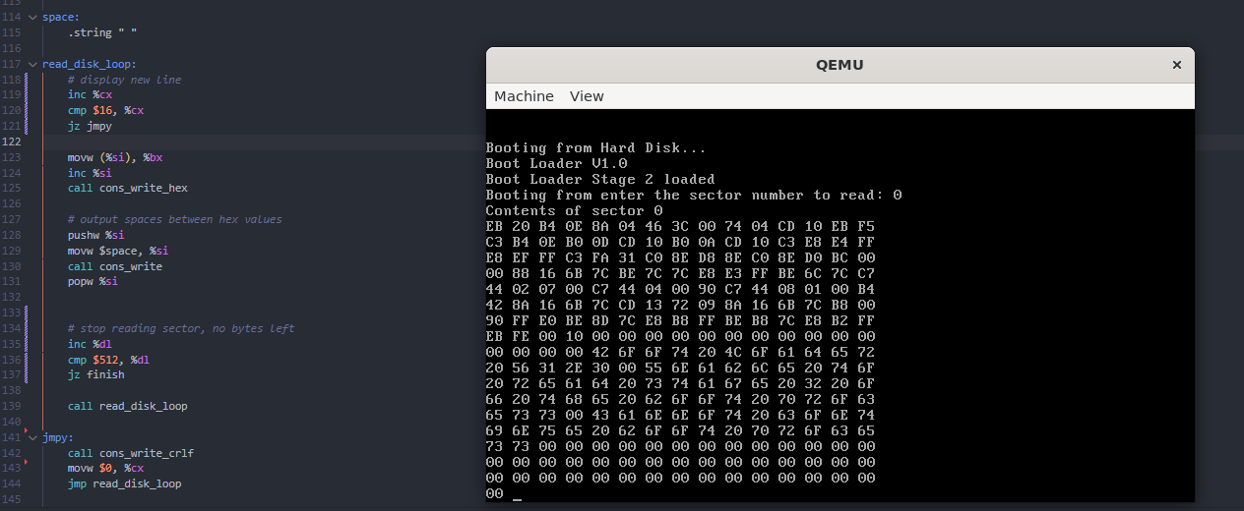

Figure

A glaring issue with figure 17 is that an extra byte is read at the end of the output, after a long time of debugging I eventually found out that the problem was due to me trying to compare %dl with a value of 512, and since %dl is an 8bit register the maximum number that could be inside of it was 255, so the code was not running correctly.

# 15/11/2023 1h

Showing keyboard input working

