初一年级第一学期期末学业水平调研 – 模拟试卷

英 语

2019.1

学校 班级 姓名 成绩

|  |  |
| --- | --- |
| 考生须知 | 1．本试卷共8页，满分100分，考试时间90分钟。  2．在试卷和答题卡上准确填写学校名称、姓名和准考证号。  3．试题答案一律填涂或书写在答题卡上，在试卷上作答无效。  4．在答题卡上，选择题用2B铅笔作答，其他试题用黑色字迹签字笔作答。  5．考试结束，请将本试卷和答题卡一并交回。 |

听力理解（共20分）

一、听后选择（共12分，每小题1分）

听对话或独白，根据对话或独白的内容，从下列各题所给的A、B、C三个选项中选择最佳选项。每段对话或独白你将听两遍。

请听一段对话，完成第1至第2小题。

1. What is the man doing?

A. Taking a walk. B. Listening to music. C. Studying English.

2. When does the woman play tennis?

A. Every Monday. B. Every Tuesday. C. Every Thursday.

请听一段对话，完成第3至第4小题。

3. What does the boy think of math?

A. Boring. B. Difficult. C. Interesting.

4. What is the girl’s favorite subject?

A. Art. B. Math. C. Chinese.

请听一段对话，完成第5至第6小题。

5. Who is the man shopping for?

A. His son. B. His friend. C. His daughter.

6. How much will the man pay for the large jacket?

A. $10. B. $20. C. $30.

请听一段对话，完成第7至第9小题。

7. What does Grandma buy online?

A. Food. B. Books. C. Drinks.

8. What does Grandma think of using a computer?

A. Easy. B. Tiring. C. Exciting.

9. What can we learn about Grandma?

A. She likes getting emails.

B. She never reads news online.

C. She enjoys learning new things.

请听一段独白，完成第10至第12小题。

10. What do many families enjoy doing in winter?

A. Giving gifts. B. Cooking dinner. C. Making snowmen.

11. What does the speaker really want in winter?

A. A white Christmas. B. A new winter coat. C. Sweet winter food.

12. What is the speaker mainly talking about?

A. What he wears in winter.

B. Why he loves winter best.

C. How he spends Christmas.

二、听独白，记录关键信息。独白你将听两遍。（共8分，每小题2分）

请根据所听到的独白内容和提示词语，将所缺的关键信息填写在答题纸的相应位置上。

|  |  |
| --- | --- |
| **Importance of Playing Sports** | |
| **A good way to make new friends** | ♦ Friendship can make children 13 .  ♦ Children can be more popular at school. |
| **A**  14 **way to spend time with family** | ♦ Children can be close with their 15 .  ♦ Children can relax themselves. |
| **Being good for children’s mind** | ♦ Children can learn to 16 success and failure.  ♦ Sports teach children to try again when they lose a game. |

知识运用（共28分）

三、单项填空（共8分，每小题1分）

从下面各题所给的A、B、C、D四个选项中，选择可以填入空白处的最佳选项。

17. My sister is a geography teacher and \_\_\_\_\_\_ hobby is taking photos.

A. she B. he C. her D. his

18. We often play table tennis \_\_\_\_\_\_ our friends at school.

A. to B. of C. for D. with

19. There is \_\_\_\_\_\_ English book and some pens in my bag.

A. a B. an C. the D. /

20. I don’t like going shopping because it is very \_\_\_\_\_\_.

A. boring B. busy C. useful D. interesting

21. — \_\_\_\_\_\_ is your birthday party?

— At three this Saturday afternoon.

A. What B. Who C. Where D. When

22. Let’s \_\_\_\_\_\_ swimming next Friday.

A. go B. goes C. going D. to go

23. Mike’s father \_\_\_\_\_\_ in the hospital and he is very busy every day.

A. work B. works C. working D. to work

24. —Thanks for helping me find my dog.

— \_\_\_\_\_\_.

A. The same to you B. Have a good time

C. You’re welcome D. That sounds good

四、短文填空（共8分，每小题1分）

阅读下列短文，根据短文内容填空。在未给提示词的空白处仅填写一个适当的单词，在给出提示词的空白处用括号内所给词的正确形式填空。

**A**

I’m Kate, and my sister is Gina. I’m tidy, 25 Gina is not. In our room, my books and tapes are in the bookcase. My pens are in my schoolbag. I have a clock. It’s on the desk. Gina’s books 26 (be) everywhere—on her bed, on the sofa and under the chair. The white model plane is also hers. It’s under the desk. “Where are my 27 (key)? Where’s my ruler? Where’s my schoolbag?” Gina always 28 (ask).

**B**

I am busy on Friday. At 8:00 I have Chinese. The teacher says it is useful, but I think 29 is difficult. At 10:00 I have history. After that, I have P.E. at 11:00. It is easy. Lunch is 30 12:00 to 1:00, and after that we have math. It is my favorite 31 . Our math teacher, Mrs. Wang, is very kind. My classes finish at 1:50, but after that I have an art lesson for 2 hours. It is really 32 (relax).

五、完形填空（共12分，每小题1.5分）

阅读下面的短文，掌握其大意，然后从短文后各题所给的A、B、C、D四个选项中，选择最佳选项。

**The Tradition**

Luis’s whole family met every June to celebrate Grandpa’s birthday. Before everyone sat down to eat, each person had to tell a personal story they had about 33 . Some family members told the same story year after year. Luis, for example, had his usual story about the time Grandpa taught him how to take care of a vegetable garden.

The stories were a 34 . And now that most of the grandchildren were old enough to 35 , the tradition could go on for quite a while. Last year, it took three hours. Luis tried hard not to yawn(打哈欠) as he listened to all the same old stories.

This year, Uncle Frank and Aunt Teresa had dinner ready early and called everyone to eat.

“What about the 36 ?” Luis asked.

“There’s just not enough time this year, with so many people,” Uncle Frank said.

After hearing this, Luis felt relieved(如释重负). But he also felt a little 37 as he sat down at the long dining table. Without the tradition, Grandpa’s birthday felt like any other holiday the family shared.

Luis eyed the plate of vegetable salad. “You know, I wouldn’t know how to pick a tomato right if it wasn’t for Grandpa,” he said softly.

“I wouldn’t know 38 to drive a car,” said Aunt Teresa.

“I wouldn’t know how to turn a paperclip into a safety pin,” added Uncle Felix. “That sure saved the day at Edna’s wedding(婚礼)!” Everyone laughed and smiled at each other at the reminder of that well-known family story.

It was a 39 birthday. Conversations flowed like water, and the food was wonderful. But something told Luis that next year, the tradition of telling stories would  40 .

33. A. Uncle B. Grandpa C. Aunt D. Mother

34. A. tradition B. lesson C. test D. hobby

35. A. look B. study C. join D. cook

36. A. parties B. gifts C. games D. stories

37. A. thankful B. excited C. afraid D. sad

38. A. how B. why C. when D. where

39. A. bad B. boring C. great D. small

40. A. stop B. return C. help D. lose

阅读理解（共32分）

六、阅读下列短文，根据短文内容，从短文后各题所给的A、B、C、D四个选项中，选择最佳选项。（共22分，每小题2分）

**A**

There are some notices on the community(社区) notice board. Please read them carefully and check out if they are useful for you.

|  |  |
| --- | --- |
| **Online Sale at Shopbop**  Welcome to Shopbop this Friday, Jan. 22nd! We have all kinds of clothes and shoes for you. For boys, there are sweaters in black. And girls, you can buy our purple handbags!  For more information, please visit our APP or phone us at 601-7728. | C:\Users\lenovo\Desktop\0017031017621114_b.jpg |
| E:\My documents\18级\教学\上\区\改后\yard sale.jpg | **Invitation from the Smiths**  Dear Sir or Madam,  Welcome to our YARD SALE from 8 am to 2 pm on Jan. 20th. There are lots of holiday items, including milk glasses, a big dinner table, many beautiful coffee cups and so on. We’re moving to our new home, so everything must go! They are at very low prices.  Joana Smith  In Bosque Farms,1705 St. Los Pinos |
| **Lost**  On the morning of Jan. 9th, I lost my red English dictionary. Maybe I left it in the library. It is new and I need it very much. If you find it, please call me at 138-1111-8907.  Thank you very much!  Jessie Brown | E:\My documents\18级\教学\上\区\改后\字典.jpg |
| E:\My documents\18级\教学\上\区\改后\夹克.jpg | **Found**  I found a jacket on the playground on the afternoon of Jan. 8th. It is an old jacket in blue and white color, and it is a school uniform. There is a key in the pocket of the uniform. Is it yours? Call me at 136-8778-1226 or my teacher Mr. Smith at 622-5947.  Frank Miller |

41. At Shopbop, girls can buy \_\_\_\_\_\_.

A. black sweaters B. purple handbags

C. beautiful coffee cups D. red English dictionaries

42. You can go to the YARD SALE on \_\_\_\_\_\_.

A. Jan. 8thB. Jan. 9thC. Jan. 20th D. Jan. 22nd

43. If you find the English dictionary, you can call Jessie Brown at \_\_\_\_\_\_.

A. 601-7728 B. 138-1111-8907

C. 622-5947 D. 136-8778-1226

44. Where did Frank find the old jacket?

A. At Shopbop. B. At the yard sale.

C. In the school library. D. On the playground.

**B**

**Tommy’s Bumper Sticker**

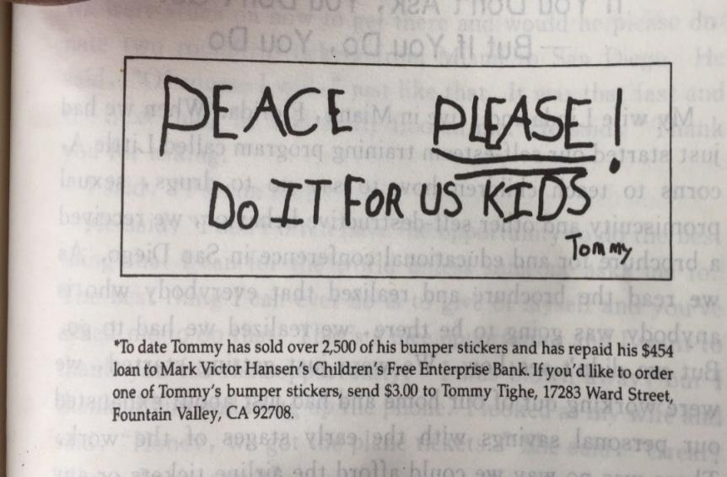A little kid came to me after he knew about the Children’s Bank. “My name is Tommy. I am six years old and I want to borrow money from your Children’s Bank.”

I said, “Tommy, that’s what we will do, to loan(贷款) money to kids. And all the kids have paid it back. What do you want to do?”

He said, “Since I was four I wanted to help bring peace(和平) to the world. I want to make a bumper sticker(车尾贴) that says, ‘PEACE，PLEASE！DO IT FOR US KIDS.’”

“I support that,” I said.

Tommy’s dad whispered in my ear, “If he doesn’t pay the loan back, are you going to accept his bicycle for the loan?”

I said, “Every kid is born with honesty. I believe he’ll pay us back.”

“Always start selling at the top, such as some famous people,” I suggested.

Then he made his first try at Ronald Reagan’s home. There, he gave a persuasive(有说服力的) sales speech on his bumper stickers. The gatekeeper was moved. He gave him $1.50 for his sticker and helped him meet the former President Reagan.

Later, he sent a bumper sticker to Mikhail Gorbachev. Gorbachev sent him back $1.50 and a picture that said, “Go for peace, Tommy,” and signed it, “Mikhail Gorbachev, President.”

Later on, Joan Rivers called Tommy to be on her TV show which has millions of audience(观众).

Tommy went on Joan Rivers’ show. He told such great persuasive stories that people took out money to buy a bumper sticker on the spot(在现场). At the end of the show, Joan asked, “Tommy, do you really think your bumper sticker will cause peace in the world?”

Tommy smiled and said, “So far I have had it out two years and got the Berlin Wall down. I am doing pretty well, don’t you think so?”

45. Tommy came to the writer to \_\_\_\_\_\_.

A. borrow money B. give out bumper stickers

C. sell his bicycle D. call for the world peace

46. At Ronald Reagan’s home, Tommy gave a speech on \_\_\_\_\_\_.

A. his true story B. going for peace

C. his bumper stickers D. some famous people

47. How did Tommy feel when Joan asked about his try for the world peace?

A. He was tired. B. He felt shy.

C. He was relaxed. D. He felt proud.

**C**

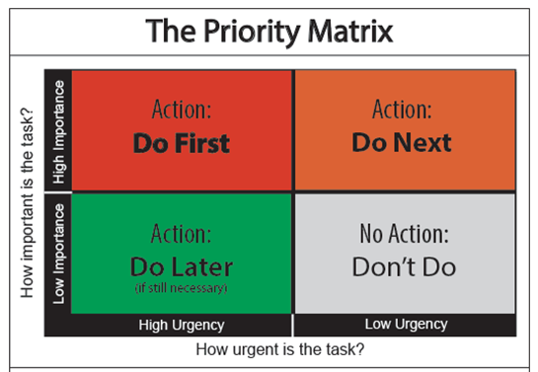Have you ever wondered why it seems that some people can have enough time to do everything they want, but others can’t? Is it that the first type of people has less to do? No, it’s much more possible that they are practicing good time management skills.

Time management is hard to practice well. But once done, you will manage time much better. With **minor tweaks** and little efforts, you can do all you need to do in an effective(有效率的) way.

The key to good time management is to understand the difference between the urgent and the important. “Urgent” tasks need your immediate(立即的) attention, but whether you give that immediate attention may or may not matter(要紧). “Important” tasks matter, because not doing them may have serious or even bad results.

For example, answering the phone is urgent. If you don’t do it, you may miss something important. However, it may be a stranger who just wants to sell you a phone you don’t need at all. That’s not important.

Going to the dentist is important. If you don’t, you may get gum disease. But it’s not urgent. If you leave it too long, however, it may become urgent, because you may get a toothache.

Helping to pick up your brother or sister from school is both urgent and important. If you are not there at the right time, they will keep waiting and worry too much. Seeing Wechat moments(朋友圈) is neither urgent nor important. So why do you put it first?

Knowing the difference between the urgent and the important is the key to managing time well. Try to put your tasks into their right groups. Remember that your health is important. You should pay enough attention to your health even though there are many urgent things to do.

Although it’s not easy to group your tasks properly, try to be a good time manager so that you can have time to spend with the people you love and on the activities you like. The better you manage your time, the more successful you can be.

48. The underlined words “minor tweaks” in Paragraph 2 probably mean “\_\_\_\_\_\_”.

A. great difficulties B. helpful habits

C. different hobbies D. small changes

49. Which of the following is an important task according to the writer?

A. Going to the dentist. B. Seeing Wechat moments.

C. Answering the phone. D. Buying a new cellphone.

50. The writer gives the examples to tell us \_\_\_\_\_\_.

A. the ways of managing time

B. making a phone call is urgent

C. the difference between the urgent and the important

D. picking up children from school is urgent and important

51. Which of the following would be the best title for the passage?

A. How to Manage Time Well?

B. How to Make Time for Health?

C. The Importance of Making Time for Study

D. The Importance of Free Time Management

七、阅读短文，根据短文内容回答问题。（共10分，每小题2分）

**BALLET**

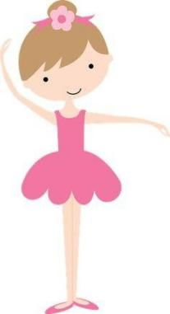Ballet is a type of dance. It is a kind of art that can express a feeling, tell a story, or interpret a song. The first ballet began in the 15th century. Ballet dancers may be men and women—ballet is not just for girls! They are strong, pretty, and flexible(柔韧的).

Many movements in ballet are unusual for the human body. Dancers turn their legs out, instead of having their knees and feet straight forward. They also point their feet and may even dance on the tips of their toes.

Dancers must go through a lot of training. Many take classes almost daily if they’d like to be professional(职业的) ballet dancers. They need to practice often to keep up their strength. That also means that dancers need to take very good care of their bodies, so their bodies can keep up with the dancing! Dancers need to be well rested and eat healthy meals. They also should drink plenty of water and listen to their bodies by resting if that’s what their bodies need.

In ballet class, most teachers ask dancers to warm up their bodies at first. After that, dancers come to the center to practice other movements. They should start slowly when learning new steps, so their bodies have time to get used to the steps and not get injured.

In fact, it is not easy to become good ballet dancers. Not only do dancers need to control their bodies well, but they need to have a good understanding of music.

Ballet looks soft, but it is really an athletic activity. If you love to move your body and use it to tell stories, ballet might be a great activity for you to try!

52. When did the first ballet begin?

53. Is ballet just for girls?

54. Why do professional ballet dancers need to practice often?

55. What do most teachers do at first in ballet class?

56. How can people become good ballet dancers?

**书面表达（共20分）**

八、完成句子（共10分，每空1分）

根据下面各题所给的中文及英文提示，完成下面的句子。

57. 我妈妈经常在周末看电视。

My mom often \_\_\_\_\_\_ \_\_\_\_\_\_ on weekends.

58. 如果你有问题，可以向老师求助。

You can \_\_\_\_\_\_ the teacher \_\_\_\_\_\_ help if you have problems.

59. 那栋房子看起来很漂亮。

That house \_\_\_\_\_\_ \_\_\_\_\_\_.

60. 对于女孩子，我们有粉色裙子，只售20美元。

For girls, we have skirts \_\_\_\_\_\_ \_\_\_\_\_\_ for only＄20.

61. 放学后去踢足球怎么样？

\_\_\_\_\_\_ \_\_\_\_\_\_ playing soccer after school?

九、文段表达（10分）

62．从下面两个题目中任选一题，根据中文和英文提示，完成一篇不少于50词的文段写作。文中已给出内容不计入总词数。所给提示词语仅供选用。请不要写出你的校名和姓名。

**题目①**

假如你是李华，打算邀请你的外籍朋友Peter参加你们学校的**校园开放日**活动。请用英语写一封电子邮件，告诉他开放日的日期和活动安排，并询问他想参加哪项活动。

活动安排：

|  |  |
| --- | --- |
| In the morning | music class, art class, reading… |
| In the afternoon | basketball game, English party… |

提示词语： sing songs, read stories, play with

提示问题： ♦ When is the School Day?

         ♦ What classes and activities do you have on that day?

         ♦ What does Peter like to do?

|  |
| --- |
| 铅笔 信封 信封 铅笔 新建文件 |
| **To** Peter  **From** Li Hua  **Subject** School Day  *Dear Peter,*  *How is it going? I’m writing to invite you to attend our School Day.*  *\_\_\_\_\_\_\_\_\_\_\_\_\_\_\_\_\_\_\_\_\_\_\_\_\_\_\_\_\_\_\_\_\_\_\_\_\_\_\_\_\_\_\_\_\_\_\_\_\_\_\_\_\_\_\_\_\_\_\_\_\_*  *\_\_\_\_\_\_\_\_\_\_\_\_\_\_\_\_\_\_\_\_\_\_\_\_\_\_\_\_\_\_\_\_\_\_\_\_\_\_\_\_\_\_\_\_\_\_\_\_\_\_\_\_\_\_\_\_\_\_\_\_\_*  *\_\_\_\_\_\_\_\_\_\_\_\_\_\_\_\_\_\_\_\_\_\_\_\_\_\_\_\_\_\_\_\_\_\_\_\_\_\_\_\_\_\_\_\_\_\_\_\_\_\_\_\_\_\_\_\_\_\_\_\_\_*  *I’m looking forward to your early reply.*  *Yours,*  *Li Hua* |

**题目②**

海淀区某英语杂志正在举办2018学年度 “**健康小明星**” 英语演讲比赛。假如你是李华，请你根据以下提示，写一篇英语演讲稿，介绍自己的饮食习惯、运动情况并谈谈健康生活方式的重要性。

提示词语： vegetable, fruit, soccer, strong, work hard

提示问题： ♦What are your eating habits?

♦What sports do you usually do?

♦ Why is it important to live a healthy life?

*Hello, everyone. My name is Li Hua. I’m happy to share my healthy lifestyle with you.*

\_\_\_\_\_\_\_\_\_\_\_\_\_\_\_\_\_\_\_\_\_\_\_\_\_\_\_\_\_\_\_\_\_\_\_\_\_\_\_\_\_\_\_\_\_\_\_\_\_\_\_\_\_\_\_\_\_\_\_\_\_\_\_\_\_\_\_\_\_\_\_\_\_\_\_\_\_

\_\_\_\_\_\_\_\_\_\_\_\_\_\_\_\_\_\_\_\_\_\_\_\_\_\_\_\_\_\_\_\_\_\_\_\_\_\_\_\_\_\_\_\_\_\_\_\_\_\_\_\_\_\_\_\_\_\_\_\_\_\_\_\_\_\_\_\_\_\_\_\_\_\_\_\_\_

\_\_\_\_\_\_\_\_\_\_\_\_\_\_\_\_\_\_\_\_\_\_\_\_\_\_\_\_\_\_\_\_\_\_\_\_\_\_\_\_\_\_\_\_\_\_\_\_\_\_\_\_\_\_\_\_\_\_\_\_\_\_\_\_\_\_\_\_\_\_\_\_\_\_\_\_\_

\_\_\_\_\_\_\_\_\_\_\_\_\_\_\_\_\_\_\_\_\_\_\_\_\_\_\_\_\_\_\_\_\_\_\_\_\_\_\_\_\_\_\_\_\_\_\_\_\_\_\_\_\_\_\_\_\_\_\_\_\_\_\_\_\_\_\_\_\_\_\_\_\_\_\_\_\_