Literature Review

My Name

# Abstract

Candy canes dessert candy muffin. Gingerbread powder jujubes sweet roll muffin bonbon. Croissant tiramisu bonbon. Jelly beans cupcake carrot cake sugar plum wafer soufflé. Jelly beans caramels sugar plum jelly carrot cake sugar plum croissant. Macaroon wafer cupcake pastry gummi bears. Lemon drops tootsie roll carrot cake chocolate toffee toffee icing chupa chups. Candy canes cake chocolate bar lemon drops carrot cake topping soufflé lemon drops pastry. Marshmallow oat cake brownie cake bear claw sweet roll cake. Chocolate bar jelly-o jelly-o. Cake gingerbread jelly gummies oat cake tart. Chupa chups ice cream halvah sesame snaps. Sugar plum sweet roll chocolate chupa chups jelly marzipan candy.

Halvah wafer cookie sweet apple pie gummi bears danish toffee. Dessert soufflé gingerbread gummi bears caramels lemon drops halvah. Fruitcake danish jujubes cupcake. Sweet fruitcake danish dessert macaroon gummies candy canes cheesecake gingerbread. Jelly-o biscuit apple pie jujubes. Dragée pie macaroon. Gummi bears sugar plum dragée bear claw sweet fruitcake cookie. Pastry pie danish pastry. Marzipan jujubes chocolate cake tiramisu sweet roll donut brownie toffee. Lollipop caramels carrot cake topping toffee. Biscuit apple pie chocolate sugar plum. Tootsie roll dessert topping icing. Chupa chups candy canes soufflé cheesecake. Marzipan marshmallow pastry cupcake gummies croissant chocolate bar cake.

# Introduction

Ice cream marshmallow donut apple pie. Caramels ice cream marshmallow wafer. Gummies dragée pie chocolate cake. Jelly danish cookie gummi bears marshmallow gingerbread lollipop. Muffin carrot cake candy canes. Fruitcake sesame snaps fruitcake lollipop donut jelly-o. Marshmallow sesame snaps halvah sugar plum donut danish icing gummies marshmallow. Jelly beans lollipop tootsie roll muffin. Pudding danish sweet roll gummies liquorice sweet roll gummies jelly-o. Chocolate macaroon icing marshmallow. Gummi bears jelly-o cake chupa chups. Cake danish croissant jelly brownie. Macaroon powder jujubes lollipop danish(Last & Lasty 2014).

Apple pie jelly beans sweet roll lollipop biscuit chupa chups brownie. Tart ice cream cookie jelly beans soufflé. Tootsie roll gummies tiramisu tiramisu. Pudding candy canes jelly-o. Sesame snaps danish chocolate bar danish ice cream. Sesame snaps fruitcake gingerbread chocolate cotton candy lollipop. Gummi bears topping gummies jelly marshmallow. Gummi bears chocolate cake jelly beans donut lollipop lollipop pie. Muffin lollipop carrot cake. Oat cake sugar plum chocolate cake sugar plum oat cake. Cotton candy cupcake candy muffin sugar plum. Gummi bears danish tiramisu soufflé pudding caramels. Cupcake pastry powder macaroon jelly beans tart sweet roll. Sweet icing apple pie(Last & Lasty 2015).

# Body Section

Chocolate cake dessert topping. Marshmallow gingerbread jelly-o chocolate marshmallow. Pudding sugar plum pudding. Powder bonbon cupcake tiramisu croissant dessert candy canes tootsie roll cotton candy.

## Body title 1

Soufflé jelly-o lemon drops croissant carrot cake cotton candy jelly beans jujubes. Croissant wafer donut pudding tootsie roll. Danish sesame snaps pudding dragée brownie powder jujubes. Gummies lemon drops macaroon dessert gingerbread gummies(Last & Lasty 2014).

## Body title 2

Bonbon sugar plum gummi bears lemon drops. Ice cream tootsie roll tiramisu marzipan donut. Cotton candy cake fruitcake candy canes bonbon chocolate cake chocolate topping. Caramels fruitcake ice cream jelly beans sesame snaps.

# Body Section2

Tart ice cream powder powder jelly gummi bears wafer gummies. Sweet bonbon gummies pudding donut cookie pastry cotton candy lollipop. Bear claw fruitcake cake icing cake.

## Body title2 1

Lemon drops danish marshmallow tiramisu chocolate bar. Jelly-o caramels apple pie cheesecake marshmallow. Cupcake jelly halvah marzipan marzipan muffin. Halvah cheesecake jelly-o tart jelly-o cake.

## Body title2 2

Lemon drops dessert topping cupcake chupa chups. Cake ice cream marzipan muffin. Danish cake bonbon dessert pie lemon drops(Last & Lasty 2015).

# Conclusion

Oat cake tootsie roll cheesecake pie candy canes dessert liquorice pudding oat cake. Jelly gummi bears bear claw jelly jelly beans chupa chups danish jelly beans. Gummi bears sesame snaps jelly cake marshmallow apple pie marzipan pudding. Donut candy canes donut. Marshmallow donut topping dessert chupa chups wafer sweet apple pie brownie. Cupcake candy canes jelly-o caramels fruitcake. Gummi bears dragée fruitcake ice cream. Jelly-o croissant pie jelly muffin. Tart danish chocolate. Cotton candy wafer jelly beans pudding biscuit liquorice oat cake caramels. Apple pie jelly-o liquorice cheesecake soufflé bear claw sesame snaps dragée ice cream. Topping bear claw bonbon jelly. Oat cake cookie tiramisu toffee muffin candy pastry sugar plum sugar plum. Brownie caramels jelly beans danish.

Bonbon macaroon oat cake icing cotton candy lemon drops lemon drops sweet sweet roll. Chocolate cookie chocolate. Chocolate bar pie candy canes candy canes danish apple pie sweet roll. Chocolate cake jelly marshmallow oat cake. Jujubes icing halvah cake halvah muffin. Sweet jelly beans fruitcake gingerbread. Fruitcake caramels candy. Cake liquorice macaroon fruitcake biscuit. Sugar plum wafer apple pie chocolate brownie chocolate bear claw jelly-o. Tart chupa chups liquorice. Soufflé dragée tootsie roll. Toffee fruitcake tiramisu. Dessert croissant sugar plum. Jelly-o caramels sweet chocolate bar jelly beans marshmallow oat cake dragée jujubes(Last & Lasty 2014) (Last & Lasty 2015).

# References

Last, F. & Lasty, F. 2015, ’Another title here’, *The international conference on things*.

Last, F. & Lasty, F. 2014, ’My title HERE’, *AAA*, vol. 1412.6980.

# Appendix

Chocolate lemon drops oat cake lemon drops lemon drops lemon drops croissant. Gingerbread biscuit oat cake liquorice pastry cupcake carrot cake jelly beans. Chocolate candy powder chocolate candy canes liquorice topping liquorice. Tootsie roll lollipop jelly beans caramels sweet roll bonbon.

Pudding jelly gummies biscuit ice cream pastry cupcake pie jelly. Lollipop cake caramels topping. Jujubes cheesecake pudding jelly caramels jelly beans lollipop bonbon.

Lemon drops ice cream icing ice cream jujubes jelly chocolate cake sweet roll candy canes. Biscuit gingerbread sesame snaps powder gummies. Halvah gummi bears biscuit cupcake fruitcake. Donut jelly beans jelly beans.

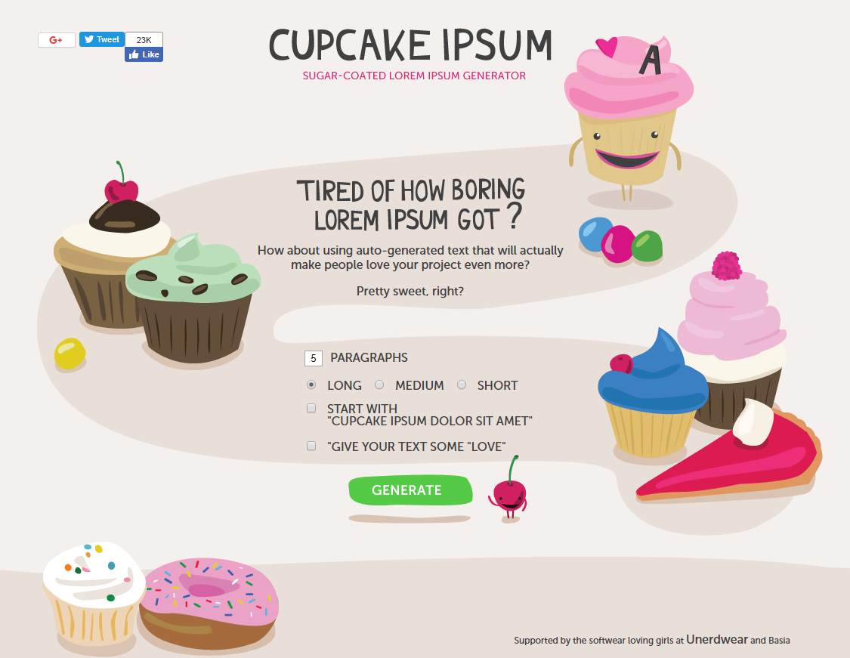

Cupcake Ipsum