CL/BSCSD/19/82 / st20171735

Mohammed Niaz Mohammed Inzamam

Advanced Student Information System with Student Guiding and Recommendation and Results Prediction System for Greendale College to Enhance Student Performance

# Abstract

Advanced Student Information System with Student Guiding and Recommendation and Results Prediction System for Greendale College is a web based system for the education that can be used to managed student information and data. This system is designed for Greendale College it would help administrators, lecturers to manage students data more efficiently it would also help students to do their university course works within a less time and more easily.

Students Management System consists of two modules including administrators and students Profile. By this system has functions like Student Exam Results, Comment Reply and SMS notification. Administrators can use this system to register information of student and managing student’s profile and all the student details. Students can view results courses assignments and payment details through this system

This system has functions to recommend how student must work to improve their results and guiding them in their coursework and predict student upcoming results. This system uses student past results for their course modules to give recommendations and predict future results for their course work in the college. This system can benefit to administrators and students they will able to carry out their daily educational and university activities more efficiently and accurately.

# Chapter 01

# Introduction

Technology is widely used in present and people are used to live with it. However, some web applications are too old to run parallel with todays. The schools and education nowadays also already changed. For not only Universities and high school, primary school also must have their own management systems. However, the current management system of Greendale College is already defined as old generation management system and it already cannot satisfy the users

As a result, a system called Greendale College Student Information System will be developing as an upgrade version of the old system or to replace manual system to solve problem that facing when was using the old system or manual system. Advanced student information system with student guiding and recommendation system for Greendale College is a software application for education that use to managed student’s information and data.

This design of this system is web-based type, so the user also can directly use the system by connecting to the internet. The users of this system are given to two groups, which are administrators and students. The functions of administrators are read, write and edit. Through this system, administrators can manage all student data and information easily and the students can easily know their performance easily.

Besides that, this system added new technologies for automatically give recommendations and Guides for students and predict student’s future results using their past result to improve their college course work. In order to do that system use students past result for each subjects and system will automatically give recommendations and prediction of upcoming subject results to improve student’s results in exams and assignments in their course work.

This new system will replace the current system that is used in Greendale College and surely, this system will improve the student management system of the college and efficiency of the job.

# Background of the problem

# Problem Statement

Using manual system to manage the students which are records all information and in the book or paper was causing the job of the lecturers becomes more and troublesome. The record in the have a possibility missing or destroy when happen any accident. While now already have the university use the computer to manage the student information, but both of the systems they use are already out dated system. The system they use all are standalone and separately, one system only have one function. This was cause lecturers harder to use all the system on the same time. The separately system without connection with each other also cause the same data and information the needed key in in every system. Besides that, the system that using also does not have the result predicting feature or a student recommendation and guiding system. This will cause the student will get less marks for future assignments and the exams and student would not motivate for their university studies and works. Furthermore, the approach used does not provide a predictive feature for the outcome. As a result, the student will receive poor grades on subsequent assignments and tests.

# Solution

Introducing full-automated Advanced Student Information System for Greendale College with Student Guiding and Recommendation and Result Prediction System to Enhance Students Performance. This system would make administration to do their job easily through the system. In this student management system admin, students all user levels have different new functionalities. Students can download and submit their assignments, view their payments, results, make complains, get notices and notifications from university can be do through the system, administrators can manage all the data of the student and the lecturers through this system and also store student date and information.

Failed in test or scores dropped are causing the student were scared and less marks made their grade low and sometimes fail their subjects but using new function to predict future results of the students make themselves to study hard to improve their performance and students can also see their performance. Every students learning ability are different, some of them are good, some of them weak. So the results that gets also different. As student if they got recommendations to for their results students also try hard to make themselves to study to improve their results according to the recommendation they got via the system. This recommendation system will make student motivate for their course work and make good performance in their grades.

# Project Objectives

This project is mainly developed in order to solve the issues that students face in common, which are getting low marks and failing exams. Using the decision-making statements, this system is predicting the future results of the student and forecast the future outcomes of the student by looking to the students past results.

The system is using student results to build graphs, progress bars, and bar charts of student performance. As a result of this, lecturers will be able to determine whether students' status, progress, or performance has improved as a result of their results. By this, the lecturer can identify the weak spot of the student and help them to achieve further good results.

The aim is to create a cutting-edge student management system that meets the client's requirements. We should identify the project's goals using SMART criteria.

Finally, the project is also able to improve the students time management through smart application features.

# Scope

The ultimate goal of this project is to create and design a sophisticated student management system website for Greendale College to Enhance Student Performance that will allow them to easily track their students' exam and assignment results, grades, and payments for student success, among other things.

Our student management system can meet all of the Greendale College requirements. Both personal and academic information about the students will be held. This will also keep track of the students' fees. Management will be able to easily obtain data from each and every student who has previously studied at this university, and administration will be able to provide assignments, exams, and results through the system. The most significant aspect is that this device will automatically predict student future exam and assignment outcomes by analyzing past results and making decisions. Furthermore, lecturers can view their students' output using graphs, progress bars, and bar charts based on the outcomes of each module.

This system includes some algorithm called decision making algorithm, that’s the main part of the system which predicts students future results. This is a very big advantage for nowadays systems because non of the systems contain this kind of a function which predicts students future results.

PHP, HTML, CSS, JavaScript, Xampp, and PHP, MyAdmin, as well as SQL databases, has been the software of choice for building interfaces and databases.

# Functionalities and Non-Functionalities of the system

## Admins main functionalities

* Login
* administrator must login to the system first. he can login using by user name and password
* admin have to use the correct password incorrect username and he can login to system directly
* if administrator going to using the incorrect password and username he can see the error message on the top of screen.
* Register
* administrator cannot register the system. because he has a username and password in the database
* Enrol Students
* Admin can register students and also he can update the student’s records and details.
* Manage Users
* Admin can add users to the system also he can manage users details and he or she can update the user details also he can register a student to the system.
* Manage Profiles
* Admin can manage the user’s records and details.
* Manage Students
* Administrators should have permission to update the students results and students assignments marks and there details
* Manage Courses
  + - administrator can add courses to the system and he can also update the course details and remove the courses from the systems
* Manage Fees
* administrator can update the course fee and another course fee to the system
* Manage Results
* administrator can and student’s assignments and exams results to the system and he can also update the student’s results
* Manage Assignments
* administrator can add assignment to the system and he can also remove the assignment from the system and update the assignment details
* Reply for Complains
* admin can view complaints and reply for it

## Admins main functionalities

* Login
* Students should be given the ability to log in to the system by id as the user name and the password.
* With using own id and pass word. Students will be allowed to login in to the system.
* View future results predictions
* student can view their future results prediction in the system
* View Recommendations and Guiding
* system will be automatically send the guiding and Recommendation messages from the system
* View payments
* Students can view their payments information on the system
* View Results
* Students can view their Results information on the system
* Submit and download assignments
* students can download the assignments and view their assignments and also he can upload to upload their assignments to system
* Make Complains
  + student can make a complaint

## Non functional requirements

* performance
* students can easily work with the systems because the system can manage lot of users at the same time.
* Security

# Current System Explanation

Currently, all information is handled manually by the Greendale College where staff in the university enters data to the staff university. Students, receive both assignment and send the assignment to the lecturer through email. Also, all the payments are done by the students where they go to the finance department of the university and complete the payment or the students can pay the fees to a particular bank and send the payment slip through email with their information to the university. Moreover, each and every student’s results are being sent through the email personally to every student. The enrollment of students is even done by filling details for a given paper by the university. Furthermore, all the details of the lecturers and the staff members of the university are managed by access database and computers. Even if any student is needing to request something or to make any complaint, he/she must go and meet coordinates in university. Above mentioned all details represent the current situation in the Greendale College

# Drawbacks of the Current System

It becomes increasingly difficult for staff members, administrators and lecturers to handle all the records of the students through a manual system such as handling journals, papers and books. Paper records are much less reliable than digital files as data and information of private documents can fall into a wrong person’s hand or it might be lost, destroyed or stolen. While the university has long used computers to manage student records, each of the systems it employs are now obsolete. As employees use manual databases to process data, it takes a long time for them to retrieve a single piece of information from the database, which is time - consuming process. Manually processing and keeping all documents is not a secure practice. When data is duplicated, it may lead to errors in data management. It wastes a lot of time, which is a huge drawback for university day-to-day tasks. The very same information duplication is frequently generated by separate systems that are not connected to each other. Such manual method also has an impact on student academics because administration lecturers lack a proper way to instruct and monitor students, leading to low academic performance, which lead students to fail their exams and assignments. When using a paper work document, it is also more tough to create adjustments if they desire. The major drawback of the manual method is that it can quickly turn into a huge expense, causing the company to lose money by increasing these expenses.

# Explanation of the Proposed System

To address these issues, we created a fully integrated sophisticated student management system for the Greendale College, which will enable administration and lecturers to do their jobs more efficiently. Since introducing this student management system, the manual system of paper works can no longer be used at this university. All user levels in this student management framework have various new functionalities, including the admin, teachers, lecturers, and students. Students can use the system to download and view their grades, upload assignments, view their course information, display their fees, view their course modules, file complaints, view their assignments and tests and receive university notes and alerts. Administrators can monitor all of the student's data. Also, Lecturers can review students in various batches, student module results, module assignments, and students submitted assignments via this system, as well as make complaints, display alerts and notices sent from the university via the system, and so on.

Inability to pass the exam results in lower grades. Students are afraid, and low grades cause them to fail their subjects. But, by using decision making to anticipate future outcomes, students motivate themselves to work harder in order to better their performance, and students can therefore see their performance. Each learner's ability to learn is different, with some being excellent and others being bad.

Lecturers will be able to see from the graphs and charts that there has been an improvement in the status, success, or performance of students using this new student’s performance function.

Limitations

# Literature review

For the last few years, researchers are working to address the issue of student result analysis and prediction. In Mining Educational Data to Analyse Students Performance is a decision tree-based classification technique to predict students’ final exam results has presented. The authors stated that educational databases’ hidden information could play a vital role in students’ performance development (B. K. Bhardwaj, S. Pal, 2011)

Another research was held by Ralph, Buskirk, and Schmidt (2007) which is about the usage of web based projects, students for online activities showed that the availability to the lecturer for quick and simple response was an incredible resource. Furthermore, this research found that when using the technology, they discuss about the funds that need to spend for these technologies, the ability to use internet, trustiness of the new technologies. Exploration on student’s discernments and fulfillment with online courses give bits of knowledge to student’s responses and fulfillment with execution of an online test. (Hale, 2007)

Lewis Adam Whitley’s Educational data mining and its uses to predict the most prosperous learning environment research to predict the most affluent learning environment. Within this research project, the author would attempt to use data from the University of North Carolina at Pembroke and process the data into environmental factors that may or may not influence a student’s learning ability. The author determined the best method in order to seek a learning environment and try to discover the factors that could impact on a student’s academic performance (Whitley, 2018)

Professor Krithi and Doctor M Ramakrishna claims that in International Research Journal of Computer Science in 2017 about this (SIRS) in this Student Information Report System (SIRS) the system has come up with many variabilities for educational institutions to track the student progress and managing attendance. It favors both student and parents to keep track of student progress without travelling to the educational institute. It also notifies student and parents during the time of important events, that happen in the college. One more feature is the parent will be notified when the student is failed in the exam. The student information that is being collected is as follows; registration number, DOB, Students’ sex, Guardians contact number, residential address, guardian name. All these data that has been entered will be stored in the database. The Student Information Report System is a very convenient method for all educational institutes, schools, colleges and etc. It can be customized per the client’s needfulness. It can be used in both private and the government sectors. SIRS application is a web-based application we can login to the system from anywhere and everywhere, where there is internet availability and the coverage. The paper provides the particulars to carry out the performance, management and decision-making functions of enterprises or organizations. When there is rapid increment in the student enrolments and etc., it will be a very hard task to save all the student details manually and also there is a risk of losing of the student data when it is done manually (paper based). So by using this system, it automates everything and is very easy to use. The student’s data can be retrieved within a fraction of a second since, all the data is being stored in the database. To overcome difficulties, we come up with this new approach student information management system with additional features. This new approach will provide fast processing, efficient student tracking, and produces desired result. This approach will allow students to save their personal details. It is more secure, reliable and easy to use. (Ramakrishna, 2020)

The access to services is at the heart of any system's efficiency, since users often rate the overall system's output based on their satisfaction with those services. Almost every online student management system offers a variety of services to meet the needs and demands of its users. According to Maere (2011), the SMS is responsible for student administration, which involves enrollment, examination records, evaluation process, finance, room assignment, transcripts, students union electronic voting, mobile text messaging, and examination results reviews. As a result, it is likely that online student management systems will be developed in-house at most institutions of higher learning to aid in student registration, online profiling, financial recording, examination grade records, transcript production, student housing management, and maintaining student records. As a result, it is likely that online student management systems will be developed in-house at most institutions of higher learning to aid in student registration, online profiling, financial recording, examination grade records, transcript production, student housing management, and maintaining student records. (LUBANGA, 2017)

And also in 2006 Patterson held a survey about how the students completing their exams through online. By that research that he has done he has come to an end where that he says that a majority of students are likely to take part in the online examination systems. From the responses what he got is 87% respondents said that utilization of online tests is much better for future. Not only that Patterson found that the completion of online test methodology utilized made it feasible for students to take the test at when and where based on their personal preference. And also, through his study he also has come into a conclusion that this method reduces the candidates stress other than doing all of them through the paperwork. (patterson, 2020)

Cristobal Romero ET. Al Data Mining Algorithms to Classify Students Classify Students Collected real data of seven Moodle courses from Cordoba University students to develop a specific Moodle data mining tool. The authors compared different data mining techniques to classify students based on their Moodle usage data and the final marks obtained in their respective courses. The authors concluded that a classifier for educational decision making should be both comprehensive and accurate (C. Romero, S. Ventura, P. G. Espejo, C. Hervás, 2008).

# Chapter 03

## Methodology/Design

### 3.1 Methodology

When a new program is developed, before even software design, data must be investigated, analyzed, and then designed. There seem to be a number of steps to be completed before generating software. This is a set of actions that should be carried out in a specific order, almost like a model. As a result, a number of general models will be given by an amount of people. We've chosen such a role model from in them to help us improve our program. We chose the Water Fall Model to construct our system. More data on this model, as well as the rationale for its selection, may be found further down.

The waterfall model is the system development life cycle model that we are utilizing to construct our website, Greendale College Modern Student Management System, because we aim to create it in stages, following the steps of installation, troubleshooting, implementation, testing, design, and maintenance. Our major goal is to produce an error-free website by following this approach.

As a result, production is established at each level of the waterfall model, and the project manager is aware of the system's development, making it more efficient and dependable. Because of our limited funds, the method must be expense. Nonetheless, there are certain flaws in this concept. As though slight modifications might cause a major problem in any of the previous phases, which are all interdependent. This model carries a greater risk.

To acquire all of the criteria, we had to visit some private sector as well as government university student managements, such as ICBT Campus and Esoft Metro Campus, and meet program managers and coordinators, counsellors, and marketing managers at the Greendale College. We used the fact-gathering procedures listed below to acquire all of the requirements.

### Quantitative Data Analysis

We successfully analyzed quantitative data in accordance with the project. As a result, for the questioners, we must employ quantitative data analysis and interviews to obtain needs:

Quantitative data is easy to analyze in real-time contexts, and researchers acquire data for the quantitative assessment process, allowing analysis of the data to happen nearly quickly. Experiments, surveys, and interviews provide fast results from a data-driven strategy. Less time spent acquiring these resources makes it easier to spot connections that finally lead to a beneficial result.

When opinions are accepted as acceptable substitutes, anything is conceivable. Quantitative analysis eliminates this question since it only considers real-world data. The work is validated since, despite the presence of randomized conditions, the results still point to the very same data. Throughout time, minute differences can be uncovered, however the general assumptions made by researchers that use this approach stay valid.

Researchers can utilize the quantitative approach to focus on a topic they would like to study in the broad population. When a set of data points within a demographic are particularly valuable, this method is frequently used. A mechanism allows us to analyze the reasons for our decisions, behaviors, or actions from a social perspective.

# Selected development methodoly – SSADM (structured systems analysis and design method)

Procedural programming is comparable to structured programming. It's also possible that it's a subclass of Procedural programming. It's used to improve the consistency and clarity of the programming language, resulting in more logical and readable program execution.

Structured programming languages employ structured control flow, which includes the structure of subroutines, iteration, selection, and sequence blocks, as well as the code of that programming language implemented according to the structure in which it was written, as you may have guessed from the name. Structured programming, like Procedural Programming, frequently employs a top-to-bottom technique, meaning that the code produced in Structured programming is executed in a sequential order from top to bottom, one after the other. Sequence, iteration, collection, and subroutines are all necessary components of programming for Organized Control Structure.

Advantages and disadvantages of structured programming

**Advantages of Structured Programming :**

1. Easier to read and understand
2. User Friendly
3. Easier to Maintain
4. Mainly problem based instead of being machine based
5. Development is less difficult because it takes less time and effort. Easier to Debug
6. Machine-Independent, mostly

**Disadvantages of Structured Programming:**

1. Since it is Machine-Independent, So it takes time to convert into machine code.
2. The resulting machine code differs from assembly language code.

3. The software is dependent on variables that can be changed, such as data types. When a result, it must be updated as the need arises.

4.Because this strategy is language-dependent, it usually takes longer to develop. Assembly language, on the other hand, takes less time to design because it is pre-programmed for the machine.

## Structured Systems Analysis & Design Method Techniques

SSADM uses a combination of the three methods:

Logical data modeling;

A logical data model (LDM) describes the concepts, relationships, and interpretations of data values. It's a logical data model since it doesn't specify the physical structures in which data can be stored in files or databases, or sent among service units.

Data flow modeling;

A data flow model is a diagrammatic description of how information flows and exchanges inside a system. Data flow models are being used to depict the flow of data in an information system graphically by detailing the procedures involved in transporting data from input to file storage and report production.

Entity behavior modeling;

The act of recognizing, modeling, and documenting the events that effect each entity, as well as the order in which they occur.

Every one of those three process model presents the same system from a different angle, and each point of view is required to form a complete model of the system in development. The three strategies are cross-referenced against each other to guarantee that the overall application is full and precise.

For this complex Student Management System, we must build the following diagrams: ER Diagram level 0, level 1, and, DFD Context as per the project.

### Software Development Life Cycle (SDLC)

The system project plan, often known as the System Development Life Cycle (SDLC), is split into six primary stages:

* Requirement Analysis
* Design
* Development
* Maintenance of system
* Testing
* The Software Development Life Cycle (SDLC) is a set of processes that start with a set of user requirements and end with a process that serves those criteria.
* The current tendency is to incorporate numerous checks throughout the SLDC to guarantee that the mistakes upon finishing is kept to a minimum.

This method, often known as the waterfall model or the linear period of the waterfall, is a logical explanation of the phases involved in the building of data systems. The meaning of the term "waterfall" will be described in the accompanying diagram.

: 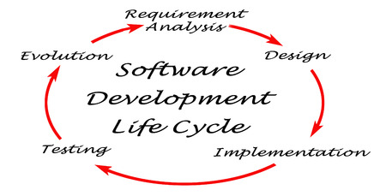

### Waterfall model

The waterfall model was the first process model to be presented. It is simple to comprehend and apply. The whole software project is divided into stages in this paradigm. The input for the next step is constantly influenced by the effects of the previous phase. This means that each level of development begins only after the previous one has been finished.

The following are the reasons why this design was chosen for the project.

Has a well-defined structure.

When contrast to other methods, Waterfall emphasizes a logical, well-defined sequence of phases. It has a simple structure.

2.Information is effectively transferred.

Waterfall is a methodical technique, therefore it should make no difference that it promotes a clear transmission of information at each phase.

3. Early on, the eventual goal is determined.

Devoting to a final result, goal, or deliverable at the start is one of the defining elements of Waterfall, and teams should resist deviating from that commitment.

## Sequential phases in waterfall model according to the project

Requirement gathering and analysis- This marks the beginning of the waterfall's evolution. This step gathers all project specifications from users and captures and documents the system to be created. To get all of the requirements from the Greendale College, I'll need to employ questioners and a literary survey at this point.

System design- The needs acquired in the previous step are then used to create the program's software in this stage. I'm utilizing structured programming for this student management system. Prior to implementing the system, I must design and create all of the diagrams, Relational Schema, including the ER, Context, Level 0 and Level 1 Diagrammatic. An entity relationship diagram, also known as an entity relationship model, is a graphical depiction of a data structure. The Data Flow Diagram is a graphical representation of a system's data flow. By creating a Data Flow Diagram, you may describe the data provided by and given to someone who participates in system processes.

Implementation- As per the database and system architecture in the previous step, the system is initially developed with every function in little programs called units. To implement the student outcome prediction function, we use decision making statements like nested if otherwise, and to develop the lecturer user level key task, we apply decision making a statement like nested if otherwise.

Integration and testing- All units developed throughout the implementation process are included into a system after they have been tested. After integration, the entire system is thoroughly tested for any flaws or defects. Following the deployment of the student management system, I must perform testing for each system function; for this, I am employing manual testing with a test plan and test scenarios.

Development of system- When the functional and non-functional program is done, the device is implemented in the client setting or published into the Greendale College. As per this step, we must host this system, so we select a hosting plan such as Cloud Hosting, which allows many other virtual servers (clouds) to collaborate to host a website or a network of websites. This has limitless capacity to deal with traffic spikes. A cloud-hosted website is not tied to a single server, and the resources allocated to it will shrink or dynamically expand depending on how much traffic it receives. That is an excellent solution for huge websites, newsletters, such as e-commerce sites, and blogs. Once your web hosting has been acquired, we can obtain Name Servers (also known as Domain Name Servers or DNS), which are the Internet's version of a phone book holding IP numbers. Have your website up and running, we'll need to alter your domain name servers. You may now upload Greendale College Student Management System to the account using either cPanel's File Manager or an FTP client such as FileZilla by connecting to the server using either cPanel's File Manager or an FTP client such as FileZilla.

Maintenance- When there are issues that affect the system's users, maintenance is usually undertaken. A system update has been published to address these issues. In the last stage, we'll hand it over to the Greendale College University's IT department, along with a user manual, and they'll be in charge of maintaining the system going forward.

## Design

A software architect or designer can spot a design flaw that has already been addressed by another. A prototype or pattern that represents a solution to a common issue is referred to as a design pattern. Reusing techniques that have already been tested and proven will speed up the software development process. There are two types of design stages.

● Database Design

● Interface Design

## database

The process of grouping the columns and tables of a relational database to avoid redundancy is known as database normalization. Splitting and detecting links between huge data into smaller, less repetitive tables is what normalization entails. The goal is to isolate data such that field additions, removals, and alterations can be done in a single table and then distributed throughout the database using defined linkages.

## Entity relationship diagram – ER diagram

The Entity Relationship Diagram is a diagram that depicts the relation between two entities. The Entity Relationship Model (ERD) is a visual representation of a data structure that describes the relationships between people, objects, places, ideas, and events inside that system. An Entity relationship diagram visualization framework that may be used to classify company categories and build up a social database.

Er diagram

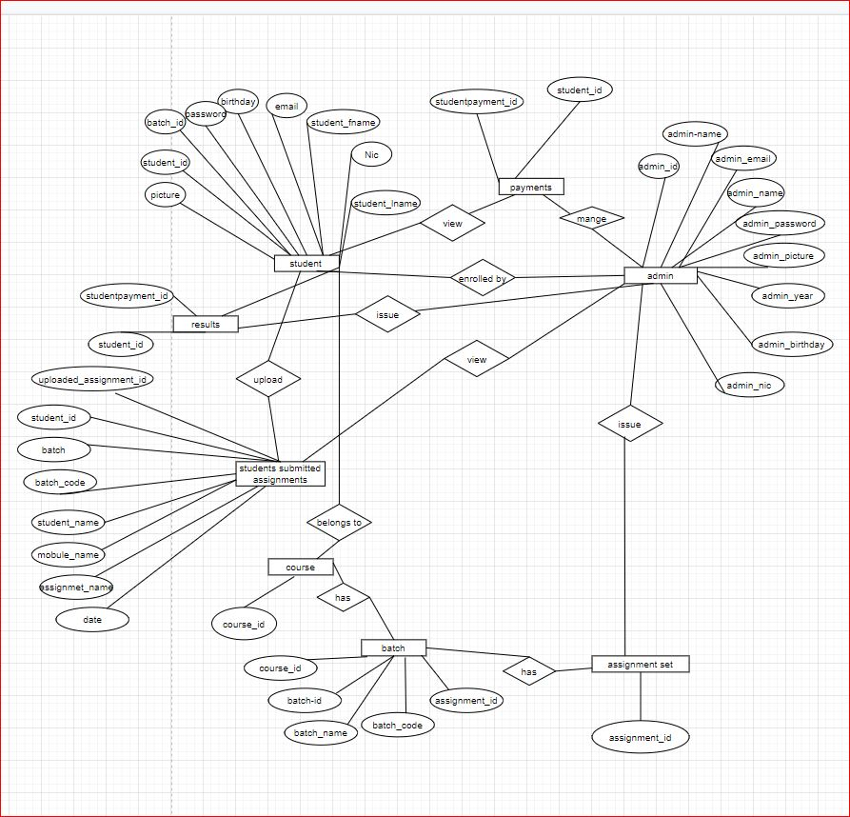

# Normalized Relational Schema

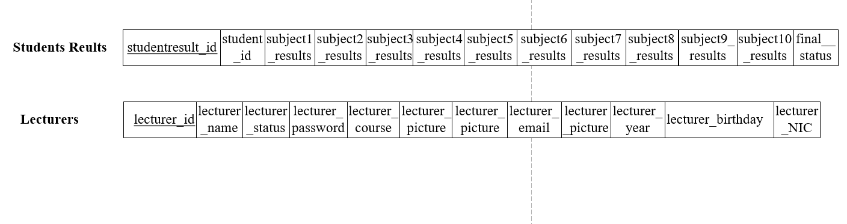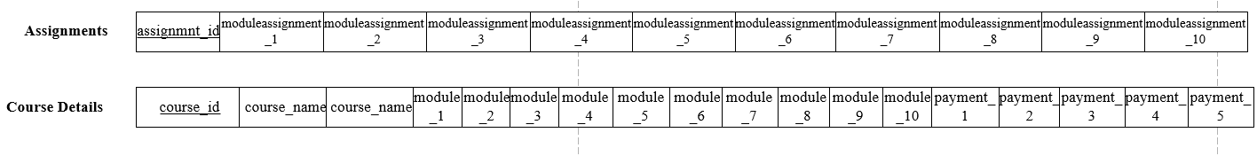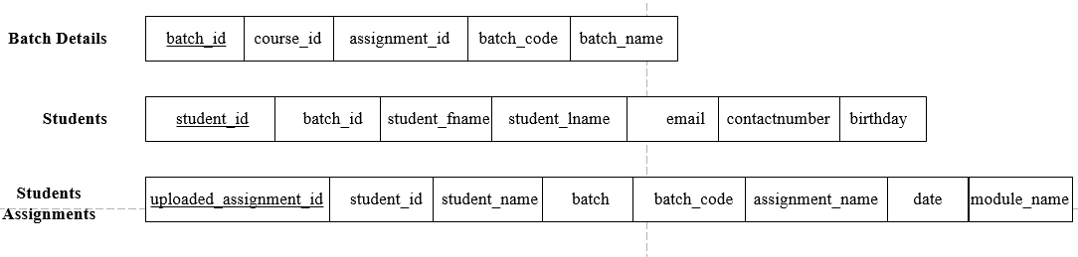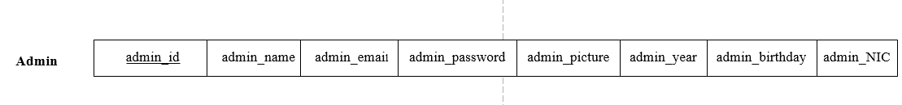SSTEP 2: MAPPING OF THE WEAK ENTITIES

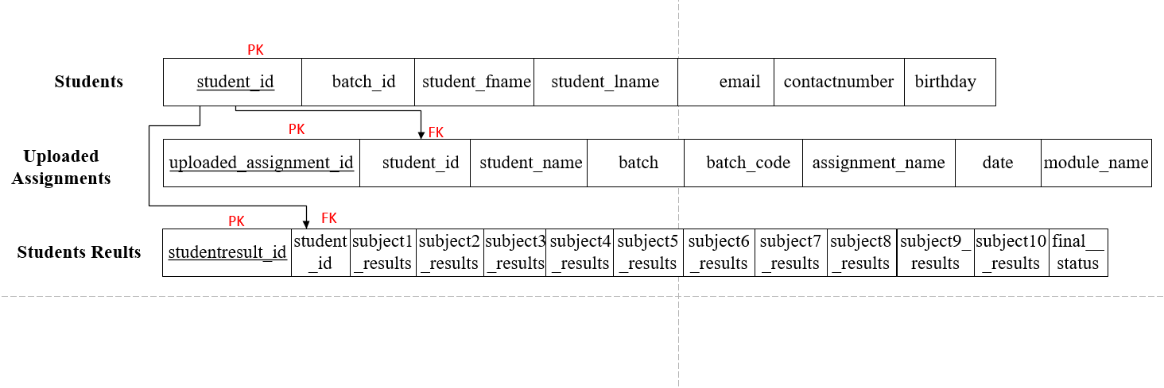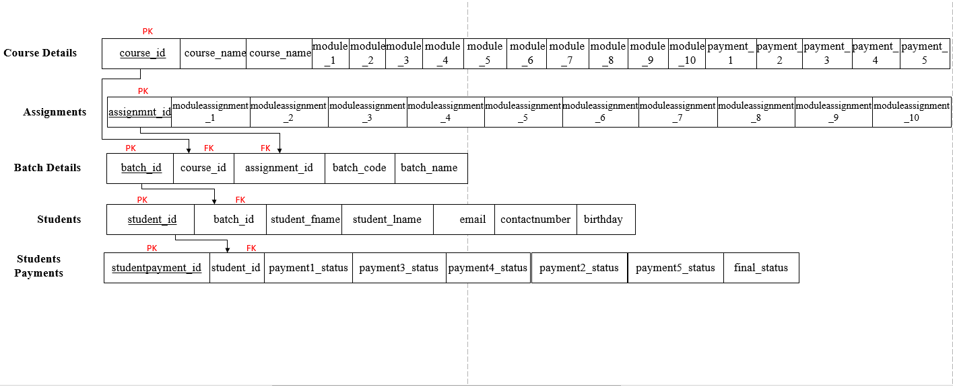

### Context level diagram

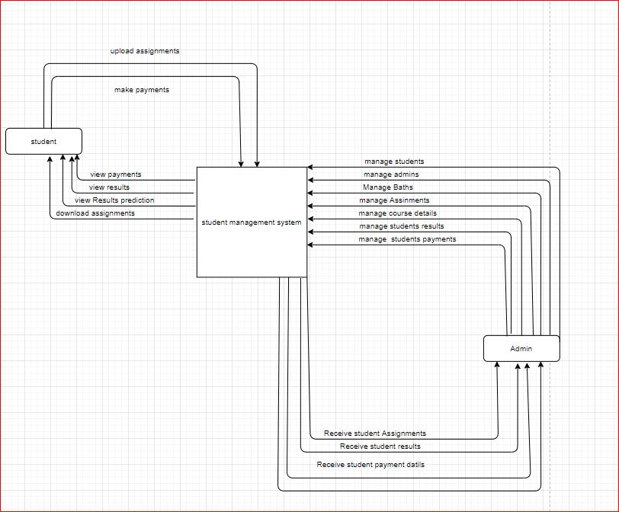

# Level 1

# 

# Chapter 04

## FEASIBILITY STUDY

OPERATIONAL FEASIBILITY

Operational feasibility is a proportion of how well a proposed framework takes care of the issues and acts accordingly to overcome the issues and act accordingly for the given particular tasks. This is subject to HR accessible for the venture and includes anticipating whether the framework will be utilized on the off chance that it is created and executed.

### TECHNICAL FEASIBILITY

The technical feasibility is all about the specialized and calculated components. The technical feasibility deals with all the materials and technical forms that has been used to implement this system. It provides the high level of reliability, availability and compatibility The specialized necessities are then contrasted with the specialized ability of the association. The frameworks venture is considered in fact attainable if the inner specialized ability is adequate to help the undertaking necessities.

Hardware and software requirements;

• 8GB or higher RAM

• Intel core i5 processor

• Windows 10 operating system or any other operating system.

ECONOMICAL FEASIBILITY

In the event that the normal advantages rise to or surpass the normal costs, the framework can be decided to be financially achievable. In monetary achievability, money saving advantage examination is done in which expected expenses and advantages are assessed. Monetary investigation is utilized for assessing the viability of the proposed framework. It doesn't require any extra equipment or programming.

Financial plan for this framework is referenced beneath. What's more, as per planned expense on the off chance that it is approach or surpass the advantages that normal this will be a financially achievable.

### LEGAL FEASIBILITY

Obtaining approval from certain places from the police and the other high commission of the government.

Legal viability defines whether there is a conflict between the proposed system and legal requirements. This model of requirement relies much of the time on government laws. Until the program is implemented, it will be inspected by the government. It will check what source of features are present in the system, if there are any features that are not suitable, whether or not the system complies with the governments laws and restrictions. This student management system should be registered under the state at the end of the day. Then, under this name, no one can create the same website.

### REQUIREMENT GATHERING

In order to make this project more successful, we will need the opinions from a third party so the we can make the system more and more advanced by their feedbacks. Questionnaires, interviews etc. can be done in order to gather the requirements that are needed. In this proposed system. My requirement gathering method was a questionnaire for the students on with regard to my project scope. The questionnaire that I have produced is as follows;