User Table

SuspentionDate

IsSuspended

IsActive

Active Date

User Creation Date

Last Modification Date

Services

Subscribes date,

UnSubscribed Date

When he request subscription of application

When he request on Reception

Report

Made new tab for check who is reserving more who has

Need low to high filter in reports

Total Amount paid show in Reports

New tab for Sold Packages

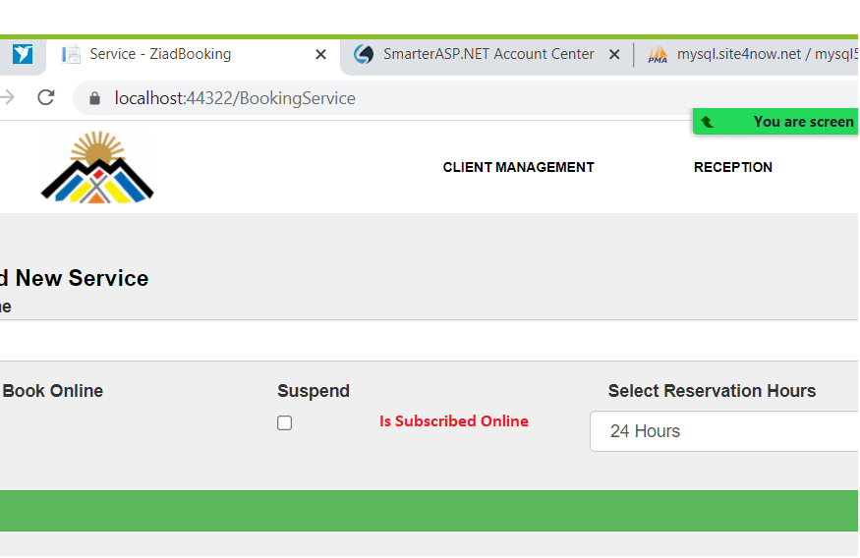

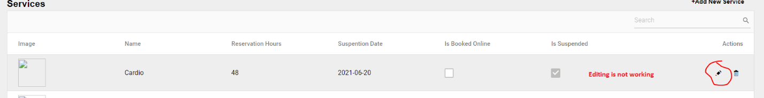

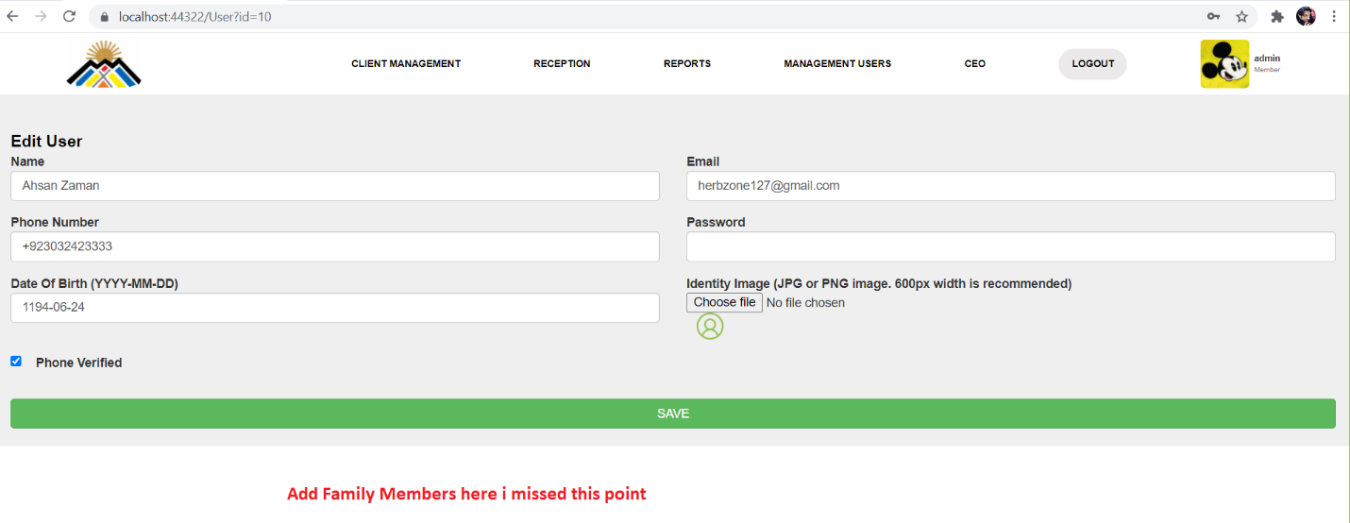

**Add Family Member point missed**