**WSPR 4.0 User’s Guide**

Joe Taylor, K1JT

Revision date: December 29, 2012

# Overview

WSPR (pronounced "whisper") stands for “Weak Signal Propagation Reporter.” The WSPR software is designed for probing potential radio propagation paths using low-power beacon-like transmissions. WSPR signals convey a callsign, Maidenhead grid locator, and power level using a compressed data format with strong forward error correction and narrowband 4-FSK modulation. With two-minute T/R sequences the protocol is effective at signal-to-noise ratios as low as –28 dB in a 2500 Hz bandwidth. Receiving stations with internet access may automatically upload reception reports to a central database. The [WSPRnet.org](http://wsprnet.org/drupal/) web site provides a simple user interface for querying the database, a mapping facility, user forums, and many other features.

Version 4.0 of WSPR introduces a new sub-mode called WSPR-15, intended for experimental use on the MF and LF bands. WSPR-15 uses 15-minute T/R sequences and is effective at signal-to-noise ratios as low as –37 dB.

# System Requirements

* SSB receiver or transceiver and antenna
* Computer running the Windows, Linux, FreeBSD, or OS X operating system.
* 1.5 GHz or faster CPU and at least 500 MB of available RAM
* Monitor with at least 800 x 600 resolution
* Sound card supported by your operating system and capable of 48 kHz sample rate
* If you will transmit as well as receive, an interface using a serial port to key your PTT line or a serial or USB cable for CAT control. Linux and FreeBSD implementations can also use a parallel port for PTT. Alternatively, you can use VOX control.
* Audio connection(s) between receiver/transceiver and sound card
* A means for synchronizing your computer clock to UTC

# Basic Operating Instructions

The following steps should get you on the air quickly with WSPR. Most instructions assume that you will be operating in the standard WSPR mode, now also called WSPR-2. See page 13 for details concerning the experimental WSPR-15 mode.

1. Download WSPR 4.0 from the WSJT Home Page, <http://www.physics.princeton.edu/pulsar/K1JT/>. Click on the WSPR link at the left margin and then on the appropriate download link. Install the program in the usual way for your computer platform. Under Windows, execute the downloaded file and follow the installation instructions. With Vista or Windows 7, I recommend installing to a directory such as C:\Radio\WSPR rather than the default location C:\Program Files\WSPR. See page 14 for other operating systems.
2. Connect appropriate interface cables between radio and computer. For help with the hardware interface, refer to one of the many HowTo’s for sound card modes, for example <https://txarmymars.org/downloads/Basic-Soundcard-Training.pdf>. In general, you will need to connect the radio’s audio output to the computer’s soundcard input; for receive-only systems, that’s all you need! If you will also be transmitting you must patch soundcard output to the radio’s microphone or data input. Simple direct-conversion receivers or transceivers such as the SoftRock make excellent WSPR radios. For these you will need dual-channel (“stereo”) audio connections to handle the in-phase and quadrature (I and Q) signals. For T/R switching and CAT control you may need one or two serial or USB cables.
3. Start WSPR by double-clicking on its desktop icon or another method of your choice. On the **Setup | Station parameters** dialog screen enter your callsign and 6-digit grid locator, select audio input and output devices, and choose your transmitter power in dBm. Use the nearest value from the drop-down list. (See Appendix A for a Watts-to-dBm conversion table. If you allow the mouse pointer to hover over the dBm value for a few seconds, the corresponding power will be displayed in a small pop-up.) SWLs should provide a unique identifier (up to 8 characters) in place of a callsign.
4. If you choose to transmit as well as receive, WSPR will control your T/R sequencing. Select the desired **PTT method**: DTR, RTS, CAT, or VOX. For DTR- or RTS-controlled switching, select a **PTT port**. For receive-only or VOX-controlled systems, set **PTT port** to None.
5. WSPR offers limited CAT control of your transceiver, usable for T/R switching and frequency setting. To use this feature check **Enable CAT** and fill in the remaining parameters on the **Station parameters** screen. Consult the manual for your radio to determine necessary parameter values for a serial connection.
6. You may confirm proper operation of the WSPR decoder by opening a sample audio file recorded by WSPR. Select **File | Open,** navigate to the …\save\Samples directory under the installation directory, and open the file 091022\_0436.wav. A total of six WSPR signals should be decoded, and your screen should look like the image on the next page. You might find it interesting to listen to the sample file using Windows Sound Recorder or a similar utility program. The WSPR signals are barely audible, if at all, and the recording includes many atmospheric static crashes, yet WSPR decodes the signals without errors.
7. Select an operating band from the **Band** menu. The default WSPR frequency will appear in the **Dial** frequency box. For example, you should see 10.138700 MHz for the 30 m band. Set your transceiver to this frequency in USB or a USB-based data mode. (If you enabled CAT control, the frequency setting should be automatic.) Select a desired **Tx** frequency by double-clicking somewhere in the graphical display area. Available **Tx** frequencies fall in the range 1400–1600 Hz above the dial frequency. Clicking near the bottom of the graphical area gives a frequency near the lower limit, and clicking near the top puts you near the upper limit.
8. WSPR uses two-minute time slots for transmitting and receiving. The slider labeled **Tx fraction** sets the average proportion of two-minute slots allocated for transmitting. The default setting of 20% is a good compromise under typical conditions: it means that you will transmit approximately once every ten minutes and receive the rest of the time. The exact T/R sequence will be randomized so as to maximize your chances of receiving other WSPR stations. For receive-only operation, set the **Tx fraction** slider to zero.
9. When neither transmitting nor receiving, you may click the **Tune** button to produce a short unmodulated test transmission. Duration of the transmission (in seconds) is set by the **Tx fraction** slider.

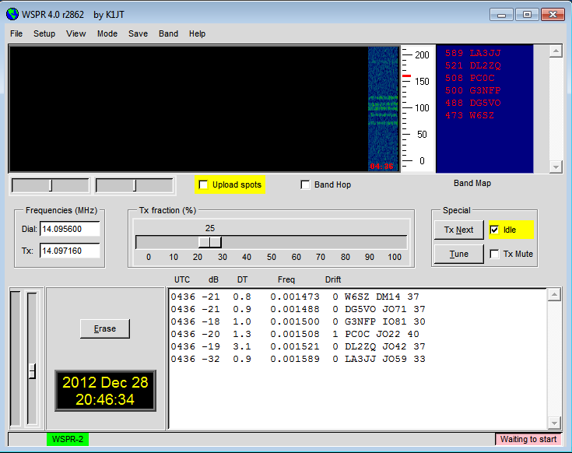

1. Be sure that your computer clock is correct to within about ±1 second. Most operators synchronize with an Internet time service and software such as “Meinberg ntp”, available at <http://www.meinberg.de/english/sw/ntp.htm>. Excellent step-by-step installation instructions for Windows are available at <http://www.satsignal.eu/ntp/setup.html>. For Ubuntu Linux you should install ntp, select **System | Administration | Time and Date**, choose a couple of time servers near you, and activate **Automatic Synchronization**. Macintosh OS X users should ensure that **Set date and time automatically** is checked in the **Date & Time** panel.
2. If you have internet access and wish to upload your reports automatically to WSPRnet, check the box labeled **Upload spots**.
3. To begin normal operation, clear the **Idle** checkbox. WSPR will then begin a receive sequence at the start of the next T/R sequence. In the normal WSPR-2 mode this will be an even-numbered UTC minute; in WSPR-15 it will be at the start of a quarter-hour. After reception has started, you may use the computer’s sound mixer and/or the volume controls on your radio or soundcard interface to adjust the audio level (lower left corner of main WSPR screen, see picture on next page) to roughly midscale on the vertical signal-level bar graph. As a last resort you may use the slider next to the level indicator. At the end of each reception interval, the waterfall will update and any decoded WSPR transmissions will appear in the main text window. At any time you can click **Tx Next** to force the next two-minute sequence to be a transmission.

# Additional Details

## Main Screen

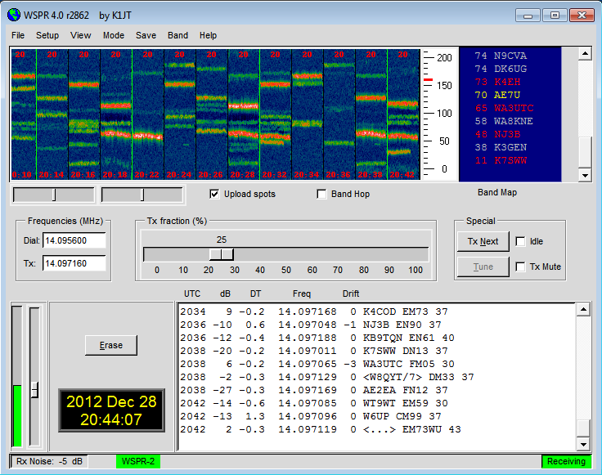

In normal operation on a single band, your WSPR screen will look something like the illustration above. The decoder looks for all detectable WSPR signals in a 200 Hz passband and displays its results in a waterfall spectrogram, a text window, and a Band Map. The spectrogram covers a narrow frequency range (slightly more than 200 Hz) in the vertical direction; the last three digits of the received frequency, in Hz, are displayed on a scale at right. Time runs from left to right in the spectrogram. On a typical computer screen each two-minute interval is a strip about 1 cm wide. The times of your own transmissions are denoted by thin green vertical lines in the spectrogram.

Each decoded WSPR signal produces text showing the UTC, measured signal-to-noise ratio in dB (in a 2500 Hz reference bandwidth), time offset DT in seconds, measured frequency in MHz, drift rate in Hz/minute, and the decoded message. Time offsets greater than about ±2 seconds indicate a significant timing error at transmitter or receiver, or possibly both. For best performance your computer clock should be kept accurate to within ±1 second. Apparent frequency drifts greater than ±1 Hz per minute can usually be traced to the transmitter, and should be corrected if possible. Of course, receiver drifts could also contribute to a measured drift — but they are easily recognized because nearly all signals will appear to drift by the same amount.

Color coding is used in the Band Map to indicate elapsed time since a station was decoded. Calls in red have been seen within 15 minutes of the last line of decoded text; yellow callsigns are 15-30 minutes old, light gray 30-45 minutes, and darker gray 45-60 minutes. Callsigns more than an hour older than the most recent one are deleted from the Band Map.

## Station Parameters

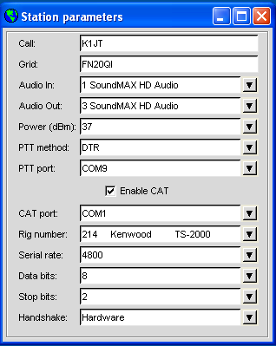The **Station parameters** dialog can be called from the **Setup** menu or by typing **F2.** Compound callsigns such as PJ4/K1ABC, W7/VE3DEF, and even WA2XYZ/37 are permitted but should be used only when necessary. Doubly compounded callsigns such as PJ4/K1ABC/P are not supported. (See Appendix B for further details on message structure.) As illustrated in the example at left, it is permissible to use one serial port for T/R switching (via the DTR or RTS line) and a second serial port for CAT control of the radio’s dial frequency. Consult the operator’s manual for your radio to determine correct parameters for CAT control, including **Serial rate**, **Data bits**, **Stop bits**, and **Handshake** method. With the exception of callsign and grid locator, it is generally best to use values from the drop-down lists rather than typing parameters from the keyboard.

## **Receiver noise level, Bandwidth, and AGC**

For best performance the background noise level going into the computer should be set to show approximately 0 dB on the WSPR status bar. Deviations as large as ±20 dB from the nominal 0 dB level will not affect WSPR’s decoding capability significantly. The idea is to have the baseline noise level high enough for quantization noise to be negligible, but low enough to give adequate dynamic range. Signal levels reported for each WSPR decode are the measured ratio of signal power to average noise power, scaled to a reference bandwidth of 2500 Hz. Within broad limits, this ratio is independent of the measured Rx noise level.

Under most conditions a receiver bandwidth normal for voice SSB communication, say 2.4 kHz, is a good choice. Narrower bandwidths are perfectly acceptable if you have problems with strong signals well outside the 200 Hz WSPR passband. There is no particular advantage in using a bandwidth as small as 200 Hz, however, since WSPR does all necessary narrow-band filtering in software.

Usually it is not critical whether AGC is on or off. A good default procedure is to leave it on, and set the desired audio level by reducing the RF gain. In effect this means that AGC will be activated only when very strong signals are present in the passband. Slow-recovery AGC settings are generally not desirable for WSPR.

# Setup for I-Q Mode

I-Q mode is intended for use with direct conversion receivers or transceivers like the SoftRock. To use such a radio select **PTT method** = CAT and **Rig number** = 2509 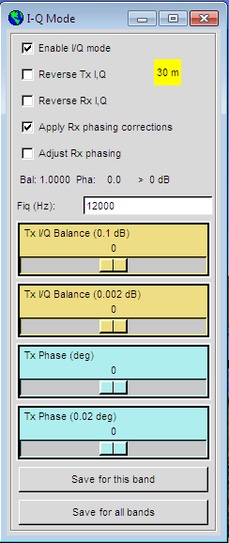on the **Setup | Station Parameters** screen. Then select **IQ Mode** from the **Setup** menu, which will display the screen shown below.

Depending on how you have wired your SoftRock, you may or may not need to check **Reverse Rx I,Q** or **Reverse Tx I,Q**.  Mine does not need these boxes checked. The parameter **Fiq (Hz)** determines the frequency offset between **Dial frequency** specified on the WSPR main screen and the frequency (times 1/4) of the SoftRock’s Si570 programmable oscillator.  The default value for **Fiq** is 12000 Hz; this puts the 200 Hz WSPR band 12 kHz above mid-band. For example, when operating on the 30 m band you might set **Dial frequency** = 10.1387 MHz and **Fiq** = 12000 Hz. These settings result in a commanded Si570 frequency of (10.138700–0.012000) × 4 = 40.506800 MHz.

You will probably need to calibrate the frequencies produced by your Si570 oscillator. Use the procedure outlined in Appendix C. Remember that for most effective use of WSPR, you will want your frequencies correct to within a few Hz.

If your direct conversion receiver has a fixed local oscillator frequency, compute the value of **Fiq** from the equation

fiq = fdial – fLO – fBFO + 1500.

Be sure all values are in Hz, and remember that (unless you have changed it) the BFO frequency is 1500 Hz so the last two terms cancel.

# *Image Rejection*

WSPR 3.0 includes facilities for optimizing image rejection on transmit and receive. You should start by establishing whether **Reverse Rx I,Q** or **Reverse Tx I,Q** need to be checked. (With these boxes unchecked, the assumed routing of in-phase and quadrature signals to the soundcard is “I=Left, Q=right.”) A typical SoftRock should exhibit around 30 dB of unwanted sideband rejection without further adjustment. However, rejections of 60 dB or more can easily be achieved in WSPR. Here’s how.

To adjust Tx image rejection you need a separate communications receiver. Start WSPR, select the desired band, check the **Idle** box, set **Tx fraction** to 100%, and click the **Tune** button. WSPR will send a series of long dashes at the selected frequency. Tune in the main signal on the separate receiver; then find the unwanted image, which will be offset in frequency by twice the sum of Fiq and the Rx BFO frequency. (For the example setup described above, the image is 27 kHz below the desired signal.) While listening to the unwanted image, slowly adjust the sliders labeled **Tx I/Q Balance** and **Tx Phase** on the **Setup | I-Q Mode** screen, seeking a null. There are two sliders for each parameter — the upper one for coarse adjustments, the lower for fine. New settings are applied at the start of each transmitted dash. When you have found the best null you may exit WSPR. The program will remember your last settings of **Tx I/Q Balance** and **Tx Phase.**

Rx image rejection is accomplished in a semi-automatic way. With another transmitter or stable signal generator, generate a moderately strong signal inside (or within ± 500 Hz of) the 200 Hz WSPR band you will be receiving. Start WSPR, clear the **Idle** box, and set **Tx fraction** to 0. After a reception interval starts, check the box **Adjust Rx phasing** and watch the numbers labeled **Bal** and **Pha** converge to stable values. This may take 30 seconds or so. You may then uncheck **Adjust phasing** and check **Apply Rx phasing corrections**. The measured phasing parameters will then be applied to received signals at the end of each Rx interval.

With this procedure, unwanted sideband suppression should be better than 60 dB. An example is illustrated by the following screen shot showing the WSPR waterfall for two successive Rx intervals.

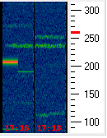At the start of the first interval the signal generator was set near the center of the WSPR band, producing the bright unmodulated carrier just above 200 Hz. **Adjust Rx phasing** was checked at t = 10 s and unchecked at t = 50 s, by which time the **Bal** and **Pha** numbers had stabilized. At t = 60 s, halfway through the 2-minute Rx interval, the signal generator was moved 27 kHz lower, to the image frequency. The partially suppressed image is visible on the waterfall just below 200 Hz. (The small frequency offset is twice the error in the SoftRock’s LO frequency setting.) During the second Rx interval, the box **Apply Rx phasing corrections** was checked. As shown in the second waterfall segment, the newly determined phasing parameters suppress the unwanted signal enough to make it completely invisible. The measured suppression was more than 70 dB.

I-Q Phasing and balance parameters are saved and restored on a “per band” basis. Use button **Save for this Band** to save settings you have determined for the current band. You can make those settings the default for all bands by clicking **Save for all bands**.

## Advanced Setup

The **Advanced** dialog can be called up from the **Setup** menu or by typing **F7**.

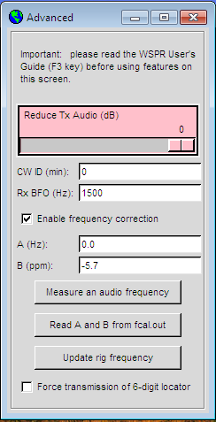If your licensing authority requires callsign identification in Morse code at specified intervals, you may set the interval in the **CW ID** field. Your callsign will then be sent in CW at the end of WSPR transmissions, at the specified interval. Because CW at 25 wpm uses several times more bandwidth than a WSPR signal, it is strongly recommended that you *not* use the **CW ID** feature unless required to do so.

Users of homebrew receiving equipment may require a different BFO frequency than the standard 1500 Hz used for SSB transceivers. You can enter a nonstandard value in the field labeled **Rx BFO (Hz)**.

Many modern transceivers use a master oscillator from which most other frequencies are synthesized. If the master oscillator is slightly off frequency, all dial readings may be high or low in a predictable way. Appendix C outlines a simple procedure for determining whether your radio can be calibrated in this way, and if so how to determine the calibration constants **A** and **B**. Then, if you are using CAT control, you can improve the accuracy of your transmitted and received frequencies by entering these values and checking **Enable frequency correction** on the **Advanced** setup screen. Frequencies sent to the radio will then be adjusted according to your calibration constants. The button labeled **Measure an audio frequency** may be useful in determining values for **A** and **B**. See Appendix C for details. If using CAT control, you can force a frequency-setting command by clicking **Update rig frequency**.

# *Tx Audio Level*

As shown in the screen shot above, a slider control allows you to reduce your Tx audio signal by a specified amount. The normal setting for full output is 0 dB (slider all the way to the right). You can reduce power by up to 30 dB by moving the slider to the left. Changes take effect at the start of the next transmission. It may be convenient to adjust this slider by setting **Tx fraction** to 100% and clicking the **Tune** button to produce a series of transmitted dashes. Each dash will then reflect any new slider setting.

## Special Message Formats

Normal WSPR messages consist of a callsign, 4-digit grid locator, and power level in dBm. These messages are always preferred when appropriate. However, compound callsigns (i.e., callsigns with add-on prefix or suffix) cannot fit into the 28 bits allocated in a standard message. Similarly, 6-digit locators cannot fit into 15 bits. Messages using these components are therefore sent using a two-transmission sequence. For example, if the callsign is PJ4/K1ABC, the 6-digit grid locator is FK52UD, and the power level 37 dBm, the following messages will be sent in alternating transmissions:

PJ4/K1ABC 37   
  <PJ4/K1ABC> FK52UD 37

If you have special need to use a 6-digit locator with a normal callsign, check the box **Force transmission of 6-digit locator**. If the callsign is K1ABC, the 6-digit grid locator FN42AX, and the power level 37 dBm, the following messages will then be sent in alternating transmissions:

K1ABC FN42 37   
  <K1ABC> FN42AX 37

Callsigns enclosed in angle brackets are actually sent as 15-bit hash codes. If such a code is received by another station before the full callsign has been received, it will be displayed as <...> on the decoded text line. Once the full callsign has been received, the decoder will thereafter recognize the hash code and fill in the blanks. Two very different callsigns might have the same hash code, but the 15-bit hash-code length ensures that in practice such collisions will be rare.

## **Band Hopping**

WSPR 3.0 allows those with CAT-controlled radios to investigate propagation on bands without user intervention. Coordinated hopping enables a sizable group of stations around the world to move together from band to band, thereby maximizing the chances of identifying open propagation paths.

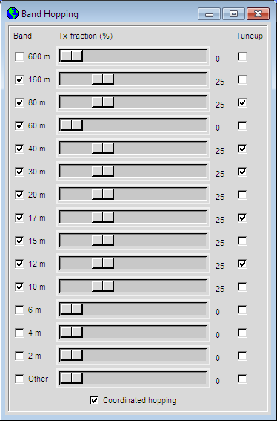Select **Band Hopping** on the **Setup** menu or type **F9**, and you'll see the screen shown at left. You can select any mix of active bands and Tx fractions. If you then check **Band Hop** in the main window, WSPR will switch bands randomly after each 2-minute interval. If the box labeled **Tuneup** is checked for a particular band, WSPR will transmit an unmodulated carrier for several seconds just after switching to that band and before the normal Rx or Tx period starts. This feature can be used to activate an automatic antenna tuner (ATU) to tune a multi-band antenna to the newly selected band. Check the box **Coordinated hopping** to enable sequential hopping through as many as ten bands, according to the schedule shown in the table below.

|  |  |  |  |  |  |  |  |  |  |  |
| --- | --- | --- | --- | --- | --- | --- | --- | --- | --- | --- |
| UTC minute | 00  20  40 | 02  22  42 | 04  24  44 | 06  26  46 | 08  28  48 | 10  30  50 | 12  32  52 | 14  34  52 | 16  36  56 | 18  38  58 |
| Band (m) | 160 | 80 | 60 | 40 | 30 | 20 | 17 | 15 | 12 | 10 |

The band-selection schedule repeats starting at UTC minutes 20 and 40, for a total of three full ten-band sequences in each hour. If the designated band for a given time slot has not been checked as active, a random choice is made among the active bands. The algorithm for choosing whether to receive or transmit guarantees at least one transmission on each active band every two hours.  If all ten bands are active, up to three transmissions may be made on a given band in a two hour period.

Depending on your station and antenna setup, band changes might require other switching besides retuning your radio.  To make this possible in an automated way, whenever WSPR executes a successful band-change command to a CAT-controlled radio, it looks for a file named user\_hardware.bat, user\_hardware.cmd, user\_hardware.exe, or user\_hardware in the working directory.  If one of these is found, WSPR tries to execute the command

user\_hardware nnn

where nnn is the band-designation wavelength in meters. You will need to write your own program, script, or batch file to do the necessary switching at your station.  I wrote a simple Python program for this purpose.  One of my antennas is an all-band dipole fed with open-wire line through a 4:1 current balun and an automatic ATU.  Other antennas include a shunt-fed tower for 160 m and a tri-band trap dipole for 20, 15, and 10 m.  The desired antenna is selected automatically, by band. When the all-band dipole is selected, the ATU adjusts itself during the several seconds just before a transmission or reception period begins.

The WSPR-15 Mode

WSPR-15 is an experimental mode intended for use with extremely weak signals on the MF and LF bands. In effect, everything is slowed down by a factor of 8 relative to the normal WSPR mode (which is now also called WSPR-2, when confusion might otherwise arise). Keying rate and tone separation in WSPR-15 are 0.183 baud and 0.183 Hz, respectively; the total bandwidth is 0.732 Hz, and the weakest decodable signals have S/N around –37 dB in a 2500 Hz reference bandwidth. WSPR-15 does not presently support I/Q mode or band hopping.

When used with standard SSB transceivers, WSPR-2 uses audio frequencies in the range 1400-1600 Hz for both transmission and reception. Signal frequencies are therefore above the transceiver’s dial frequency by amounts somewhere in that 200 Hz range. To avoid QRM between the two sub-modes, WSPR-15 uses audio frequencies in the range 1600-1625 Hz, just above the nominal WSPR-2 sub-band.

To operate in the experimental mode, select **WSPR-15** from the **Mode** menu. The scale in the graphics area will change to show a 25 Hz range that extends from 1600 to 1625 Hz above the dial frequency. (If the Rx BFO frequency has been set to something other than1500 Hz on the **Setup | Advanced** menu, the active Rx frequency range extends from fBFO + 100 to fBFO + 125 Hz.) As in WSPR-2 mode, you can select a Tx frequency by double-clicking at the appropriate frequency in the graphics area. In nearly all other ways, WSPR-15 operates in the same manner as WSPR-2.

Linux, FreeBSD, OS X, and Source Code

The WSPR code is “open source” and by design is mostly platform independent. A click-to-install binary package is currently available only for Windows. Binary packages for other UNIX-like operating systems or distributions may become available in the future.

WSPR can be compiled from source code for Linux, FreeBSD, Macintosh OS X, and other Unix-like operating systems as well as Windows. The latest versions of source code (as well as all previous versions) are available from the SVN repository at <http://developer.berlios.de/projects/wsjt/> .

WSPR from the Command Line

Some special-purpose applications can benefit from a simple implementation of the WSPR protocol in a program driven from the command line. The standard WSPR 3.0 distribution includes a simple program “wspr0” for this purpose. As distributed, wspr0 always uses the system default audio devices and it does not implement automatic uploading of spots, rig control, I/Q mode, or band hopping. The program runs in a single thread. Its source code is easy to modify as desired for particular applications. Full operational details are described in an accompanying document, <WSPR0_Instructions.TXT>.

## **WSPRnet**

To access the features of WSPRnet, point your browser to <http://wsprnet.org/>. This excellent site is designed and maintained by Bruce Walker, W1BW. It provides a chat facility, band-by-band counts of stations reporting WSPR spots (or reported by others) in the past ten minutes, a world-wide map showing active WSPR stations and propagation paths, an interface to the historical database, and statistical summaries derived from the data. The map can be zoomed and panned, and you can set various criteria to determine which spots are shown. An examples of the world-wide map is shown below, and the WSPRnet home screen on the next page.

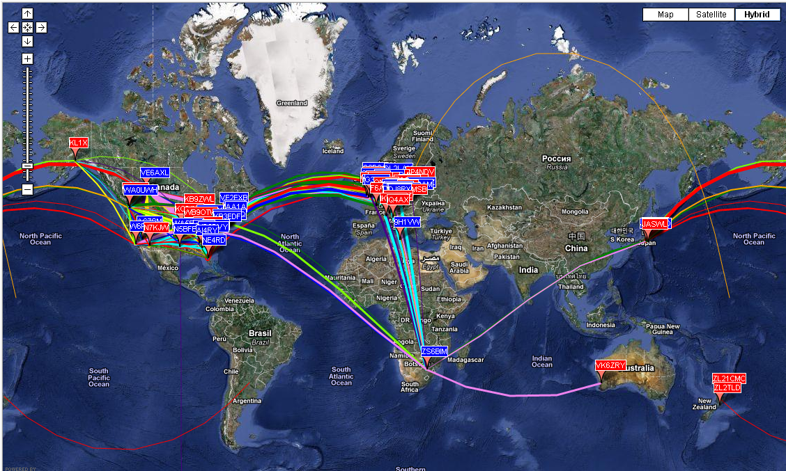

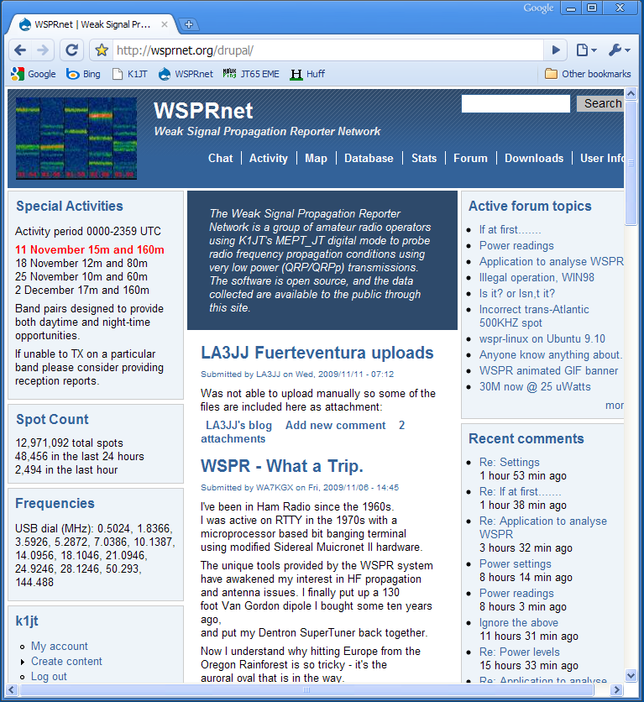

Appendix A: Conversion Table, dBm to Watts

0 1 mW (milliwatt)

3 2

7 5

10 10

13 20

17 50

20 100

23 200

27 500

30 1 W (Watt)

33 2

37 5

40 10

43 20

47 50

50 100

53 200

57 500

60 1000 kW (kilowatt)

Appendix B: Specifications of the WSPR Protocol

* Standard message: callsign + 4-digit locator + dBm

K1ABC FN20 37

* Messages with a compound callsign and/or 6-digit locator use a two-transmission sequence. The first transmission carries compound callsign and power level, or standard callsign, 4-digit locator, and power level; the second transmission carries a hashed callsign, 6-digit locator, and power level. Examples:

PJ4/K1ABC 37 K1ABC FN42 37  
  <PJ4/K1ABC> FK52UD 37 <K1ABC> FN42AX 37

Add-on prefixes can be up to three alphanumeric characters; add-on suffixes can be a single letter or one or two digits.

* Standard message components after lossless compression: 28 bits for callsign, 15 for locator, 7 for power level, 50 bits total. Further details are contained in the source code, available at <http://developer.berlios.de/projects/wsjt/>.
* Forward error correction (FEC): convolutional code with constraint length K=32, rate r=1/2.
* Number of binary channel symbols: nsym = (50+K-1) 2 = 162.
* Keying rate: WSPR-2, 12000/8192 = 1.4648 baud; WSPR-15, 12000/65536 = 0.1831 baud.
* Modulation: continuous phase 4-FSK, tone separation 1.4648 Hz (WSPR-2) or 0.1831 Hz (WSPR-15).
* Occupied bandwidth: about 6 Hz (WSPR-2), 0.73 Hz (WSPR-15)
* Synchronization: 162-bit pseudo-random sync vector.
* Data structure: each channel symbol conveys one sync bit (LSB) and one data bit (MSB).
* Duration of transmission: 162 8192/12000 = 110.6 s (WSPR-2), 162 65536/12000 = 884.7 s (WSPR-15)
* Transmissions nominally start one second into an even UTC minute: i.e., at hh:00:01, hh:02:01 … (WSPR-2) or one second into an even quarter-hour, hh:00:01, hh:15:01, … (WSPR-15).
* Minimum S/N for reception: around –28 dB on the WSJT scale (2500 Hz reference bandwidth) for WSPR-2, –37 dB for WSPR-15.

## Further details on the structure of WSPR Messages

At the user level, WSPR messages can have one of three possible formats illustrated by the following examples:

Type 1: K1ABC FN42 37

Type 2: PJ4/K1ABC 37

Type 3: <PJ4/K1ABC> FK52UD 37

Type 1 messages contain a standard callsign, a 4-character Maidenhead grid locator, and power level in dBm. Power levels will be rounded so as to fall in the sequence 0, 3, 7, 10, 13, …, 60. Type 2 messages omit the grid locator but include a compound callsign, while type 3 messages replace the callsign with a 15-bit hash code and include a 6-character locator as well as the power level. Lossless compression techniques squeeze all three message types into exactly 50 bits of user information. Standard callsigns require 28 bits and 4-character grid locators 15 bits. In Type 1 messages, the remaining 7 bits convey the power level. In message types 2 and 3 these 7 bits convey power level (in the restricted range 0 to 60 dBm) along with an extension or re-definition of the fields normally used for callsign and locator. Together, these compression techniques amount to “source encoding” the user message into the smallest possible number of bits.

After source encoding, redundancy is added in the form of a strong error correcting code (ECC). WSPR uses a convolutional code with constraint length K=32 and rate r=1/2. The convolution procedure extends the 50 user bits into a total of (50 + K – 1) × 2 = 162 one-bit symbols. Interleaving is applied to scramble the order of these symbols, thereby minimizing the effect of short bursts of errors in reception that might be caused by QSB, QRM, or QRN. The data symbols are combined with an equal number of synchronizing symbols, a pseudo-random pattern of 0’s and 1’s. The 2-bit combination for each symbol is the quantity that determines which of four possible tones to transmit in any particular symbol interval. Data information is taken as the most significant bit, sync information the least significant. Thus, on a 0 – 3 scale, the tone for a given symbol is twice the value (0 or 1) of the data bit, plus the sync bit.

Some arbitrary choices define further details of message packing and the ordering of channel symbols. These choices are best described with actual examples, and by referring to the source code. To make it easy for others to implement the WSPR protocol, a Fortran program has been written to illustrate the encoding and decoding procedure and provide examples of each stage in the process. A compiled version of this program for Windows is available at <http://physics.princeton.edu/pulsar/K1JT/WSPRcode.exe>, and full source code can be found in the WSJT repository. An example of program invocation and output for the message “K1ABC FN42 37” is shown on the next page. A WSPR transmitter should generate frequencies corresponding to the numbers given for channel symbols, where 0 is the lowest frequency tone and 3 the highest.

C:\wspr> WSPRcode "K1ABC FN42 37"

Message: K1ABC FN42 37

Source-encoded message (50 bits, hex): F7 0C 23 8B 0D 19 40

Data symbols:

1 1 0 0 1 0 0 0 0 0 1 0 0 1 0 1 1 1 0 0 0 1 1 1 0 1 1 1 1 0

1 0 0 0 1 1 0 0 1 1 1 1 0 0 1 1 1 1 0 0 0 1 1 1 1 0 0 1 1 0

1 1 0 1 1 1 0 1 1 0 1 0 1 0 0 1 0 0 1 0 1 0 1 1 0 1 1 0 0 1

1 1 1 0 1 1 1 0 1 0 1 0 1 0 0 0 1 1 0 1 0 0 0 1 1 1 0 1 1 0

1 0 1 1 1 0 1 1 1 0 0 0 0 0 0 1 1 0 0 1 1 1 1 1 1 0 1 1 1 1

1 1 1 1 1 0 0 1 0 1 1 1

Sync symbols:

1 1 0 0 0 0 0 0 1 0 0 0 1 1 1 0 0 0 1 0 0 1 0 1 1 1 1 0 0 0

0 0 0 0 1 0 0 1 0 1 0 0 0 0 0 0 1 0 1 1 0 0 1 1 0 1 0 0 0 1

1 0 1 0 0 0 0 1 1 0 1 0 1 0 1 0 1 0 0 1 0 0 1 0 1 1 0 0 0 1

1 0 1 0 1 0 0 0 1 0 0 0 0 0 1 0 0 1 0 0 1 1 1 0 1 1 0 0 1 1

0 1 0 0 0 1 1 1 0 0 0 0 0 1 0 1 0 0 1 1 0 0 0 0 0 0 0 1 1 0

1 0 1 1 0 0 0 1 1 0 0 0

Channel symbols:

3 3 0 0 2 0 0 0 1 0 2 0 1 3 1 2 2 2 1 0 0 3 2 3 1 3 3 2 2 0

2 0 0 0 3 2 0 1 2 3 2 2 0 0 2 2 3 2 1 1 0 2 3 3 2 1 0 2 2 1

3 2 1 2 2 2 0 3 3 0 3 0 3 0 1 2 1 0 2 1 2 0 3 2 1 3 2 0 0 3

3 2 3 0 3 2 2 0 3 0 2 0 2 0 1 0 2 3 0 2 1 1 1 2 3 3 0 2 3 1

2 1 2 2 2 1 3 3 2 0 0 0 0 1 0 3 2 0 1 3 2 2 2 2 2 0 2 3 3 2

3 2 3 3 2 0 0 3 1 2 2 2

Decoded message: K1ABC FN42 37 ntype: 37

# Appendix C: Frequency Calibration

The digital frequency readouts of modern synthesized radios depend on a master oscillator for their accuracy. If the frequency of this oscillator is off by even a few parts per million (ppm), it can significantly degrade the accuracy of your WSPR spots and transmitting frequencies. WSPR 2.0 has built-in facilities that can help you measure and enable calibration constants for your radio, all done with software.

**Quick two-frequency calibration procedure**

The following procedure should work for most modern radios. You will need access to two signals of known frequency — ideally one at a low frequency, say 3 MHz or less, and one at least several times higher. Good choices in North America would be WWV at 2.5 and 10 MHz, as illustrated below. In other parts of the world you can probably still access WWV at 10 MHz, and for a low frequency you could use a standard AM broadcast station. Many other choices are possible, of course.

1. Put receiver in USB mode with RIT off, dial frequency f1 = 2.500 MHz (or whatever the known station frequency may be). The receiver should be thoroughly warmed up.
2. Turn on RIT, set it to –1500 Hz
3. With WSPR running in **Idle** mode, click **Measure an audio frequency** on the **Advanced** dialog screen.
4. Subtract 1500 Hz from the measured audio frequency reported by WSPR in the console window, and record the result as dial error d1.
5. Repeat steps 1–4 for a second standard-frequency station. You should now have two pairs of numbers: (f1, d1) and (f2, d2). Note that f1, f2 are in MHz but d1, d2 are in Hz.
6. Now solve the following pair of simultaneous linear equations (which you learned how to do when in high school):

d1 = A + B f1

d2 = A + B f2

The desired calibration constants are given by

B = (d2 – d1) / (f2 – f1)

A = d1 – B f1

1. Example with numbers: the audio frequency measurements with my TS-2000 were 1505.49 Hz on the 2.5 MHz WWV signal, and 1515.01 Hz on the 10 MHz signal. Thus f1 = 2.5, d1 = 1505.49 – 1500 = 5.49, f2 = 10.0, and d2 = 1515.01 – 1500 = 15.01. These values yield the results

B = (15.01 – 5.49) / (10.0 – 2.5) = 1.269 ppm

A = d1 – B f1 = 2.32 Hz

1. Alternatively, A and B can be calculated by using the fcal program (see the following section “More thorough calibration”).
2. When satisfied that your results are repeatable and reliable, enter the computed values of **A** and **B** in WSPR’s **Advanced** dialog.

**More thorough calibration**

The figure reproduced below illustrates the results of about an hour’s work with my Kenwood TS-2000. I made measurements as described in steps 1–4 above, and repeated them for 68 different stations. The first 8 of these were the standard-frequency broadcasts of WWV (US) at 2.500, 5.000, 10.000, 15.000, and 20.000 MHz and CHU (Canada) at 3.330, 7.850, and 14.670 MHz. These measurements are plotted as filled circles in the graph. It’s easy to see that measurements of the eight standard-frequency signals make an extremely good fit to a straight line.

fcal

The remaining measurements were made for standard AM and shortwave broadcast stations, chosen more or less at random. In North America, assigned frequencies of AM broadcast stations are integer multiples of 10 kHz. Most shortwave broadcast stations also follow this pattern, although some are at odd integer multiples of 5 kHz. Useful stations are those that give measured audio frequencies close to 1500 Hz when the radio dial is set at the appropriate round number and RIT is set at –1500 Hz. Measurements for the 60 broadcast stations are plotted as small crosses in the figure. By my measurements, about two-thirds of the broadcast stations are within 1 Hz of their assigned frequency (a few are off by as much as 5–10 Hz). By rejecting the more discrepant measurements, you could calibrate reasonably well by using these or a similar group of broadcast stations.

A simple command-line program fcal is included with your WSPR installation. An example data file containing my own measurements of WWV and CHU is also included as the file fcal.dat. If you are comfortable running computer programs from the command line, open a Command Prompt window, change to the WSPR installation directory, and type the command “fcal fcal.dat”. The results should look like this

C:\Radio\WSPR> fcal fcal.dat

Freq DF Meas Freq Resid Call

(MHz) (Hz) (MHz) (Hz)

------------------------------------------------

2.500 5.490 2.500005490 0.102

3.330 6.410 3.330006410 -0.048

5.000 8.610 5.000008610 0.000

7.850 12.270 7.850012270 -0.012

10.000 15.010 10.000015010 -0.042

14.670 21.060 14.670021060 -0.009

15.000 21.420 15.000021420 -0.074

20.000 28.020 20.000028020 0.083

A: 2.17 Hz B: 1.2885 ppm StdDev: 0.067 Hz

err: 0.05 0.0040

Parameter A (measured in Hz) is the intercept of the best-fit straight line with the y-axis; B is the slope of the line, measured in parts per million. These results show that for my TS‑2000 the best-fit calibration constants are A=2.17 ± 0.05 Hz and B = 1.289 ± 0.004 ppm. The standard deviation of the measurements about the fitted line is less than 0.1 Hz, which shows that the measurements are very good and a linear correction to the radio’s dial frequency should be reliable.

You can use the file fcal.dat as a guide for preparing a file with your own calibration measurements. To obtain values for **A** and **B**, use your file name as a command-line argument to program fcal, for example

C:\Program Files\WSPR> fcal mycal.dat

Click the button labeled **Read A and B from fcal.out** to transfer the fitted values to the entry fields for A and B.

# Appendix D: Troubleshooting

**I don’t see any WSPR signals in the waterfall spectrogram.**

1. Is the **Idle** box is unchecked?
2. Have you selected the correct **Audio in** device in the **Station parameters** dialog?
3. Is audio reaching the computer?
4. The **Rx Noise** level displayed at bottom left of the WSPR window during a reception period should be at least –10 dB. If it is very low, e.g. –30 dB, you might need to adjust the volume level in your computer operating system and/or receiver.
5. Are any stations active on the selected band? For new users, 30 m is a good starting band as it generally has high activity and good propagation. Check the WSPRnet Activity page <http://wsprnet.org/drupal/wsprnet/activity> to see how many stations are active on a band, and where they are located.
6. Is your receiver is on the correct frequency and in USB mode? The readout frequency should be the one given in the **Dial** box. Use a standard-frequency signal such as WWV to determine your receiver's calibration accuracy and then, if necessary, adjust the receiver dial frequency accordingly.

**I see WSPR traces in the spectrogram but no decodes.**

1. Reboot your computer. When it has rebooted, see if WSPR is working before starting any other programs.
2. Is your computer clock is set accurately enough? WSPR’s time readout should be within about ±1 second of the correct UTC.
3. Is your receiver drifting in frequency? If most WSPR traces slope either upward or downward in the spectrogram, the receiver is probably drifting too much. Try waiting half an hour to see if it stabilizes.
4. If you are transmitting, additional heat generated by the transmitter may contribute to the drift. Try reducing your output power or reducing **Tx fraction** so that you transmit less often.

**No decodes of my signal are appearing on WSPRnet.org.**

1. Perhaps your signal simply isn't being received by anyone. A simple antenna and a few watts should allow you to decode other people's signals, and vice-versa, on 30 m during daylight hours. Turning up your power level beyond 5 to 10 watts is not recommended, as lack of decodes on 30 m is most likely a setup issue and not related to your power level.
2. The WSPRnet Activity page <http://wsprnet.org/drupal/wsprnet/activity> can be used to see how many stations are active on a band and where they are located.
3. Is your transmitter switching to transmit? Check that you have selected the correct **PTT method** and **PTT port** or **CAT** settings. These parameters are configured in the **Station parameters** dialog.
4. Is your transmitter generating output? Use its metering features or a field strength meter or SWR bridge to ensure that you are generating a signal.
5. If you have no power output, check that you have selected the correct **Audio out** device in the **Station parameters** dialog. You may also need to adjust the sound output volume level in your operating system’s audio mixer, or a sound level setting in your transmitter (e.g. Mic level).
6. Are you transmitting in upper sideband (USB) in the specified 200 Hz WSPR frequency range? With a transceiver, if you don't see WSPR signals in the waterfall or they are not evenly spread above and below the center frequency, your transceiver may not be set to the correct frequency, or its frequency readout not calibrated accurately.

**My spots of other stations are not appearing in the WSPRnet.org database.**

1. Have you checked the **Upload spots** checkbox? Be aware that if you have used the **File** menu features to decode saved files, **Upload spots** will have been unchecked automatically.
2. Are you successfully decoding WSPR signals? You should see WSPR messages in the large text box towards the bottom of the WSPR window, and callsigns in the Band Map at top right.
3. If you are decoding callsigns successfully, make sure that your computer clock is set to the correct UTC hour of the day and correct UTC day. (The minutes could be correct while the hour or day are wrong.)

**My locator is displayed as only 4 digits in the WSPRnet.org database.**

1. Have you entered a 6 digit locator in the **Station parameters** dialog? You should always enter a 6 digit locator here.
2. On the WSPRnet web site, ensure that in your account details you have entered a 6 digit locator.

**CAT control is not working properly with my radio.**

1. Your radio may require settings beyond those made available on the Setup screen. You can insert additional rig-control parameters by editing the **Handshake** line on the **Station parameters** screen. For example, if you need Handshake = Hardware and parity = Even, the **Handshake** line should read

Hardware –C serial\_parity=Even

1. Some radios (e.g., Yaesu FT-450, FT-950, and FlexRadio 3000) do not like the default timing parameters used by the rigctl program. CAT control of these radios requires the following text on the Handshake line:

Hardware –C write\_delay=0

**I’m running WSPR under Linux, and the labels above decoded text are poorly aligned.**

1. Details of screen appearance depend on configuration of your window manager, installed fonts, etc. You can experiment with fonts by editing the file wsprrc. An example of the resulting screen appearance under Ubuntu 9.04 is shown on the next page.

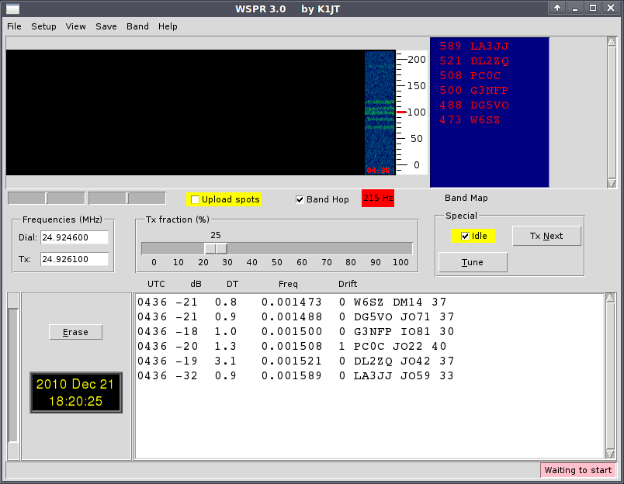

**Still having problems?**

The WSPRnet community is very helpful and can be contacted via the Forums facility at <http://wsprnet.org/drupal/forum>, and via the wsjtgroup email reflector [wsjtgroup@yahoogroups.com](mailto:wsjtgroup@yahoogroups.com).

# Acknowledgments

Many people have contributed to the success and popularity of WSPR. Members of the WSJT Development Group, especially G4KLA, OH2GQC, VA3DB, W1BW, W6CQZ, and JCDutton have written code, particularly code addressing platform portability issues. The band-hopping features were first implemented by 4X6IZ. G3ZOD, LZ1BB, OZ1PIF, and VK3SB have spent many hours helping to debug beta releases and prepare distribution packages. G3ZOD drafted most of the troubleshooting hints in Appendix D of this manual. Many thanks to all for these efforts!