SIT223/753 – HD Task - Answer Sheet
- A link to the demo video
[PENDING – VIDEO LINK] Insert the real demo video URL here after recording. See video-script.md and README.md (section “After recording”) in the repository for the exact steps to replace this marker and re-export this PDF.
- Provide a link to your GitHub repository containing the Jenkins pipeline script. Please ensure that your marking tutor has been granted appropriate access
https://github.com/8ccs/sit223-7.3hd-incident-tracker
This repository is public, so both the Marker and the Unit Chair already have full read access to the code and the Jenkinsfile without needing an individual invite. (The assignment brief requires access for both roles, even though this template section only names the marking tutor.)
- Specify how many stages you have implemented
7 of 7 stages implemented and verified end-to-end: Build, Test, Code Quality, Security, Deploy, Release, and Monitoring.
- A brief description of your project and the technologies used.
Incident Tracker is a small but functionally deep incident-management web application, built as the subject of this seven-stage Jenkins pipeline.
It provides a REST API and a server-rendered dashboard for creating, listing, filtering, updating, and deleting incidents. Each incident has a title, description, severity (low/medium/high/critical), and status (open/in_progress/resolved/closed). A business rule blocks deletion of any incident that is still open or in progress.
Data is stored in SQLite, with a separate database file for each environment. The app also exposes /health (readiness) and /metrics (Prometheus format) endpoints, which the Monitoring stage uses.
Technologies: Python 3.11, Flask 3.1, prometheus-client, SQLite (standard library), and Waitress as the production WSGI server. Testing: pytest and pytest-cov. Code quality: flake8, pylint, radon. Security: Bandit and pip-audit. Monitoring: Prometheus and Alertmanager. CI/CD: Jenkins 2.568 (declarative pipeline), running natively on Windows.
This machine did not have Docker installed, so the Build stage produces a versioned zip artifact instead of a container image, and Deploy/Release run the app as isolated per-environment Python processes instead of containers. This decision, and the reasoning behind it, is explained in the repository README.
- A screenshot of your Jenkins pipeline.
Jenkins Stage View, build #11, commit ca34848 -- all 7 required stages (Build, Test, Code Quality, Security, Deploy, Release, Monitoring) passed:
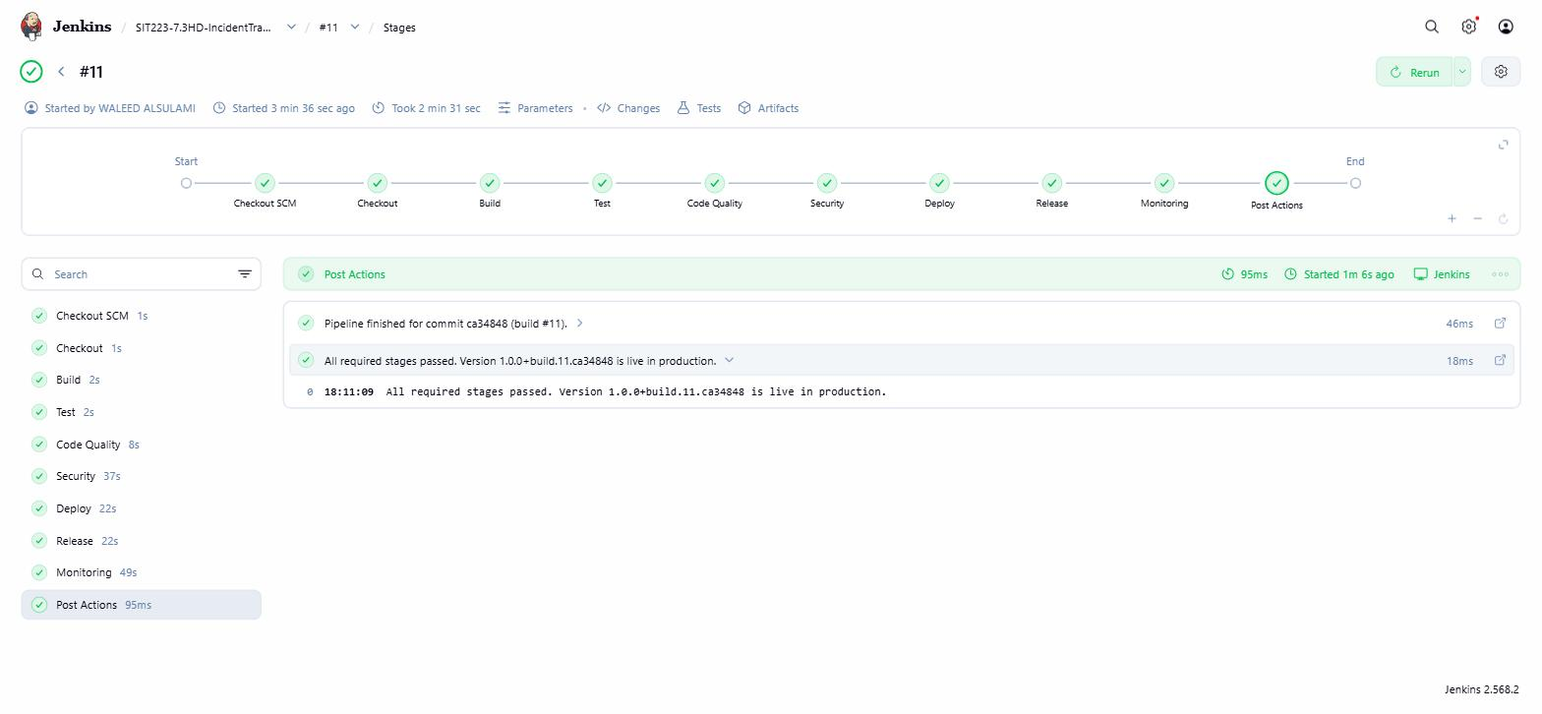
- A brief description of each stage of your pipeline including the used frameworks/tools.
  - Build:
Jenkins runs scripts/package_artifact.ps1, which packages the app into a zip artifact and stamps its filename with the Git commit hash and the Jenkins build number (for example, incident-tracker-1.0.0+build.12.a0f1f0a.zip). The artifact is archived by Jenkins and also copied to a shared artifact store, so every later stage uses the exact same file. The pipeline is triggered automatically by SCM polling every 5 minutes, because this local Jenkins has no public URL for a GitHub webhook to reach.
  - Test:
pytest runs 48 unit and integration tests: unit tests check validation rules and the SQLite data layer in isolation; integration tests call the real Flask routes, including failure cases such as invalid input and deleting an incident that is still open. Coverage is measured with pytest-cov and gated at 80% (currently 98%). Results are published to Jenkins through the JUnit plugin. A failing test, or coverage below the threshold, fails the build and stops Deploy and Release from running.
  - Code Quality
flake8, pylint, and radon run against the app code. scripts/quality_gate.py enforces two explicit thresholds: a pylint score of at least 8.0/10 (currently 9.96/10) and cyclomatic complexity no worse than rank C. This gate caught two real issues during development – a variable-scope bug and an overly complex function – both fixed; details are in the project README.
  - Security
Bandit scans the code for common vulnerability patterns, and pip-audit checks all runtime dependencies against known CVEs. scripts/security_gate.py fails the build on any HIGH-severity Bandit finding or any dependency vulnerability with an available fix. Real findings were fixed during development (binding to all network interfaces; a dynamic SQL column name), and one residual finding is explicitly allow-listed and documented rather than silently suppressed. pip-audit currently reports zero known vulnerabilities.
  - Deployment
scripts/deploy.ps1 extracts the build artifact into an isolated staging environment (its own port, virtual environment, and SQLite database), waits for a /health readiness check, then runs 5 real HTTP smoke tests against the live staging app before Release is allowed to run.
  - Release
The same artifact, never rebuilt, is deployed to a separate production environment by the same script, then health-checked again. The released version is recorded to a file for traceability. scripts/rollback.ps1 can redeploy the previous version with no rebuild, and is exposed as a Jenkins boolean parameter (ROLLBACK_PRODUCTION) so a rollback can be triggered directly from Jenkins.
  - Monitoring
Prometheus scrapes live /metrics from the production app every 5 seconds. Three alert rules watch for the app being down, a high error rate, and high latency. Alertmanager routes firing alerts to a local webhook inbox (a documented stand-in for a real Slack/Teams channel). scripts/verify_alert_path.py automates the full path on every pipeline run: it stops production, confirms Prometheus marks it down, confirms the alert fires, confirms the notification arrives, restarts production on the same version, then confirms the target recovers, the alert clears, and a resolved notification arrives. This was verified end-to-end in under 40 seconds.

