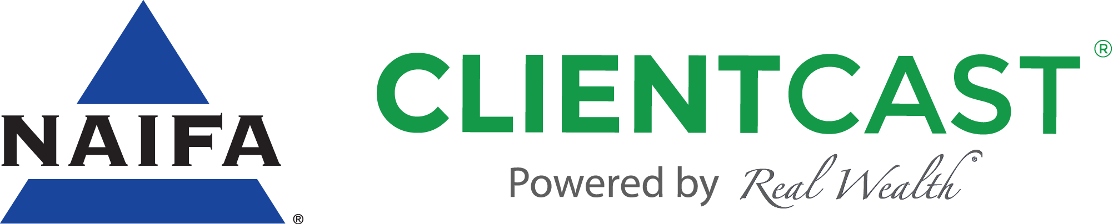
We’re delighted you joined us at <<<<INSERT EVENT NAME>>>>!
As a thank you, we’d like to provide you with our educational podcast series, NAIFA ClientCast®. Simply provide us with your name and email address, and we’ll send it along! Each episode features experts and guests like Steve Forbes and Molly Shannon, all sharing great information and personal stories with you. We cover topics like saving for college, considerations for buying a home, maximizing Social Security benefits, reducing your car insurance premium… and much more!
Enjoy the show, and we’ll be in touch!

<<<<INSERT ADVISOR SIGNATURE AND CONTACT INFORMATION>>>>

FIRST & LAST NAME
________________________________
________________________________
________________________________
________________________________
________________________________
________________________________
________________________________
________________________________
________________________________
________________________________
________________________________

EMAIL ADDRESS
________________________________
________________________________
________________________________
________________________________
________________________________
________________________________
________________________________
________________________________
________________________________
________________________________
________________________________

