Social Media Announcement Messages  
Build your Social Media Networks & introduce them to NAIFA ClientCast®!

*This content is provided with the understanding that social media platforms evolve quickly and these instructions may expire. These are general guidelines, but we always encourage you to learn the newest Email/Social Media tips & tricks at a free tutorial. Visit* [*www.RealWealthMarketing.com/Tutorial*](http://www.RealWealthMarketing.com/Tutorial) *for more info!* ***OR*** *Premier Members get personalized Marketing Consultations. Learn more at* [*http://naifaclientcast.com/upgrade.php*](http://naifaclientcast.com/upgrade.php)*.*

**LinkedIn:**

**To announce your new podcast to your existing connections**

1. From the top of the Home page, click on the words “Share an article, photo, or update.”

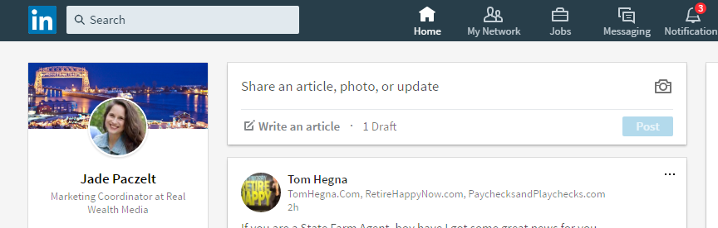

1. Type or copy and paste this pre-written “Update” post:

Check out my new podcast, NAIFAClientCast®! It’s full of great information so you can get the latest industry news and trends in between our meetings. If you know anyone who would benefit from the information discussed on the podcast, please feel free to ‘Share’ my Updates from this site with your own connections. Or you can tune in to NAIFAClientCast® any time, and share it with your non-LinkedIn friends and family directly from the site. Enjoy the show! <http://realwealthmedia.com/naifa> *(or* [*http://realwealthmedia.com/yourcustomlink*](http://realwealthmedia.com/yourcustomlink) *if you’re a Premier Member!)*

1. Click “Post” to share.

**To connect with new people (clients, prospects, community leaders, etc.)**

1. Every time you meet someone new, search for him/her on <https://www.linkedin.com>. When you find him/her, click on his/her name and once on his/her page, click “Connect”



1. Once connected (the invitee will need to accept your invitation on their end), the “Connect” button will be replaced with a button that will let you send him/her a private message.



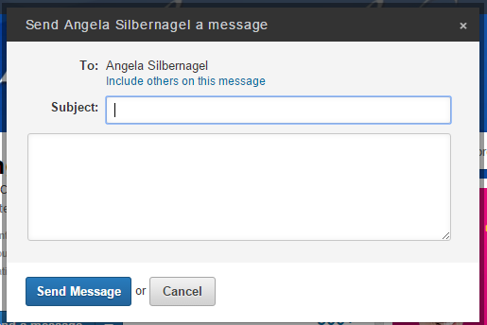

1. For the subject, write “Thanks for connecting.” And in the body, type or copy and paste this pre-written message:

Hi, thanks for connecting with me! I’ll be sharing some interesting updates, including links to my podcast. If you have any questions, don’t hesitate to reach out. Also, if you think others would benefit from the information, please feel free to “Share.” Thanks, [Your name] <http://realwealthmedia.com/naifa> *(or* [*http://realwealthmedia.com/yourcustomlink*](http://realwealthmedia.com/yourcustomlink) *if you’re a Premier Member!)*

1. Click “Send Message” to send.

**Twitter:**

**To announce your new podcast to your existing followers**

1. From the top right corner of the Home page, click on the Tweet button.



1. Type or copy and paste this pre-written Tweet into the “What’s happening?” window:

Check out my new #podcast! Get industry updates and great stories: <http://realwealthmedia.com/naifa> *(or* [*http://realwealthmedia.com/yourcustomlink*](http://realwealthmedia.com/yourcustomlink) *if you’re a Premier Member!)*

1. Click “Tweet” to share.

**To connect with new people (clients, prospects, community leaders, etc.)**

1. Every time you meet someone new, search for him/her on <https://twitter.com>. When you find him/her, click on his/her name and once on his/her page, click the “Follow” button:



1. Under their profile picture click on “Tweet to [their name]”



1. A Tweet box will appear with the contact’s Twitter name so you can type them a message. Leave their @UserName there, so they are tagged in the message and will therefore see it!

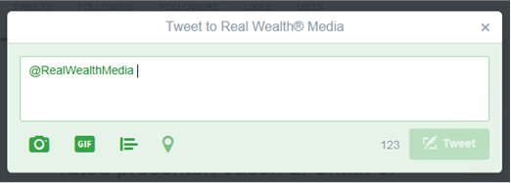

1. Type or paste this pre-written message:

Hi! I tweet some helpful info, #reachout if you have any Qs and #retweet to share with others!

1. Click “Tweet” to share with him/her.

**Facebook:**

**To announce your new podcast to your existing connections**

1. From the top of the Home page, click on the words “Write Something.”

(image on the next page)

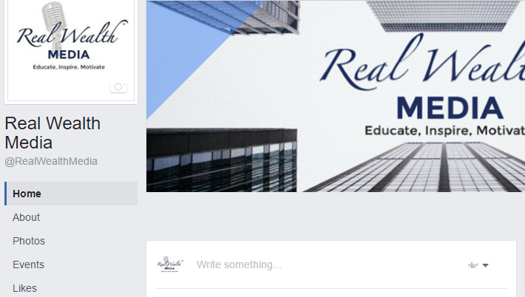

1. Type or copy and paste this pre-written Post:

Check out my new podcast, NAIFA ClientCast®! It’s full of great information so you can get the latest industry news and trends in between our meetings. If you know anyone who would benefit from the information discussed on the podcast, please feel free to ‘Share’ my Updates from this site with your own connections. Or you can tune in to NAIFA ClientCast® any time, and share it with your non-Facebook friends and family directly from the site. Enjoy the show! <http://realwealthmedia.com/naifa> *(or* [*http://realwealthmedia.com/yourcustomlink*](http://realwealthmedia.com/yourcustomlink) *if you’re a Premier Member!)*

1. Click “Publish” to share.

**To connect with new people (clients, prospects, community leaders, etc.)**

1. Unfortunately, there isn’t a way (yet) to invite people to like your Facebook Business Page if you’re not “Friends” with them on your Personal Facebook Profile. We recommend reaching out via email or another written form of communication, and inviting clients & prospects to “like” your Business Page that way. For example:
   1. When emailing new clients & prospects, provide them with the link and request that they like your page:
      1. To stay up-to-date and motivated to reach your goals in between our meetings, I highly recommend that you ‘Like’ our Facebook Page to see posts about making smart choices with your money. Go to <https://www.facebook.com/RealWealthMedia> [replace with your Facebook Business Page Link] and click ‘Like.’
   2. Add a Facebook link or graphic to your email signature:
      1. Jane Doe, ChFC

*Name of your business*

123 Penny Lane

Milwaukee, WI 12345

[Check out my Facebook Page!](https://www.facebook.com/RealWealthMedia/) [Update the link to your own page!]

(or)

* + 1. Jane Doe, ChFC

*Name of your business*

123 Penny Lane

Milwaukee, WI 12345

Like us on [](https://www.facebook.com/RealWealthMedia/) ! [🡨 Hyperlink the logo!]

* 1. Add a tagline on your business cards or letterhead:
     1. ‘Like’ us on Social Media for the latest info - *Facebook.com/RealWealthMedia* [replace with your Facebook Business Page Link]

1. You can, however, invite Friends of your *personal* Facebook Page to like your Business Page.
   1. If you are the “admin” of your own business Facebook Page:
      1. Go to your business page, and on the top hover over “More” and then click on “Invite Friends”

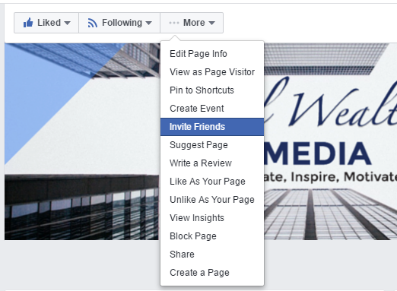

* + 1. Next to each person you’d like to invite, click “invite.” That’s it! ☺ (image on next page)

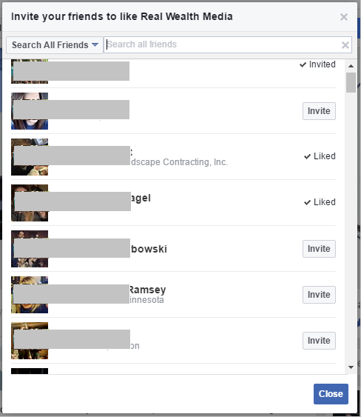

* 1. If you are NOT the “admin” to your own business Facebook Page:
     1. Go to your business page, and on the right you will see “Invite friends to like this Page.” Click on that.

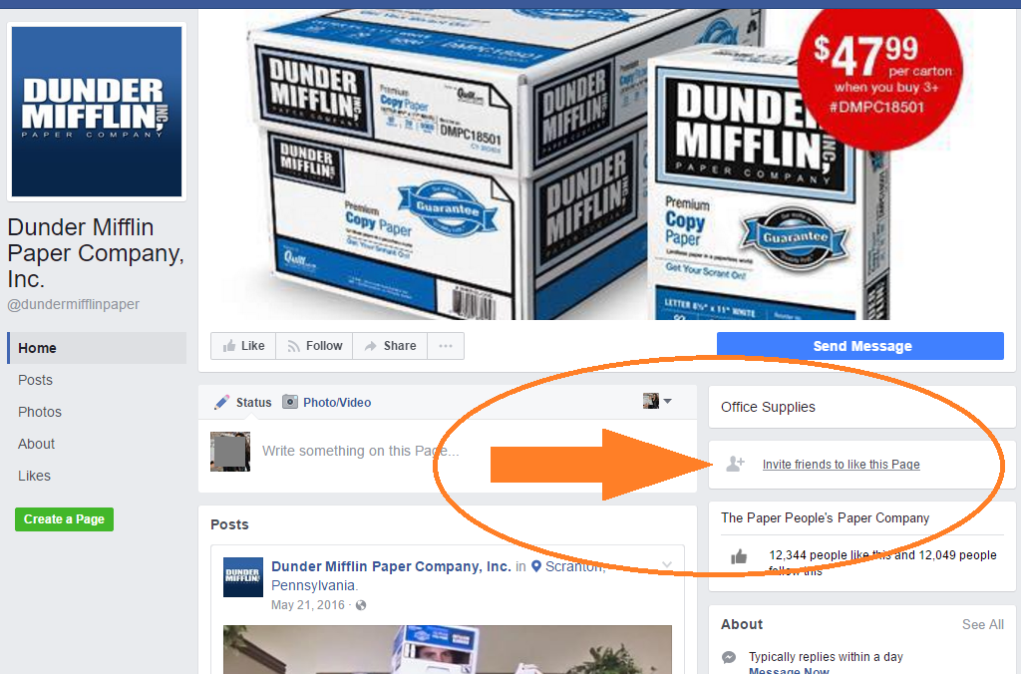

* + 1. Next to each person you’d like to invite, click “invite.” That’s it! ☺ (image on next page)



**For more support documents & other great info about your**

**NAIFA ClientCast® Marketing program, visit**

[**www.NAIFAClientCast.com**](http://www.NAIFAClientCast.com)

Much success to you,

The NAIFA ClientCast® Team

[www.NAIFAClientCast.com](http://www.NAIFAClientCast.com)

[Info@NAIFAClientCast.com](mailto:Info@NAIFAClientCast.com)

(877) 825-7579