# My game idea is to recreate Hangman in VB.Net Console. The purpose of this game is to challenge the user to guess the word the computer has generated which length is determined by the user (i.e. the difficulty level the user selects).

The things I would like my game to achieve are

* Use users name throughout the program
* Display the hangman as the user plays
* Have different length words
* Asks the user for a difficulty between 3-9 (i.e. the length of the word)
* Check to see user has not guessed letter before (so they can’t re-try the same letter and lose)
* User has specific amount of lives
* Display the word the user has guessed so far

**Testing Plan**

* User can enter their name successfully
  +  (This should not cause any errors)
* It should display the splash-screen
  + 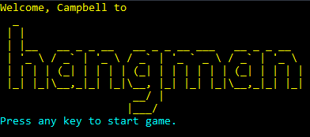(This should include the user name)
* You should be able to press any key to start the game
* When asked for the difficulty level, you should not be able to enter greater than the upper bound
  + This should always throw a user error
* When asked for the difficulty level, you should not be able to enter a smaller number than the lower bound
  + This should always throw a user error
* You should only be able to enter numbers when asked for the difficulty
  + This should always throw
* You should always be able to enter a number with the lower and upper bounds
  + This should always work
* The user difficulty should match the length of characters the game makes you guess
  + 
  + 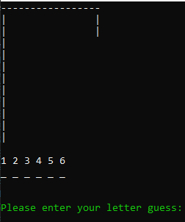
  + We entered 6 as our difficulty and get a word to guess of length 10
* In the core game, it should display the hangman current status
  + 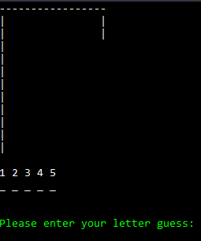 Should look something like this
* After typing a letter, it should update the word guess if it was a letter in the final word
  + 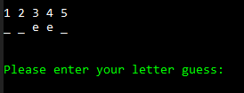 This should show up if it is a valid letter guess
* In the core game, it should not accept letter guesses outside the a-z range (A-Z should also be allowed)
  + 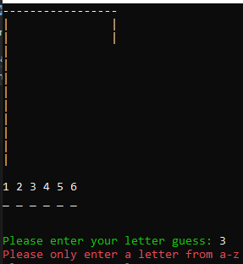An informative error message should show up if a letter that is not a-z or A-Z shows up
* In the core game, it should accept input that is both A-Z and a-z (difference being the uppercasing)
* In the core game, if you enter a letter you have already guessed, it should give an informative error message
  + 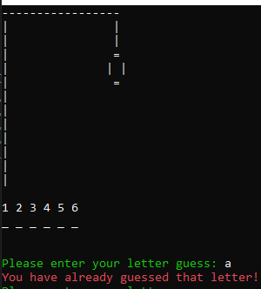An error message alike this should be displayed.