Third party plug-ins 2
MSXML4.0 2
Quantum: 2
Registering dll’s 2
Set the QTP Logger Registration key 3
Configure QTP Testing Options 3
Running the Demo 4

Third party plug-ins

MSXML4.0
- Install MSXML4.0
http://www.microsoft.com/downloads/details.aspx?displaylang=en&familyid=3144b72b-b4f2-46da-b4b6-c5d7485f2b42

Quantum:
Install the XML Object Repository Manager
http://www.qantom.shubharaghu.com/html/repository_manager.html

Install the DOR Parser:
http://www.qantom.shubharaghu.com/html/dor_download.html

Registering dll’s
Mercury support & downloads have supplied some additional dll’s to interface with Quick Test Pro. Below is a list of the 4 dll’s and a brief description of it’s purpose:
DescriptiveOR.dll Parses XML Repository
clipboard.dll Works with csolib2.dll to Capture screen shots
csolib2.dll Works with clipboard.dll to Capture screen shots
JSListVw.dll Creates a Dialog listbox

The dll’s are in the QTP_Demo\Lib folder

- Extract the files to C:\WINNT\System32
- Each of the dll’s will need to be registered with the regsvr32 command. In the command prompt, type the following command for each dll:
regsvr32 C:\WINNT\system32\DescriptiveOR.dll
regsvr32 C:\WINNT\system32\clipboard.dll
regsvr32 C:\WINNT\system32\csolib2.dll
regsvr32 C:\WINNT\system32\JSListVw.dll

A successful registration will display the following
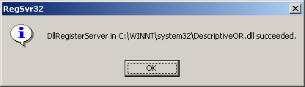

If you get this error, just click OK. I get it each time, yet it still works
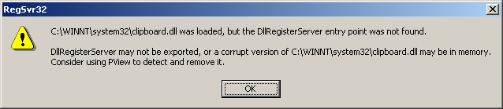

Set the QTP Logger Registration key

Set up QTP's built-in log file on the Quick Test Pro Machine, the value of the following key needs to be set to 1:
HKEY_LOCAL_MACHINE\SOFTWARE\Mercury Interactive\QuickTest Professional\Logger\Media\Log\Active

Configure QTP Testing Options
The script configure_testsettingsoptions.vbs will configure the necessary QTP testing options for running the QTP_Demo. Instructions for the QTP_Demo are in the next section.
- Double click the VBScript file: configure_testsettingsoptions.vbs

- Expect this error, just click OK and ignore it. I haven’t fixed this yet.
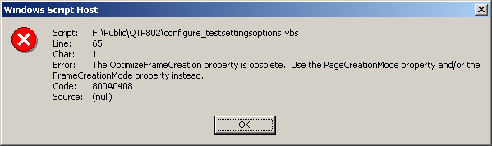

Running the Demo
The Demo script ensures all the 3rd party plug-ins and options have been set correctly. If you haven’t completed all the steps in the section “Additional 3rd Party Plug-ins”, this Demo will not work.

- Extract the QTP_Demo script to the C:\ drive of the machine where Quick Test Pro is installed
- Start Quick Test Pro, open the script called ‘kickoff’ located in C:\QTP_Demo\Scripts

- Run the Script

- Accept either option for the Results folder, click OK
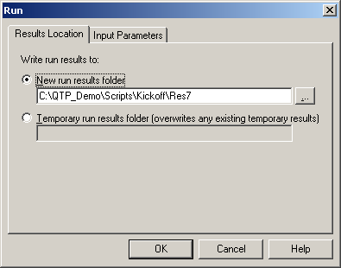

- Select the URL, click OK
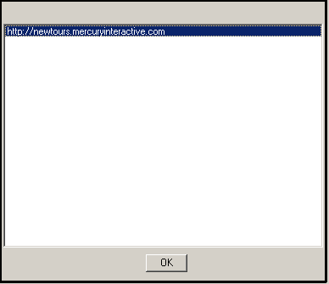

- Sit back and let the script run through Mercury’s Demo site, don’t click on anything until you see the Results screen below
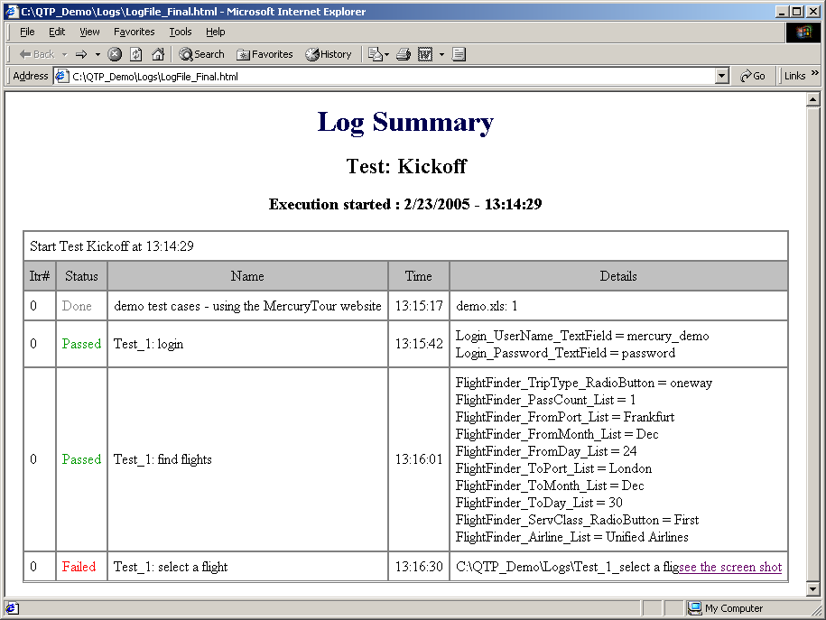

- There is a bug in the script that sometimes messes up the screen shot in the results file. If the very last line looks like this, with “see the screen shot” attached to the previous word: C:\QTP_Demo\Logs\Test_1_select a fligsee the screen shot
The link is broken. It’s supposed to link to the bitmap screenshot displaying the error on the webpage.
- However, if the Mercury site happened to throw an error, the script should catch it and display a screenshot of the error.
- Keep in mind it is just a Demo.

