Выполнить 0_Orange_Pi_User_Manual.odt ( conda )

Train Custom Data
(base) user@userevgeny:~/yolov5$ conda create -n yolo5 python=3.10
(base) user@userevgeny:~/yolov5$ conda activate yolo5
(yolo5) user@userevgeny:~/yolov5$
(yolo5) user@userevgeny:~$ git clone https://github.com/ultralytics/yolov5
(yolo5) user@userevgeny:~$ cd yolov5
(yolo5) user@userevgeny:~/yolov5$ pip install -r requirements.txt (Долгая установка пакетов)
(yolo5) user@userevgeny:~/yolov5$ pip install snowballstemmer (Пришлось доустановить)
(yolo5) user@userevgeny:~/yolov5$ pip install -r requirements.txt

Option 2: Create a Manual Dataset
2.1 Create dataset.yaml (https://docs.ultralytics.com/yolov5/tutorials/train_custom_data/#13-prepare-dataset-for-yolov5)
# Train/val/test sets as 1) dir: path/to/imgs, 2) file: path/to/imgs.txt, or 3) list: [path/to/imgs1, path/to/imgs2, ..]
path: ../datasets/coco128 # dataset root dir
train: images/train2017 # train images (relative to 'path') 128 images
val: images/train2017 # val images (relative to 'path') 128 images
test: # test images (optional)

# Classes (80 COCO classes)
names:
0: person
1: bicycle
2: car
# ...
77: teddy bear
78: hair drier
79: toothbrush
2.2 Create Labels (https://docs.ultralytics.com/yolov5/tutorials/train_custom_data/#13-prepare-dataset-for-yolov5)
2.3 Organize Directories
3. Select a Model
4. Train
(yolo5) user@userevgeny:~/yolov5$ python train.py --img 640 --epochs 3 --data coco128.yaml --weights yolov5s.pt
All training results are saved to runs/train/ with incrementing run directories, i.e. runs/train/exp2, runs/train/exp3 etc.
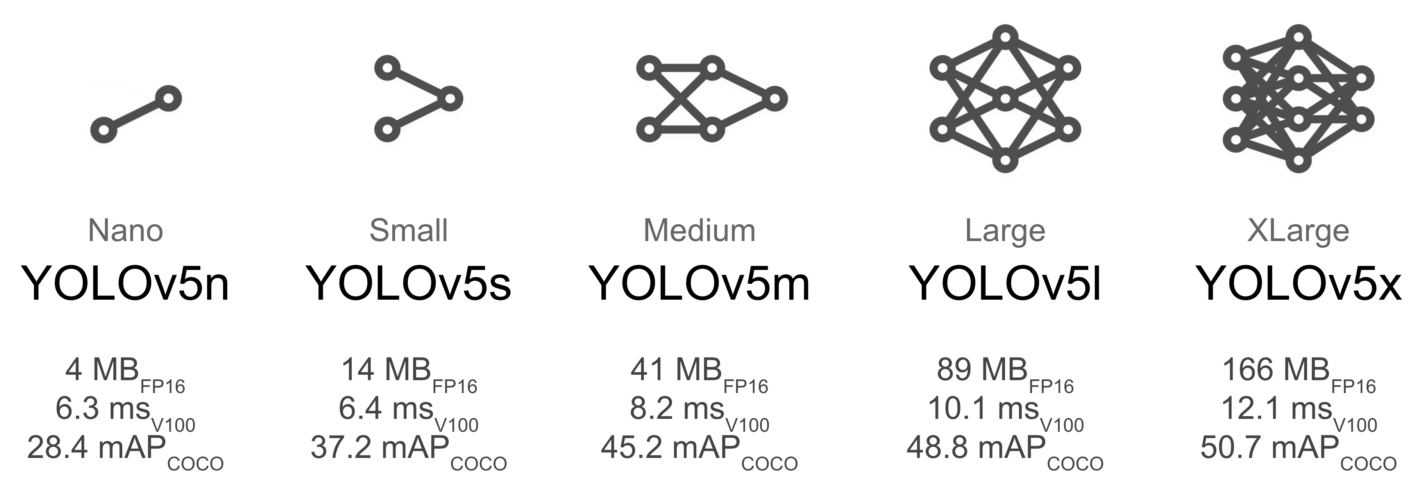

(yolo5) user@userevgeny:~/yolov5$ python train.py --img 640 --epochs 3 --data coco128.yaml --weights yolov5n.pt
(yolo5) user@userevgeny:~/yolov5$ python train.py --img 640 --epochs 3 --data coco128.yaml --weights yolov5m.pt
(yolo5) user@userevgeny:~/yolov5$ python train.py --img 640 --epochs 5 --data coco128.yaml --weights yolov5l.pt
(yolo5) user@userevgeny:~/yolov5$ python train.py --img 640 --epochs 5 --data coco128.yaml --weights yolov5x.pt (не работает CUDA out of memory. )

5. Visualize
(yolo5) user@userevgeny:~/yolov5$ pip install comet_ml
далее смотри сайт.

Next Steps
Once your model is trained you can use your best checkpoint best.pt to:
test2.py
import cv2
import torch
from PIL import Image
# Model
# model = torch.hub.load("ultralytics/yolov5", "yolov5s")
# model = torch.hub.load("ultralytics/yolov5", "custom", path="/home/user/yolov5/runs/train/exp10/weights/best.pt")
model = torch.hub.load("/home/user/yolov5", "custom", path="/home/user/yolov5/runs/train/exp10/weights/best.pt", source="local")
# Images
# for f in "zidane.jpg", "bus.jpg":
# torch.hub.download_url_to_file("https://ultralytics.com/images/" + f, f) # download 2 images
#im1 = Image.open("zidane.jpg") # PIL image
#im2 = cv2.imread("bus.jpg")[..., ::-1] # OpenCV image (BGR to RGB)
im1 = "/home/user/WORK/Github/sublime_tests/Current/openCL_yolo/22.jpg"
im2 = "/home/user/WORK/Github/sublime_tests/Current/openCL_yolo/33.jpg"
# Inference
results = model([im1, im2], size=640) # batch of images
# Results
results.print()
results.save() # or .show()
results.show()
results.xyxy[0] # im1 predictions (tensor)
results.pandas().xyxy[0] # im1 predictions (pandas)

(yolo5) user@userevgeny:~$ cd /home/user/WORK/Github/sublime_tests/Current/openCL_yolo
(yolo5) user@userevgeny:~/WORK/Github/sublime_tests/Current/openCL_yolo$ python test2.py РАБОТАЕТ!!!
Результаты в /home/user/WORK/Github/sublime_tests/Current/openCL_yolo/runs/detect

EXPORT to onnx
(yolo5) user@userevgeny:~/yolov5$ python export.py --weights "/home/user/yolov5/runs/train/exp10/weights/best.pt" --include onnx
ONNX: export success ✅ 20.7s, saved as /home/user/yolov5/runs/train/exp10/weights/best.onnx (178.0 MB)

cd /home/user/rknpu2/examples/rknn_yolov5_demo/convert_rknn_demo/yolov5
(base) user@userevgeny:~/rknpu2/examples/rknn_yolov5_demo/convert_rknn_demo/yolov5$ conda activate fastdeploy
(fastdeploy) user@userevgeny:~/rknpu2/examples/rknn_yolov5_demo/convert_rknn_demo/yolov5$ python3 onnx2rknn.py

Модель находится в папке
(base) user@userevgeny:~/rknpu2/examples/rknn_yolov5_demo/convert_rknn_demo/yolov5/rknn_models$ ls
yolov5s-640-640_rk3588.rknn

