Для установки v4l-utils
sudo apt install v4l-utils

https://docs.nvidia.com/jetson/archives/r35.4.1/DeveloperGuide/text/SD/CameraDevelopment.html

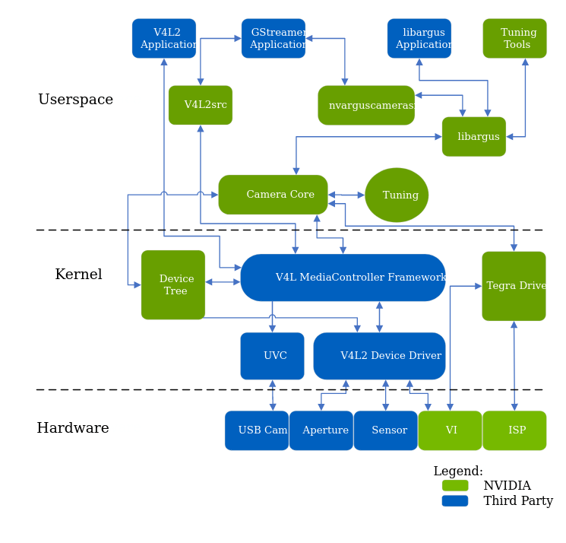

The camera architecture includes the following NVIDIA components:
- libargus : Provides a low-level API based on the camera core stack.
- nvarguscamerasrc : NVIDIA camera GStreamer plugin that provides options to control ISP properties using the ARGUS API.
- v4l2src : A standard Linux V4L2 application that uses direct kernel IOCTL calls to access V4L2 functionality.

