**Report Title:**

Initial testing and validation of the fourth wet test fixture with python GUI

**Contributions:**

Testing, Isaiah Baker

Report preparation, Isaiah Baker

**Client:**

Profound Medical Inc, 2400 Skymark Ave #6, Mississauga, ON L4W 5K5, Canada

**Date:**

July 7th, 2022

**Executive Summary:**

The fourth wet test fixture with python GUI has high frequency efficiency results that are repeatable within a tolerance of +/- 0.41 percent, low frequency efficiency results that are repeatable within a tolerance of +/- 0.71 percent, element X position measurements that are fully repeatable at a 0.4 mm resolution, and element Theta position measurements that are fully repeatable at a 0.4 mm resolution.

When compared with the stored calibration data from previous wet test fixture(s), the P value of a two-tailed, paired, student’s T test between all elements is

**Blocked UA Test (Control)**

As a control to demonstrate the noise floor of the system and its ability to detect the presence or absence of ultrasound radiation force, the UA was surrounded by a roll of paper within the tank in an attempt to dampen any detectable ultrasound.

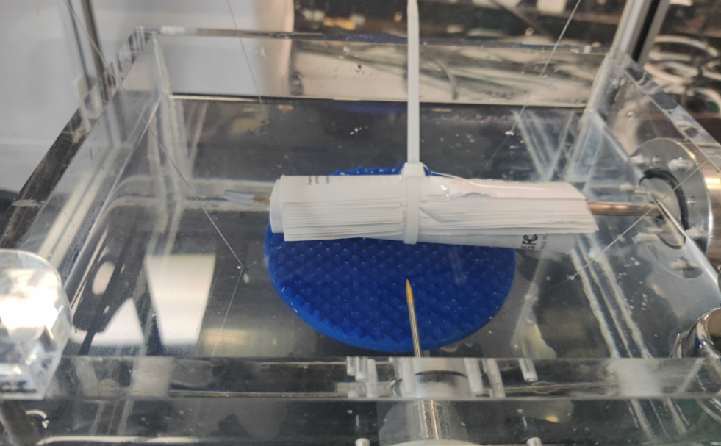

Figure Blocked UA

A find element sequence was done on element 5 of the UA, as well as low frequency and high frequency efficiency test sequences.

Figure Find Element Theta Profile with UA blocked

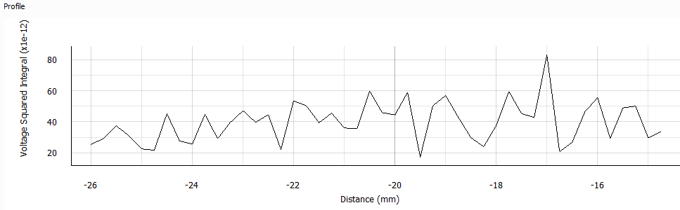

Figure Find Element X Profile with UA blocked

As expected, the find element results were indistinguishable from random noise with the UA disconnected and showed no clear trend towards a maximum.

Figure Measure Element Efficiency Data with UA blocked

The measure element efficiency data showed typical forward and reflected electrical power, and no detectable acoustic power, sh

**Single Element Repeatability Test**

**Comparison With Previous Wet Test Fixtures**

|  |  |  |  |  |  |  |  |
| --- | --- | --- | --- | --- | --- | --- | --- |
|  |  | Efficiency (percent) | | | | |  |
|  |  | Low Frequency | | | High Frequency | | |
|  | Element | Prev. WTF | WTF 4 | % diff | Prev. WTF | WTF 4 | % dfif |
| GD0439 (Good) | 1 | 65.4 | 61 | 6.7 | 38.2 | 41 | 7.3 |
| 2 | 63.3 | 62 | 2.1 | 35.7 | 42 | 17.6 |
| 3 | 63.7 | 61 | 4.2 | 38.3 | 44 | 14.9 |
| 4 | 65.2 | 73 | 12.0 | 38.9 | 48 | 23.4 |
| 5 | 68 | 61 | 10.3 | 39.1 | 49 | 25.3 |
| 6 | 78.8 | 63 | 20.1 | 41.4 | 46 | 11.1 |
| 7 | 66.3 | 63 | 5.0 | 35.6 | 44 | 23.6 |
| 8 | 63.4 | 64 | 0.9 | 37 | 42 | 13.5 |
| 9 | 74.3 | 76 | 2.3 | 30.2 | 41 | 35.8 |
| 10 | 65.2 | 62 | 4.9 | 34.7 | 39 | 12.4 |
| GB0325 (Good) | 1 | 68.8 | 64 | 7.0 | 38.8 | 38 | 2.1 |
| 2 | 77.3 | 76 | 1.7 | 35 | 41 | 17.1 |
| 3 | 73.4 | 65 | 11.4 | 39 | 47 | 20.5 |
| 4 | 69.9 | 63 | 9.9 | 42.5 | 48 | 12.9 |
| 5 | 51.1 | 50 | 2.2 | 45 | 47 | 4.4 |
| 6 | 76.5 | 58 | 24.2 | 45.8 | 51 | 11.4 |
| 7 | 71.2 | 70 | 1.7 | 44.9 | 49 | 9.1 |
| 8 | 69.3 | 66 | 4.8 | 47.8 | 53 | 10.9 |
| 9 | 72.4 | 62 | 14.4 | 47.7 | 52 | 9.0 |
| 10 | 65.9 | 62 | 5.9 | 46.7 | 49 | 4.9 |
| FG0210 (Good) | 1 | 73.3 | 59 | 19.5 | 46 | 51 | 10.9 |
| 2 | 74.7 | 74 | 0.9 | 46.1 | 54 | 17.1 |
| 3 | 78.2 | 65 | 16.9 | 47.7 | 58 | 21.6 |
| 4 | 77.9 | 66 | 15.3 | 44.4 | 50 | 12.6 |
| 5 | 72 | 67 | 6.9 | 45.3 | 52 | 14.8 |
| 6 | 76.4 | 65 | 14.9 | 46.6 | 54 | 15.9 |
| 7 | 74.8 | 60 | 19.8 | 42.3 | 51 | 20.6 |
| 8 | 73.1 | 68 | 7.0 | 45.4 | 55 | 21.1 |
| 9 | 74.5 | 67 | 10.1 | 41 | 53 | 29.3 |
| 10 | 69.6 | 69 | 0.9 | 43.2 | 52 | 20.4 |
| HB0558 (Bad, DNF) | 1 | 44 | 47 | 6.8 | 17 | 38 | 123.5 |
| LC0014 (Bad) | 1 | 77.3 | 80 | 3.5 | 40.5 | 41 | 1.2 |
| 2 | 62.7 | 62 | 1.1 | 38.3 | 39 | 1.8 |
| 3 | 64.4 | 69 | 7.1 | 42.3 | 49 | 15.8 |
| 4 | 79.7 | 82 | 2.9 | 41 | 47 | 14.6 |
| 5 | 79.4 | 80 | 0.8 | 41.8 | 52 | 24.4 |
| 6 | 77.2 | 82 | 6.2 | 44.5 | 53 | 19.1 |
| 7 | 76.5 | 78 | 2.0 | 40.1 | 47 | 17.2 |
| 8 | 75.6 | 77 | 1.9 | 42.4 | 50 | 17.9 |
| 9 | 71.4 | 77 | 7.8 | 40.7 | 45 | 10.6 |
| 10 | 72.9 | 75 | 2.9 | 44.5 | 46 | 3.4 |
| HB0462 (Bad, DNF) | 1 | 49 | 56.8 | 15.9 | 22 | 26.5 | 20.5 |
| 2 | 51 | 56.6 | 11.0 | 26 | 26.5 | 1.9 |
| 3 | 42 | 53.1 | 26.4 | 21 | 26.5 | 26.2 |
|  | Mean: | 69.02 | 66.31 |  | 39.83 | 46.08 | 17.5 |
|  | Systematic error (%) | | | 3.93 |  |  | 15.70 |
|  | Average Percent Difference | | | 8.3 |  |  | 17.7 |