INM 120 – Assignment 1 Instructions:

**Create a web page using HTML and style it with CSS based on the provided screenshots.**

* Strictly adhere to the HTML elements displayed in the screenshots, including headings, paragraphs, lists, etc.
* Utilize relevant images from the internet for the img tag; ensure there are no broken images.
* Incorporate class and id attributes in HTML tags to facilitate targeted styling with CSS.
* Exercise creativity in styling, incorporating various attributes such as font size, color, background color, and more.
* Employ different CSS types – inline, internal, and external – to enhance the visual appeal of the web page.

**Submission Instructions:**

* Record a concise video where you explain the code and demonstrate the output. Keep the video duration to a couple of minutes, providing insights into HTML elements and CSS attributes.
* Log in to YouTube using your Gmail ID and upload the recorded video as unlisted on your default channel.

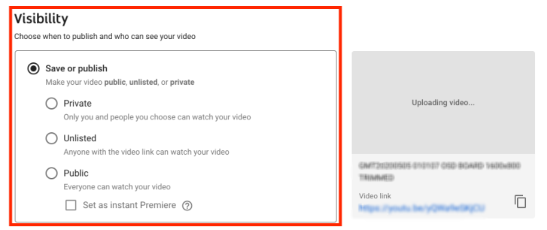

* Submit:
  + The **zipped project folder** containing HTML and CSS files.
  + **Screenshots** of both the code and the output (in a pdf document) – do not zip this (upload it directly to the submission area).
  + The **link** to the YouTube video (paste the link directly to the submission area)..
  + Adhere to the naming convention for the zipped folder and screenshots:

**assignment1-firstname_lastname-INM120**,

e.g., assignment1-simul_bista-INM120.