 | Bachelor’s Degree in Biomedical Engineering

INSTRUMENTATION AND MULTIMODALITY IMAGING

Practical session on optical imaging

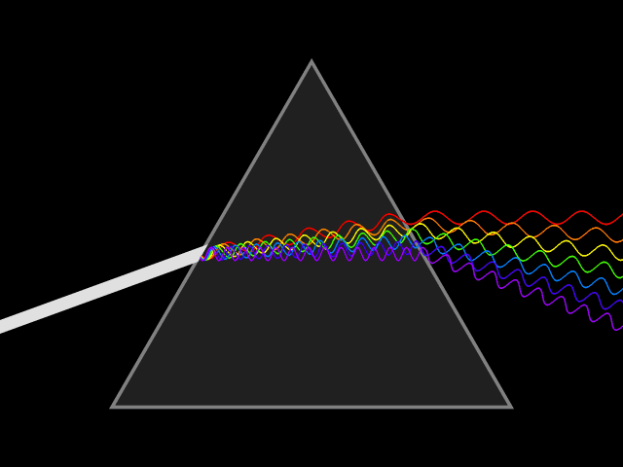

Introduction
Light is electromagnetic radiation within a certain portion of the electromagnetic spectrum. The word usually refers to visible light, which is the portion of the spectrum that can be perceived by the human eye. Visible light is usually defined as having wavelengths in the range of 400-700 nanometers (nm), or 4.00 × 10⁻⁷ to 7.00 × 10⁻⁷ m, between the infrared (with longer wavelengths) and the ultraviolet (with shorter wavelengths). This wavelength means a frequency range of roughly 430-750 terahertz (THz).
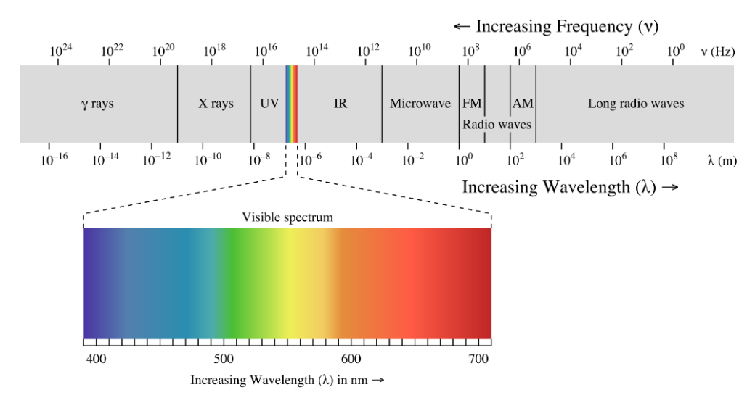

Light propagation through medium
Light propagation in a medium induces a medium response via interaction of light with electrons and nuclei in the medium. The medium response in turn affects the light propagation and brings about various optical effects.
Either solid, liquid or gas each type of matter interacts with light. Some of the main interactions are shown below.
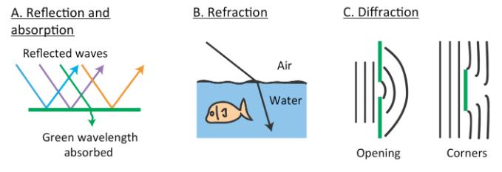
Light scattering explains why we see changes in color when the sun rises or sets. Molecules in our atmosphere (nitrogen and oxygen) change the direction of light and this is called scattering. Sunlight that reaches our atmosphere is composed of all the colors of the rainbow (ROYGBV). The different wavelengths of light are scattered differently by particles in the air. Smaller wavelengths scatter more than longer wavelengths.

Spatial resolution of a system
One of the quality parameters of an imaging system is the spatial resolution, which is the ability to distinguish small details. A way to measure the spatial resolution of a system is by obtaining the Point spread function, which represents the degradation of a point by the system. In the figure, (a) is the image obtained in the system (of the point spread by the system), (b) is the profile across the center, known as the Point Spread Function (PSF). As we can see in (c) and (d), if the PSF is too wide, we will not be able to distinguish points that are close to each other.
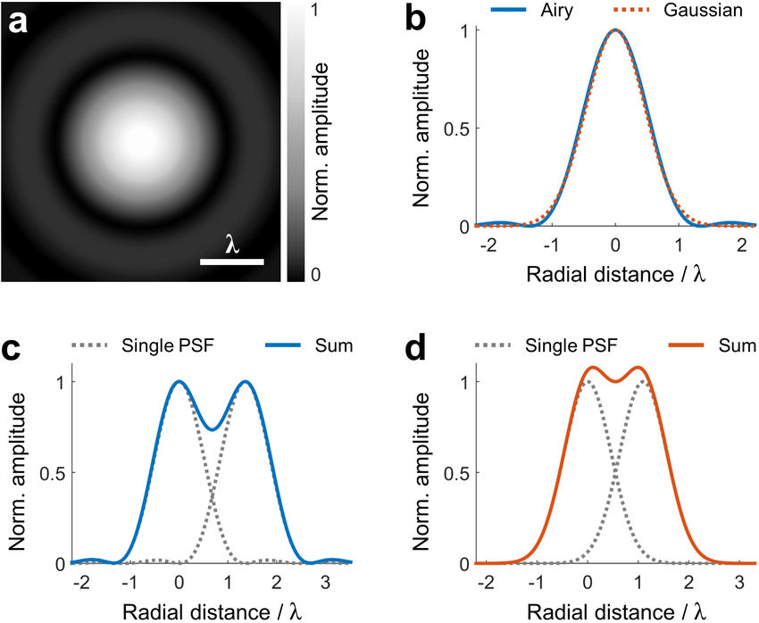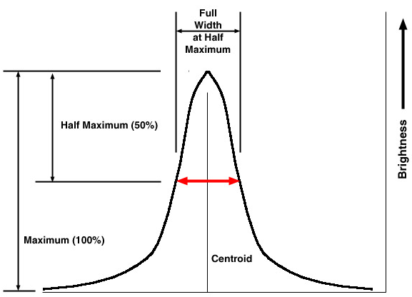

The PSF is normally approximated to a Gaussian curve Gaussian curve, given mathematically by:
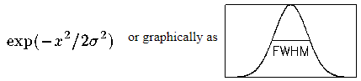
A quantitative value of the spatial resolution can be given by the Full Width Half Maximum (FWHM) of the PSF, that is, the width of the profile at a height of half of its maximum value.
- The milk scatter experiment – evaluating the spatial resolution
You will need the following materials for the experiment:
- Transparent container
- Water
- A digital camera
- The flashlight of the cellphone
- Two unidentified milk samples: Labeled Sample A and Sample B (one is skimmed milk and the other is semi-skimmed milk)
- Syringe to add milk to the water-filled container

Experiment steps
  - Setup the system on a homogeneous background, maybe with a black paper at the base of the container with a hole that allows where the light will pass through. Choose the size of the hole. Measure it.
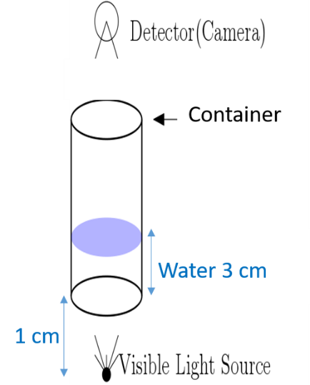
  - Fill the container with water up to 200 ml
  - Take the first picture with the digital camera, with Autofocus and HDR deactivated, no flash, with only water in the container
  - Milk Addition: Add 0.2 ml of Milk Type A using the syringe.
  - Mix the milk to disperse the fat molecules properly (important!)
  - Take a picture, with Autofocus and HDR deactivated, no flash
  - Repeat adding increments of milk (0.2 ml) and collect minimum 25 pictures repeating the steps 4 – 6
  - Second Run: Empty, clean, and refill the container with 200 ml of pure water. Repeat Steps 1–7 using Milk Type B.
All the pictures need to be taken without moving the setup, maintaining all the distances and avoiding shadows.
As an additional step, measure the bottom of the container.
- Image processing part and FWHM calculation:
- Download and install the ImageJ software https://imagej.nih.gov/ij/download.html
- Import images in ImageJ doing File->Import->Image Sequence. Select one image from the folder press OPEN and all the images will be loaded as a stack, with a sliding bar below, where you can use to move from image to image.
- Draw a profile passing through the light spot using the line tool of ImageJ, as in the figure:
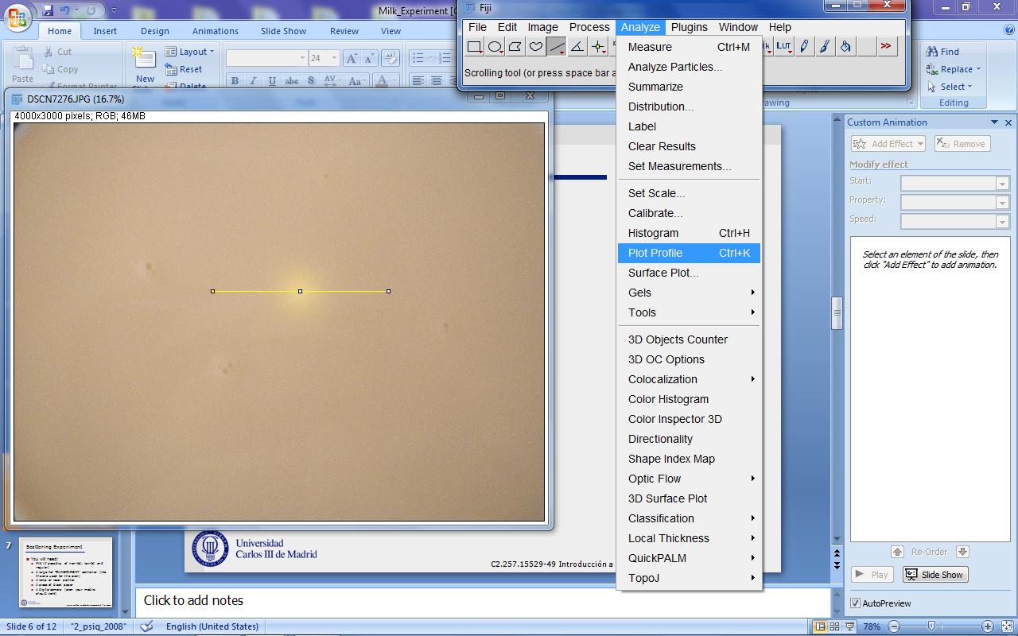
- Plot the profiles for all the images that you collected, with Analyze-> Plot Profile. You should get something similar to the figure:
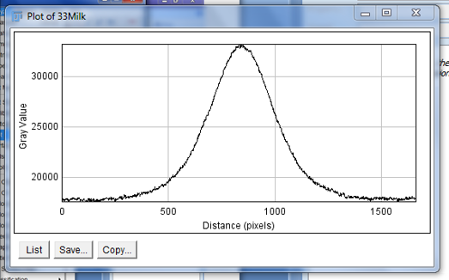
- Save the values of your plotted profiles with the save button on the window of the profile, as a .csv file
- After you collect all the .csv files of your Point Spread Function profiles from imageJ, you have to calculate the FWHM, either in Excel, imageJ, or Matlab.
- With the FWHM values for each profile of each image, and with the amount of milk for each image create the plot that reflects the degradation of the spatial resolution of the system, which will be similar to the following:
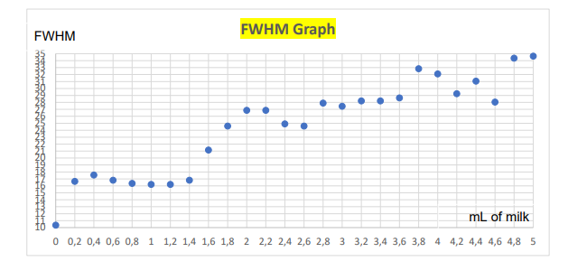
- Questions
Write a full report PER GROUP, including the following sections: Introduction, Objectives, Materials and methods, Results, Discussion and Conclusions. Write the name of the participants in the cover. Upload it in PDF format.
  - Provide a detailed explanation of the materials used and the experimental procedure carried out in the laboratory session, and (b) clearly describe the step-by-step method used to compute the FWHM.
  - Include a photo of the experimental setup.
  - Include the hole and beaker measurements.
  - Explain the purpose of placing the black board with a hole below the beaker. What would happen to your measurements if you didn't use it? (b) How would you expect the spatial resolution (FWHM) to change if the hole in the black board was larger?
  - Calculate the physical size of one detector pixel using the known dimensions of the beaker bottom as a reference. Show your calculations and include the line profile measurements used to determine the pixel size. Check if the pixel size is square or not.
  - Include 5 images of the beaker captured during the experiment and their corresponding line profiles. First and last picture of the experiment must be included. Label each image with its corresponding milk concentration.
  - For the 5 line profiles shown in Section 2.4, show how you applied your FWHM computation method.
For both sets of images (Sample A and Sample B):
  - Calculate the FWHM (in mm) for all captured images across both experimental runs. Plot both FWHM vs. Volume of Milk (ml) curves on a single graph. Use distinct markers/colors for Sample A and Sample B, and include a clear legend.
  - Based on your plotted curves, identify which sample (Sample A or Sample B) corresponds to skimmed milk and which corresponds to semi-skimmed milk. Justify your conclusion based on the differences in milk content and how they interact with light.

