MIE 1622h-s aSSINMENT 1 REPORT

Submitted by Yifan Shao 1004534435

100

University of Toronto

February, 13, 2018

Contents

1. Problem Description 2

2. Methods 2

2.1 Buy and Hold Strategy 2

2.2 Equally Weighted Strategy 2

2.3 Minimum Variance Strategy 2

2.4 Maximum Sharpe Ratio Strategy 3

2.5 Program 3

3. Results 4

3.1 Results 4

3.2 Comparison 9

4. Discussion 10

# 1. Problem Description

A portfolio with initial value of around 1 million USD is given along with its initial positions. The portfolio contains 20 stocks, the prices of the 20 stocks in from 2015 to 2016 is provided. The portfolio will rebalance every 2 months, having 12 periods in 2-year span. There will be four portfolio rebalancing strategies: buy and hold, equally weighted, minimum variance and maximum Sharpe ratio. The objective is to write MATLAB program to calculate the daily performance of the portfolio following the four strategies and compare the performance differences in four strategies.

# 2. Methods

## 2.1 Buy and Hold Strategy

The buy and hold strategy is extremely simple, the position of the portfolio will remain the same as the initial position throughout the whole 12 periods.

## 2.2 Equally Weighted Strategy

The equally weighted strategy assigns each asset same weight of the portfolio. Assume there are n assets in the portfolio, $i$ represent an asset, $p_{i}$ is the price of the asset, then:

$$w_{i}=\frac{1}{n}$$

$$x_{i}=\frac{w_{i}*total value of portfolio}{p_{i}}$$

$x_{i}$ is the position on asset $i$.

## 2.3 Minimum Variance Strategy

The minimum variance strategy selects the portfolio with minimum variance on the efficient frontier. Let Q be the covariance matrix, the we can try to minimize with constraints:

$${\min{ }w}^{T}Qw$$

$$s.t. \sum_{i}{w_{i}}=1$$

$$w≥0$$

$$x_{i}=\frac{w_{i}*total value of portfolio}{p_{i}}$$

The example was given in lecture slides, use CPLEX in MATLAB to solve the weight, and then use the price and the weight to calculate the position on asset $i$.

## 2.4 Maximum Sharpe Ratio Strategy

The maximum Sharpe ratio strategy will try to reach the maximum excess return per unit of risk in a portfolio. It can be solved as an optimization problem:

$$w^{*}=\frac{y}{k}$$

$$min y^{T}Qy$$

$$s.t. \sum_{i}{(μ_{i}}-r_{f})y_{i}=1$$

$$\sum_{i}{y_{i}}=k$$

$$l*k ≤Ay≤u*k$$

$$k≥0$$

Use CPLEX to solve the optimization of the weight, then use the price to calculate the position.

## 2.5 Program

The following table shows the MATLAB program used for this assignment:

|  |  |
| --- | --- |
| Function name | Purpose |
| portf_optim.m | Main program |
| portf_optim_example2.m | Program that used in discussion section, implements new strategies 5,6,7, plots figure 4. |
| strat_buy_and_hold.m | Function that performs buy and hold strategy |
| strat_equally_weighted.m | Function that executes equally weighted strategy rebalancing |
| strat_min_variance.m | Function that executes minimum variance strategy rebalancing |
| strat_max_Sharpe.m | Function that executes max Sharpe ratio strategy rebalancing |
| weight_calculation.m | Function that calculates the weight of given strategy in all 12 periods. |
| daily_portf_value.m | Function that calculates daily portfolio value of a strategy, only used in portf_optim_example2.m |

Table 1: MATLAB Program List

# 3. Results

## 3.1 Results

The following results are produced after running MATLAB program.

Initial portfolio value = $ 1000002.12

Period 1: start date 1/2/2015, end date 2/27/2015

Strategy "Buy and Hold", value begin = $ 1000002.12, value end = $ 1043785.08

Strategy "Equally Weighted Portfolio", value begin = $ 992848.53, value end = $ 1019393.70

Strategy "Minimum Variance Portfolio", value begin = $ 991408.93, value end = $ 1015580.73

Strategy "Maximum Sharpe Ratio Portfolio", value begin = $ 990001.96, value end = $ 1007342.46

Period 2: start date 3/2/2015, end date 4/30/2015

Strategy "Buy and Hold", value begin = $ 1045234.09, value end = $ 1069877.19

Strategy "Equally Weighted Portfolio", value begin = $ 1029992.65, value end = $ 1010607.92

Strategy "Minimum Variance Portfolio", value begin = $ 1022725.22, value end = $ 1013032.45

Strategy "Maximum Sharpe Ratio Portfolio", value begin = $ 1016703.26, value end = $ 1054972.62

Period 3: start date 5/1/2015, end date 6/30/2015

Strategy "Buy and Hold", value begin = $ 1085647.24, value end = $ 1027659.63

Strategy "Equally Weighted Portfolio", value begin = $ 1020591.14, value end = $ 986798.35

Strategy "Minimum Variance Portfolio", value begin = $ 1008133.69, value end = $ 968537.68

Strategy "Maximum Sharpe Ratio Portfolio", value begin = $ 1056131.59, value end = $ 1014116.15

Period 4: start date 7/1/2015, end date 8/31/2015

Strategy "Buy and Hold", value begin = $ 1035245.91, value end = $ 947793.98

Strategy "Equally Weighted Portfolio", value begin = $ 990676.59, value end = $ 933672.91

Strategy "Minimum Variance Portfolio", value begin = $ 971088.88, value end = $ 931145.90

Strategy "Maximum Sharpe Ratio Portfolio", value begin = $ 1009818.98, value end = $ 923233.62

Period 5: start date 9/1/2015, end date 10/30/2015

Strategy "Buy and Hold", value begin = $ 912055.56, value end = $ 1027307.87

Strategy "Equally Weighted Portfolio", value begin = $ 903885.81, value end = $ 1022042.37

Strategy "Minimum Variance Portfolio", value begin = $ 899228.86, value end = $ 939601.41

Strategy "Maximum Sharpe Ratio Portfolio", value begin = $ 878319.06, value end = $ 1096488.99

Period 6: start date 11/2/2015, end date 12/31/2015

Strategy "Buy and Hold", value begin = $ 1039856.20, value end = $ 1003328.46

Strategy "Equally Weighted Portfolio", value begin = $ 1038986.57, value end = $ 1034277.71

Strategy "Minimum Variance Portfolio", value begin = $ 944161.93, value end = $ 958781.57

Strategy "Maximum Sharpe Ratio Portfolio", value begin = $ 1099487.62, value end = $ 1213880.17

Period 7: start date 1/4/2016, end date 2/29/2016

Strategy "Buy and Hold", value begin = $ 994608.85, value end = $ 970570.87

Strategy "Equally Weighted Portfolio", value begin = $ 1013919.72, value end = $ 953539.35

Strategy "Minimum Variance Portfolio", value begin = $ 947891.88, value end = $ 944291.94

Strategy "Maximum Sharpe Ratio Portfolio", value begin = $ 1172818.51, value end = $ 1005297.83

Period 8: start date 3/1/2016, end date 4/29/2016

Strategy "Buy and Hold", value begin = $ 999683.25, value end = $ 975547.52

Strategy "Equally Weighted Portfolio", value begin = $ 981539.01, value end = $ 1051538.89

Strategy "Minimum Variance Portfolio", value begin = $ 955844.10, value end = $ 988644.99

Strategy "Maximum Sharpe Ratio Portfolio", value begin = $ 1028637.94, value end = $ 1000339.71

Period 9: start date 5/2/2016, end date 6/30/2016

Strategy "Buy and Hold", value begin = $ 982170.01, value end = $ 1000838.49

Strategy "Equally Weighted Portfolio", value begin = $ 1064864.42, value end = $ 1106513.27

Strategy "Minimum Variance Portfolio", value begin = $ 993178.38, value end = $ 1062321.58

Strategy "Maximum Sharpe Ratio Portfolio", value begin = $ 1004208.14, value end = $ 1092853.63

Period 10: start date 7/1/2016, end date 8/31/2016

Strategy "Buy and Hold", value begin = $ 1003605.67, value end = $ 1067751.34

Strategy "Equally Weighted Portfolio", value begin = $ 1117615.96, value end = $ 1223358.01

Strategy "Minimum Variance Portfolio", value begin = $ 1062588.35, value end = $ 1048802.26

Strategy "Maximum Sharpe Ratio Portfolio", value begin = $ 1092185.06, value end = $ 1114685.29

Period 11: start date 9/1/2016, end date 10/31/2016

Strategy "Buy and Hold", value begin = $ 1073361.15, value end = $ 1090939.15

Strategy "Equally Weighted Portfolio", value begin = $ 1225209.48, value end = $ 1223852.62

Strategy "Minimum Variance Portfolio", value begin = $ 1045193.10, value end = $ 1020278.39

Strategy "Maximum Sharpe Ratio Portfolio", value begin = $ 1113425.40, value end = $ 1176375.20

Period 12: start date 11/1/2016, end date 12/30/2016

Strategy "Buy and Hold", value begin = $ 1077523.53, value end = $ 1173675.24

Strategy "Equally Weighted Portfolio", value begin = $ 1210184.77, value end = $ 1347945.01

Strategy "Minimum Variance Portfolio", value begin = $ 1006865.16, value end = $ 1119876.26

Strategy "Maximum Sharpe Ratio Portfolio", value begin = $ 1156273.97, value end = $ 1533165.64

The following figure shows the daily portfolio value of four strategies.

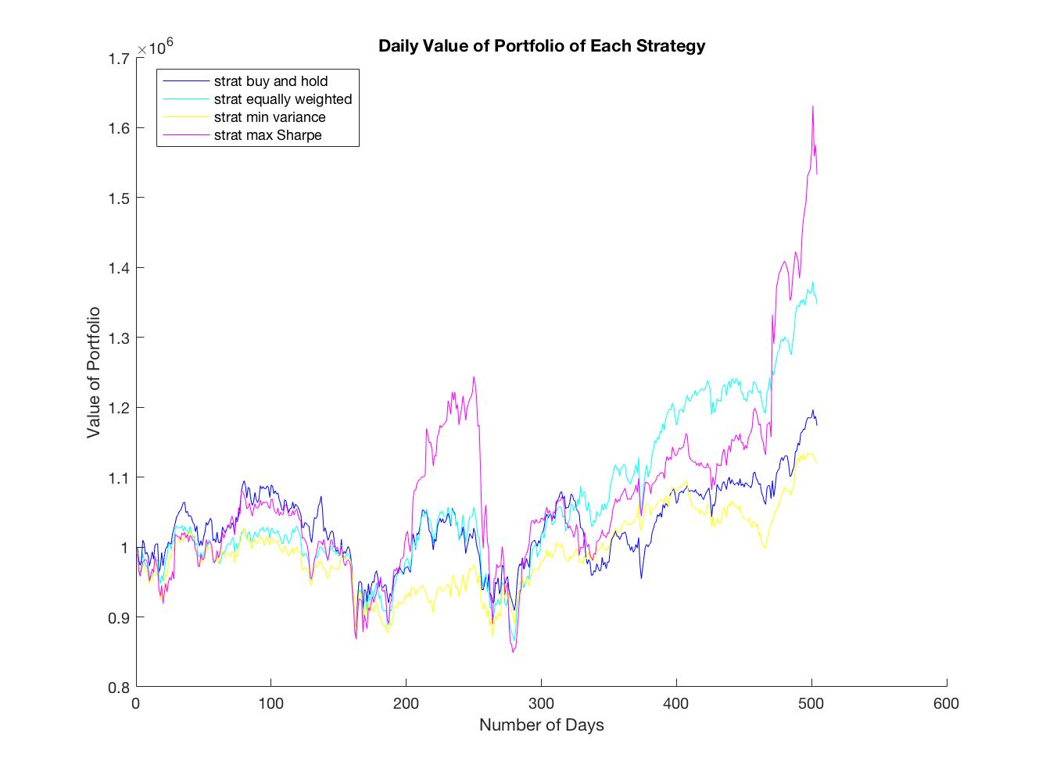

Figure 1: Daily Portfolio Value of Four Strategies

The following figures shows the positions of minimum variance strategy in 12 periods. At period 0 on x-axis, the value represents the initial position of the portfolio before the 1st rebalancing at the beginning of 1st period.

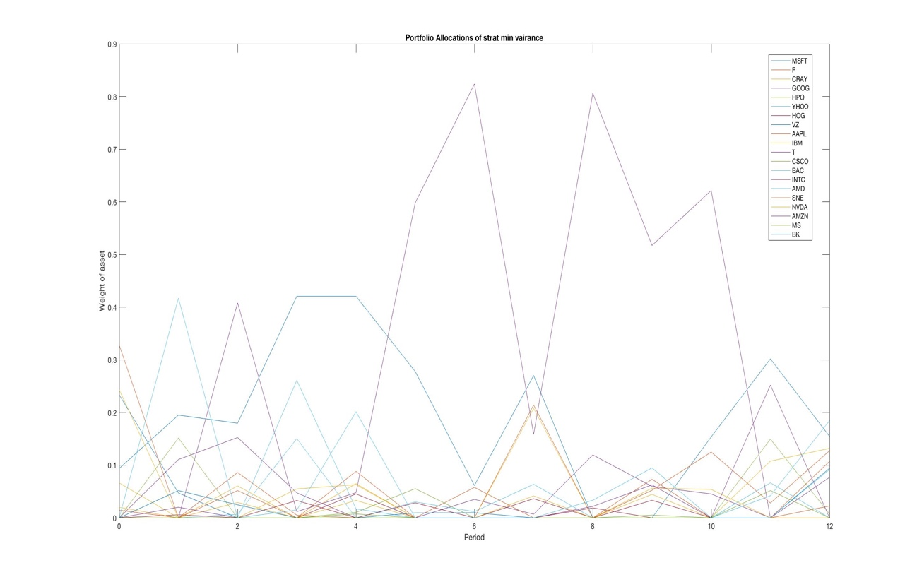

Figure 2: Portfolio Position of Minimum Variance Strategy in 12 Periods

The following figure shows the positions of maximum Sharpe ratio in 12 Periods.

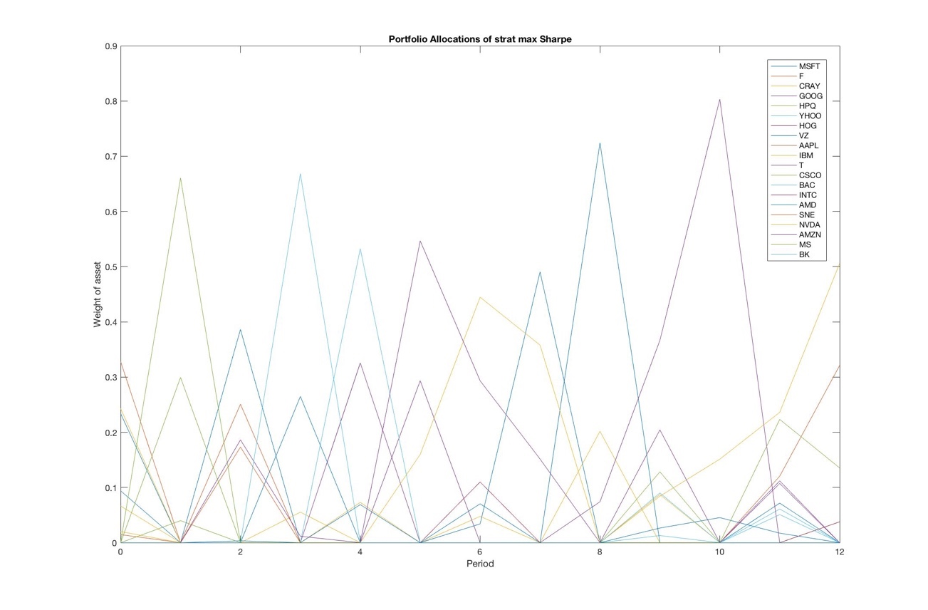

Figure 3: Portfolio Position of Maximum Sharpe Ratio Strategy in 12 Periods

## 3.2 Comparison

From figure 1, the buy and hold strategy gives higher portfolio value in around first 1/3 of the time, in the middle 1/3 of the time, it gives roughly the same portfolio value as the minimum variance and equally weighted strategies. In the last 1/3 of the time, it was beaten by equally weighted strategy and maximum Sharpe ratio strategy by large difference in portfolio value.

The equally weighted portfolio ranks 2nd in performance from the figure. For the first 1/3 of the time, its performance is similar to minimum variance strategy, then in the middle 1/3 of the time, the performance is close to buy and hold strategy, then in the end, equally weighted strategy ranks the 2nd out of 4 in portfolio value.

The minimum variance strategy gives lowest portfolio value out of the four in most of the time. When the value of other strategy portfolio is increasing, the value of minimum variance has slower growth. However, when value of other strategy portfolio is decreasing, the value of minimum variance portfolio doesn’t dip as fast as the other 3 strategies.

The maximum Sharpe ratio strategy is supposed to give maximum excess return per unit of risk. In the plot it shows that when value of all four portfolios are increasing, max Sharpe ratio strategy yields the highest increase. The difference is rather large and can be found in two places on the plot. However, when value of portfolio is decreasing, this strategy’s portfolio also experiences sharpest decline in value as well. In other times, the value of the portfolio of this strategy is close to other three strategies, usually between the values of equally weighted strategy and buy and hold strategy.

If I were to choose a strategy, I would choose maximum Sharpe ratio strategy, because it gives maximum portfolio value growth rate when underlying asset is appreciating. Although it has some disadvantage when comes to risk, I still favor it over the other strategies because I am still young, and I have more tolerance for risk, and I have a lot of working years ahead to help me with the possible loss in the future. The objective when I am young is getting as much returns as I can. However, if I am very close to retirement, I would choose minimum variance portfolio, since my priority at that time would be just keep the value of my retirement fund, and minimum variance portfolio is the safest option out of four.

# 4. Discussion

Variations of the strategies was fed to the program to for testing. Three more strategies are tested:

1. Equally weighted at beginning of period 1 and hold on until the end of period 12.
2. Minimum variance weighted at beginning of period 1 and hold on until the end of period 12.
3. Maximum Sharpe ratio weighted at beginning of period 1 and hold on until the end of period 12.

The daily values of the portfolios are plotted against the original four strategies in figure 4. Surprisingly, strategy 5. equally weighted / buy and hold, and strategy 6. min variance / buy and hold gave better performance comparing to their original counterparts. My guess of this phenomenon is due to the large transaction cost of constant rebalancing of the portfolio of the equally weighted and min variance portfolio. Therefore, holding on after first rebalancing can save large transaction cost, and yields higher daily value than doing constant rebalancing. However, it worked in the opposite way for the maximum Sharpe ratio strategy. Strategy 7, maximum Sharpe ratio / buy and hold strategy gives lowest portfolio daily value out of 7 strategies. This can imply that holding on to risky asset for long time may not result in best return. Of course, the conclusion is not certain since the limit of the portfolio size and time length cannot comprehensively represent the whole market.

To improve the strategies I have implemented, first, I think we can add short selling into the strategies, to increase the return. However, doing so will increase the loss if I do wrong prediction and make wrong moves against it. Also, risky-free assets such as U.S. Treasury bonds and derivatives such as options can be added into the portfolio to increase its diversity.

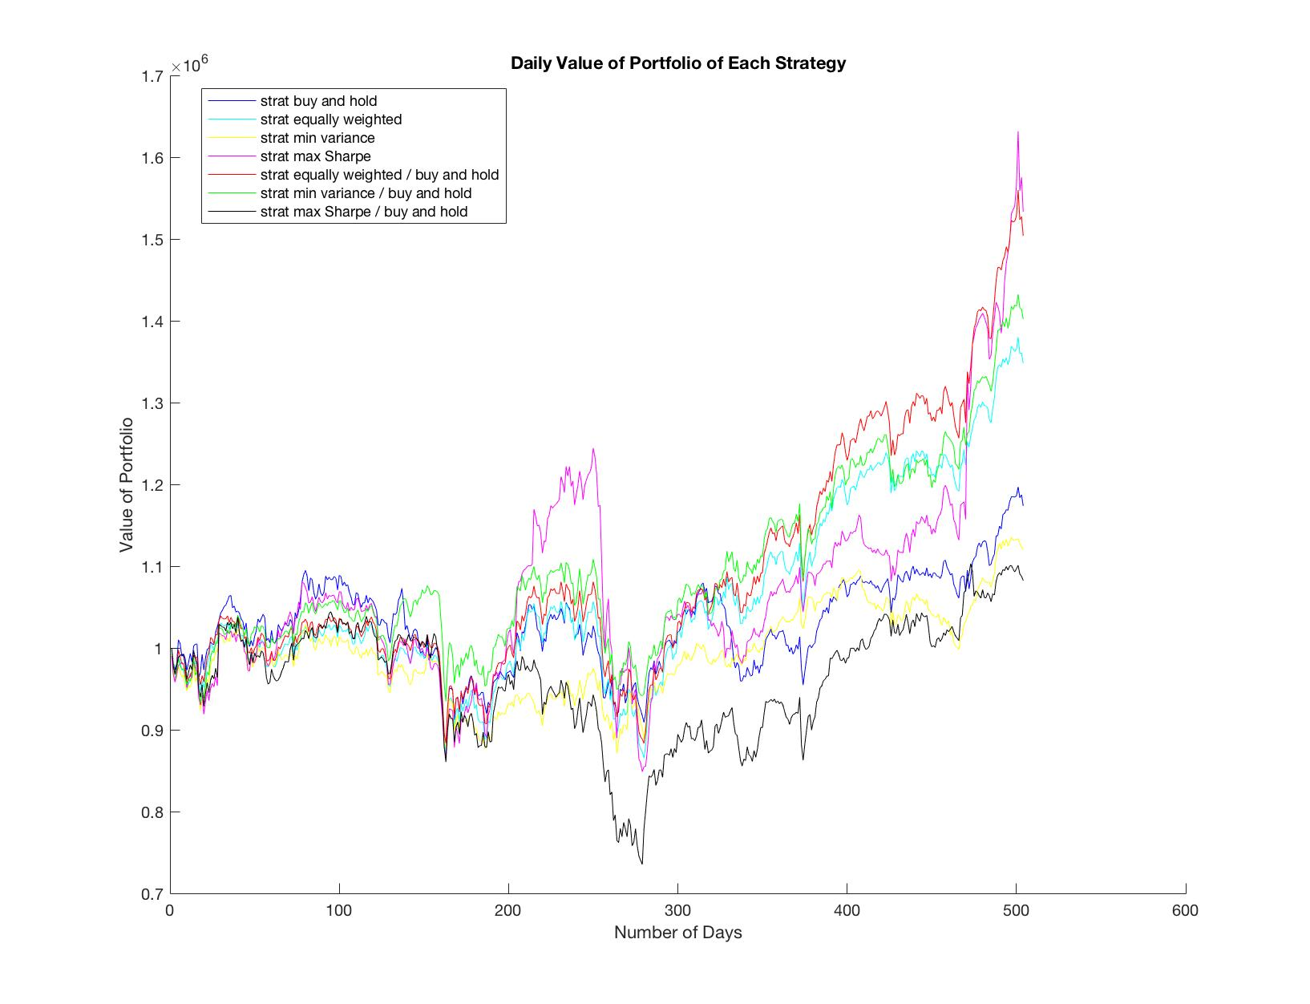

Figure 4: Daily value of the Portfolio of 7 Strategies