MIE 1622h-s aSSINMENT 2 REPORT

Submitted by Yifan Shao 1004534435

100

University of Toronto

Mar 6, 2018

Contents

1. Problem Description 2

2. Methods 2

2.1 Maximum Sharpe Ratio Strategy 2

2.2 Equal Risk Contributor Strategy 2

2.2 Leveraged Equal Risk Contributor Strategy 3

2.3 Robust MVO Strategy 3

2.5 Program 3

3. 2015 - 2016 4

3.1 Results 4

3.2 Discussion 11

4. 2008 – 2009 11

4.1 Results 11

4.2 Discussion 17

# 1. Problem Description

A portfolio with initial value of around 1 million USD is given along with its initial positions. The portfolio contains 20 stocks, the prices of the 20 stocks in from 2015 to 2016 is provided. The portfolio will rebalance every 2 months, having 12 periods in 2-year span. There will be seven portfolio rebalancing strategies: buy and hold, equally weighted, minimum variance and maximum Sharpe ratio, equal risk contributor, leveraged equal risk contributor and robust optimized. The objective is to write MATLAB program to calculate the daily performance of the portfolio following the four strategies and compare the performance differences in four strategies.

# 2. Methods

## 2.1 Maximum Sharpe Ratio Strategy

When using maximum Sharpe ratio in 2008-2009 data, the cplex will return error. To deal with this situation, if every element in $mu-rf$ vector is negative, the portfolio positions will hold and will not rebalance. In this case, it means that none of the stocks is having positive returns, their returns are negative, this violates the constraints in the max Sharpe ratio formulation. In realistic way, there’s no point to spend extra money to rebalance the portfolio if the return of portfolio is destined to be negative. As a result, I chose to not rebalance in this period.

## 2.2 Equal Risk Contributor Strategy

To validate the gradient calculation, we can take a look at the risk contributor of each asset to the portfolio, by theory, they should be the same. Below is the asset risk contribution output obtained from strat_equal_risk_contr.m, using 2015 -2016 data, at beginning of period 1.

Asset risk contributions for ERC:

RC_ERC =

1.0e-03 *

0.408759579832339

0.409683590480776

0.410697950242068

0.408755608697268

0.410669828763902

0.409349308505869

0.409229768778929

0.408420231841745

0.409375859162669

0.409590849661572

0.409084272214245

0.408950533663654

0.408719062597147

0.409268250000456

0.408850218442999

0.410838831149475

0.409633821414516

0.408978635339069

0.408905903834127

0.406679445819725

From the output above, we can see that the difference between risk contribution of each asset is very small, or small enough to be neglected. From the example above, we can validate that the strategy produce equal risk contribution for each asset, also validates the correctness of the gradient calculation.

## 2.2 Leveraged Equal Risk Contributor Strategy

This strategy is very similar to equal risk contributor strategy. At beginning of each period expect period 1, the strategy will first sell some of its positions to pay the borrowed money plus interest from last period. Then we will borrow equal amount of what’s remain of the portfolio value, basically double the value of portfolio by borrowing, hence 200% leverage. Use the new portfolio value to do rebalancing. Then in next period, repeat above procedures.

## 2.3 Robust MVO Strategy

For this strategy,

$$target return of portfolio=return of minVar portfolio$$

$$target risk of the portfolio=risk from minVar portfolio$$

## 2.5 Program

The following table shows the MATLAB program used for this assignment:

|  |  |
| --- | --- |
| Function name | Purpose |
| portf_optim2.m | Main program |
| portf_optim3.m | Program that used in Section 4, to process the data and strategies using data from 2008 -2009 |
| strat_buy_and_hold.m | Function that performs buy and hold strategy |
| strat_equally_weighted.m | Function that executes equally weighted strategy rebalancing |
| strat_min_variance.m | Function that executes minimum variance strategy rebalancing |
| strat_max_Sharpe.m | Function that executes max Sharpe ratio strategy rebalancing |
| strat_equal_risk_contr | Function that executes strategy 5 |
| strat_leverage_equal_risk_contr | Function that executes strategy 6 |
| Strat_robust_optim | Function that executes strategy 7 |
| strat_equal_risk_contr_validation | Validation example to validate the gradient calculation of strategy 5. |
| weight_calculation.m | Function that calculates the weight of given strategy in all 12 periods. |
| Weight_calc.m | Function that calculates the weight of portfolio assets given positions, current price and current cash |

Table 1: MATLAB Program List

# 3. 2015 - 2016

## 3.1 Results

The following results are produced after running MATLAB program.

Initial portfolio value = $ 1000002.12

Period 1: start date 1/2/2015, end date 2/27/2015

Strategy "Buy and Hold", value begin = $ 1000002.12, value end = $ 1043785.08

Strategy "Equally Weighted Portfolio", value begin = $ 992848.53, value end = $ 1019393.70

Strategy "Minimum Variance Portfolio", value begin = $ 991408.93, value end = $ 1015580.73

Strategy "Maximum Sharpe Ratio Portfolio", value begin = $ 990001.96, value end = $ 1007342.46

Strategy "Equal Risk Contributions Portfolio", value begin = $ 992725.29, value end = $ 1017979.13

Strategy "Leveraged Equal Risk Contributions Portfolio", value begin = $ 985443.22, value end = $ 1036572.11

Strategy "Robust Optimization Portfolio", value begin = $ 991408.60, value end = $ 1015567.18

Period 2: start date 3/2/2015, end date 4/30/2015

Strategy "Buy and Hold", value begin = $ 1045234.09, value end = $ 1069877.19

Strategy "Equally Weighted Portfolio", value begin = $ 1029992.65, value end = $ 1010607.92

Strategy "Minimum Variance Portfolio", value begin = $ 1022725.22, value end = $ 1013032.45

Strategy "Maximum Sharpe Ratio Portfolio", value begin = $ 1016703.26, value end = $ 1054972.62

Strategy "Equal Risk Contributions Portfolio", value begin = $ 1027762.33, value end = $ 1012429.72

Strategy "Leveraged Equal Risk Contributions Portfolio", value begin = $ 1046802.41, value end = $ 1015412.53

Strategy "Robust Optimization Portfolio", value begin = $ 1022710.73, value end = $ 1013018.91

Period 3: start date 5/1/2015, end date 6/30/2015

Strategy "Buy and Hold", value begin = $ 1085647.24, value end = $ 1027659.63

Strategy "Equally Weighted Portfolio", value begin = $ 1020591.14, value end = $ 986798.35

Strategy "Minimum Variance Portfolio", value begin = $ 1008133.69, value end = $ 968537.68

Strategy "Maximum Sharpe Ratio Portfolio", value begin = $ 1056131.59, value end = $ 1014116.15

Strategy "Equal Risk Contributions Portfolio", value begin = $ 1018889.67, value end = $ 985473.57

Strategy "Leveraged Equal Risk Contributions Portfolio", value begin = $ 1019095.47, value end = $ 951817.43

Strategy "Robust Optimization Portfolio", value begin = $ 1008120.50, value end = $ 968523.58

Period 4: start date 7/1/2015, end date 8/31/2015

Strategy "Buy and Hold", value begin = $ 1035245.91, value end = $ 947793.98

Strategy "Equally Weighted Portfolio", value begin = $ 990676.59, value end = $ 933672.91

Strategy "Minimum Variance Portfolio", value begin = $ 971088.88, value end = $ 931145.90

Strategy "Maximum Sharpe Ratio Portfolio", value begin = $ 1009818.98, value end = $ 923233.62

Strategy "Equal Risk Contributions Portfolio", value begin = $ 989100.88, value end = $ 936092.42

Strategy "Leveraged Equal Risk Contributions Portfolio", value begin = $ 949993.57, value end = $ 847980.93

Strategy "Robust Optimization Portfolio", value begin = $ 971074.75, value end = $ 931130.89

Period 5: start date 9/1/2015, end date 10/30/2015

Strategy "Buy and Hold", value begin = $ 912055.56, value end = $ 1027307.87

Strategy "Equally Weighted Portfolio", value begin = $ 903885.81, value end = $ 1022042.37

Strategy "Minimum Variance Portfolio", value begin = $ 899228.86, value end = $ 939601.41

Strategy "Maximum Sharpe Ratio Portfolio", value begin = $ 878319.06, value end = $ 1096488.99

Strategy "Equal Risk Contributions Portfolio", value begin = $ 906085.76, value end = $ 1015020.39

Strategy "Leveraged Equal Risk Contributions Portfolio", value begin = $ 781846.24, value end = $ 970891.54

Strategy "Robust Optimization Portfolio", value begin = $ 899789.18, value end = $ 940851.85

Period 6: start date 11/2/2015, end date 12/31/2015

Strategy "Buy and Hold", value begin = $ 1039856.20, value end = $ 1003328.46

Strategy "Equally Weighted Portfolio", value begin = $ 1038986.57, value end = $ 1034277.71

Strategy "Minimum Variance Portfolio", value begin = $ 944161.93, value end = $ 958781.57

Strategy "Maximum Sharpe Ratio Portfolio", value begin = $ 1099487.62, value end = $ 1213880.17

Strategy "Equal Risk Contributions Portfolio", value begin = $ 1031542.04, value end = $ 1025807.63

Strategy "Leveraged Equal Risk Contributions Portfolio", value begin = $ 990999.32, value end = $ 979653.65

Strategy "Robust Optimization Portfolio", value begin = $ 947044.64, value end = $ 955339.30

Period 7: start date 1/4/2016, end date 2/29/2016

Strategy "Buy and Hold", value begin = $ 994608.85, value end = $ 970570.87

Strategy "Equally Weighted Portfolio", value begin = $ 1013919.72, value end = $ 953539.35

Strategy "Minimum Variance Portfolio", value begin = $ 947891.88, value end = $ 944291.94

Strategy "Maximum Sharpe Ratio Portfolio", value begin = $ 1172818.51, value end = $ 1005297.83

Strategy "Equal Risk Contributions Portfolio", value begin = $ 1006482.27, value end = $ 954930.31

Strategy "Leveraged Equal Risk Contributions Portfolio", value begin = $ 933442.18, value end = $ 837351.88

Strategy "Robust Optimization Portfolio", value begin = $ 943369.56, value end = $ 939510.53

Period 8: start date 3/1/2016, end date 4/29/2016

Strategy "Buy and Hold", value begin = $ 999683.25, value end = $ 975547.52

Strategy "Equally Weighted Portfolio", value begin = $ 981539.01, value end = $ 1051538.89

Strategy "Minimum Variance Portfolio", value begin = $ 955844.10, value end = $ 988644.99

Strategy "Maximum Sharpe Ratio Portfolio", value begin = $ 1028637.94, value end = $ 1000339.71

Strategy "Equal Risk Contributions Portfolio", value begin = $ 981470.88, value end = $ 1031577.21

Strategy "Leveraged Equal Risk Contributions Portfolio", value begin = $ 878465.09, value end = $ 968292.81

Strategy "Robust Optimization Portfolio", value begin = $ 951007.02, value end = $ 983661.70

Period 9: start date 5/2/2016, end date 6/30/2016

Strategy "Buy and Hold", value begin = $ 982170.01, value end = $ 1000838.49

Strategy "Equally Weighted Portfolio", value begin = $ 1064864.42, value end = $ 1106513.27

Strategy "Minimum Variance Portfolio", value begin = $ 993178.38, value end = $ 1062321.58

Strategy "Maximum Sharpe Ratio Portfolio", value begin = $ 1004208.14, value end = $ 1092853.63

Strategy "Equal Risk Contributions Portfolio", value begin = $ 1040795.95, value end = $ 1084540.04

Strategy "Leveraged Equal Risk Contributions Portfolio", value begin = $ 976099.91, value end = $ 1062874.34

Strategy "Robust Optimization Portfolio", value begin = $ 988179.59, value end = $ 1056962.52

Period 10: start date 7/1/2016, end date 8/31/2016

Strategy "Buy and Hold", value begin = $ 1003605.67, value end = $ 1067751.34

Strategy "Equally Weighted Portfolio", value begin = $ 1117615.96, value end = $ 1223358.01

Strategy "Minimum Variance Portfolio", value begin = $ 1062588.35, value end = $ 1048802.26

Strategy "Maximum Sharpe Ratio Portfolio", value begin = $ 1092185.06, value end = $ 1114685.29

Strategy "Equal Risk Contributions Portfolio", value begin = $ 1092330.37, value end = $ 1153791.80

Strategy "Leveraged Equal Risk Contributions Portfolio", value begin = $ 1068251.07, value end = $ 1189052.87

Strategy "Robust Optimization Portfolio", value begin = $ 1057263.52, value end = $ 1042902.51

Period 11: start date 9/1/2016, end date 10/31/2016

Strategy "Buy and Hold", value begin = $ 1073361.15, value end = $ 1090939.15

Strategy "Equally Weighted Portfolio", value begin = $ 1225209.48, value end = $ 1223852.62

Strategy "Minimum Variance Portfolio", value begin = $ 1045193.10, value end = $ 1020278.39

Strategy "Maximum Sharpe Ratio Portfolio", value begin = $ 1113425.40, value end = $ 1176375.20

Strategy "Equal Risk Contributions Portfolio", value begin = $ 1155665.28, value end = $ 1144127.69

Strategy "Leveraged Equal Risk Contributions Portfolio", value begin = $ 1182262.02, value end = $ 1158703.18

Strategy "Robust Optimization Portfolio", value begin = $ 1040112.14, value end = $ 1015262.17

Period 12: start date 11/1/2016, end date 12/30/2016

Strategy "Buy and Hold", value begin = $ 1077523.53, value end = $ 1173675.24

Strategy "Equally Weighted Portfolio", value begin = $ 1210184.77, value end = $ 1347945.01

Strategy "Minimum Variance Portfolio", value begin = $ 1006865.16, value end = $ 1119876.26

Strategy "Maximum Sharpe Ratio Portfolio", value begin = $ 1156273.97, value end = $ 1533165.64

Strategy "Equal Risk Contributions Portfolio", value begin = $ 1132323.73, value end = $ 1242112.03

Strategy "Leveraged Equal Risk Contributions Portfolio", value begin = $ 1123711.66, value end = $ 1342838.81

Strategy "Robust Optimization Portfolio", value begin = $ 1001911.10, value end = $ 1114327.09

The following figure shows the daily portfolio value of seven strategies.

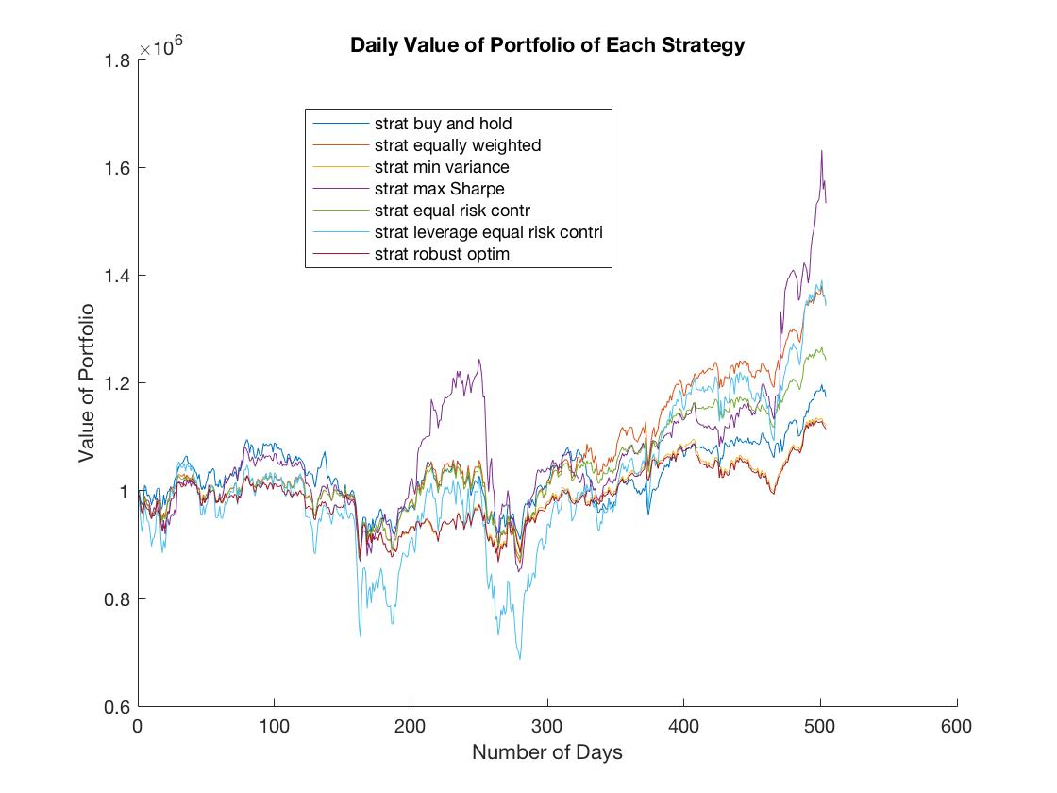

Figure 1: Daily Portfolio Value of Seven Strategies 2015-2016

The following figure shows the dynamic change in portfolio allocations under strategy 7.

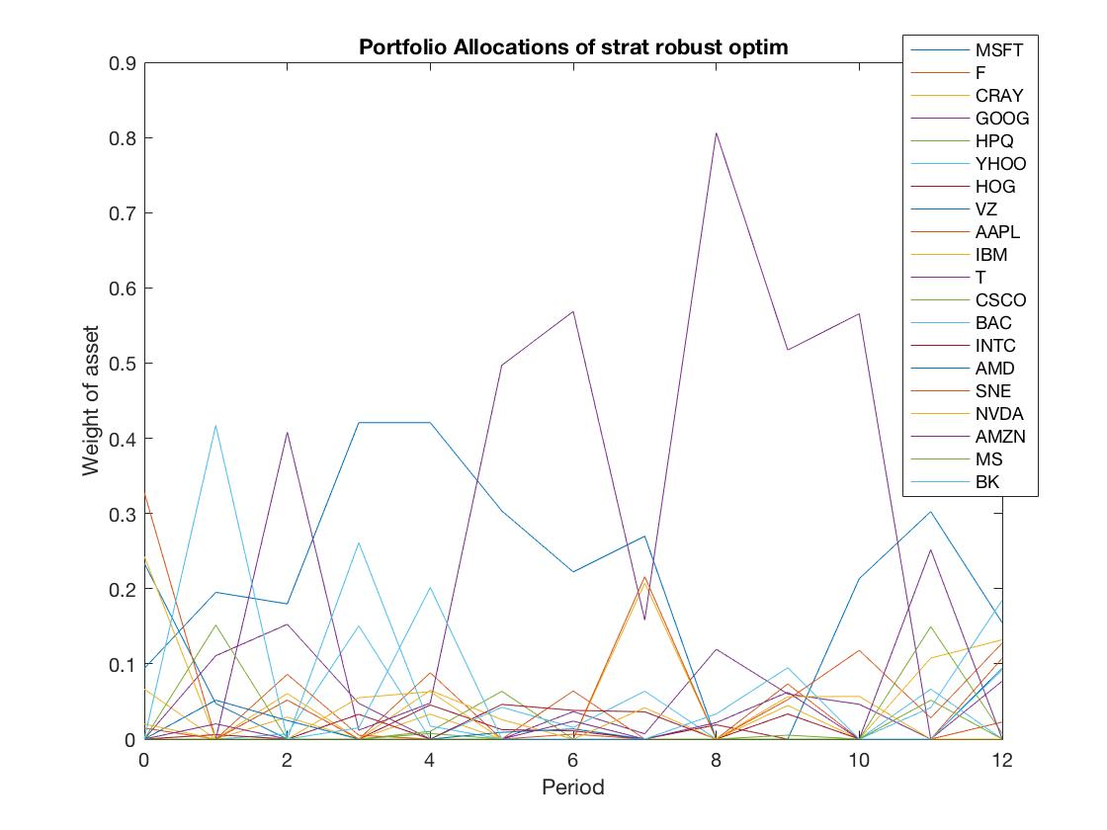

Figure 2: Dynamic Change in Portfolio Allocations under Strategy 7, 2015-2016

The following figures shows the dynamic portfolio allocation of strategy 3 and 4, these two plots are collected from report of assignment 1.

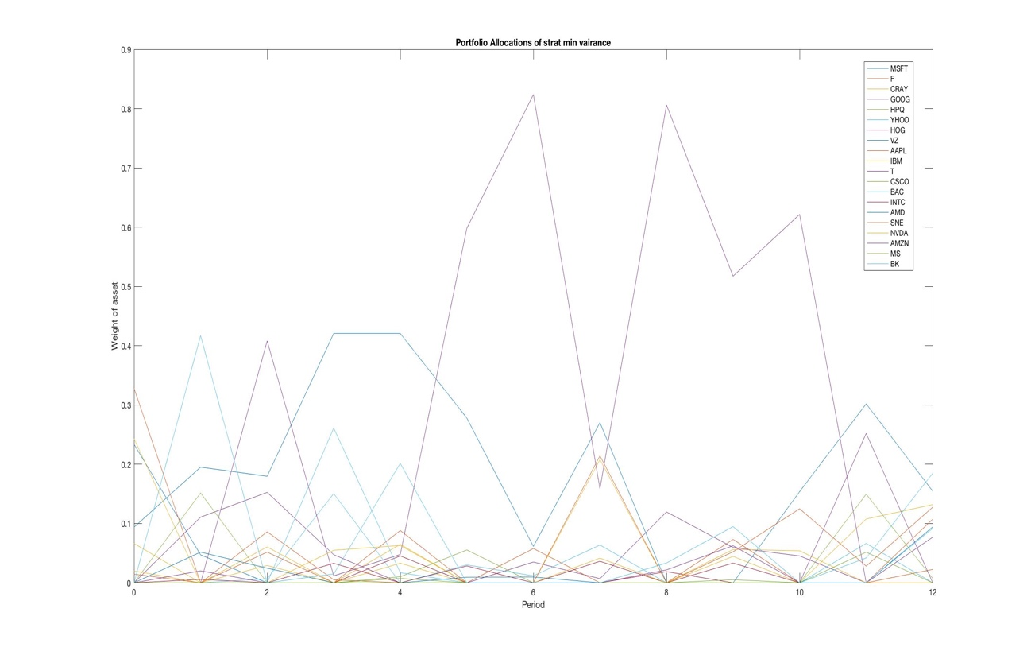

Figure 3: Dynamic Change in Portfolio Allocations under Strategy 3, 2015-2016

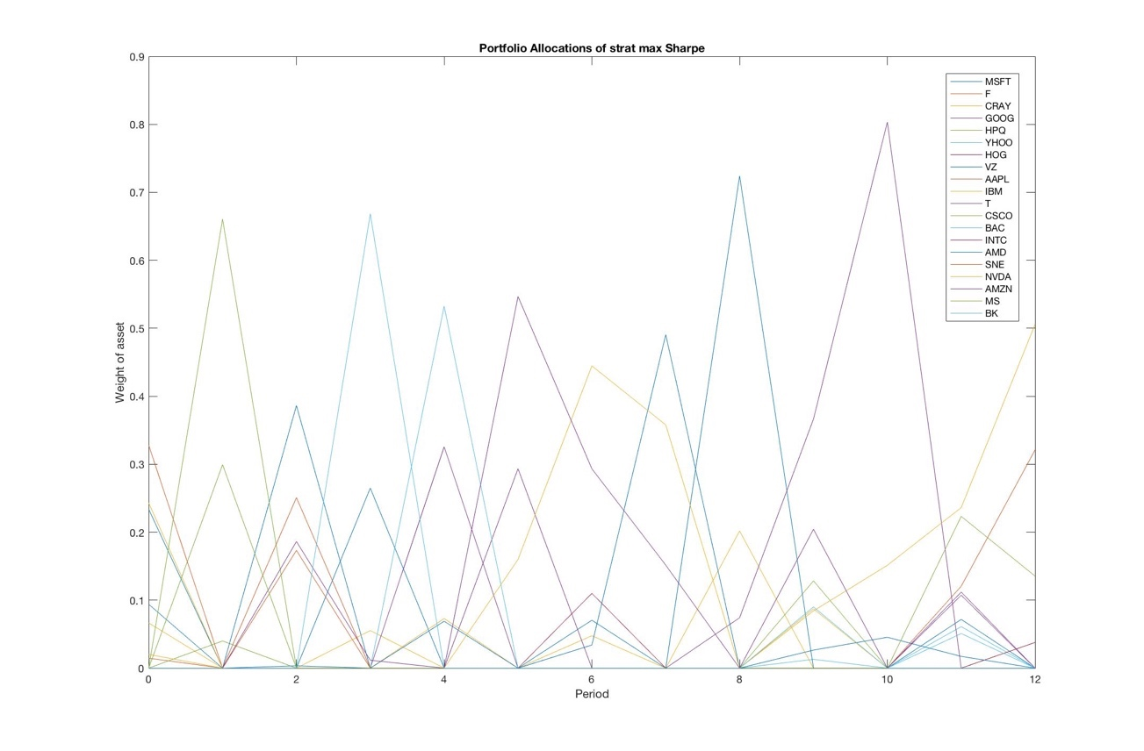

Figure 4: Portfolio Position of Minimum Variance Strategy in 12 Periods

## 3.2 Discussion

Compare the three plots above of dynamic change in portfolio allocation of strategy 3, 4, 7, I cannot reach any conclusion regarding whether robust portfolio selection strategy reduces trading comparing to strategy 3 and 4. There is no significant difference when comparing the plot of dynamic change in portfolio allocation of strategy 3 and 7.

If I were to choose a strategy, I would choose maximum Sharpe ratio strategy, because it gives maximum portfolio value growth rate when underlying asset is appreciating. Although it has some disadvantage when comes to risk, I still favor it over the other strategies because I am still young, and I have more tolerance for risk, and I have a lot of working years ahead to help me with the possible loss in the future. The reason that I do not choose leveraging equal risk contributor strategy is because that this strategy performs the worst when asset is depreciating, even worse than max Sharpe ratio. On the other hand, when assets are appreciating, max Sharpe ratio outperforms leveraging equal risk contributor strategy. Therefore, max Sharpe strategy remains my first choice.

# 

# 4. 2008 – 2009

## 4.1 Results

Initial portfolio value = $ 548247.97

Period 1: start date 1/2/2008, end date 2/29/2008

Strategy "Buy and Hold", value begin = $ 548247.97, value end = $ 465217.72

Strategy "Equally Weighted Portfolio", value begin = $ 544315.20, value end = $ 470296.23

Strategy "Minimum Variance Portfolio", value begin = $ 543898.77, value end = $ 460996.84

Strategy "Maximum Sharpe Ratio Portfolio", value begin = $ 542765.52, value end = $ 473558.50

Strategy "Equal Risk Contributions Portfolio", value begin = $ 544282.81, value end = $ 471996.27

Strategy "Leveraged Equal Risk Contributions Portfolio", value begin = $ 538762.49, value end = $ 393683.61

Strategy "Robust Optimization Portfolio", value begin = $ 543898.77, value end = $ 460996.84

Period 2: start date 3/3/2008, end date 4/30/2008

Strategy "Buy and Hold", value begin = $ 462553.95, value end = $ 511257.48

Strategy "Equally Weighted Portfolio", value begin = $ 463942.49, value end = $ 510429.95

Strategy "Minimum Variance Portfolio", value begin = $ 453728.31, value end = $ 523429.12

Strategy "Maximum Sharpe Ratio Portfolio", value begin = $ 463759.12, value end = $ 485654.84

Strategy "Equal Risk Contributions Portfolio", value begin = $ 465407.89, value end = $ 520284.71

Strategy "Leveraged Equal Risk Contributions Portfolio", value begin = $ 374808.00, value end = $ 463995.50

Strategy "Robust Optimization Portfolio", value begin = $ 453728.31, value end = $ 523429.12

Period 3: start date 5/1/2008, end date 6/30/2008

Strategy "Buy and Hold", value begin = $ 526490.95, value end = $ 486095.76

Strategy "Equally Weighted Portfolio", value begin = $ 527384.02, value end = $ 446675.45

Strategy "Minimum Variance Portfolio", value begin = $ 537839.63, value end = $ 494514.44

Strategy "Maximum Sharpe Ratio Portfolio", value begin = $ 489567.39, value end = $ 423131.71

Strategy "Equal Risk Contributions Portfolio", value begin = $ 537254.55, value end = $ 461319.45

Strategy "Leveraged Equal Risk Contributions Portfolio", value begin = $ 485847.42, value end = $ 347189.10

Strategy "Robust Optimization Portfolio", value begin = $ 537839.63, value end = $ 494514.44

Period 4: start date 7/1/2008, end date 8/29/2008

Strategy "Buy and Hold", value begin = $ 487307.50, value end = $ 485687.69

Strategy "Equally Weighted Portfolio", value begin = $ 446508.67, value end = $ 452538.06

Strategy "Minimum Variance Portfolio", value begin = $ 493763.68, value end = $ 496817.81

Strategy "Maximum Sharpe Ratio Portfolio", value begin = $ 437955.29, value end = $ 436620.75

Strategy "Equal Risk Contributions Portfolio", value begin = $ 459918.02, value end = $ 463390.29

Strategy "Leveraged Equal Risk Contributions Portfolio", value begin = $ 339333.26, value end = $ 344527.95

Strategy "Robust Optimization Portfolio", value begin = $ 493763.68, value end = $ 496817.81

Period 5: start date 9/2/2008, end date 10/31/2008

Strategy "Buy and Hold", value begin = $ 478985.24, value end = $ 369998.60

Strategy "Equally Weighted Portfolio", value begin = $ 451521.31, value end = $ 316535.84

Strategy "Minimum Variance Portfolio", value begin = $ 485586.48, value end = $ 372991.91

Strategy "Maximum Sharpe Ratio Portfolio", value begin = $ 423968.17, value end = $ 294579.43

Strategy "Equal Risk Contributions Portfolio", value begin = $ 461018.42, value end = $ 333926.73

Strategy "Leveraged Equal Risk Contributions Portfolio", value begin = $ 336707.11, value end = $ 149399.85

Strategy "Robust Optimization Portfolio", value begin = $ 485586.48, value end = $ 372991.91

Period 6: start date 11/3/2008, end date 12/31/2008

Strategy "Buy and Hold", value begin = $ 372792.12, value end = $ 338021.03

Strategy "Equally Weighted Portfolio", value begin = $ 315195.85, value end = $ 276820.91

Strategy "Minimum Variance Portfolio", value begin = $ 373266.80, value end = $ 335423.36

Strategy "Maximum Sharpe Ratio Portfolio", value begin = $ 296667.77, value end = $ 255928.94

Strategy "Equal Risk Contributions Portfolio", value begin = $ 333104.31, value end = $ 294542.09

Strategy "Leveraged Equal Risk Contributions Portfolio", value begin = $ 144974.06, value end = $ 110901.16

Strategy "Robust Optimization Portfolio", value begin = $ 373969.98, value end = $ 343768.06

Period 7: start date 1/2/2009, end date 2/27/2009

Strategy "Buy and Hold", value begin = $ 351630.52, value end = $ 325694.94

Strategy "Equally Weighted Portfolio", value begin = $ 288287.66, value end = $ 254209.46

Strategy "Minimum Variance Portfolio", value begin = $ 345285.21, value end = $ 325357.01

Strategy "Maximum Sharpe Ratio Portfolio", value begin = $ 255068.91, value end = $ 209733.86

Strategy "Equal Risk Contributions Portfolio", value begin = $ 306307.58, value end = $ 271120.37

Strategy "Leveraged Equal Risk Contributions Portfolio", value begin = $ 119576.60, value end = $ 91878.60

Strategy "Robust Optimization Portfolio", value begin = $ 354302.78, value end = $ 333747.53

Period 8: start date 3/2/2009, end date 4/30/2009

Strategy "Buy and Hold", value begin = $ 316048.57, value end = $ 392525.73

Strategy "Equally Weighted Portfolio", value begin = $ 243193.89, value end = $ 374610.39

Strategy "Minimum Variance Portfolio", value begin = $ 312536.73, value end = $ 420543.46

Strategy "Maximum Sharpe Ratio Portfolio", value begin = $ 199638.54, value end = $ 280048.49

Strategy "Equal Risk Contributions Portfolio", value begin = $ 260357.47, value end = $ 380676.47

Strategy "Leveraged Equal Risk Contributions Portfolio", value begin = $ 82089.02, value end = $ 158657.93

Strategy "Robust Optimization Portfolio", value begin = $ 320600.30, value end = $ 431391.98

Period 9: start date 5/1/2009, end date 6/30/2009

Strategy "Buy and Hold", value begin = $ 394998.62, value end = $ 426991.87

Strategy "Equally Weighted Portfolio", value begin = $ 373920.70, value end = $ 412492.83

Strategy "Minimum Variance Portfolio", value begin = $ 417445.79, value end = $ 423098.87

Strategy "Maximum Sharpe Ratio Portfolio", value begin = $ 271380.79, value end = $ 295036.98

Strategy "Equal Risk Contributions Portfolio", value begin = $ 379699.57, value end = $ 408545.90

Strategy "Leveraged Equal Risk Contributions Portfolio", value begin = $ 156170.66, value end = $ 180139.90

Strategy "Robust Optimization Portfolio", value begin = $ 428214.60, value end = $ 434013.73

Period 10: start date 7/1/2009, end date 8/31/2009

Strategy "Buy and Hold", value begin = $ 429930.17, value end = $ 467013.68

Strategy "Equally Weighted Portfolio", value begin = $ 413438.34, value end = $ 462699.96

Strategy "Minimum Variance Portfolio", value begin = $ 421680.61, value end = $ 446439.37

Strategy "Maximum Sharpe Ratio Portfolio", value begin = $ 290528.83, value end = $ 287784.53

Strategy "Equal Risk Contributions Portfolio", value begin = $ 409237.57, value end = $ 448368.93

Strategy "Leveraged Equal Risk Contributions Portfolio", value begin = $ 178524.30, value end = $ 212958.57

Strategy "Robust Optimization Portfolio", value begin = $ 432558.57, value end = $ 457934.75

Period 11: start date 9/1/2009, end date 10/30/2009

Strategy "Buy and Hold", value begin = $ 457407.27, value end = $ 489396.95

Strategy "Equally Weighted Portfolio", value begin = $ 447693.12, value end = $ 479917.81

Strategy "Minimum Variance Portfolio", value begin = $ 435361.96, value end = $ 458712.35

Strategy "Maximum Sharpe Ratio Portfolio", value begin = $ 272230.49, value end = $ 275400.38

Strategy "Equal Risk Contributions Portfolio", value begin = $ 435526.63, value end = $ 466288.21

Strategy "Leveraged Equal Risk Contributions Portfolio", value begin = $ 199211.86, value end = $ 227605.15

Strategy "Robust Optimization Portfolio", value begin = $ 446569.57, value end = $ 470523.62

Period 12: start date 11/2/2009, end date 12/31/2009

Strategy "Buy and Hold", value begin = $ 490582.55, value end = $ 542246.05

Strategy "Equally Weighted Portfolio", value begin = $ 481607.05, value end = $ 550969.21

Strategy "Minimum Variance Portfolio", value begin = $ 455039.64, value end = $ 509693.47

Strategy "Maximum Sharpe Ratio Portfolio", value begin = $ 274117.81, value end = $ 310522.17

Strategy "Equal Risk Contributions Portfolio", value begin = $ 466755.51, value end = $ 522301.06

Strategy "Leveraged Equal Risk Contributions Portfolio", value begin = $ 225294.62, value end = $ 279456.34

Strategy "Robust Optimization Portfolio", value begin = $ 466756.58, value end = $ 522815.46

The figure below is the daily portfolio value of seven strategies in 2008-2009.

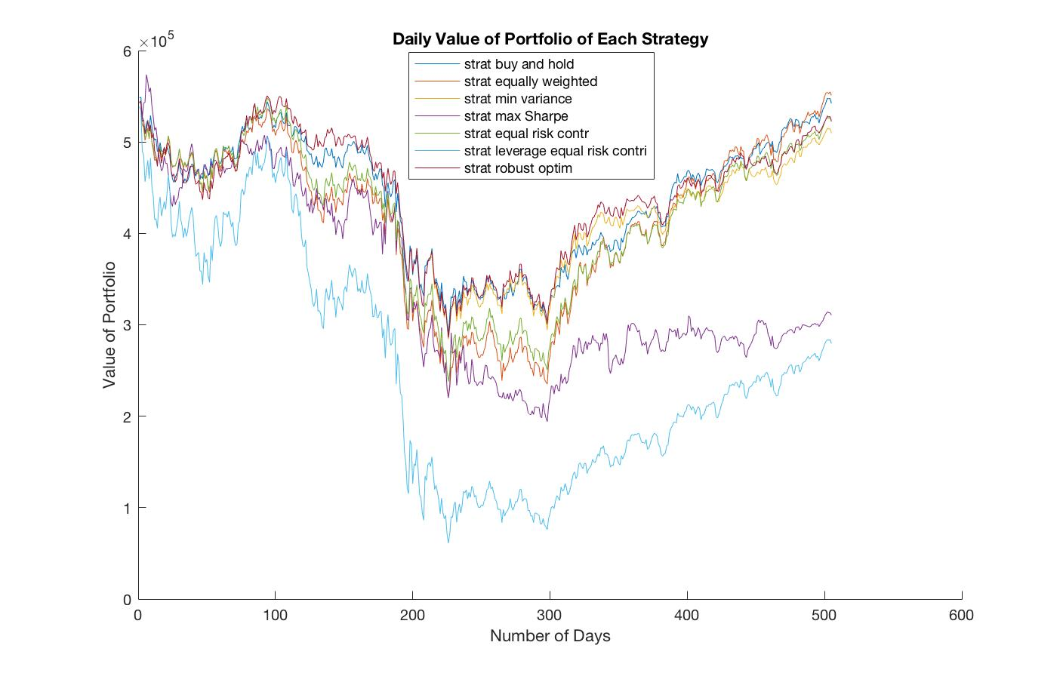

Figure 5. Daily Portfolio Value of Seven Strategies in 2008 -2009

Below 3 figures are dynamic changes in portfolio allocations under strategy 3, 4 and 7 respectively in 2008 -2009

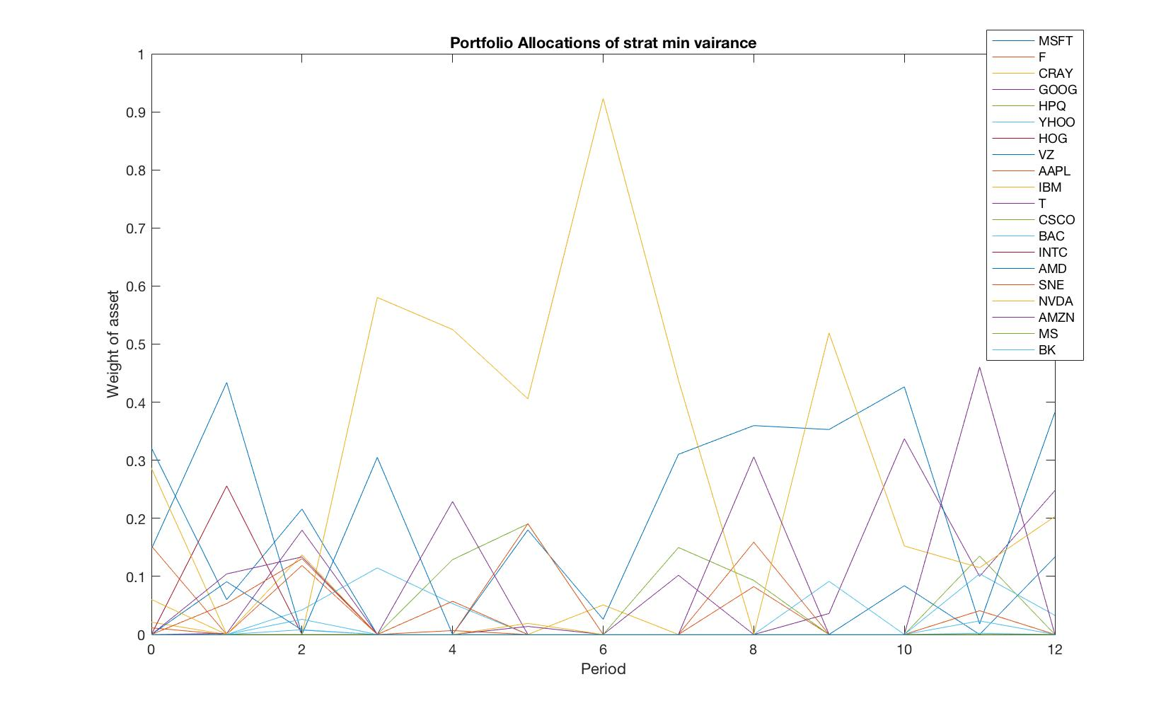

Figure 6: Dynamic Change in Portfolio Allocations under Strategy 3, 2008-2009

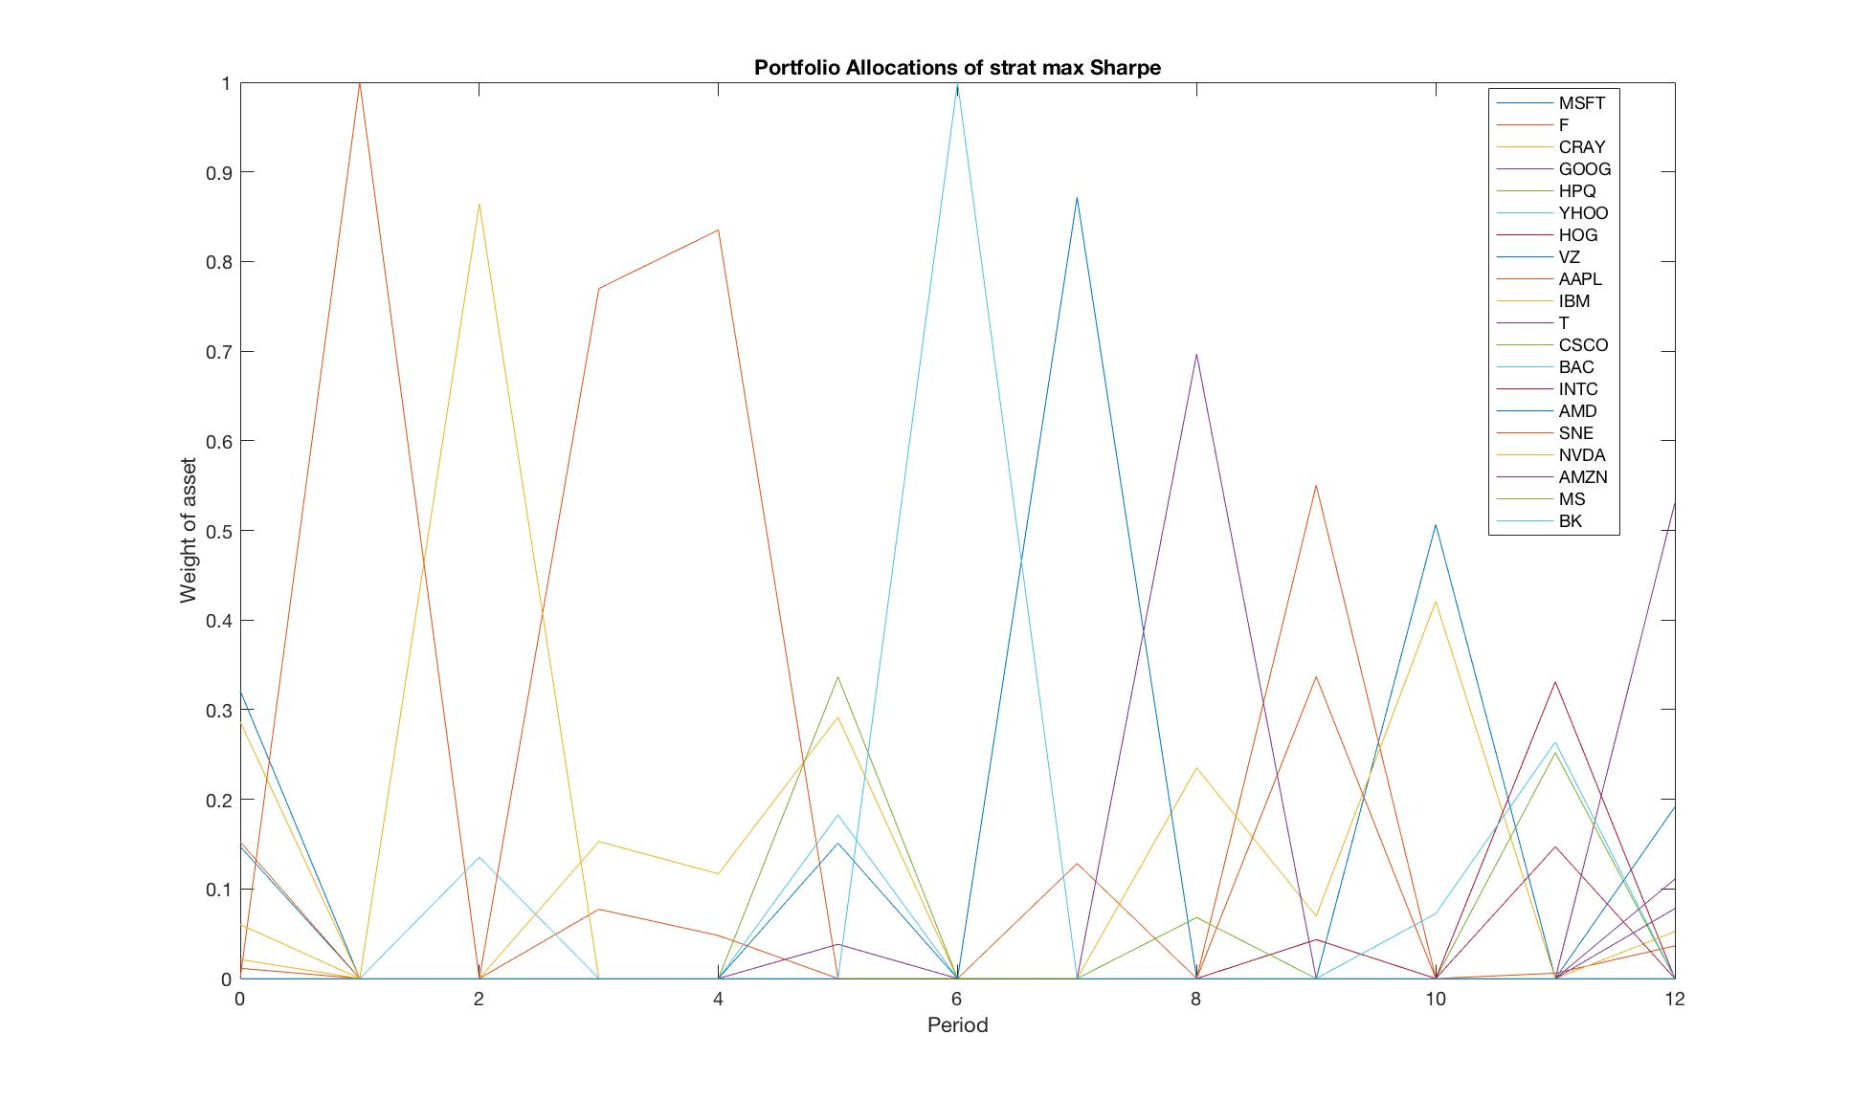

Figure 7: Dynamic Change in Portfolio Allocations under Strategy 4, 2008-2009

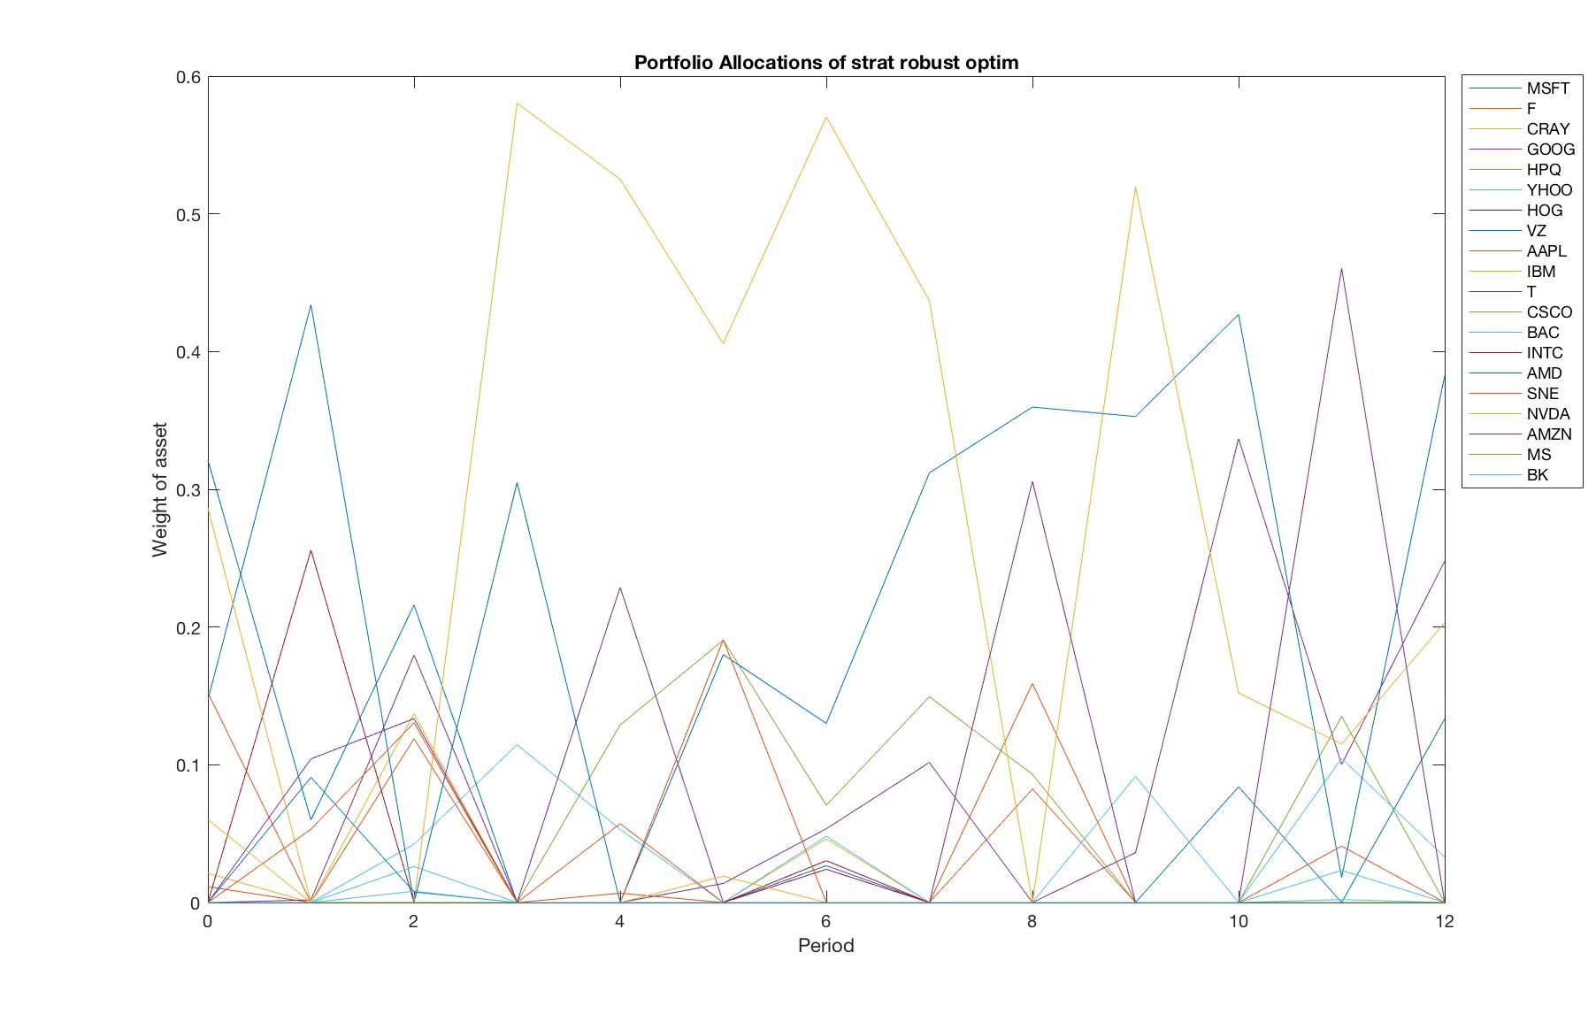

Figure 8: Dynamic Change in Portfolio Allocations under Strategy 7, 2008-2009

## 4.2 Discussion

Compare the three plots above of dynamic change in portfolio allocation of strategy 3, 4, 7, it seems that when putting figure 6 and 8 side by side for comparison, strategy 7, which is robust portfolio selection causes more trading activity than minimum variance strategy. To me, from the plot, the robust portfolio selection strategy actually has more trading activity than both strategy 3 and 4. However, the plots are very complicated, and I am just using my eyes to compare the plots, therefore there might be biased error in my observation.

If I were to choose a strategy, I would choose minimum variance strategy if the time is set in 2008 – 2009. From Figure 5, strategy 4 and strategy 6 are having heavy losses during the crisis. Since it’s in the crisis, I would want to minimize my losses in this time. If I have to choose one out of the seven strategies, I would choose minimum variance strategy, because from figure 5, it is one of the strategies that has least losses.