MIE 1622h-s aSSINMENT 4 REPORT

Submitted by Yifan Shao 1004534435

100

University of Toronto

Apr 9, 2018

Contents

1. Problem Description 2

2. Methods 2

2.1 Program 2

3. Results 2

3.1 Closed Form and Monte Carlo Simulation 2

3.2 Result Analysis 3

3.2.1 Plot 3

3.2.1 Comparing 3 strategies 5

3.2.1 Difference between European and Barrier option 5

3.2.1 Volatility up 10% 5

3.2.2 Volatility down 10% 5

4. Discussion 6

4.1 Find Parameter to Achieve Same Price as Black Scholes Formula 6

# 1. Problem Description

Use closed form Black-Scholes equation to calculate the put and call option price of a stock with $S_{0}=100, K=105, T=1, risk-free rate=0.05, drift μ=0.05 and volatility σ=0.2.$ Use Monte Carlo simulation to simulate the Geometric Random Walk to represent the price of the stock at expiration. Also consider knock-in up option pricing for the same stock. Then change the volatility of the stock for +/- 10%. In the end find the optimal number of paths and number of scenarios for Monte Carlo simulated option price so that the difference from closed form solution is less than 1 cent.

# 2. Methods

## 2.1 Program

The following table shows the MATLAB program used for this assignment:

|  |  |
| --- | --- |
| Function name | Purpose |
| Option_pricing.m | Main program |
| BS_european_price.m | To calculate price of European option using Black-Shcoles Formula |
| MC_european_price.m | To calculate price of European option using Monte Carlo simulation results |
| MC_barrier_knockin_price.m | To calculate price of knock-in Barrier option using Monte Carlo simulation results |
| GRWPaths.m | To produce stock price paths using Geometric Random Walk |
| Knock_in.m | To determine if the stock price paths breached the barrier and knock-in happens |

Table 1: MATLAB Program List

# 3. Results

## 3.1 Closed Form and Monte Carlo Simulation

The following output is obtained from MATLAB command window after running the code. For the one-step MC price of European call/put option, I used $numSetps = 1 and numPaths = 10000$, I chose 10000 scenarios because the results produced is fairly close to the closed form result, while the computational time is not too long if I use this parameter. For the multi-step MC price of European call/put option, I used $numSetps = 252 and numPaths = 10000$, I chose 10000 scenarios because the results produced is fairly close to the closed form result, while the computational time is not too long if I use this parameter. I chose 252 steps to represent 252 trading days in a year.

Black-Scholes price of an European put option is 7.9004

One-step MC price of an European call option is 7.9427

One-step MC price of an European put option is 7.9187

Multi-step MC price of an European call option is 7.8992

Multi-step MC price of an European put option is 7.9141

One-step MC price of an Barrier call option is 21.2472

One-step MC price of an Barrier put option is 0

Multi-step MC price of an Barrier call option is 11.953

Multi-step MC price of an Barrier put option is 3.1461

## 3.2 Result Analysis

### 3.2.1 Plot

The Plots below are obtained from MATLAB, **the plotting part in is code is commented out, to save computational time.**

First, I use Geometric Random Walk paths to represent the trend of the stock price in 1 year in each scenario, which is Figure 1. I check the price of the stock at time of expiration of the option, from that I calculate the put option payoff and call option payoff. I calculate the mean of those values and use them as expected price of the option, Figure 2 and 3. In the end, I discount the price back to present using continuous compounding at risk free interest rate.

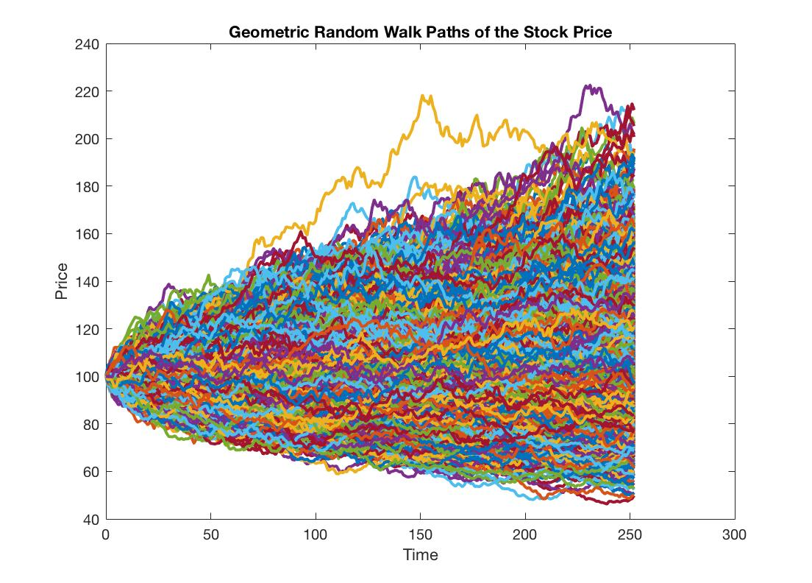

Figure 1: GRW Path plot of Stock Price

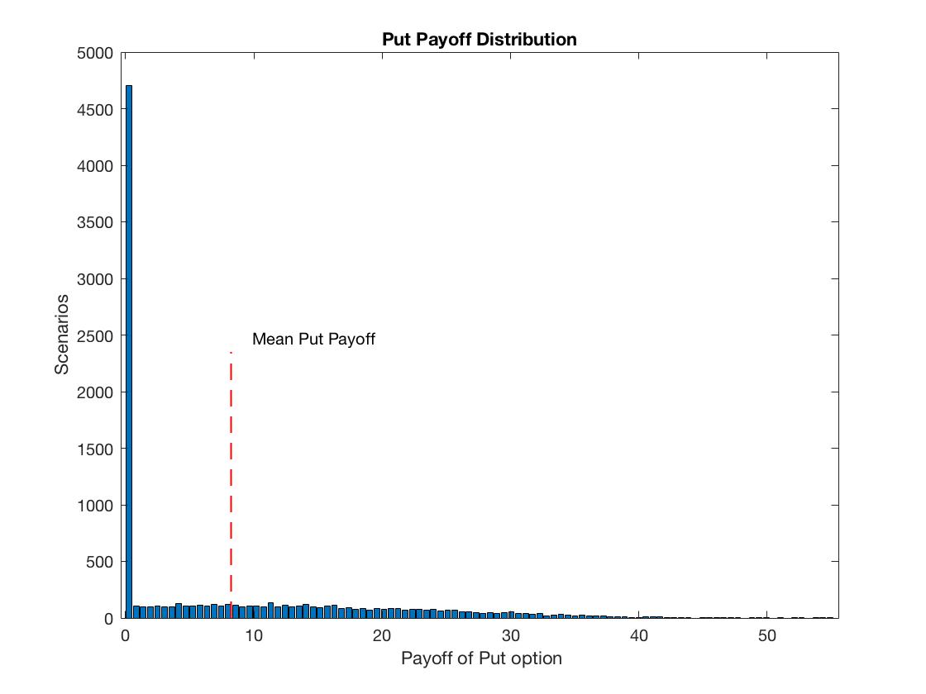

Figure 2: Put payoff distribution

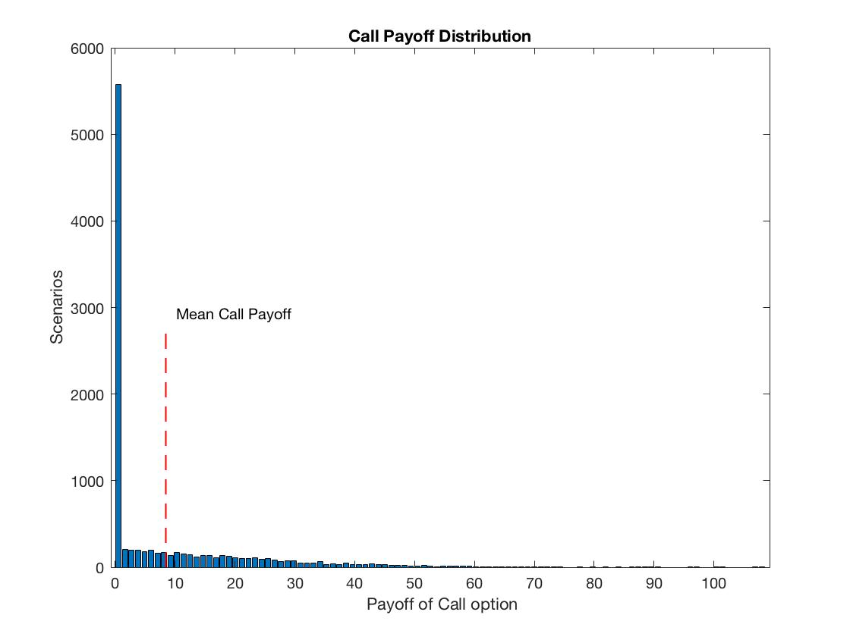

Figure 3: Call payoff distribution

### 3.2.1 Comparing 3 strategies

While Monte Carlo simulation results are very close to closed form of Black Scholes equation results, we can see between multi-step simulation and one-step simulation, the difference between them is so small, that I think the multi-step does not have any significant impact on the accuracy of the Monte Carlo simulation. I think the number of scenarios plays big part in this, and if I increase the number of scenarios I used in calculation, the one-step Monte Carlo simulation results will eventually approach the closed form result with error within 0.01 dollar.

### 3.2.1 Difference between European and Barrier option

From the results in 3.1, we can see that the price of the Barrier call option is significantly larger than the European call price, on the contrary, the price of Barrier put option is significantly lower than the price of European put option price. My interpretation of this is, the barrier is 110 dollars, the strike price is 105 dollars, hence when Barrier call option knocks in, the payoff is already around 5 dollars. Simply put, once the Barrier call option knocks in, it almost certainly will have positive payoff. The payoff of European call option is either positive or 0. At this time, we can see that the average of Barrier call option payoff will certainly be larger than the average payoff of European call option. Same things apply to the Barrier put option and European call option. When barrier is breached, nobody is willing to sell at 105 when the market price is around 110. Hence once the barrier knocks in, there is almost very few chances the price will go back down below 105, that’s why Barrier put option is very cheap comparing to European put option.

### 3.2.1 Volatility up 10%

If the volatility goes up by 10% , the prices of the Barrier option is :

One-step MC price of an Barrier call option is 23.0126

One-step MC price of an Barrier put option is 0

Multi-step MC price of an Barrier call option is 12.8745

Multi-step MC price of an Barrier put option is 3.7582

If compare the result with $σ=2$, The prices of Barrier call and put option actually increases when volatility goes up. I interpret this is because the increase volatility, the price of the stock will have more chances to breach to barrier and reach a higher price. Hence the price of the call and put option increases.

### 3.2.2 Volatility down 10%

If the volatility of the stock goes down by 10%, the prices of the Barrier option is:  
One-step MC price of an Barrier call option is 18.9305

One-step MC price of an Barrier put option is 0

Multi-step MC price of an Barrier call option is 11.273

Multi-step MC price of an Barrier put option is 2.5154

If compare the result with $σ=2$, The prices of Barrier call and put option actually decreases when volatility goes down. I interpret this is because the decrease in volatility, the price of the stock will have less chances to breach to barrier and reach a higher price. Hence the price of the call and put option goes down as well.

# 4. Discussion

## 4.1 Find Parameter to Achieve Same Price as Black Scholes Formula

For this part, I decided to use while loop to sweep search the best number of scenarios that allow the Monte Carlo simulation to achieve the same price as the Black Scholes Formula. In this part, I opt to use numSteps = 1, because in 3.1 I found out that the numSteps has very little impact on the simulation result accuracy toward the Black Scholes Formula results. Therefore, to save computational time, I decided to only sweep search parameter number of paths. The interval of each sweep is 100. As the result from MATLAB, to achieve same price as Black Scholes Formula,

$$numSteps=1$$

$$numPaths= 15100$$